February 2018 ERCOT Monthly Operations Report
Reliability and Operations Subcommittee Meeting
April 5th, 2018

Table of Contents
1. Report Highlights 2
2. Frequency Control 3
2.1. Frequency Events 3
2.2. Responsive Reserve Events 4
2.3. Load Resource Events 4
3. Reliability Unit Commitment 4
4. Wind Generation as a Percent of Load 5
5. COP Error Analysis 5
6. Congestion Analysis 7
6.1. Notable Constraints 7
6.2. Generic Transmission Constraint Congestion 11
6.3. Manual Overrides 11
6.4. Congestion Costs for Calendar Year 2018 11
7. System Events 12
7.1. ERCOT Peak Load 12
7.2. Load Shed Events 12
7.3. Stability Events 12
7.4. Notable PMU Events 12
7.5. DC Tie Curtailment 13
7.6. TRE/DOE Reportable Events 13
7.7. New/Updated Constraint Management Plans 13
7.8. New/Modified/Removed RAS 13
7.9. New Procedures/Forms/Operating Bulletins 13
8. Emergency Conditions 13
8.1. OCNs 13
8.2. Advisories 14
8.3. Watches 14
8.4. Emergency Notices 14
9. Application Performance 14
9.1. TSAT/VSAT Performance Issues 14
9.2. Communication Issues 14
9.3. Market System Issues 14
10. Model Updates 14
Appendix A: Real-Time Constraints 16

Report Highlights
- The unofficial ERCOT peak for February was 55,150 MW.
- There were six frequency events in February. PMU data indicates the ERCOT system transitioned well in each case.
- There was four instances where Responsive Reserves were deployed.
- There were no RUC commitments in February.
- Congestion in February was concentrated in the North, South, and West Load Zones and can be attributed mostly to high wind output in the Panhandle as well as planned outages. There were 40 instances over 27 days on the Generic Transmission Constraints (GTCs) in February, including 27 days on the Panhandle GTC and 13 days on the Nelson Sharpe – Rio Hondo GTC. There was no activity on the remaining GTCs during the month.
- There was one DC Tie curtailment, including one DC Tie Tag curtailed, in February.

Frequency Control

Frequency Events
The ERCOT Interconnection experienced four frequency events in February, all of which resulted from Resource trips. The average event duration was approximately 0:03:48.

A summary of the frequency events is provided below. The reported frequency events meet one of the following criteria: Delta Frequency is 60 mHz or greater; the MW loss is 350 MW or greater; resource trip event triggered RRS deployment. Frequency events that have been identified as Frequency Measurable Events (FME) for purposes of BAL-001-TRE-1 analysis are highlighted in blue. When analyzing frequency events, ERCOT evaluates PMU data according to industry standards. Events with an oscillating frequency of less than 1 Hz are considered to be inter-area, while higher frequencies indicate local events. Industry standards specify that damping ratio for inter-area oscillations should be 3.0% or greater. For the frequency events listed below, the ERCOT system met these standards and transitioned well after each disturbance.

Date and Time | Delta Frequency | Max/Min Frequency | Duration of Event | PMU Data |  | MW Loss | Load | Wind | Inertia
 | (Hz) | (Hz) |  | Oscillation Mode (Hz) | Damping Ratio |  | (MW) | % | (GW-s)
2/2/2018 23:46 | 0.068 | 59.88 | 0:02:46 | No PMU Report Created |  | 292 | 36,175 | 37% | 176,347
2/5/2018 14:04 | 0.171 | 59.83 | 0:05:34 | 0.67 | 8% | 816 | 40,685 | 19% | 219,925
2/6/2018 18:19 | 0.069 | 59.90 | 0:01:34 | No PMU Report Created |  | 363 | 46,359 | 8% | 262,328
2/14/2018 6:30 | 0.159 | 59.86 | 0:03:18 | 0.65 | 11% | 784 | 41,838 | 19% | 226,783
2/22/2018 6:39 | 0.086 | 59.93 | 0:03:27 | No PMU Report Created |  | 491 | 46,585 | 1% | 289,797
2/22/2018 15:24 | 0.060 | 59.92 | 0:06:07 | No PMU Report Created |  | 328 | 44,370 | 3% | 281,247

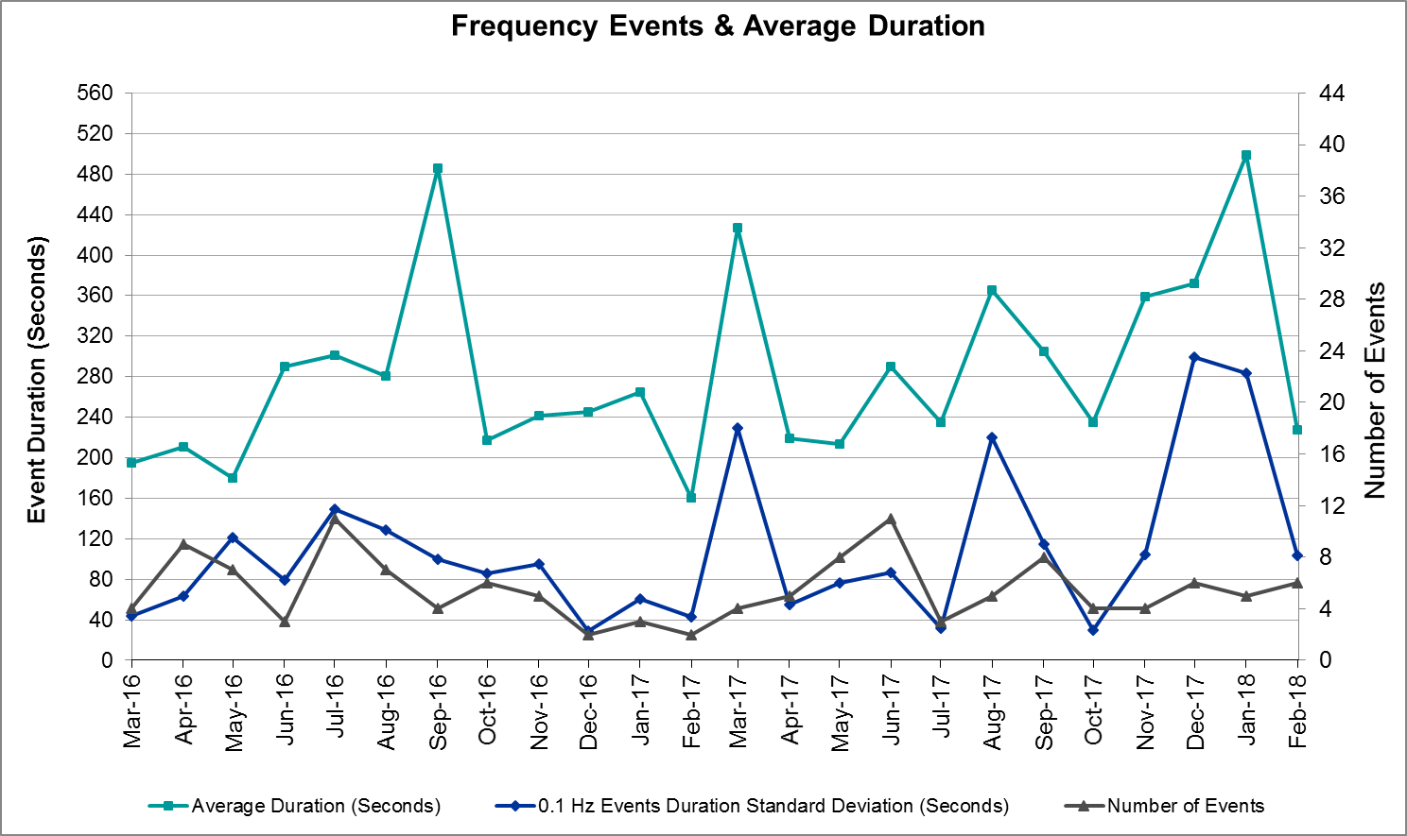
(Note: All data on this graph encompasses frequency event analysis based on BAL-001-TRE-1.)

Responsive Reserve Events
There were four events where Responsive Reserve MWs were released to SCED in February. The events highlighted in blue were related to frequency events reported in Section 2.1 above.

Date and Time Released to SCED | Date and Time Recalled | Duration of Event | Maximum MWs Released | Comments
2/2/2018 23:46:42 | 2/2/2018 23:49:58 | 0:03:16 | 679.97
2/5/2018 14:04:56 | 2/5/2018 14:10:00 | 0:05:04 | 939.17
2/6/2018 18:19:50 | 2/6/2018 18:21:22 | 0:01:32 | 270.98
2/14/2018 6:30:28 | 2/14/2018 6:33:12 | 0:02:44 | 273.04

Load Resource Events
None.

Reliability Unit Commitment
ERCOT reports on Reliability Unit Commitments (RUC) on a monthly basis. Commitments are reported grouped by operating day and weather zone. The total number of hours committed is the sum of the hours for all the units in the specified region. Additional information on RUC commitments can be found on the MIS secure site at Grid Generation Reliability Unit Commitment.

There were no DRUC commitments in February.

There were no HRUC commitments in February.

Wind Generation as a Percent of Load
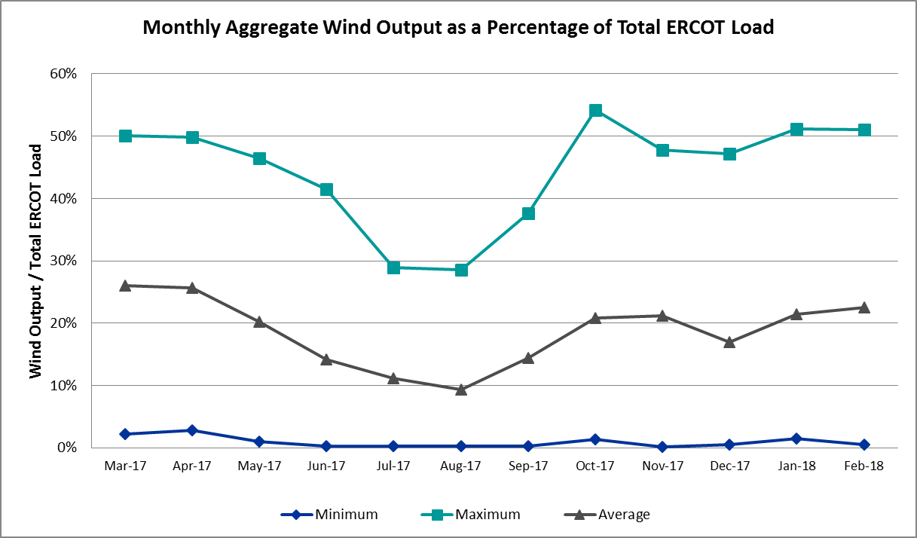

COP Error Analysis
COP Error is calculated as the capacity difference between the COP HSL and real-time HSL of the unit. Mean Absolute Error (MAE) stayed high around 9,000 MW until Day-Ahead at 12:00, then dropped significantly to 1,408 MW by Day-Ahead at 14:00. In the following chart, Under-Scheduling Error indicates that COP had less generation capacity than real-time and Over-Scheduling Error indicates that COP had more generation capacity than real-time. Under-Scheduling persisted from beginning of Day-Ahead to end of the Operating Day. Snapshot on the Operating Day considers all Operating Hours, including past hours. However, COP error for the Operating Hour freezes after the Adjustment Period.
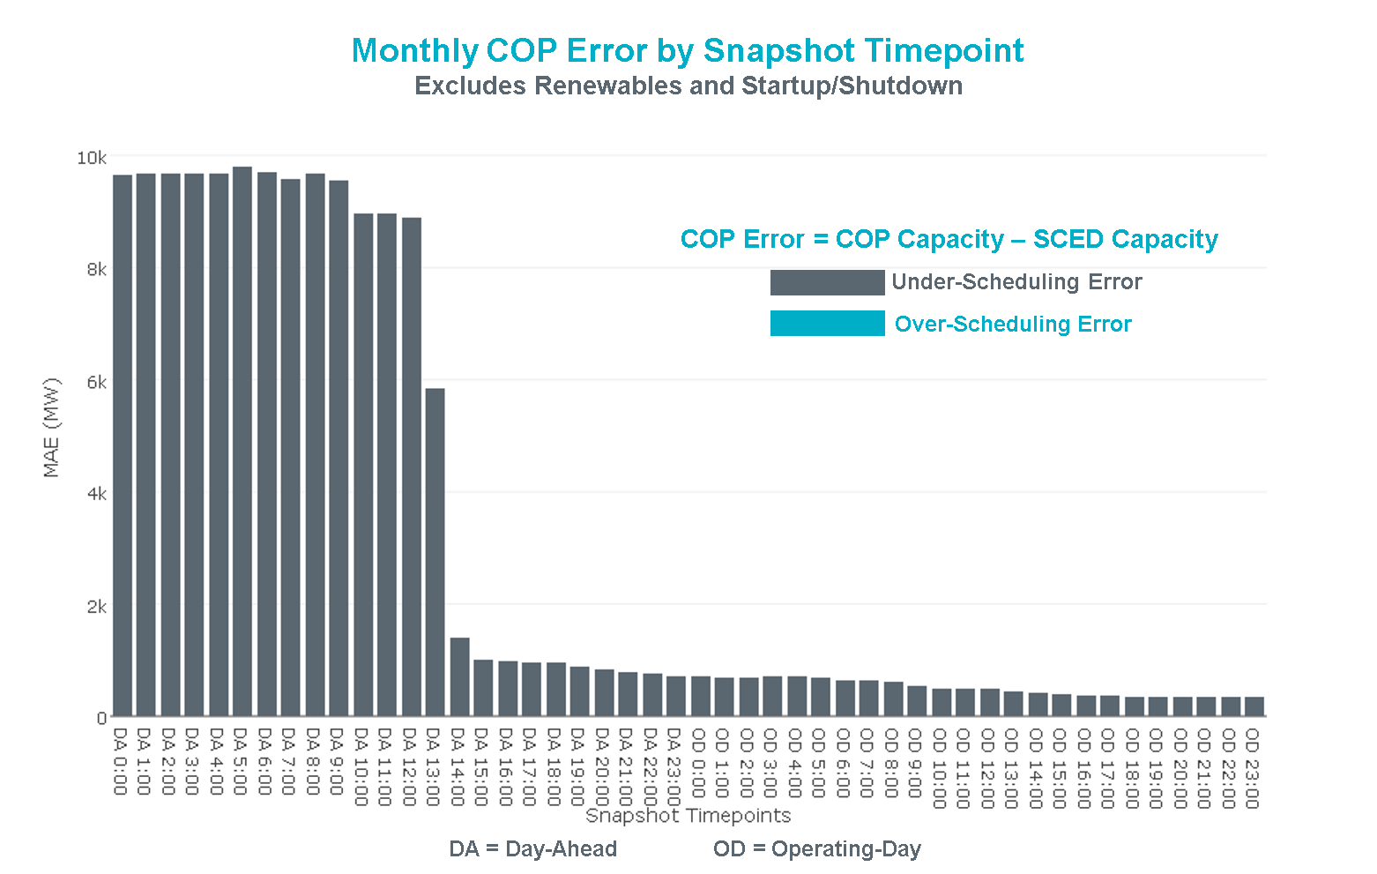

Latest COP at the end of the Adjustment Period had MAE of 334 MW with median ranging from -119 MW for Hour-Ending (HE) 12 to 114 MW for HE 20. Feb 19th HE 8 had the largest Over-Scheduling Error (1,240 MW) and Feb 10th HE 18 had the largest Under-Scheduling Error (-3,308 MW).
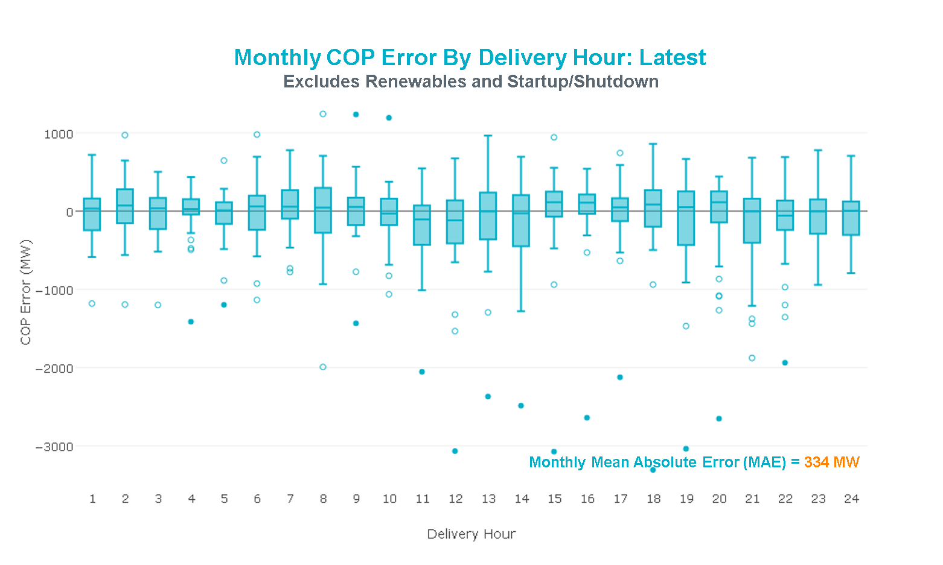

Day-Ahead COP at 12:00 had MAE of 8,894 MW with median ranging from -10,213 MW for Hour-Ending (HE) 19 to -5,990 MW for HE 2. Feb 14th HE24 had the largest Over-Scheduling Error (1,156 MW) and Feb 22nd HE 9 had the largest Under-Scheduling Error (-22,564 MW).
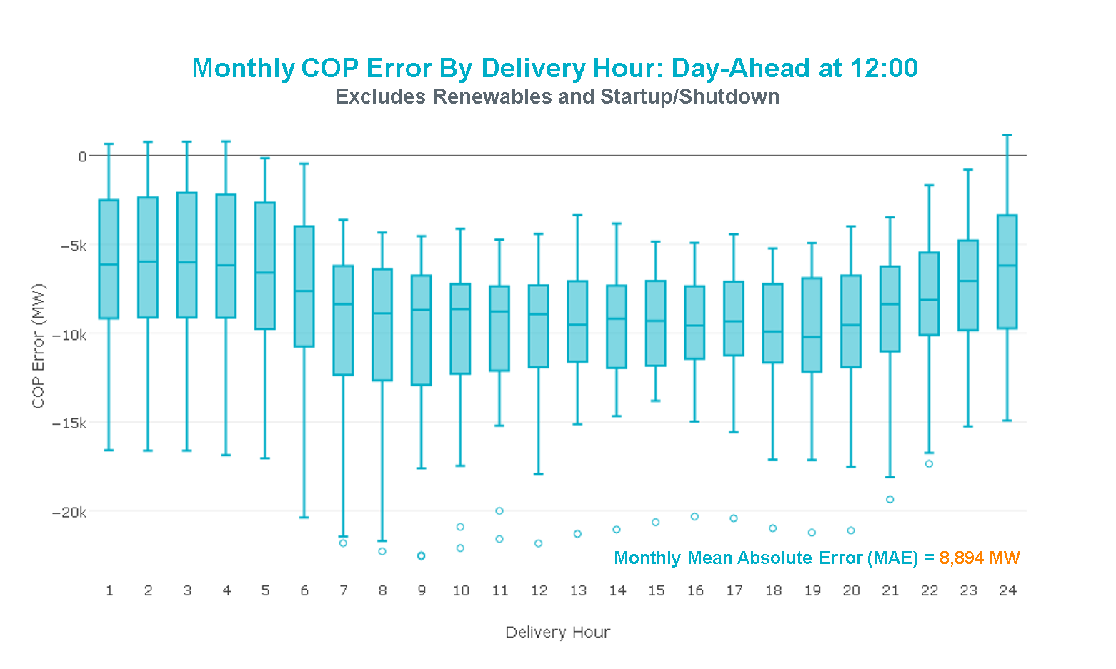

Congestion Analysis
The total number of congestion events experienced by the ERCOT system decreased in February. There were 40 instances over 27 days on the Generic Transmission Constraints (GTCs) in February.

Notable Constraints
Nodal protocol section 3.20 specifies that ERCOT shall identify transmission constraints that are active or binding three or more times within a calendar month. As part of this process, ERCOT reports congestion that meets this criterion to ROS. In addition ERCOT also highlights notable constraints that have an estimated congestion rent exceeding $1,000,000 for a calendar month. These constraints are detailed in the table below. Rows highlighted in blue indicate the congestion was affected by one or more outages. For a list of all constraints activated in SCED for the month of February, please see Appendix A at the end of this report.

Contingency Name | Overloaded Element | # of Days Constraint Active | Congestion Rent | Transmission Project
Basecase | PNHNDL GTC | 27 | $28,828,565.62 | LP&L Option 4ow & Panhandle Loop (5180, 5208)
CRLNW-LWSSW 345kV | Carrollton Northwest - Lakepointe Tnp 138kV | 16 | $3,368,632.03
Re Roserock Solar Plant to L | Barrilla - Fort Stockton Switch 69kV | 24 | $3,287,417.36 | Far West Texas Project
Cagnon-Kendal 345kV & Mengcr-Ranch | Marion 345/1kV | 2 | $2,971,733.76
EMSES-SAGNA 138kV | Eagle Mountain Ses - Eagle Mountain Compressor 138kV | 1 | $2,267,695.95
NORTH PHARR to POLK AVENUE LIN 1 | North Mcallen - West Mcallen 138kV | 2 | $1,942,337.21
Jewet-Sng 345kV | Btu_Jack_Creek - Twin Oak Switch 345kV | 10 | $1,160,064.93 | Houston Import Project (4458)
KLEBERG AEP to LOYOLA SUB LIN 1 | Loyola Sub 138/69kV | 10 | $773,675.97 | AEP_Angstrom (15TPIT0069)
LAQUINTA to LOBO LIN 1 | Bruni Sub 138/69kV | 11 | $694,681.11
LON HILL to NELSON SHARPE LIN 1 | Rodd Field - Holly 138kV | 9 | $683,293.64
CITGO N OAK PARK to NUECES BAY LIN | Morris Street - Nueces Bay 138kV | 3 | $583,764.35
Basecase | NELRIO GTC | 13 | $545,580.67
Asphalt Mines to Blewett (3) | Hamilton Road - Maverick 138kV | 11 | $449,354.22 | Brackettville to Escondido (5206)
COLETO CREEK to PAWNEE SWITCHING S | Coleto Creek - Rosata Tap 138kV | 3 | $363,684.59
LON HILL to PAWNEE SWITCHING STATI | Pettus - Normanna 69kV | 4 | $354,192.03 | Kenedy Switch to Tuleta: Build double circuit 138 kV line
Cagnon-Kendal 345 &Cico-Meng | Medina Lake - Tally_Rd 138kV | 11 | $332,939.87
Basecase | Pig Creek - Solstice 138kV | 23 | $305,669.62 | Solstice to Permian Basin: Rebuild 138 kV line
Rns-Rtw & Sng-Tb 345kv | Singleton - Zenith 345kV | 4 | $220,999.66 | Houston Import Project (4458)
Elmcreek-Stp 345kv | Blessing - Lolita 138kV | 4 | $198,772.67
Entpr-Trses & Mlses-Scses 34 | Herty North Switch - Nacogdoches Se 138kV | 7 | $186,086.44
ALAMITO CREEK to MARFA LIN 1 | Alpine - Paisano 69kV | 9 | $176,811.84
Riohondo-Nedin 345kV&Harlnsw 138kV | Burns Sub - Rio Hondo 138kV | 4 | $145,252.15
Basecase | Omega - Horse Hollow Generation Tie 345kV | 10 | $141,411.48
Fergus-Granmo&Wirtz-Starck 138kV | Bertram - Burnet 69kV | 5 | $138,081.15
MCAN_SW TO RIOP 138 KV | Pig Creek - Solstice 138kV | 4 | $133,680.85 | Solstice to Permian Basin: Rebuild 138 kV line
NELSON SHARPE TRX XF1 345/138 | Rodd Field - Holly 138kV | 3 | $121,665.42
North Lamar POI to LORAINE SOUTH P | Eskota Switch - Longworth 69kV | 3 | $107,501.26
ASPERMONT AEP to PAINT CREEK LIN 1 | Aspermont Aep 138/69kV | 5 | $81,985.75 | Aspermont: Replace the 138/69 kV autotransformer (6569)
North Lamar POI to LORAINE SOUTH P | Eskota Switch - Longworth 69kV | 3 | $81,473.22
SOUTH LANE CITY to LANE CITY LIN 1 | Sargent Sub - Franklins Camp Sub 69kV | 5 | $78,008.69
Elmcreek-Stp 345kv | Sargent Sub - Franklins Camp Sub 69kV | 3 | $71,399.33
Wirtz-Burnet&Starck 138kV | Granite Mountain - Marble Falls 138kV | 14 | $55,469.97
NICOLE to OAK CREEK AEP LIN 1 | Tennyson - Nicole 138kV | 3 | $50,138.05
ROCK ISLAND to GLIDDEN LCRA LIN 1 | Glidden 138/69kV | 3 | $32,417.06
BRACKETTVILLE to HAMILTON ROAD LIN | Hamilton Road - Maverick 138kV | 5 | $29,250.81 | Brackettville to Escondido (5206)
CAGNON to KENDALL LIN 1 | Cico - Comfort 138kV | 8 | $27,695.72
Basecase | Randado Aep - Zapata 138kV | 12 | $27,183.60
North Lamar POI to LORAINE SOUTH P | Roby - Round Tree Tap 69kV | 3 | $24,461.51
JARDIN to DILLEY SWITCH AEP LIN 1 | Dilley Switch Aep - Cotulla Sub 69kV | 4 | $22,338.17
Elmcreek-Sanmigl 345kV | Beeville - Normanna 69kV | 3 | $21,247.93
COLETO CREEK GEN COLETOG1 | Blessing - Lolita 138kV | 4 | $20,634.71
COLETO CREEK to VICTORIA LIN 1 | Coleto Creek - Victoria 138kV | 4 | $14,346.46
Fergus-Corona & Granmo 138kV | Starcke - Wirtz 138kV | 3 | $1,675.41
Cagnon-Kendal 345kV & Mengcr-Ranch | Txresrch - Tally_Rd 138kV | 2 | $1,412.43
North Lamar POI to LORAINE SOUTH P | Roby - Round Tree Tap 69kV | 3 | $1,096.67

Generic Transmission Constraint Congestion
There were 27 days on the Panhandle GTC and 13 days on the Nelson Sharpe – Rio Hondo GTC in February. There was no activity on the remaining GTCs during the month.

Note: This is how many times a constraint has been activated to avoid exceeding a GTC limit, it does not imply an exceedance of the GTC occurred or that the GTC was binding.

Manual Overrides
None.

Congestion Costs for Calendar Year 2018
The following table represents the top twenty active constraints for the calendar year based on the estimated congestion rent attributed to the congestion. ERCOT updates this list on a monthly basis.

Contingency | Binding Element | # of 5-min SCED Intervals | Estimated Congestion Rent | Transmission Project
Basecase | PNHNDL GTC | 9,863 | 59,680,169.37 | LP&L Option 4ow & Panhandle Loop (5180, 5208)
NORTH EDINBURG TRX 1382 345/138 | North Edinburg 345/1kV | 661 | 28,832,407.40
Basecase | VALIMP GTC | 328 | 17,313,039.25
Castrvll-Razorbac&Txresrch 1 | Hondo Creek Switching Station - Moore Switching Station 138kV | 605 | 15,342,875.43
CRLNW-LWSSW 345kV | Carrollton Northwest - Lakepointe Tnp 138kV | 5,074 | 14,370,086.70
LON HILL TRX LON_HILL_3_2 345/138 | Lon Hill 345/1kV | 972 | 6,429,992.43
Jewet-Sng 345kV | Btu_Jack_Creek - Twin Oak Switch 345kV | 2,425 | 5,716,460.50 | Houston Import Project (4458)
Rns-Rtw & Sng-Tb 345kv | Singleton - Zenith 345kV | 1,919 | 5,195,375.21 | Houston Import Project (4458)
East Harrison to La Palma 69 | Haine Drive - La Palma 138kV | 471 | 5,189,980.11
Re Roserock Solar Plant to F | Barrilla - Fort Stockton Switch 69kV | 4,650 | 4,325,444.72 | Far West Texas Project
Cagnon-Kendal 345kV & Mengcr-Ranch | Marion 345/1kV | 220 | 2,971,733.76
NELSON SHARPE TRX XF1 345/138 | Rodd Field - Holly 138kV | 738 | 2,597,024.08
Chevron Has to Ward Gulf Tap | Winkler County 6 Tnp - Wickett Tnp 69kV | 846 | 2,469,291.66
Asphalt Mines to Blewett (3) | Hamilton Road - Maverick 138kV | 3,051 | 2,299,664.55 | Brackettville to Escondido (5206)
EMSES-SAGNA 138kV | Eagle Mountain Ses - Eagle Mountain Compressor 138kV | 70 | 2,267,695.95
SAN MIGUEL 345_138 KV SWITCHYARDS | San Miguel Gen 345/1kV | 1,022 | 2,217,650.42 | San Miguel 345/138 kV autotransformer replacements
LANE CITY to BLESSING LIN 1 | El Campo - Lane City Pump 138kV | 58 | 2,156,089.20
Coleto Creek to Lon Hill 345 | Warburton Road Switching Station - Victoria 138kV | 350 | 2,098,294.33
NORTH PHARR to POLK AVENUE LIN 1 | North Mcallen - West Mcallen 138kV | 161 | 1,942,337.21
SAN MIGUEL 345_138 KV SWITCHYARDS | San Miguel Gen 345/1kV | 727 | 1,863,241.15 | San Miguel 345/138 kV autotransformer replacements

System Events

ERCOT Peak Load
The unofficial ERCOT peak load for the month was 55,150 MW and occurred on February 12th during hour ending 08:00.

Load Shed Events
None.

Stability Events
None.

Notable PMU Events
ERCOT analyzes PMU data for any significant system disturbances that do not fall into the Frequency Events category reported in section 2.1. The results are summarized in this section once the analysis has been completed.

None.

DC Tie Curtailment
There was one DC Tie curtailment for a total of one DC Tie Tag curtailed in February.

Date | DC Tie | Curtailing Period | # of Tags Curtailed | Initiating Event | Curtailment Reason
02/28/2018 | Railroad | HE 07:00 | 1 | QSE-initiated adjustment of its own schedules. | Minimum flow of 15MW was no longer met.

TRE/DOE Reportable Events
None

New/Updated Constraint Management Plans
None

New/Modified/Removed RAS
None.

New Procedures/Forms/Operating Bulletins
Procedure Title | POB
DC Tie Desk | 824
Real Time Desk | 825
Reliability Risk Desk | 826
Reliability Unit Commitment Desk | 827
Resource Desk | 828
Scripts Desk | 829
Shift Supervisor Desk | 830
Transmission and Security Desk | 831

Emergency Conditions

OCNs
None.

Advisories
None.

Watches
Date and Time | Description
2/28/2018 05:40 | ERCOT issued a Transmission Watch for Railroad DC Tie due to minimum bandwidth allowance of 15MW.

Emergency Notices
None.

Application Performance

TSAT/VSAT Performance Issues
None.

Communication Issues
None.

Market System Issues
None.

Model Updates
The Downstream Production Change (DPC) process allows ERCOT to make changes in the on-line Network Operations Model without loading a completely new model. The purpose of this process is to allow for reliable grid operations as system conditions change between designated Network Operations Model database loads. The DPC process is limited in scope to just those items listed below, with equipment ratings updates being the most common. ERCOT has seen a rise in the use of the DPC process to make on-line updates to the Network Operations Model in recent years, instead of through the standard Network Operations Model Change Request process.

- Static Line ratings (Interim Update)
- Dynamic Line ratings (non-Interim Update)
- Autotransformer ratings (non-Interim Update)
- Breaker and Switch Normal status (Interim Update)
- Contingency Definitions (Interim Update)
- RAP and RAS changes or additions (Interim Update)
- Net Dependable and Reactive Capability (NDCRC) values (Interim Update)
- Impedance Updates (non-Interim)

Transmission Operator | Number of DPCs
CENTERPOINT ENERGY HOUSTON ELECTRIC LLC (TDSP) | 2
DENTON MUNICIPAL ELECTRIC (TDSP) | 1
ERCOT | 4
LCRA TRANSMISSION SERVICES CORPORATION (TDSP) | 1
ONCOR ELECTRIC DELIVERY COMPANY LLC (TDSP) | 4
SHARYLAND UTILITIES LP (TDSP) | 1
TEXAS MUNICIPAL POWER AGENCY (TDSP) | 1

Appendix A: Real-Time Constraints
The following is a complete list of constraints activated in SCED for the month of February. Full contingency descriptions can be found in the Standard Contingencies List located on the MIS secure site at Grid Generation Reliability Unit Commitment.

Contingency | Constrained Element | From Station | To Station | # of Days Constraint Active
BASE CASE | PNHNDL | n/a | n/a | 27
SWCSBOO8 | BARL_FTSW1_1 | FTSW | BARL | 24
BASE CASE | PIGCRE_SOLSTI1_1 | SOLSTICE | PIGCREEK | 23
DCRLLSW5 | 591__A | LKPNT | CRLNW | 16
DWIRSTA8 | 342T195_1 | GRANMO | MARBFA | 14
BASE CASE | NELRIO | n/a | n/a | 13
BASE CASE | RANDAD_ZAPATA1_1 | ZAPATA | RANDADO | 12
BASE CASE | RANDAD_ZAPATA1_1 | RANDADO | ZAPATA | 12
DCAGCI58 | 460T460_1 | MEDILA | W1 | 11
SBRAUVA8 | HAMILT_MAVERI1_1 | HAMILTON | MAVERICK | 11
SLAQLOB8 | BRUNI_69_1 | BRUNI | BRUNI | 11
BASE CASE | HHGTOM_1 | HHGT | OMEGA | 10
SKLELOY8 | LOYOLA_69_1 | LOYOLA | LOYOLA | 10
DJEWSNG5 | JK_TOKSW_1 | TOKSW | JK_CK | 10
SMARALM9 | ALPINE_PAIS1_1 | ALPINE | PAIS | 9
SN_SLON5 | HOLLY4_RODD_F1_1 | RODD_FLD | HOLLY4 | 9
SMARALM9 | ALPINE_PAIS1_1 | PAIS | ALPINE | 9
SCAGKEN5 | 74T148_1 | COMFOR | CICO | 8
DENTSCS5 | 1170__A | NCDSE | HNRSW | 7
SASPPAI8 | ASPM_69T1 | ASPM | ASPM | 5
DKENCA58 | V3_W1_1 | W1 | V3 | 5
SBRAHAM8 | HAMILT_MAVERI1_1 | HAMILTON | MAVERICK | 5
SLCLAN8 | SAR_FRAN_1 | FRANKC | SARGNTS | 5
DFERSTA8 | 32T311_1 | BURNET | BERTRA | 5
DKENCA58 | V3_W1_1 | V3 | W1 | 5
DRNS_TB5 | SNGZEN98_A | SNG | ZEN | 4
DRIOHAR5 | BURNS_RIOHONDO_1 | RIOHONDO | MV_BURNS | 4
UCOLCOL1 | BLESSI_LOLITA1_1 | BLESSING | LOLITA | 4
DMCARIO8 | PIGCRE_SOLSTI1_1 | SOLSTICE | PIGCREEK | 4
SVICCO28 | COLETO_VICTOR2_1 | COLETO | VICTORIA | 4
DELMTEX5 | BLESSI_LOLITA1_1 | BLESSING | LOLITA | 4
SPAWLON5 | NORMAN_PETTUS1_1 | PETTUS | NORMANNA | 4
SJARDIL8 | DIL_COTU_1 | DILLEYSW | COTULAS | 4
DFERGRA8 | 654T654_1 | WIRTZ | STARCK | 3
DELMSAN5 | BEEVIL_NORMAN1_1 | NORMANNA | BEEVILLE | 3
SSWDMGS8 | ROBY_RONDTP1_1 | RONDTPT | ROBY | 3
DELMTEX5 | SAR_FRAN_1 | FRANKC | SARGNTS | 3
SSWDMGS8 | 6780__A | ESKSW | LONGWRTH | 3
SSWDMGS8 | 6780__A | LONGWRTH | ESKSW | 3
SROCGL28 | GLIDDE_AT2 | GLIDDE | GLIDDE | 3
XN_S58 | HOLLY4_RODD_F1_1 | RODD_FLD | HOLLY4 | 3
SOAKNIC8 | NICOLE_TENNYS1_1 | NICOLE | TENNYSON | 3
BASE CASE | LGD_SANTIA1_1 | LGD | SANTIAGO | 3
SCITNUE8 | MORRIS_NUECES1_1 | NUECES_B | MORRIS | 3
SSWDMGS8 | ROBY_RONDTP1_1 | ROBY | RONDTPT | 3
DELMSAN5 | BEEVIL_NORMAN1_1 | BEEVILLE | NORMANNA | 3
SCOLPAW5 | COLETO_ROSATA1_1 | COLETO | ROSATA | 3
SBOSWHT5 | ELMOT_MR2L | ELMOT | ELMOT | 2
DELMSAN5 | NORMAN_PETTUS1_1 | PETTUS | NORMANNA | 2
DRIOHAR5 | HAINE__LA_PAL1_1 | LA_PALMA | HAINE_DR | 2
SSWDMGS8 | LONGWR_ROBY1_1 | LONGWRTH | ROBY | 2
UCOLCOL1 | SAR_FRAN_1 | FRANKC | SARGNTS | 2
SCRDLOF9 | BOW_FMR1 | BOW | BOW | 2
SMCEABS8 | ROBY_RONDTP1_1 | ROBY | RONDTPT | 2
DPDSCNR8 | 3655__B | PRCSW | PRCRK | 2
SWCSBOO8 | 6332__A | YUCSW | GASPAD | 2
DELMSAN5 | COLETO_ROSATA1_1 | COLETO | ROSATA | 2
SPOLPHA8 | GCB_100_1 | N_MCALLN | W_MCALLN | 2
BASE CASE | HHGT_400MVAR_1 | HHGT | HHGT | 2
SSWDMGS8 | LONGWR_ROBY1_1 | ROBY | LONGWRTH | 2
SN_SLON5 | LOYOLA_69_1 | LOYOLA | LOYOLA | 2
BASE CASE | SNYDER_WKN_BK1_1 | ENAS | WKN_BKR | 2
SBOSELM5 | 1030__B | BOSQUESW | RGH | 2
DKENCA58 | MARION_AT2H | MARION | MARION | 2
SNICBLU8 | NICOLE_TENNYS1_1 | NICOLE | TENNYSON | 2
DMARGPI8 | 95T302_1 | MARION | CIBOLO | 2
BASE CASE | BURNS_RIOHONDO_1 | RIOHONDO | MV_BURNS | 2
SBOSWHT8 | OLKW_BOS_1 | BOSQUESW | LKWHITNY | 2
SROCGL18 | GLIDDE_AT2 | GLIDDE | GLIDDE | 2
SMGPBRN8 | HAS_XFM2 | HAS | HAS | 2
DAUSSND5 | HWRDLN_1 | HWRDTP | HWRDLN | 2
DMARZOR5 | 459T459_1 | KENDAL | CAGNON | 2
SAJORI25 | BESSEL_LON_HI1_1 | LON_HILL | BESSEL | 1
SSONFRI8 | SANTIA_SAPOWE1_1 | SANTIAGO | SAPOWER | 1
SMDOPHR5 | G138_10C_1 | FRDSWOOD | SEMINOLE | 1
XLO2N58 | LON_HILL_381H | LON_HILL | LON_HILL | 1
DELMSAN5 | OAKS9_69_1 | OAKS9 | OAKS9 | 1
DMARGPI8 | 290T305_1 | CIBOLO | MCQUEE | 1
DMARPA_8 | 32T311_1 | BURNET | BERTRA | 1
DCPSES12 | 505__A | THSES | SAMSW | 1
DDILCOT8 | DIL_COTU_1 | DILLEYSW | COTULAS | 1
SCOLBAL8 | DRSY_SANA_T1_1 | SANA_TAP | DRSY | 1
DWAP_OB5 | DV_HT_24_A | HT | DV | 1
DFPPHOL5 | FAYETT_AT2H | FAYETT | FAYETT | 1
SKINKLE8 | LOYOLA_69_1 | LOYOLA | LOYOLA | 1
DELMSAN5 | POT_OAKS_1 | OAKS9 | POTEETS | 1
DFER_WI8 | 37T187_1 | FERGUS | SHERSH | 1
DLONWAR5 | BONIVI_RINCON1_1 | RINCON | BONIVIEW | 1
SWEILON8 | CHAMPL_WEIL_T1_1 | WEIL_TRC | CHAMPLIN | 1
DAUSLOS5 | CKT_3122_1 | FPPYD2 | HOLMAN | 1
DFPPHOL5 | FAYETT_AT2L | FAYETT | FAYETT | 1
BASE CASE | ROBY_RONDTP1_1 | ROBY | RONDTPT | 1
SBEVASH8 | BIG_BRUN_1 | BIGWELS | BRUNDGS | 1
DELMSAN5 | BLESSI_LOLITA1_1 | BLESSING | LOLITA | 1
SHOLWES8 | HOLLY4_SOUTH_1_1 | HOLLY4 | SOUTH_SI | 1
SCOLPAW5 | KENEDS_ROSATA1_1 | ROSATA | KENEDSW | 1
SBAKBIG5 | PIGCRE_SOLSTI1_1 | SOLSTICE | PIGCREEK | 1
SSPUASP8 | ROBY_RONDTP1_1 | ROBY | RONDTPT | 1
DZORHAY5 | 459T459_1 | KENDAL | CAGNON | 1
DEMSSAG8 | 6260__C | EMSES | EMMCP | 1
SKENCO28 | BEEVIL_NORMAN1_1 | BEEVILLE | NORMANNA | 1
DCC3_NED | BLESSI_LOLITA1_1 | BLESSING | LOLITA | 1
SILLFTL8 | HAMILT_MAXWEL1_1 | MAXWELL | HAMILTON | 1
SBRAUVA8 | SANTIA_SAPOWE1_1 | SANTIAGO | SAPOWER | 1
DCAGCI58 | V3_W1_1 | W1 | V3 | 1
DAUSSND5 | 921T163_1 | MCNEIL_ | HWRDTP | 1
SN_SAJO5 | BURNS_RIOHONDO_1 | RIOHONDO | MV_BURNS | 1
DCE_GA58 | GARZA_69A1 | GARZA | GARZA | 1
DGBY_GS8 | JN_WW_25_A | JN | WW | 1
SMDOOAS5 | JN_WW_25_A | JN | WW | 1
SMCEABS8 | MKLT_TRNT1_1 | TRNT | MKLT | 1
XMAR58 | PAR_TRI_CNTY_1 | F5 | PARKWA | 1
DWAP_OB5 | PK_MID90_A | MID | PK | 1
DELMSAN5 | POT_OAKS_1 | POTEETS | OAKS9 | 1
SSCUSU28 | ROTN_WOLFGA1_1 | WOLFGANG | ROTN | 1
SSPUMW18 | ROTN_WOLFGA1_1 | WOLFGANG | ROTN | 1
SKEYWLV8 | 6610__D | BSPSW | BSCTP | 1
SMCEABS8 | 6780__A | ESKSW | LONGWRTH | 1
DLONWAR5 | AIRCO4_RINCON1_1 | RINCON | AIRCO4 | 1
XDCS58 | CRD_CRD1 | CRD | CRD | 1
SBRAHAM8 | EAGLHY_ESCOND1_1 | EAGLHYTP | ESCONDID | 1
SALAN_28 | HOLLY4_RODD_F1_1 | RODD_FLD | HOLLY4 | 1
DGS_CF_8 | HR_NS_91_A | HR | NS | 1
DELMSAN5 | SAR_FRAN_1 | FRANKC | SARGNTS | 1
SMDOPHR5 | 138_ALV_MNL_1 | ALVIN | MAINLAND | 1
SWLFMON8 | 6345__B | GNTSW | SPRTP | 1
UMOZWIN1 | 6780__A | ESKSW | LONGWRTH | 1
SLCLAN8 | BAY_SARG_1 | SARGNTS | BAYCTYS | 1
DSTEXP12 | BLESSI_LOLITA1_1 | LOLITA | BLESSING | 1
SPAWLON5 | BONIVI_RINCON1_1 | RINCON | BONIVIEW | 1
SSANFER8 | CORONA_AT4 | CORONA | CORONA | 1
DFRAPAR8 | F4_Z4_1 | Z4 | F4 | 1
DELMSAN5 | PAWNEE_SPRUCE_1 | CALAVERS | PAWNEE | 1
DWO5_EU8 | DV_HT_24_A | HT | DV | 1

The Duration of Event is defined as the time it takes for the frequency to recover to pre-disturbance frequency or 60 Hz as applicable.
PMU reports are typically generated when frequency drops below 59.9, but PMU data is available for other events.
Delta Frequency is defined as the difference between the starting point of the frequency event (t(0) or “A-point”) and minimum/maximum frequency (“C-Point”).
Currently, the Critical Inertia Level for ERCOT is approximately 100,000 MW-s (Source: link)
All DC Tie Curtailments are posted publically on the ERCOT Market Information System. See that posting for additional details for the event(s) in question.
See DC Tie Operating Procedure (http://www.ercot.com/mktrules/guides/procedures) for more details.

