January 2018 ERCOT Monthly Operations Report
Reliability and Operations Subcommittee Meeting
March 1st, 2018

Table of Contents
1. Report Highlights 2
2. Frequency Control 3
2.1. Frequency Events 3
2.2. Responsive Reserve Events 4
2.3. Load Resource Events 4
3. Reliability Unit Commitment 4
4. Wind Generation as a Percent of Load 5
5. COP Error Analysis 5
6. Congestion Analysis 8
6.1. Notable Constraints 8
6.2. Generic Transmission Constraint Congestion 11
6.3. Manual Overrides 11
6.4. Congestion Costs for Calendar Year 2018 12
7. System Events 13
7.1. ERCOT Peak Load 13
7.2. Load Shed Events 13
7.3. Stability Events 13
7.4. Notable PMU Events 13
7.5. DC Tie Curtailment 14
7.6. TRE/DOE Reportable Events 14
7.7. New/Updated Constraint Management Plans 14
7.8. New/Modified/Removed RAS 14
7.9. New Procedures/Forms/Operating Bulletins 14
8. Emergency Conditions 14
8.1. OCNs 14
8.2. Advisories 15
8.3. Watches 15
8.4. Emergency Notices 15
9. Application Performance 15
9.1. TSAT/VSAT Performance Issues 15
9.2. Communication Issues 15
9.3. Market System Issues 15
10. Model Updates 15
Appendix A: Real-Time Constraints 17

Report Highlights
- The unofficial ERCOT peak for January was 65,750 MW.
- There were four frequency events in January. PMU data indicates the ERCOT system transitioned well in each case.
- There was one instance where Responsive Reserves were deployed.
- There were five RUC commitments in January.
- Congestion in January was related to outages and was concentrated in the South and West Load Zones. There were 40 instances over 31 days on the Generic Transmission Constraints (GTCs) in January. There were five days on the Valley Import GTC, 24 days on the Panhandle GTC and 11 days on the Nelson Sharpe – Rio Hondo GTC in January. There was no activity on the remaining GTCs during the month.
- There was one DC Tie curtailment for a total of two DC Tie Tags curtailed in January.

Frequency Control

Frequency Events
The ERCOT Interconnection experienced four frequency events in January, all of which resulted from Resource trips. The average event duration was approximately 0:09:17. A summary of the frequency events is provided below. The reported frequency events meet one of the following criteria: Delta Frequency is 60 mHz or greater; the MW loss is 350 MW or greater; Resource trip event triggered RRS deployment. Frequency events that have been identified as Frequency Measurable Events (FME) for purposes of BAL-001-TRE-1 analysis are highlighted in blue. When analyzing frequency events, ERCOT evaluates PMU data according to industry standards. Events with an oscillating frequency of less than 1 Hz are considered to be inter-area, while higher frequencies indicate local events. Industry standards specify that damping ratio for inter-area oscillations should be 3.0% or greater. For the frequency events listed below, the ERCOT system met these standards and transitioned well after each disturbance.

Date and Time | Delta Frequency | Max/Min Frequency | Duration of Event | PMU Data |  |  | MW Loss | Load | Wind | Inertia
 | (Hz) | (Hz) |  | Oscillation Mode (Hz) |  | Damping Ratio |  | (MW) | % | (GW-s)
1/1/2018 8:05 | 0.050 | 59.93 | 0:10:47 | No PMU Report Created |  |  | 487 | 55,307 | 7% | 331,849
1/5/2018 9:10 | 0.078 | 59.90 | 0:02:39 | No PMU Report Created |  |  | 496 | 47,226 | 7% | 282,439
1/16/2018 8:24 | 0.043 | 59.95 | 0:14:11 | 0.67 | 12% |  | 354 | 58,926 | 18% | 322,264
1/17/2018 6:44 | 0.065 | 59.92 | 0:09:32 | No PMU Report Created |  |  | 606 | 65,233 | 8% | 345,142

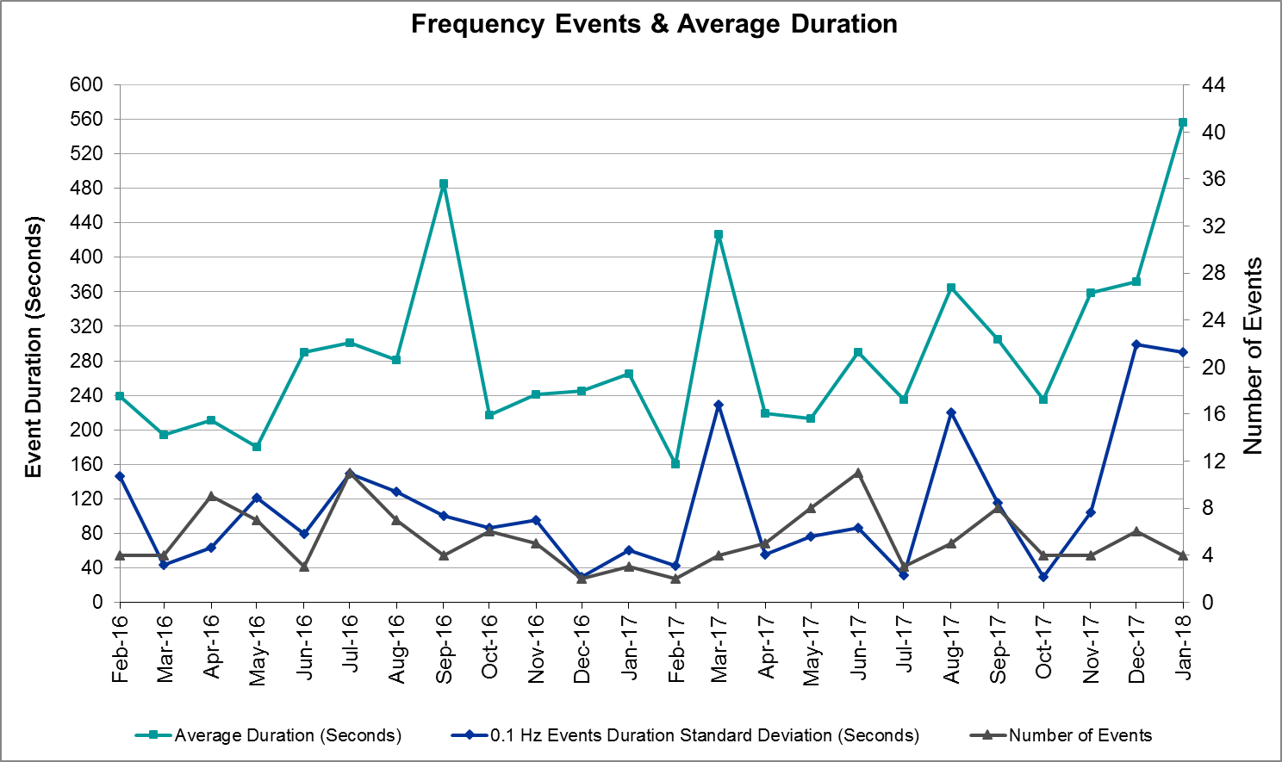
(Note: All data on this graph encompasses frequency event analysis based on BAL-001-TRE-1.)

Responsive Reserve Events
There was one event where Responsive Reserve MWs were released to SCED in January. The events highlighted in blue were related to frequency events reported in Section 2.1 above.

Date and Time Released to SCED | Date and Time Recalled | Duration of Event | Maximum MWs Released | Comments
1/5/2018 9:10:55 | 1/5/2018 9:12:19 | 0:01:18 | 299.99

Load Resource Events
None.

Reliability Unit Commitment
ERCOT reports on Reliability Unit Commitments (RUC) on a monthly basis. Commitments are reported grouped by operating day and weather zone. The total number of hours committed is the sum of the hours for all the units in the specified region. Additional information on RUC commitments can be found on the MIS secure site at Grid Generation Reliability Unit Commitment.

There were no DRUC commitments in January.

There were 5 HRUC commitments in January.

Resource Location | # of Resources | Operating Day | Total # of Hours Committed | Total MWhs | Reason for Commitment
Southern | 1 | 1/16/2018 | 5 | 213 | Voltage Stability
Southern | 2 | 1/17/2018 | 17 | 877 | Congestion
Southern | 3 | 1/18/2018 | 25 | 1,203 | Voltage Stability
Southern | 1 | 1/19/2018 | 3 | 123 | Voltage Stability
South Central | 1 | 1/30/2018 | 3 | 141 | Congestion

Wind Generation as a Percent of Load
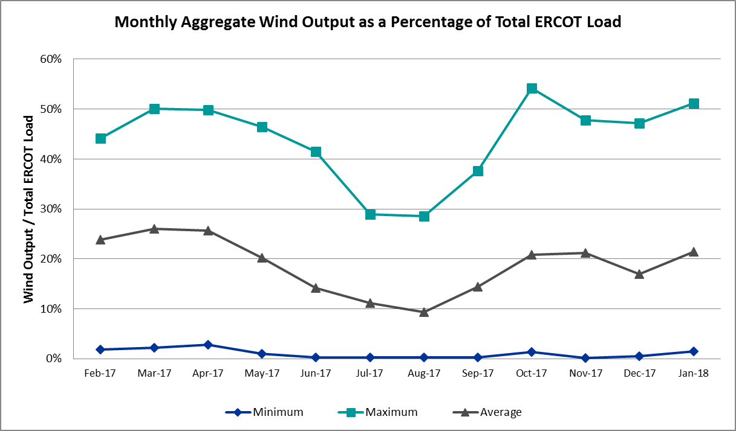

COP Error Analysis
COP Error is calculated as the capacity difference between the COP HSL and real-time HSL of the unit. Mean Absolute Error (MAE) stayed high around 9,000 MW until Day-Ahead at 12:00, then dropped significantly to 1,362 MW by Day-Ahead at 14:00. In the following chart, Under-Scheduling Error indicates that COP had less generation capacity than real-time and Over-Scheduling Error indicates that COP had more generation capacity than real-time. Under-Scheduling persisted until Day-Ahead at 17:00 and Over-Scheduling continued afterward. Snapshot on the Operating Day considers all Operating Hours, including past hours. However, COP error for the Operating Hour freezes after the Adjustment Period.
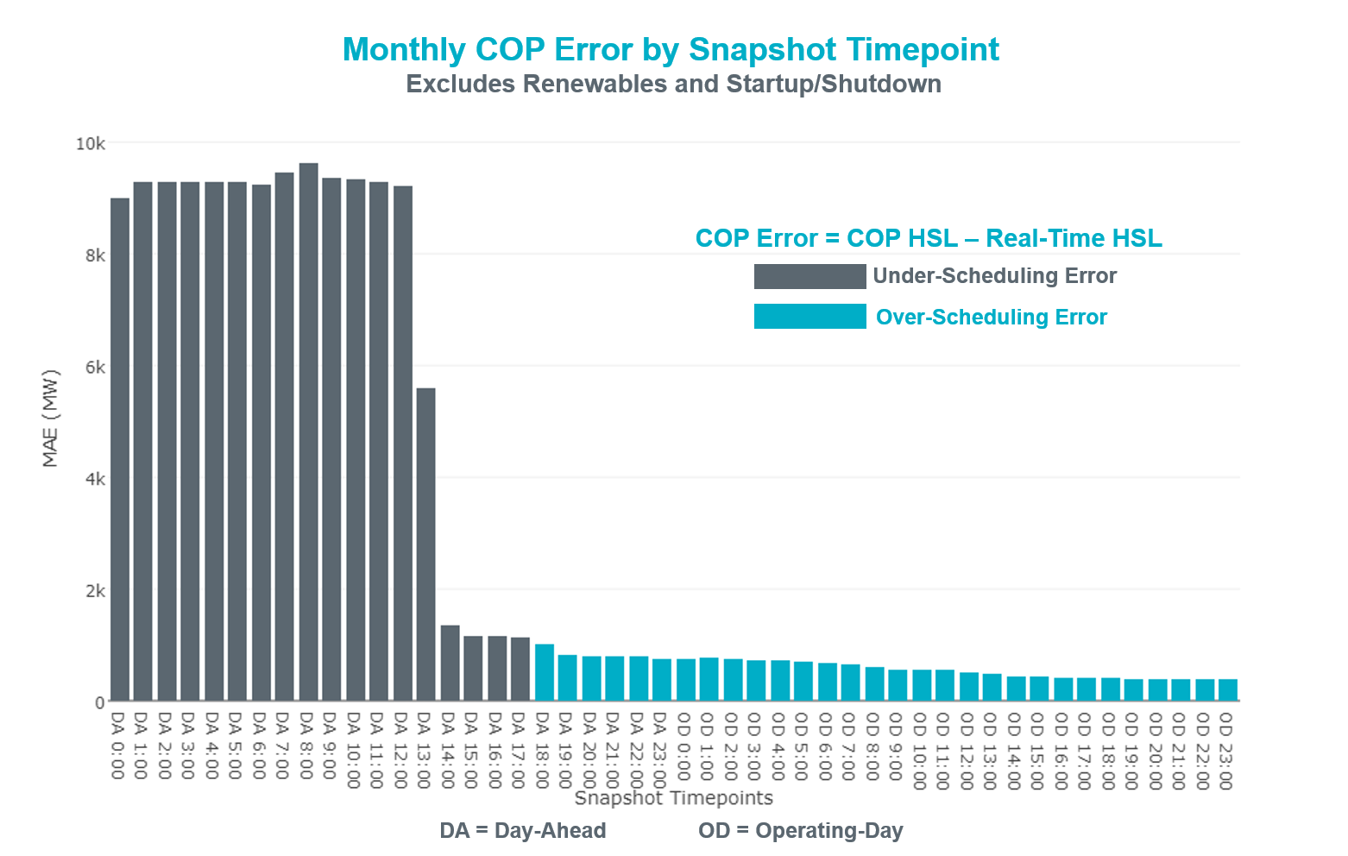

Latest COP at the end of the Adjustment Period had MAE of 384 MW with median ranging from 43 MW for Hour-Ending (HE) 3 to 633 MW for HE 8. Jan 1st HE 10 had the largest Over-Scheduling Error (3,216 MW) and Jan 23rd HE 8 had the largest Under-Scheduling Error (-2,962 MW).
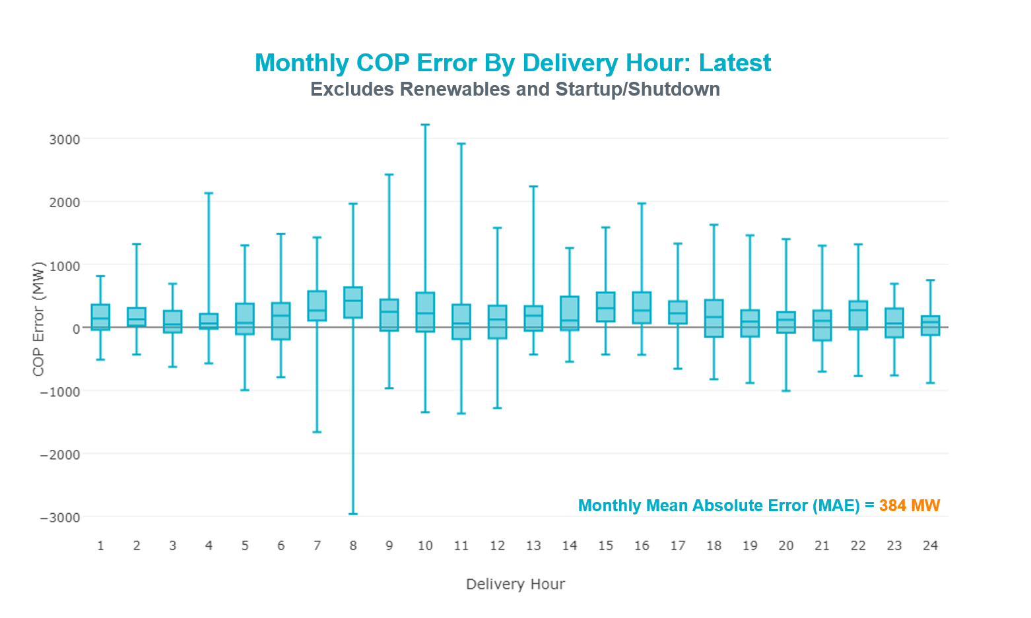

Day-Ahead COP at 12:00 had MAE of 9,222 MW with median ranging from -11,230 MW for Hour-Ending (HE) 8 to -6,700 MW for HE 24. Jan 6th HE 24 had the largest Over-Scheduling Error (70 MW) and Jan 16th HE 20 had the largest Under-Scheduling Error (-20,865 MW).
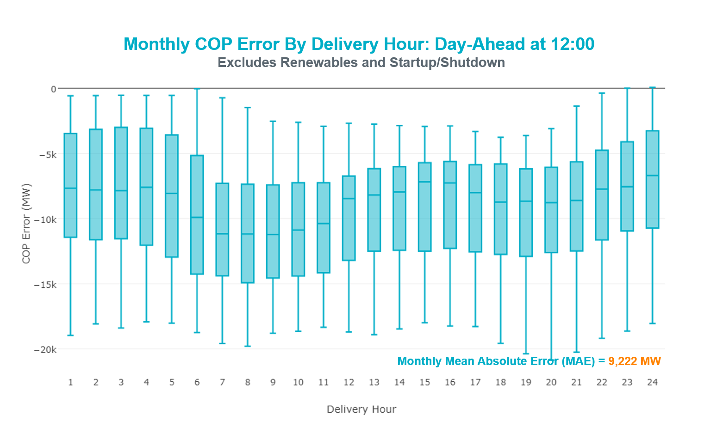

Congestion Analysis
The total number of congestion events experienced by the ERCOT system increased in January. There were 40 instances over 31 days on the Generic Transmission Constraints (GTCs) in January.

Notable Constraints
Nodal protocol section 3.20 specifies that ERCOT shall identify transmission constraints that are active or binding three or more times within a calendar month. As part of this process, ERCOT reports congestion that meets this criterion to ROS. In addition ERCOT also highlights notable constraints that have an estimated congestion rent exceeding $1,000,000 for a calendar month. These constraints are detailed in the table below. Rows highlighted in blue indicate the congestion was affected by one or more outages. For a list of all constraints activated in SCED for the month of January, please see Appendix A at the end of this report.

Contingency Name | Overloaded Element | # of Days Constraint Active | Congestion Rent | Transmission Project
NORTH EDINBURG TRX 1382 345/138 | North Edinburg 345/1kV | 4 | $28,832,407.40 | Stewart Road: Construct 345 kV cut-in (5604)
Basecase | PNHNDL GTC | 24 | $23,591,343.13 | South Plains RPG Proposal & Panhandle Loop (5180, 5208)
Basecase | VALIMP GTC | 5 | $17,313,039.25
Castrvll-Razorbac&Txresrch 1 | Hondo Creek Switching Station - Moore Switching Station 138kV | 4 | $15,342,875.43
CRLNW-LWSSW 345kV | Carrollton Northwest - Lakepointe Tnp 138kV | 17 | $9,109,871.16
East Harrison to La Palma 69 | Haine Drive - La Palma 138kV | 2 | $5,189,980.11
Rns-Rtw & Sng-Tb 345kv | Singleton - Zenith 345kV | 7 | $4,974,375.55 | Houston Import Project (4458)
Jewet-Sng 345kV | Btu_Jack_Creek - Twin Oak Switch 345kV | 15 | $4,556,395.57 | Houston Import Project (4458)
NELSON SHARPE TRX XF1 345/138 | Rodd Field - Holly 138kV | 7 | $2,475,358.66
SAN MIGUEL 345_138 KV SWITCHYARDS | San Miguel Gen 345/1kV | 5 | $2,217,650.42 | San Miguel 345/138 kV autotransformer replacements
LANE CITY to BLESSING LIN 1 | El Campo - Lane City Pump 138kV | 1 | $2,156,089.20
Coleto Creek to Lon Hill 345 | Warburton Road Switching Station - Victoria 138kV | 5 | $2,098,294.33
SAN MIGUEL 345_138 KV SWITCHYARDS | San Miguel Gen 345/1kV | 4 | $1,863,241.15
Asphalt Mines to Blewett (3) | Hamilton Road - Maverick 138kV | 18 | $1,674,609.84 | Brackettville to Escondido (5206)
DYANN to CANEY LIN A | El Campo - Lane City Pump 138kV | 3 | $1,335,885.02
CENTER to PH ROBINSON LIN A | Cedar Bayou Plant - Strang 138kV | 2 | $1,147,578.91 | Chorin to Cedar Bayou Ckt87 (5763B)
DUPONT SWITCH - INGLESIDE to INGLE | Dupont Pp1 - Ingleside - Dupont Switch - Ingleside 138kV | 1 | $1,085,242.76
Re Roserock Solar Plant to F | Barrilla - Fort Stockton Switch 69kV | 17 | $1,027,919.55 | Far West Texas Project
Alazan to Barney Davis (2)13 | Rodd Field - Holly 138kV | 7 | $1,027,249.19
CADDO SW STA TNP to GREENBELT TNP | Tejas Tnp - Comanche Switch Tnp 138kV | 1 | $1,026,549.81
Bunsen to Lon Hill 138 KV | Calallen Sub - Robstown Sub 69kV | 3 | $919,260.60
COLETO CREEK GEN COLETOG1 | Blessing - Lolita 138kV | 5 | $914,264.66
DMTSW-SCOSW 345KV | Knapp - Scurry Chevron 138kV | 6 | $888,331.95
Elmcreek-Sanmigl 345kV | Pawnee Switching Station - Calaveras 345kV | 7 | $866,859.05
Re Roserock Solar Plant to F | Yucca Drive Switch - Gas Pad 138kV | 3 | $675,266.40
LON HILL to NELSON SHARPE LIN 1 | Rodd Field - Holly 138kV | 8 | $581,361.08
KLEBERG AEP to LOYOLA SUB LIN 1 | Loyola Sub 138/69kV | 9 | $546,659.18 | AEP_Angstrom (15TPIT0069)
Elmcreek-Sanmigl 345kV | Coleto Creek - Rosata Tap 138kV | 3 | $360,508.23
LAQUINTA to LOBO LIN 1 | Bruni Sub 138/69kV | 11 | $349,173.72
Elmcreek-Sanmigl 345kV | Pawnee Switching Station - Calaveras 345kV | 7 | $287,028.22
LON HILL to PAWNEE SWITCHING STATI | Pettus - Normanna 69kV | 3 | $228,970.39 | Kenedy Switch to Tuleta: Build double circuit 138 kV line
Basecase | NELRIO GTC | 11 | $224,690.23
BLESSING TRX 1382 345/138 | Sargent Sub - Franklins Camp Sub 69kV | 4 | $169,262.23
Cagnon-Kendal 345 &Cico-Meng | Medina Lake - Tally_Rd 138kV | 3 | $152,298.94
JARDIN to DILLEY SWITCH AEP LIN 1 | Dilley Switch Aep - Cotulla Sub 69kV | 3 | $149,239.81
Zorn-Marion & Cleasp 345kV | Henne - Zorn 138kV | 3 | $129,487.50
MCAN_SW TO RIOP 138 KV | Pig Creek - Solstice 138kV | 5 | $117,422.03 | Solstice to Permian Basin: Rebuild 138 kV line
Basecase | Pig Creek - Solstice 138kV | 11 | $111,102.49 | Solstice to Permian Basin: Rebuild 138 kV line
Entpr-Trses & Mlses-Scses 34 | Herty North Switch - Nacogdoches Se 138kV | 6 | $104,789.36
BRACKETTVILLE to HAMILTON ROAD LIN | Hamilton Road - Maverick 138kV | 9 | $93,913.03 | Brackettville to Escondido (5206)
Dilleysw-Sanmgsw&Cotulas 138 | Dilley Switch Aep - Cotulla Sub 69kV | 3 | $46,023.83
ASPERMONT AEP to PAINT CREEK LIN 1 | Aspermont Aep 138/69kV | 3 | $41,568.70 | Aspermont: Replace the 138/69 kV autotransformer (6569)
Basecase | Randado Aep - Zapata 138kV | 4 | $23,064.04
Scotland to Scotland (Oncor) | Olney 138/69kV | 4 | $22,547.22
Riohondo-Nedin 345kV&Harlnsw 138kV | Burns Sub - Rio Hondo 138kV | 3 | $14,850.00
Barton Chapel Wind Farm to O | Graham - Olney Pod 69kV | 4 | $8,877.34
SUN SWITCH to SCURRY SWITCH LIN 1 | Wolfgang - Rotan 69kV | 4 | $4,455.30
Lon_Hill-Coleto 345kV&Warburtn 138 | Bonnieview - Rincon 69kV | 3 | $3,845.67
COLEMAN LAKE IVIE TAP to EAST COLE | Santa Anna Tap - Dressey 69kV | 3 | $2,601.43
FORT LANCASTER to ILLINOIS #4 LIN | Hamilton Road - Maxwell 138kV | 4 | $1,961.86 | Brackettville to Escondido (5206)

Generic Transmission Constraint Congestion
There were five days on the Valley Import GTC, 24 days on the Panhandle GTC and 11 days on the Nelson Sharpe – Rio Hondo GTC in January. There was no activity on the remaining GTCs during the Month.

Note: This is how many times a constraint has been activated to avoid exceeding a GTC limit, it does not imply an exceedance of the GTC occurred or that the GTC was binding.

Manual Overrides
None.

Congestion Costs for Calendar Year 2018
The following table represents the top twenty active constraints for the calendar year based on the estimated congestion rent attributed to the congestion. ERCOT updates this list on a monthly basis.

Contingency | Binding Element | # of 5-min SCED Intervals | Estimated Congestion Rent | Transmission Project
NORTH EDINBURG TRX 1382 345/138 | North Edinburg 345/1kV | 661 | 28,832,407.40
Basecase | PNHNDL GTC | 4,257 | 23,591,343.13 | South Plains RPG Proposal & Panhandle Loop (5180, 5208)
Basecase | VALIMP GTC | 328 | 17,313,039.25
Castrvll-Razorbac&Txresrch 1 | Hondo Creek Switching Station - Moore Switching Station 138kV | 605 | 15,342,875.43
CRLNW-LWSSW 345kV | Carrollton Northwest - Lakepointe Tnp 138kV | 2,749 | 9,109,871.16
East Harrison to La Palma 69 | Haine Drive - La Palma 138kV | 471 | 5,189,980.11
Rns-Rtw & Sng-Tb 345kv | Singleton - Zenith 345kV | 1,339 | 4,974,375.55 | Houston Import Project (4458)
Jewet-Sng 345kV | Btu_Jack_Creek - Twin Oak Switch 345kV | 1,714 | 4,556,395.57 | Houston Import Project (4458)
NELSON SHARPE TRX XF1 345/138 | Rodd Field - Holly 138kV | 602 | 2,475,358.66
SAN MIGUEL 345_138 KV SWITCHYARDS | San Miguel Gen 345/1kV | 1,022 | 2,217,650.42 | San Miguel 345/138 kV autotransformer replacements
LANE CITY to BLESSING LIN 1 | El Campo - Lane City Pump 138kV | 58 | 2,156,089.20
Coleto Creek to Lon Hill 345 | Warburton Road Switching Station - Victoria 138kV | 350 | 2,098,294.33
SAN MIGUEL 345_138 KV SWITCHYARDS | San Miguel Gen 345/1kV | 727 | 1,863,241.15 | San Miguel 345/138 kV autotransformer replacements
Asphalt Mines to Blewett (3) | Hamilton Road - Maverick 138kV | 2,022 | 1,674,609.84 | Brackettville to Escondido (5206)
DYANN to CANEY LIN A | El Campo - Lane City Pump 138kV | 296 | 1,335,885.02
CENTER to PH ROBINSON LIN A | Cedar Bayou Plant - Strang 138kV | 148 | 1,147,578.91 | Chorin to Cedar Bayou Ckt87 (5763B)
DUPONT SWITCH - INGLESIDE to INGLE | Dupont Pp1 - Ingleside - Dupont Switch - Ingleside 138kV | 39 | 1,085,242.76
Re Roserock Solar Plant to F | Barrilla - Fort Stockton Switch 69kV | 1,417 | 1,027,919.55 | Far West Texas Project
Alazan to Barney Davis (2)13 | Rodd Field - Holly 138kV | 379 | 1,027,249.19
CADDO SW STA TNP to GREENBELT TNP | Tejas Tnp - Comanche Switch Tnp 138kV | 9 | 1,026,549.81

System Events

ERCOT Peak Load
The unofficial ERCOT peak load for the month was 65,750 MW and occurred on January 17th during hour ending 08:00.

Load Shed Events
None.

Stability Events
None.

Notable PMU Events
ERCOT analyzes PMU data for any significant system disturbances that do not fall into the Frequency Events category reported in section 2.1. The results are summarized in this section once the analysis has been completed.

Date and Time | Duration of Oscillation | Dominant Oscillation Mode | Oscillation Signals | Max Peak to Peak Oscillation
1/14/2018 15:40  &  1/19/2018 10:23 | 1 Hr 20 Mins  2 Hrs 17 Min | 0.52 Hz | Voltage Magnitude,  Reactive Power | ~2.0 kV,  ~10 MVArs

DC Tie Curtailment
There was one DC Tie curtailment for a total of two DC Tie Tags curtailed in January.

Date | DC Tie | Curtailing Period | # of Tags Curtailed | Curtailment Reason
01/25/2018 | Eagle Pass | 0900-1700 | 2 | Eagle Pass Tie forced out because of bad power supply

TRE/DOE Reportable Events
- AEP submitted an OE-417 report on January 01, 2018 Reportable Event Type: Distribution Media Appeal RGV and Laredo Area.
- ONCOR submitted a EOP-004 report on January 04, 2018 Reportable Event Type: Physical Threat and Damage or Destruction of a Facility to a Facility.
- ONCOR submitted a EOP-004 report on January 11, 2018 Reportable Event Type: Physical Threat and Damage or Destruction of a Facility to a Facility
- AEP submitted an OE-417 report on January 15, 2018 Reportable Event Type: Distribution Media Appeal South and Central Texas Service Area.
- ERCOT ISO submitted an OE-417 on January 16, 2018 Reportable Event Type: Electrical System Separation (Islanding)

New/Updated Constraint Management Plans
- MP_2017_10 was updated based on AEP feedback.
- PCAP_2014_01 was updated based on AEP feedback.

New/Modified/Removed RAS
None.

New Procedures/Forms/Operating Bulletins
None.

Emergency Conditions

OCNs
Date and Time | Description
01/12/18 11:36 | At 11:30, ERCOT is issuing an OCN for a potential extreme cold weather system with the possibility of frozen precipitation approaching the ERCOT region from 0/15/18 to 01/18/18.

Advisories
Date and Time | Description
01/13/18 13:59 | At 14:00 ERCOT is issuing an Advisory for a potential extreme cold weather system with the possibility of frozen precipitation approaching the ERCOT region from 01/15/18 to 01/18/18.
01/18/18 07:37 | Loss of ERCOTs RTCA and SE > 15 minutes: ERCOT's RTCA and State Estimator have not solved in the last 15 minutes. Please monitor your own service area and notify ERCOT if you exceed the normal rating of your transmission elements. Continue to monitor voltages in your area and notify ERCOT of any forced line operations in your area.
01/22/18 13:23 | ERCOT has postponed the deadline for the posting of the DAM Solution for Operating Day 01/23/2018 due to long solution processing time.

Watches
Date and Time | Description
01/14/18 14:53 | At 1500, ERCOT is issuing a Watch for a potential extreme cold weather system with the possibility of frozen precipitation approaching the ERCOT region from 01/15/18 to 01/18/18.
01/16/18 08:58 | ERCOT is issuing a Watch due to freezing precipitation in the San Antonio to Houston areas.
01/22/18 17:59 | ERCOT issued a Watch due to DRUC not completing by 1800.
01/25/18 08:30 | ERCOT issued a transmission watch at 0800, for the Eagle Pass DC Tie, due to Eagle Pass DC Tie Outage extension.

Emergency Notices
None.

Application Performance

TSAT/VSAT Performance Issues
None.

Communication Issues
None.

Market System Issues
None.

Model Updates
The Downstream Production Change (DPC) process allows ERCOT to make changes in the on-line Network Operations Model without loading a completely new model. The purpose of this process is to allow for reliable grid operations as system conditions change between designated Network Operations Model database loads. The DPC process is limited in scope to just those items listed below, with equipment ratings updates being the most common. ERCOT has seen a rise in the use of the DPC process to make on-line updates to the Network Operations Model in recent years, instead of through the standard Network Operations Model Change Request process.

- Static Line ratings (Interim Update)
- Dynamic Line ratings (non-Interim Update)
- Autotransformer ratings (non-Interim Update)
- Breaker and Switch Normal status (Interim Update)
- Contingency Definitions (Interim Update)
- RAP and RAS changes or additions (Interim Update)
- Net Dependable and Reactive Capability (NDCRC) values (Interim Update)
- Impedance Updates (non-Interim)

Transmission Operator | Number of DPCs
ONCOR | 10
CENTERPOINT | 2
ERCOT | 1
STEC | 1

Appendix A: Real-Time Constraints
The following is a complete list of constraints activated in SCED for the month of January. Full contingency descriptions can be found in the Standard Contingencies List located on the MIS secure site at Grid Generation Reliability Unit Commitment.

Contingency | Constrained Element | From Station | To Station | # of Days Constraint Active
BASE CASE | PNHNDL | n/a | n/a | 24
SBRAUVA8 | HAMILT_MAVERI1_1 | HAMILTON | MAVERICK | 18
DCRLLSW5 | 591__A | LKPNT | CRLNW | 17
SWCSBOO8 | BARL_FTSW1_1 | BARL | FTSW | 17
SWCSBOO8 | BARL_FTSW1_1 | FTSW | BARL | 17
DJEWSNG5 | JK_TOKSW_1 | TOKSW | JK_CK | 15
SLAQLOB8 | BRUNI_69_1 | BRUNI | BRUNI | 11
BASE CASE | NELRIO | n/a | n/a | 11
BASE CASE | PIGCRE_SOLSTI1_1 | SOLSTICE | PIGCREEK | 11
SBRAHAM8 | HAMILT_MAVERI1_1 | HAMILTON | MAVERICK | 9
SKLELOY8 | LOYOLA_69_1 | LOYOLA | LOYOLA | 9
SN_SLON5 | HOLLY4_RODD_F1_1 | RODD_FLD | HOLLY4 | 8
DELMSAN5 | PAWNEE_SPRUCE_1 | CALAVERS | PAWNEE | 7
XN_S58 | HOLLY4_RODD_F1_1 | RODD_FLD | HOLLY4 | 7
DRNS_TB5 | SNGZEN98_A | SNG | ZEN | 7
SALAN_28 | HOLLY4_RODD_F1_1 | RODD_FLD | HOLLY4 | 7
XN_S58 | HOLLY4_RODD_F1_1 | HOLLY4 | RODD_FLD | 7
DELMSAN5 | PAWNEE_SPRUCE_1 | PAWNEE | CALAVERS | 7
SALAN_28 | HOLLY4_RODD_F1_1 | HOLLY4 | RODD_FLD | 7
DMTSCOS5 | 6437__F | SCRCV | KNAPP | 6
DENTSCS5 | 1170__A | NCDSE | HNRSW | 6
BASE CASE | VALIMP | n/a | n/a | 5
SCOLLON5 | VICTO_WARBU_1A_1 | VICTORIA | WARBURTN | 5
UCOLCOL1 | BLESSI_LOLITA1_1 | BLESSING | LOLITA | 5
XSAN58 | SANMIGL_ATBH | SANMIGL | SANMIGL | 5
DMCARIO8 | PIGCRE_SOLSTI1_1 | SOLSTICE | PIGCREEK | 5
SBRTORA8 | 6830__C | OLNEY | GRAHM | 4
XBLE58 | SAR_FRAN_1 | FRANKC | SARGNTS | 4
SSCUSU28 | ROTN_WOLFGA1_1 | WOLFGANG | ROTN | 4
BASE CASE | LGD_SANTIA1_1 | LGD | SANTIAGO | 4
DCASTXR8 | MHONDOCR_1 | MOORE | HONDOCK | 4
SBRTORA8 | 6830__C | GRAHM | OLNEY | 4
XSA2N58 | SANMIGL_ATAH | SANMIGL | SANMIGL | 4
SILLFTL8 | HAMILT_MAXWEL1_1 | MAXWELL | HAMILTON | 4
BASE CASE | RANDAD_ZAPATA1_1 | RANDADO | ZAPATA | 4
SSCLWF28 | OLN_FMR2 | OLN | OLN | 4
XNED258 | NEDIN_138H | NEDIN | NEDIN | 4
SJARDIL8 | DIL_COTU_1 | DILLEYSW | COTULAS | 3
SWRDYN8 | EL_CAM_LANCTY1_1 | LANCTYPM | EL_CAMPO | 3
SWCSBOO8 | 6332__A | YUCSW | GASPAD | 3
SPAWLON5 | NORMAN_PETTUS1_1 | PETTUS | NORMANNA | 3
DCAGCI58 | 460T460_1 | MEDILA | W1 | 3
SCOLBAL8 | DRSY_SANA_T1_1 | SANA_TAP | DRSY | 3
SASPPAI8 | ASPM_69T1 | ASPM | ASPM | 3
DCLEZOR5 | 89T204_1 | ZORN | HENNE | 3
DLONWAR5 | BONIVI_RINCON1_1 | RINCON | BONIVIEW | 3
SPAWLON5 | NORMAN_PETTUS1_1 | NORMANNA | PETTUS | 3
DDILCOT8 | DIL_COTU_1 | COTULAS | DILLEYSW | 3
DELMSAN5 | COLETO_ROSATA1_1 | COLETO | Unknown | 3
DRIOHAR5 | BURNS_RIOHONDO_1 | RIOHONDO | MV_BURNS | 3
SBUNLON8 | CAL_ROBS_1 | CALALS | ROBSTOS | 3
SCHYWIN8 | 6100__F | NOTSW | DHIDE | 2
SMCEABS8 | 6585__A | ESKSW | TRNT | 2
DELMSAN5 | BLESSI_LOLITA1_1 | BLESSING | LOLITA | 2
SKINKLE8 | CAL_ROBS_1 | CALALS | ROBSTOS | 2
SROCGL28 | GLIDDE_AT2 | GLIDDE | GLIDDE | 2
DVICV_D8 | GREENL_WEAVER1_1 | WEAVERRD | GREENLK | 2
DCALBEC8 | N3_U2_1 | CALAVERS | BRAUNIG | 2
DNEDPAL8 | NEDIN_N_MCAL1_1 | NEDIN | N_MCALLN | 2
BASE CASE | NWF_NOTSW_1 | NWF | NOTSW | 2
DELMSAN5 | OAKS9_69_1 | OAKS9 | OAKS9 | 2
DELMTEX5 | SAR_FRAN_1 | FRANKC | SARGNTS | 2
UCOLCOL1 | SAR_FRAN_1 | FRANKC | SARGNTS | 2
SBRAHAM8 | EAGLHY_ESCOND1_1 | EAGLHYTP | ESCONDID | 2
DAUSSND5 | HWRDLN_1 | HWRDTP | HWRDLN | 2
SCITNUE8 | MORRIS_NUECES1_1 | NUECES_B | MORRIS | 2
SSCLWF28 | 6830__B | CRDSW | OLNEY | 2
XCRD58 | CRD_CRD2 | CRD | CRD | 2
SLCLAN8 | SAR_FRAN_1 | FRANKC | SARGNTS | 2
SSPUMW18 | SPUR_69_1 | SPUR | SPUR | 2
DTRSENT5 | 1255__B | SCSES | STCKY | 2
SBRTORA8 | 6830__B | OLNEY | CRDSW | 2
SPHRCTR5 | CBYRNG87_A | CBY | RNG | 2
SCOLPAW5 | COLETO_ROSATA1_1 | COLETO | Unknown | 2
DCHBJOR5 | CV_LH_03_A | LH | CV | 2
SE_HLA_9 | HAINE__LA_PAL1_1 | LA_PALMA | HAINE_DR | 2
DLONWAR5 | LONHILL_PAWNEE_1 | PAWNEE | LON_HILL | 2
SVCAMIL8 | SCARBI_TITAN_1_1 | SCARBIDE | TITAN_SU | 2
DZORHAY5 | 459T459_1 | KENDAL | CAGNON | 2
SCOLPAW5 | COLETO_ROSATA1_1 | COLETO | ROSATA | 2
SBRAUVA8 | EAGLHY_ESCOND1_1 | EAGLHYTP | ESCONDID | 2
SGILNU78 | GILA_HIWAY_1_1 | GILA | HIWAY_9 | 2
SI_DI_48 | I_DUPP_I_DUPS2_1 | I_DUPP1 | I_DUPSW | 2
SSPUMW18 | ROTN_WOLFGA1_1 | WOLFGANG | ROTN | 2
SSCUSU28 | SPUR_69_1 | SPUR | SPUR | 2
DMTSCOS5 | 6474__A | SUNSW | MGSES | 2
SVICCOL8 | COLETO_VICTOR1_1 | COLETO | VICTORIA | 2
DBIGKEN5 | FRIR_ROCKSP1_1 | FRIR | ROCKSPRS | 2
SHIWCIT8 | MORRIS_NUECES1_1 | NUECES_B | MORRIS | 2
DCRLLSW5 | 590__B | LWVJS | LKPNT | 2
STYRELK8 | 975__E | FGRSW | EUSSE | 2
DSTPDOW5 | CKT_3124_1 | STP | HLJ | 2
SSNDAU15 | HWRDLN_1 | HWRDTP | HWRDLN | 2
SBOSWHT8 | OLKW_BOS_1 | BOSQUESW | LKWHITNY | 2
BASE CASE | SNYDER_WKN_BK1_1 | ENAS | WKN_BKR | 2
SBROALP9 | BARL_FTSW1_1 | FTSW | BARL | 1
UCOLCOL1 | BLESSI_PALACI1_1 | BLESSING | PALACIOS | 1
DBURAMD8 | CKT_979_1 | MAGPLANT | NORTHLAN | 1
SPAWCAL5 | COLETO_KENEDS1_1 | COLETO | KENEDSW | 1
DAUSLOS5 | FAYETT_AT2L | FAYETT | FAYETT | 1
SGRNCAD8 | G138_1C_1 | TEJAS | COMAN_TN | 1
SODLBRA8 | HAMILT_MAVERI1_1 | HAMILTON | MAVERICK | 1
SN_SLON5 | LOYOLA_69_1 | LOYOLA | LOYOLA | 1
SHSAPB38 | M_69_F3_1 | WICKETT | WNKLRCO6 | 1
SWOJN5 | PK_MID90_A | MID | PK | 1
SDOWMOO8 | UVALDE_W_BATE1_1 | UVALDE | W_BATESV | 1
DVICEDN8 | FORMOS_JOSLIN1_1 | FORMOSA | JOSLIN | 1
SWCSBOO8 | FTST_69T1 | FTST | FTST | 1
SCRDJON5 | HOOD_DECRDVA_1 | DCDAM | HOD | 1
SKINKLE8 | LOYOLA_69_1 | LOYOLA | LOYOLA | 1
XSAN58 | SANMIGL_ATBL | SANMIGL | SANMIGL | 1
DELMSAN5 | UVALDE_W_BATE1_1 | UVALDE | W_BATESV | 1
XRA3Y89 | WARBURTN_69_1 | WARBURTN | WARBURTN | 1
DGRSPKR5 | 6377__A | BRTSW | ORANS | 1
SMUNEAS9 | ALBNY__MRAN1_1 | MRAN | ALBNY_FD | 1
SSCUSU28 | ASPM_69T1 | ASPM | ASPM | 1
SN_SLON5 | CELANE_KLEBER1_1 | CELANEBI | KLEBERG | 1
SWEILON8 | CHAMPL_WEIL_T1_1 | WEIL_TRC | CHAMPLIN | 1
SLANBLE8 | EL_CAM_LANCTY1_1 | LANCTYPM | EL_CAMPO | 1
DHCKRNK5 | EMSES_MR1H | EMSES | EMSES | 1
XORN89 | GEO_WGWSW_1 | GEOWEST | WGWSW | 1
DSCRWEB8 | GV_HOC19_A | HOC | GV | 1
SI_DI_38 | I_DUPP_I_DUPS1_1 | I_DUPP1 | I_DUPSW | 1
SCOLPAW5 | KENEDS_ROSATA1_1 | Unknown | KENEDSW | 1
SWRDYN8 | LANCTYR1_1 | LAN_CTY | LAN_CTY | 1
SCOLLON5 | LONHILL_PAWNEE_1 | PAWNEE | LON_HILL | 1
SSIGSAN8 | NCA_SMTP_1 | SANMTAP | NCALHMS | 1
SVANRAY8 | RAYBURN_69_2 | RAYBURN | RAYBURN | 1
XVAN89 | RAYBURN_69_2 | RAYBURN | RAYBURN | 1
DLONWAR5 | REFUG_VICTO_1C_1 | VICTORIA | OCONNOR | 1
XBOM58 | 6558__B | FSHSW | WFALS | 1
SGOHJOS8 | BLESSI_PALACI1_1 | BLESSING | PALACIOS | 1
BASE CASE | BURNS_RIOHONDO_1 | RIOHONDO | MV_BURNS | 1
SBRACAL8 | C4_L2_1 | C4 | L2 | 1
DCHBJOR5 | CBYRNG87_A | CBY | RNG | 1
SVICCO28 | COLETO_VICTOR2_1 | COLETO | VICTORIA | 1
SMVRLA_8 | LA_PAL_RANGER1_1 | LA_PALMA | RANGERVL | 1
SFLAPIG8 | MUSQUI_PIGCRE1_1 | PIGCREEK | MUSQUIZ | 1
SBAKBIG5 | PIGCRE_SOLSTI1_1 | SOLSTICE | PIGCREEK | 1
DWAP_OB5 | PK_MID90_A | MID | PK | 1
XWAR89 | RAYBURN_69_2 | RAYBURN | RAYBURN | 1
STUNRIO8 | SANTIA_SAPOWE1_1 | SANTIAGO | SAPOWER | 1
DSTEXP12 | THWTAP95_1 | THW | THW | 1
SPAWLON5 | VICTO_WARBU_1A_1 | VICTORIA | WARBURTN | 1
DRENCRL5 | 2630_CBRATING_1 | CRLNW | CRLNW | 1
DLONWAR5 | AIRCO4_RINCON1_1 | AIRCO4 | RINCON | 1
SSCUSU28 | ASPM_CONA1_1 | ASPM | CONA | 1
SBEVASH8 | BIG_COTU_1 | COTULAS | BIGWELS | 1
SPAWLON5 | EDROY_SMITH1_1 | SMITH | EDROY | 1
SHLDBRN8 | HAS_XFM2 | HAS | HAS | 1
SMCEABS8 | ROBY_RONDTP1_1 | ROBY | RONDTPT | 1
SSCALOM8 | SCARBI_TITAN_1_1 | SCARBIDE | TITAN_SU | 1
SSONFRI8 | SONR_69-1 | SONR | SONR | 1
SBIGV_D8 | VAN_VNDB_1 | VANBLTSS | VANBLT69 | 1
SBOSELM5 | 1030__B | BOSQUESW | RGH | 1
DCRLLSW5 | 589_C_1 | LWSVS | CRLNW | 1
DSTEXP12 | BLESSI_LOLITA1_1 | LOLITA | BLESSING | 1
SCRDLOF9 | BOW_FMR1 | BOW | BOW | 1
DCHBJOR5 | BRNLAN86_A | LAN | BRN | 1
SROCGL18 | GLIDDE_AT2 | GLIDDE | GLIDDE | 1
SMIDWHI9 | LON_HI_WWKS_T1_1 | LON_HILL | WWKS_TAP | 1
SNORODE5 | PIGCRE_SOLSTI1_1 | SOLSTICE | PIGCREEK | 1
SSPUASP8 | ROTN_WOLFGA1_1 | WOLFGANG | ROTN | 1
SKINKLE8 | 3023_1 | CALALS | BANQUETE | 1
DMARZOR5 | 505T505_1 | CLEASP | GERONI | 1
SSCUSU28 | 6780__A | LONGWRTH | ESKSW | 1
SBEVASH8 | BIG_BRUN_1 | BIGWELS | BRUNDGS | 1
SBIGV_D8 | BLESSI_PALACI1_1 | BLESSING | PALACIOS | 1
DSKYCAL5 | COLETO_ROSATA1_1 | COLETO | Unknown | 1
SMAGLAN8 | EL_CAM_LANCTY1_1 | LANCTYPM | EL_CAMPO | 1
DCI_SA_8 | FR_THW81_A | THW | FR | 1
SSPUMW18 | GIRA_T_SPUR1_1 | SPUR | GIRA_TAP | 1
XNED258 | HAINE__LA_PAL1_1 | LA_PALMA | HAINE_DR | 1
SPAWCAL5 | KENEDS_ROSATA1_1 | Unknown | KENEDSW | 1
DSKYCAL5 | N5_R5_1 | CALAVERS | CAGNON | 1
DCE_RI58 | NEDIN_REDTAP1_1 | REDTAP | NEDIN | 1
SGRMGRS8 | OLN_FMR2 | OLN | OLN | 1
DRNS_TB5 | PK_MID90_A | MID | PK | 1
DSAMVEN5 | 100027_D_1 | WHTNY | WND | 1
DSTEXP12 | AIRCO4_RINCON1_1 | RINCON | AIRCO4 | 1
SCOLPAW5 | COLETO_KENEDS1_1 | COLETO | KENEDSW | 1
SSPJFS8 | CRNJFS94_A | JFS | CRN | 1
SMOLLOB8 | DEL_MA_LAREDO1_1 | LAREDO | DEL_MAR | 1
SHAIOLE8 | E_HARR_LA_PAL1_1 | LA_PALMA | E_HARRIS | 1
DFRAPAR8 | F4_Z4_1 | Z4 | F4 | 1
SFORJOS8 | GREENL_WEAVER1_1 | WEAVERRD | GREENLK | 1
DELMSAN5 | NORMAN_PETTUS1_1 | PETTUS | NORMANNA | 1
XLK2W89 | OLSE_BOS_1 | BOSQUESW | OLSEN | 1
DHILMAR5 | P4_E5_2_1 | ELMCREEK | SKYLINE | 1
SWARVIC8 | RAYBURN_69_2 | RAYBURN | RAYBURN | 1
SCOLLON5 | REFUG_VICTO_1C_1 | VICTORIA | OCONNOR | 1
DKENWE58 | 459T459_1 | KENDAL | CAGNON | 1
DMARZOR5 | 459T459_1 | KENDAL | CAGNON | 1
SMGIENW8 | 941__C | ENWSW | ENSSO | 1

The Duration of Event is the time it takes for the frequency to recover to pre-disturbance frequency or 60 Hz as applicable.
PMU reports are typically generated when frequency drops below 59.9, but PMU data is available for other events.
Delta Frequency is the difference between the frequency at start of event (“A-point”) and minimum/maximum frequency (“C-Point”).
Currently, the Critical Inertia Level for ERCOT is approximately 100,000 MW-s (Source: link)

