 |  |  |  | System Planning
Monthly Status Report
January 2018

 |  | Report Highlights
- ERCOT is currently reviewing proposed transmission improvements with a total cost of $272.3 Million.
- Transmission Projects endorsed in 2017 total $890 Million.
- All projects (in engineering, routing, licensing and construction) total approximately $7.07 Billion as of October 15, 2017.
- Transmission Projects energized in 2017 total about $805.4 Million as of October 15, 2017.

Regional Planning Group Project Reviews
- Garland Power & Light and Oncor have jointly submitted the North Garland Reliability Infrastructure Project (N-GRIP). This is a Tier 1 project that is estimated to cost $78 million. The ERCOT independent review for this project is currently placed on hold per the request of GPL.
- Brazos Electric Cooperative (BEC) & Rayburn Country Electric Cooperative (RCEC) have jointly submitted the Northeast Denton County & Celina/Prosper Transmission Improvement project. This is a Tier 1 project that is estimated to cost $72.9 million. BEC and RCEC have requested to withdraw this project from Regional Planning Group review. Therefore, the project is no longer under RPG review or ERCOT Independent Review.
- Brazos Electric Cooperative (BEC) has submitted the Kalgary Area Improvement project. This is a Tier 2 project that is estimated to cost $33 million. This project has completed the RPG review and the project has been re-classified as a Tier 4 Neutral project.
- Brazos Electric Cooperative (BEC) has submitted the South Denton County project. This is a Tier 2 project that is estimated to cost $42 million. This project has completed the RPG review and the project has been re-classified as a Tier 4 Neutral project.
- WETT has submitted the Bearkat Area Transmission Improvements project. This is a Tier 1 project that is estimated to cost $69.9 million. This project is currently under ERCOT Independent Review.
- Oncor has submitted the Far West Texas Dynamic Reactive Devices project. This is a Tier 1 project that is estimated to cost $86 million. This project is currently under ERCOT Independent Review.
- AEPSC has submitted the Pecos County project. This is a Tier 3 project that is estimated to cost $43 million. This project is currently under RPG study mode.
- AEPSC has submitted the LRGV Import Project. This is a Tier 1 project that is estimated to cost $73.4 million. AEPSC has also requested that ERCOT provide conditional endorsement for an additional $357.2 million project. This project is currently in the RPG study mode.

Planning Model Activities
The short term calendar of major planning model events is as follows:
- March 1, 2018 Post 17SSWG Update 2 Base Cases
- March 31, 2018 Post Contingency definitions and Planning Data Dictionary
The following table shows interconnection projects that met Planning Guide section 6.9(1) and 6.9(2) and were modeled in the SSWG cases as either complete or as a simple model in accordance with Planning Guide section 6.9. The 6.9(2) Deadline shown in red have received a notification that the 60 day deadline has past and the set of planning data has not been received.
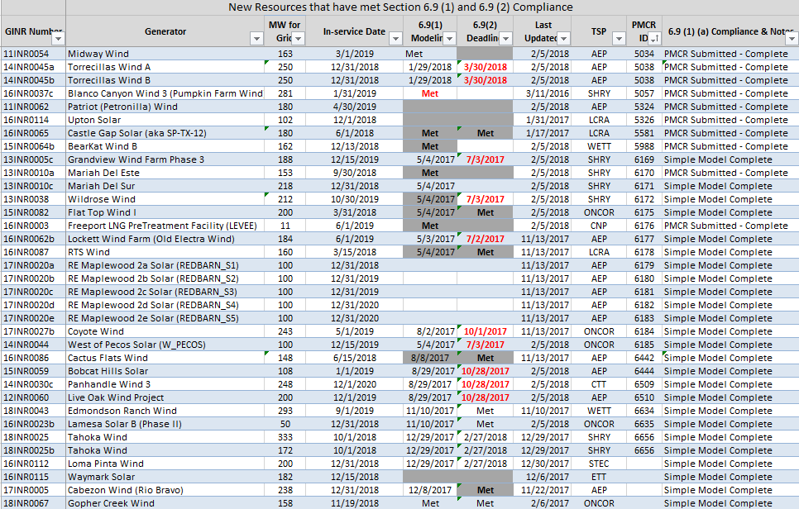

Permian Basin Oil Rig Count
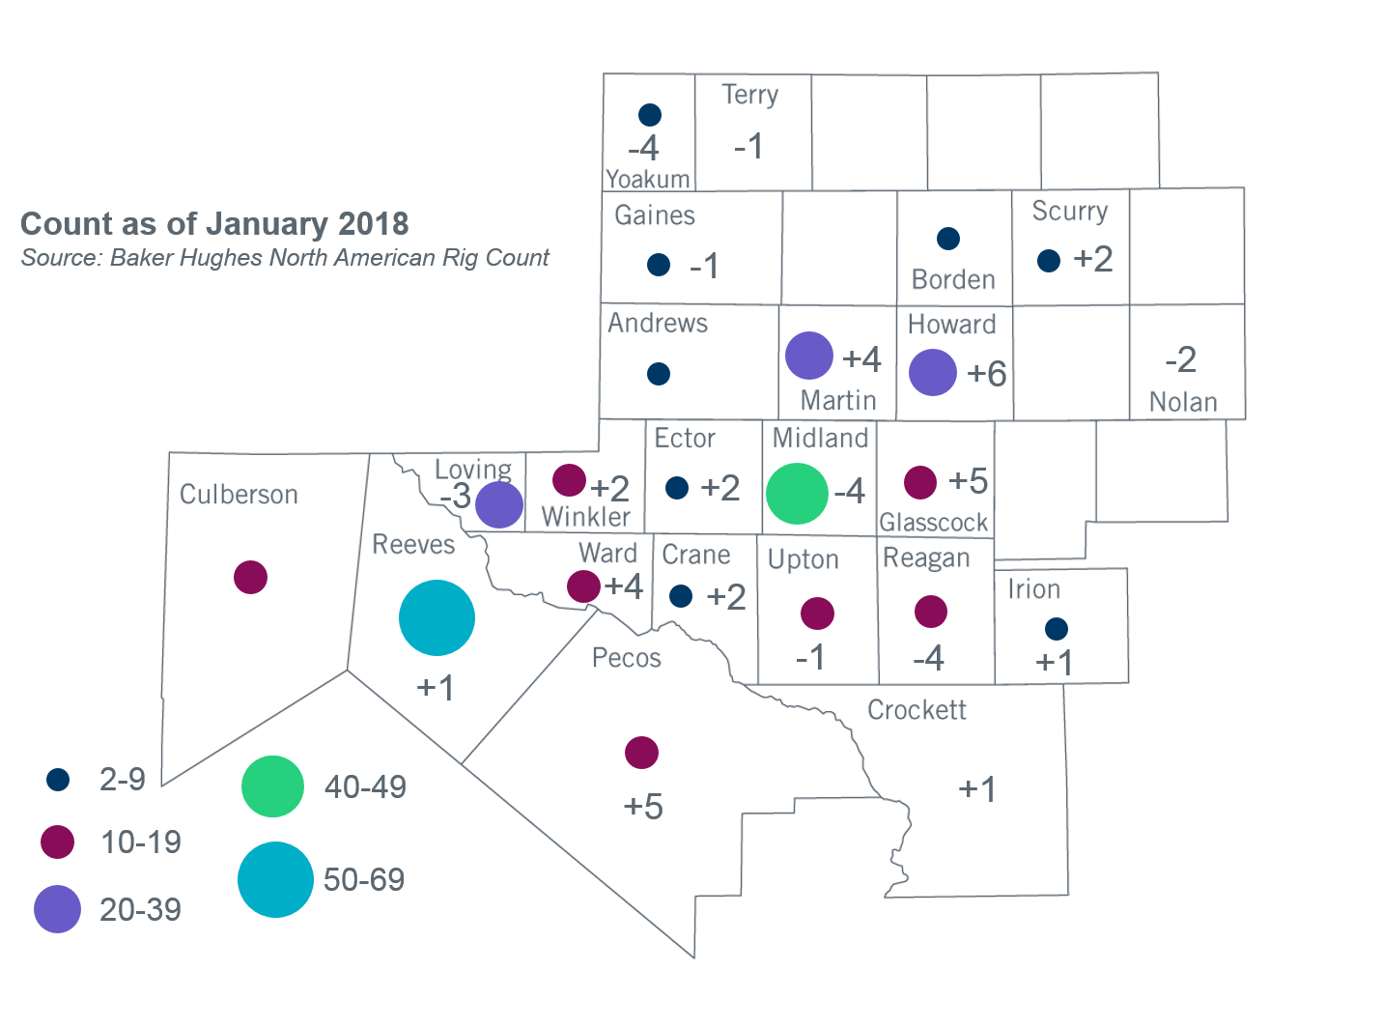
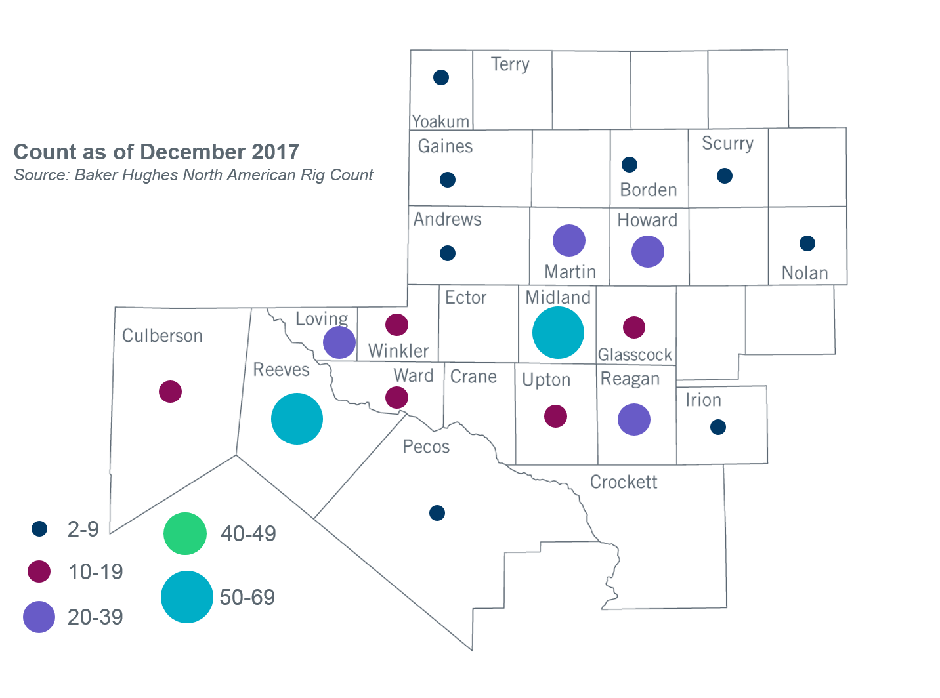

Other Notable Activities
- ERCOT has started preparation for the 2018 Regional Transmission Plan (RTP) study. ERCOT shared the draft of scope and assumptions document for the 2018 RTP at the November RPG meeting. Stakeholders are encouraged to provide feedback for the 2018 RTP study. In addition to the scope, to facilitate load review required by PG 3.1.7, ERCOT also shared the results of the initial bounded higher of comparison and resulting preliminary power flow cases. TDSP feedback on the load review is due by February 28, 2018.
- ERCOT continues to work on the 2018 Long-term System Assessment (LTSA). ERCOT is currently working on the Generation Expansion analysis for the Current Trends scenario. ERCOT recently changed vendors for the software used to perform Generation Expansion studies and is currently working on model development.
- The SPWG has completed work on the 2017 FY base cases. ERCOT sent the final pass out to the group on 06/30/2017.

+/- symbol indicates the increase or decrease from the previous month in oil rigs present in each county. There is a total increase of 15 oil rigs in the Permian Basin from December 2017 – January 2018.

