PWG Meeting Notes – January 22, 2018
WebEx 2:00 pm

Attendees:
Lindsay Butterfield – ERCOT
Bill Boswell – ERCOT
Nikki McKenna – ERCOT
Calvin Openheim - ERCOT
Sam Pak – Oncor
Sheri Wiegand – TXU
Diana Rehfeldt – TNMP
Carolyn Reed – CNP
Randy Roberts – ERCOT
Jim Lee - AEP

- ERCOT conducted elections for 2018 PWG leadership. Sheri Wiegand – TXU Energy and Sam Pak – Oncor have accepted Chair and Vice Chair positions.

- Meeting minutes from October 25th were reviewed and approved as proposed.

- Annual Validation continued discussion
- Bill Boswell presented his findings from the earlier inquiry on weather impacts, the number of data points considered, and how that determines changes to a profile
- 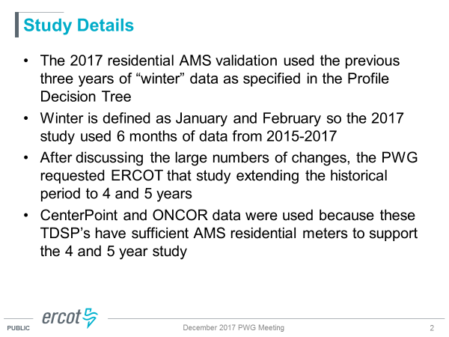
- Bill outlined his parameters for consideration in changing a residential profile from LO to HI and vice versa.
- 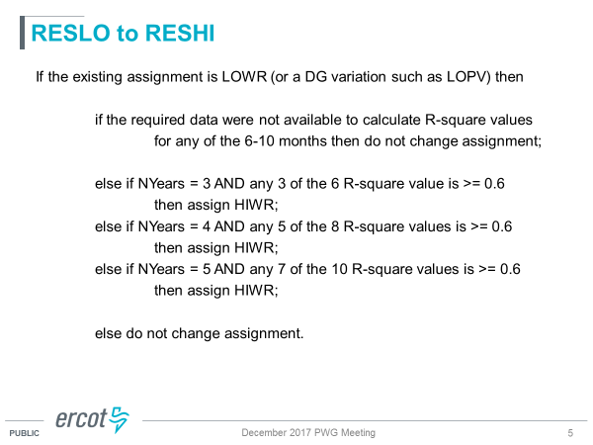
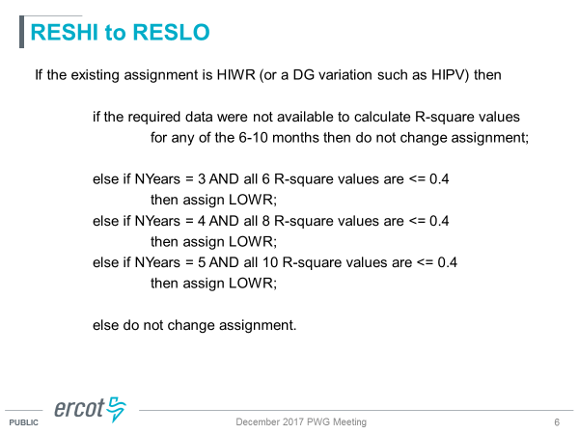
- As a result of “re-running” the 2017 using the above data points, significantly fewer number of changes occur
- 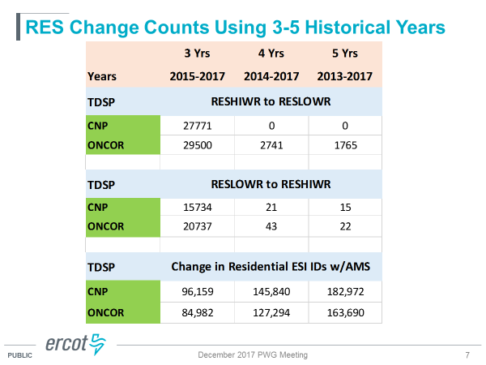
- Keeping in mind the goal of residential AV is an attempt to accurately define the consumption pattern of the ESI and a determination if the premise responds to cold temperatures likely indicating electric heating, it was determined increasing the number years may not necessarily accomplish this task.
  - AV on a new ESI does not occur until the number of data points is achieved – increasing to 4 or 5 years prolongs any analysis
  - Prior to AMS meters, the number of profile changes was significantly higher – current volumes are manageable
  - the current distribution of HI to LO by TDSP territory appears reasonable

  - 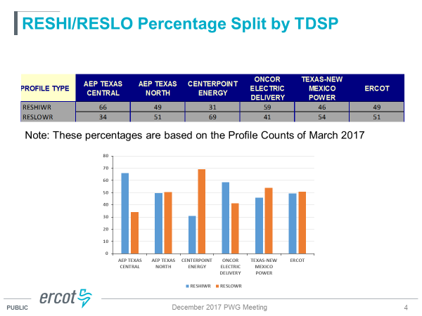
- The Working Group has concluded the AV process will remain “as is”
- ACTION ITEM: Sheri will have presentations by ERCOT posted on main PWG page for future reference if the AV process is revisited in future years

- Weather Sensitivity Report
Randy Roberts presented report run as of 1/1/18. He noted ERCOT is working with Oncor and AEP on the outstanding items .
WEATHER SENSITIVITY CHANGES REQUIRED FOR SUMMER YEAR 2017
TDSPNAME | TOTAL_COUNT | HOLD | RESOLVED | OVERDUE
AEP TEXAS CENTRAL COMPANY (TDSP) | 89 | 1 | 88 | 1
AEP TEXAS NORTH COMPANY (TDSP) | 22 |  | 22 | 0
CENTERPOINT ENERGY HOUSTON ELECTRIC LLC (TDSP) | 545 |  | 545 | 0
NUECES ELECTRIC COOP INC (TDSP) | 1 |  | 1 | 0
ONCOR ELECTRIC DELIVERY COMPANY LLC (TDSP) | 900 | 2 | 898 | 2
SHARYLAND UTILITIES LP (TDSP) | 3 |  | 3 | 0
TEXAS-NEW MEXICO POWER CO (TDSP) | 24 |  | 24 | 0
First ERCOT report date was 11/2/2017 so if not complete by 1/1/2018, these will be overdue.
11.4.3.1 - Weather Responsiveness Determination
(9)TSPs and/or DSPs shall successfully complete weather sensitivity code modifications (Load Profile ID changes) no later than 60 days after the ESI ID appears on the ERCOT report. Load Profile ID changes shall be effective as of the most current meter read date.

- 2017 Accomplishments and 2018 Goals
Both slides were reviewed with no changes. These will be presented to COPS.

- Proposed structure changes of COPS/RMS
The Working Group held a brief discussion regarding the voting item at TAC for 1/25 on the proposed restructure of RMS/COPS since PWG is directly impacted. Most parties felt the topic needed to be fully vetted at RMS and COPS.

- Meeting dates for 2018
Proposed meeting dates due to conflicts
Meeting times will be 10:00 WebEx only
- Monday, March 19th instead of Wednesday, March 21st
- Monday, July 23rd instead of Wednesday, July 25th
- Monday, October 22nd instead of Wednesday, October 25th

- Next meeting – February 21st 9:30 am WebEx only

