RMTTF
Thursday, February1 , 2018
9:30 AM
ERCOT Met Center
Room 168

Debbie McKeever, co-Chair opened the meeting and led the meeting for today.
Antitrust admin was read, agenda was reviewed.

Attending:
In Person
- Tomas Fernandez NRG
- Kathy Scott Centerpoint
- Art Deller ERCOT
- Jim Lee AEP
- Debbie McKeever Oncor
- Sheri Wiegand TXU
- Carolyn Reed Centerpoint
- Kaci Jacobs Oncor
- Monica Jones NRG

Calling in:
- Diana Rehfeldt TNMP
- Matt Tschetter ERCOT

Minutes from the last three meetings will be reviewed and posted for March’s meeting.

NOTES on the WebEx only training from Jan 30th – 31st
- Sending out email blast the week of the training was successful
  - As of Jan 26th, only a handful of participants registered. By the end of Monday, training numbers increased to 42 registered for Retail 101 and 36 for IAG training.
- Final # of participants via WebEx
  - Retail 101 – 27
  - IAG – 21
- Room 102 is too small for presenters – suggestion is to have a “live” room and an overflow room where folks have signed into WebEx
- Taylor Training facility may be a future option for WebEx trainings
- Microphone used the second day worked better
- Arrive early to avoid any last minute technical issues
- SLIDES for UPDATES:
  - RETAIL 101
    - Renewable Energy Credits information and where to locate
    - Billboards are actually metered
    - TSDPS can bill customers directly in tampering situations
    - Slide 114- remove Sharyland territory
    - Slide 20 – remove Sharyland
    - Slides 21-22 – shorten presentation on SB7
- Art has yet to schedule the revisions for Retail 101. It was suggested this occur prior to the May training in Dallas

GOALS for 2018
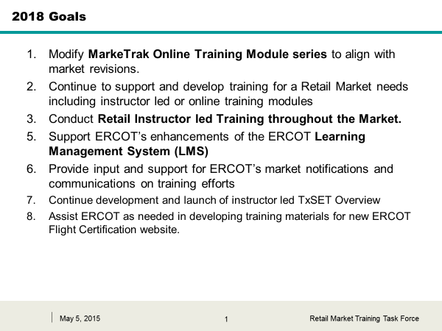

Added another goal of “Present instructor led comprehensive MarkeTrak training with an emphasis in Inadvertent Gains.

ACCOMPLISHMENTS for 2017
Completed all goals for 2017 with the addition of the following:
- Modified Cancel w/Approval training to align with NPRRxxx and SCR778
- Refreshed Overview and Switch hold on line modules
- ACTION ITEM: Deb will develop the slide for an RMS Update of 2017 accomplishments

REVIEW OF MERGED PRESENTATION for MARKETRAK and INADVERTANT GAIN TRAINING
Tomas presented the merged decks…
Initially there were ~373 slides including the appendices
It was suggested to divide the presi into two decks
- Presentation
- Appendices
Suggested revisions…
- Slide 3- revise “what is MarkeTrak? ACTION ITEM: Sheri to revise
- Slide 4 – get an updated % value and note “all listed below are Day to Day Subtypes”
- Reskinning screen shots
ASSIGNMENTS:
- Introduction – What is MarkeTrak? – Debbie McKeever
- MarkeTrak Navigation – Monica Jones
- Email Notification – Monica Jones
- Listserves – Monica Jones
- Administrator Functionality – Monica Jones
- Bulk Insert – Monica Jones
- Usage & Billing – Sheri Wiegand
- Missing Enrollments - Sheri Wiegand
- Switch Holds – Marty Allen
- Cancel w/Approval & Cancel w/o Approval – Jim Lee
- Other – Carolyn Reed
- Siebel Change – Carolyn Reed
- DEV LSE/NonLSE – Carolyn Reed
- Inadvertent Gains
  - What is IAG? - Tomas Fernandez
  - Rescission - Jim Lee
  - IAG Walkthrough – Tomas Fernandez
  - Best Practices – Tomas Fernandez
  - Verification – Synetrick Haynes
  - Reporting – Sheri Wiegand
- MT Demo , Background Reporting, GUI Reporting - Dave Michelson
ACTION ITEMS: Each presenter is responsible for reviewing their slides and providing any revisions and add any check point questions (if necessary). Sheri will have the presentation posted to the March 1st meeting page for presenter access.

LOGISTICS FOR MAY MT/IAG TRAINING
- Quick Reference Guide – Carolyn to provide copies
- Bulk Insert Tips & Tricks – laminated – NRG to provide
- Presentation deck – ERCOT
- Index cards for questions – Tomas
- 9:00 check in / 9:30 sharp training starts

TxSET Training Development - Assignments

Introduction: (Use Retail 101 TxSET slides as a starting point) (ONCOR)
- What is TxSET?
- Why do we have TxSET?
- How is TxSET executed?
  - NAESB protocal (to briefly explain)
- When are TxSET used?
- TxSET Working Group (Match Scope on ERCOT.com)
Tools/References: (CenterPoint)
- ERCOT Protocols (Ch. 15, 19, 24)
  - Overview
- Retail Market Guide
  - Overview
  - Section 7 Market Processes
  - Transaction Timing Matrix (Section 9 Appendix D1)
  - Stacking Logic (Section 11 of the RMG)
- TxSET Webpage
  - Overview
  - Swimlanes
  - EDI Guidelines
  - Testing
- Any other relevant information
Transactions: (Transaction Names Inventory V4 .0 Card handout)
- Groupings (May be able to utilize some of what was in Retail 101) (TXU)
  - 814’s
  - 810’s
  - 820’s
  - 867’s
  - 650’s
  - 824’s
  - 997’s
  - T Series
- Interaction Assignment SWIM LANES (TXU)
- Stacking Logic (TXU)
- EDI Transaction (TXU)
  - Example (Happy Path/UnHpappy Path of MVI)
  - Walkthrough of Examples of EDI transactions from implementation guides.
- MIS/Portal (Monica/Kaci/Marty Allen)
  - Review
  - Demo
- TxSET Working Group (Diana)
  - What is it
  - How it works
  - Change Controls
  - Any other Information
ACTION ITEM: Art Deller will provide ERCOT template for development of slides and send to assignees.

SCHEDULE FOR DEVELOPMENT OF TxSET
March 1st – all presenters should have documented outline of slides for their assigned sections
April 5th – Oncor & CNP should have slides prepared for review
May 3rd – TXUE & TNMP should have slides prepared (meeting in Dalllas)
- After meeting all slides should be delivered to Matt (ERCOT) to assemble for next meeting
June 7th – TF will review all slides assembled in presentation – make revisions
July 12th – review any revisions from 6/7 meeting
August 2nd – FINAL review of deck – make any final revisions
September 6th – ERCOT will present FINAL version of deck
Septebmer 14th – ERCOT will have FINAL deck ready for presenters and print
September 18th – (Monday before TxSET & TDTMS) – dry run for presenters @ 1:00 in Austin
September 26th – TxSET Training in Houston

Recommendation is TxSET is instructor led only - WebEx will be not be effective during interactive section unless video is present.

ON LINE MARKETRAK MODULES
Art presented the LMS statistics
All time: 581 completed, 781 attended
YTD: 11 completed, 18 attended

Matt presented the couple changes in the IAG module. TF approved changes and Matt will post in LMS.
Next month, Day to Day subtype module will be available for review – “reskinning”

Proposed Agenda for March 1st
- LMS Stats
- Review Day to Day module for updates
- Review merged presentation Appendices for MarkeTrak/IAG
- Review revisions/assignments for MarkeTrak/IAG merged presentation deck – slide revisions/checkpoint questions
- Review documented outline slides for TxSET sections
- Review logistics for training May training in Dallas
- Review schedule/plan for TxSET training

Items for next meeting, February 1st:
- Debriefing on January training
- MT on line stats
- Matt’s updates from two on line modules
  - Day to Day
  - Cancel w/ Approval
- Review combined MT/IAG deck
- TxSET assignments
- Goals/Accomplishments

