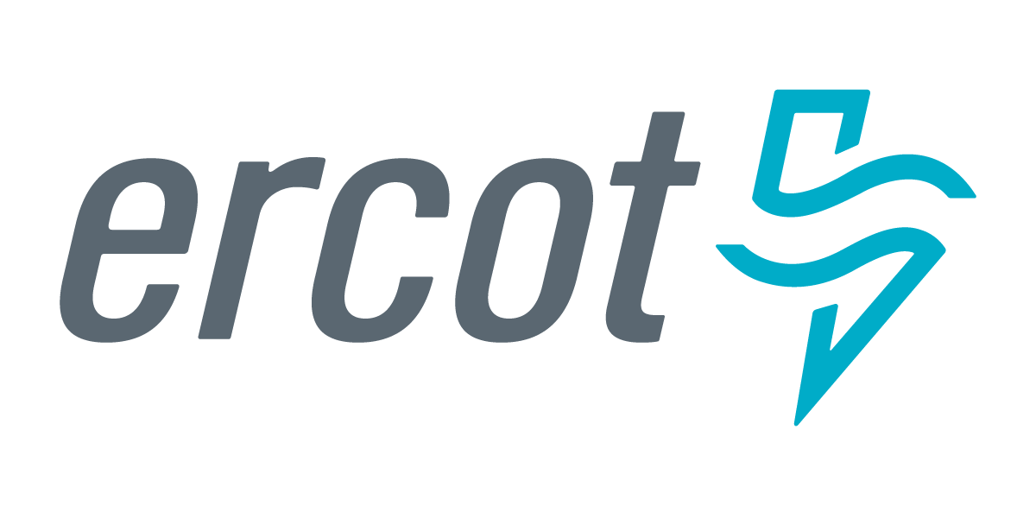 |  |  |  | System Planning
Monthly Status Report
December 2017

 |  | Report Highlights
- ERCOT is currently reviewing proposed transmission improvements with a total cost of $675.8 Million.
- Transmission Projects endorsed in 2017 total $890 Million.
- All projects (in engineering, routing, licensing and construction) total approximately $7.07 Billion as of October 15, 2017.
- Transmission Projects energized in 2017 total about $805.4 Million as of October 15, 2017.

Regional Planning Group Project Reviews
- Sharyland Utilities has submitted the South Plains Transmission project. This is a Tier 1 project that is estimated to cost $251 million. ERCOT has issued an interim report on the independent review and determined that the project does not meet the ERCOT economic planning criteria based on the assumptions used in the study. ERCOT will reevaluate the assumptions in 2018 and may perform a reassessment of the need for the project.
- Garland Power & Light and Oncor have jointly submitted the North Garland Reliability Infrastructure Project (N-GRIP). This is a Tier 1 project that is estimated to cost $78 million. The ERCOT independent review for this project is currently placed on hold per the request of GPL.
- CenterPoint Energy has submitted the Freeport Master Plan project. This is a Tier 1 project that is estimated to cost $246.7 million. The ERCOT Board endorsed this project in December.
- Brazos Electric Cooperative (BEC) & Rayburn Country Electric Cooperative (RCEC) have jointly submitted the Northeast Denton County & Celina/Prosper Transmission Improvement project. This is a Tier 1 project that is estimated to cost $72.9 million. This project is currently under ERCOT independent review.
- Brazos Electric Cooperative (BEC) has submitted the Kalgary Area Improvement project. This is a Tier 2 project that is estimated to cost $33 million. This project is currently under ERCOT independent review.
- Brazos Electric Cooperative (BEC) has submitted the South Denton County project. This is a Tier 2 project that is estimated to cost $42 million. This project is currently under ERCOT independent review.
- WETT has submitted the Bearkat Area Transmission Improvements project. This is a Tier 1 project that is estimated to cost $69.9 million. This project is currently under ERCOT Independent Review.
- Oncor has submitted the Far West Texas Dynamic Reactive Devices project. This is a Tier 1 project that is estimated to cost $86 million. This project is currently in the RPG review and comment period.
- AEPSC has submitted the Pecos County project. This is a Tier 3 project that is estimated to cost $43 million. This project is currently in the RPG review and comment period.
The below chart shows the sum of the cost estimates for the transmission projects reviewed and endorsed through the Regional Planning Group process by year since 2010.
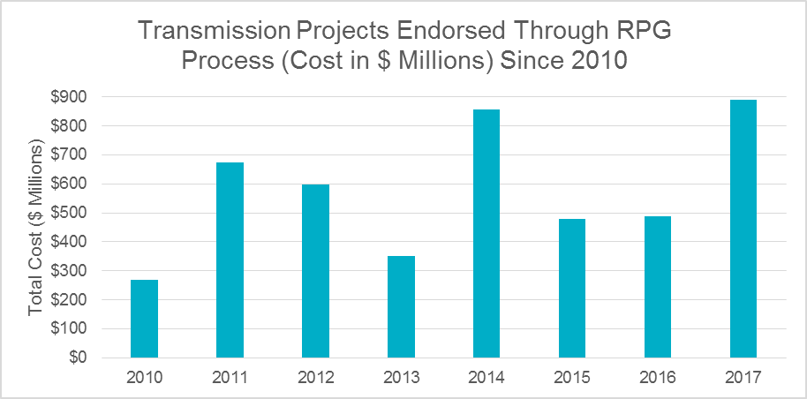

Planning Model Activities
The short term calendar of major planning model events is as follows:
- December 20, 2017 NMMS snapshot for 17SSWG Update 2
- March 1, 2018 Post 17SSWG Update 2 Base Cases
- March 31, 2017 Post Contingency definitions and Planning Data Dictionary
The following table shows interconnection projects that met Planning Guide section 6.9(1) and 6.9(2) and were modeled in the SSWG cases as either complete or as a simple model in accordance with Planning Guide section 6.9. The 6.9(2) Deadline shown in red have received a notification that the 60 day deadline has past and the set of planning data has not been received.
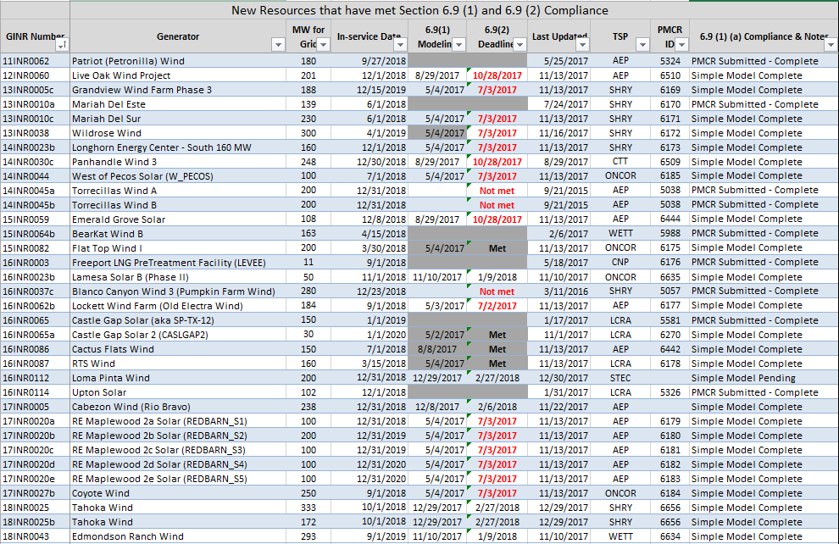

Permian Basin Oil Rig Count
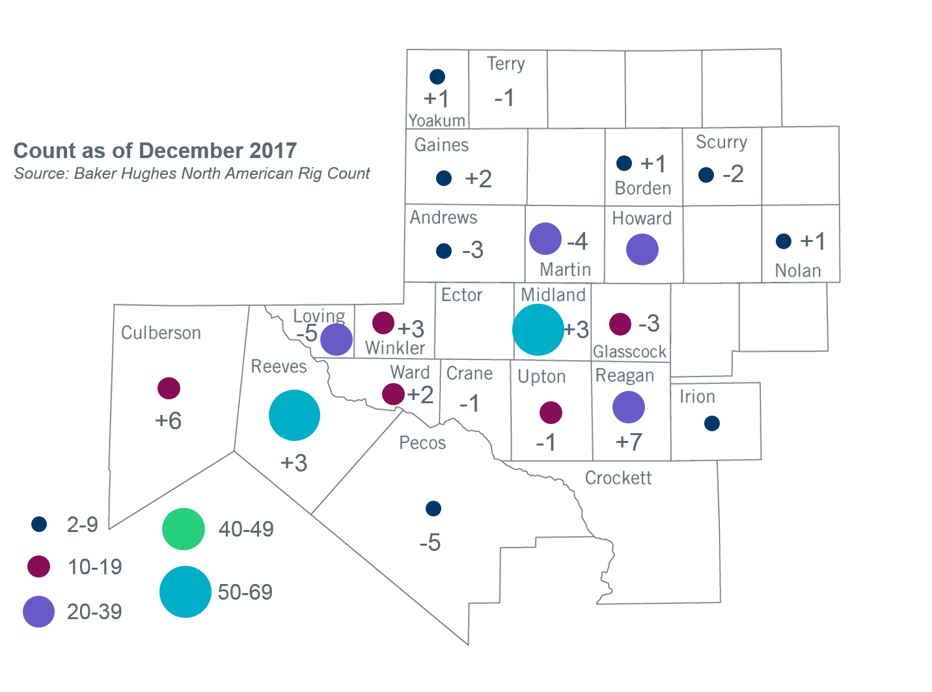

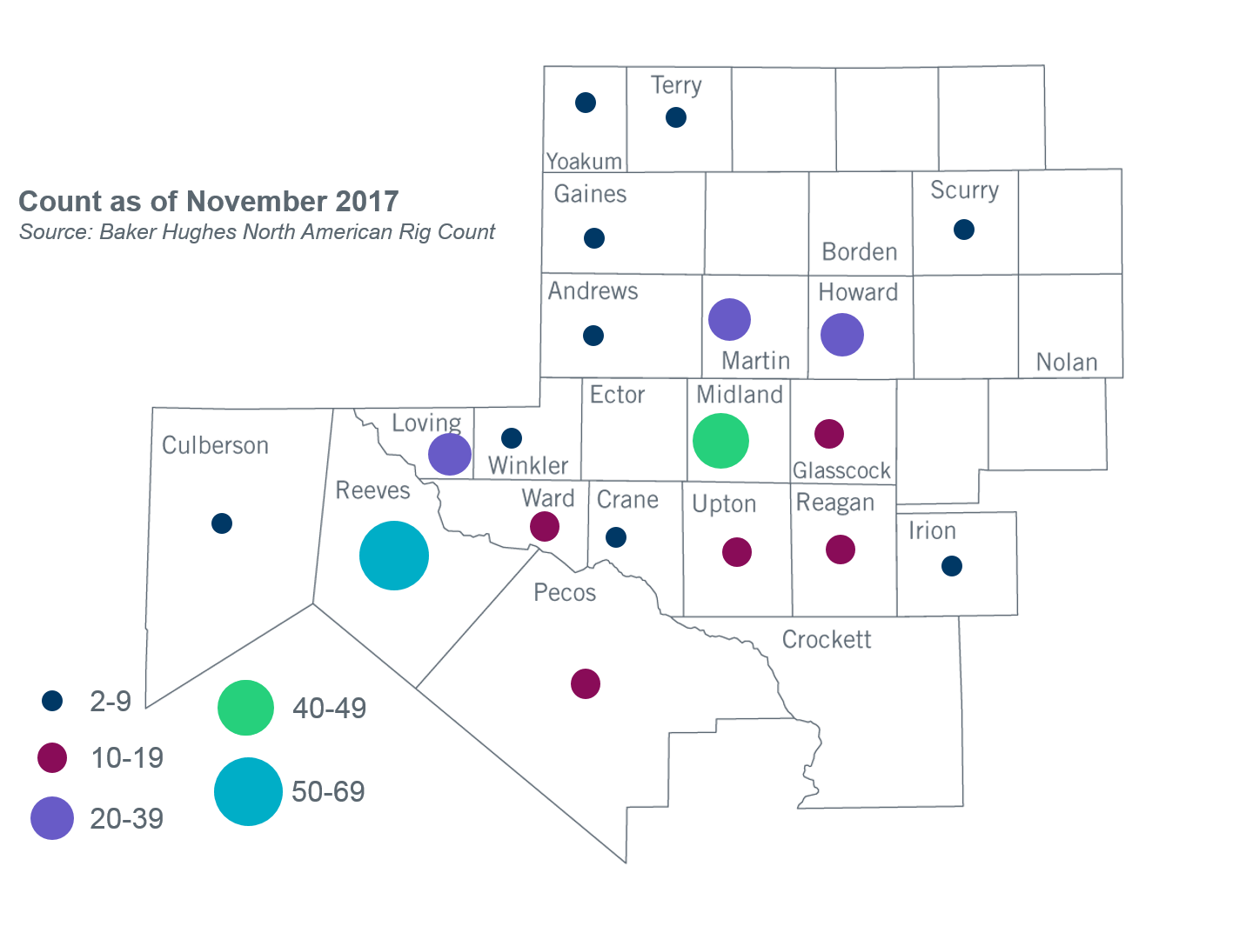

Other Notable Activities
- ERCOT has completed reliability and economic analysis for the 2017 Regional Transmission Plan (RTP). The final report and cases were shared with the RPG on December 28, 2017. In preparation for the next RTP, ERCOT shared the draft of scope and assumptions document for the 2018 RTP at the November RPG. Stakeholders are encouraged to provide feedback for the 2018 RTP study. In addition to the scope, to facilitate load review required by PG 3.1.7, ERCOT also shared the results of the initial bounded higher of comparison and resulting preliminary power flow cases. TDSPs are encouraged to review the cases and provide feedback.
- ERCOT and over thirty members in attendance at the June 2017 RPG meeting participated in a scenario development workshop for the 2018 LTSA. This session was a follow-up of the LTSA scenario development workshop conducted at the May 2017 RPG meeting. In addition to the Current Trends scenario, three new scenarios were identified as a result of the workshop. ERCOT staff compiled the results of these workshops and presented the findings on scenario descriptions and assumptions that will be studied in the 2018 LTSA at the August 2017 RPG meeting. ERCOT is currently working on load forecasting and generation expansion analysis for each of the identified scenarios.
- The SPWG has completed work on the 2017 FY base cases. ERCOT sent the final pass out to the group on 06/30/2017.

+/- symbol indicates the increase or decrease from the previous month in oil rigs present in each county. There is a total increase of four oil rigs in the Permian Basin from November-December 2017.

