MarkeTrak Users Guide
Section 3: Cancel

MarkeTrak Users Guide 1
3.1 Day to Day Issues – Cancel with Approval 3
3.1.1 Required Fields for Cancel with Approval 3
3.1.2 Definition of Cancel with Approval 3
3.1.3 Submitting Cancel with Approval 3
3.2 Day to Day (D2D) Issues – Cancel without Approval 15
3.2.1 Required fields for Cancel without Approval 15
3.2.2 Definition of Cancel without Approval 15
3.2.3 Submitting a Cancel without Approval 16

  - Day to Day Issues – Cancel with Approval

Required Fields for Cancel with Approval
Refer to Section 10 – Bulk Insert Appendix – D2D Issues

Definition of Cancel with Approval
MarkeTrak process utilized to manually cancel pending transactions when a Competitive Retailer is unable to cancel/modify the transaction via a TxSET 814_08 or 814_12.

    - CR Initiated Manual Cancels
- CRs can only request cancellation of their own service orders.
- All CR initiated manual cancellations of service orders require TDSP approval.
- The CR must obtain this approval by having the TDSP select TDSP Cancel or request that ERCOT cancel the issue by having them select ERCOT Cancel on the MarkeTrak issue.
- The TDSP can also add a comment stating they will send the 814_28 09 and select Already Cancelled when the Siebel Status shows Cancelled Unexecutable on the MarkeTrak issue.
- TDSP must be made the Assigned MP of MarkeTrak issue
- CR must try to send the Cancel on a Scheduled order:
- For MP’s that cannot generate an 814_08 due to system issues for an order that is in an In Review status in Siebel, a cancel with approval will need to be submitted, requesting ERCOT to manually cancel and send the 814_08

Before Submitting a Cancel With Approval, MPs must validate the issue against the market reports and market resource:
- Service order Full Extract Report
- Located on the Market Information System website (MIS)
- ERCOT MIS ESIID Look-Up/Transaction Look-Up
- ERCOT Market Participant (MP) Transaction Report
- Located in the FTP Reports Mailbox for each Market Participant

    - TDSP Initiated Manual Cancels – Requiring CR approval
- If the Service Order to be cancelled is Scheduled or In Review in Siebel, and is not an approved reason in the TDSP Approved Cancellation Reasons Table, CR approval is necessary prior to manual cancellation.
- For a Service Order that has completed in Siebel, a Siebel CHG/Info issue will need to be submitted. (See Section 1.12 of the User’s Guide)
- The TDSP must obtain this approval by having CR select OK to Cancel on the MarkeTrak issue.

Submitting Cancel with Approval

A CR or a TDSP can submit a Cancel with Approval

- Example: A CR submits a Cancel with Approval and TDSP cancels transaction

      - Select “Submit to my Preferred Projects” under Basic Tasks under the Submit Icon.
      - From the Submit Tree, select Cancel with Approval (Fig 3.3.3.1a)

Fig 3.1.3.1a
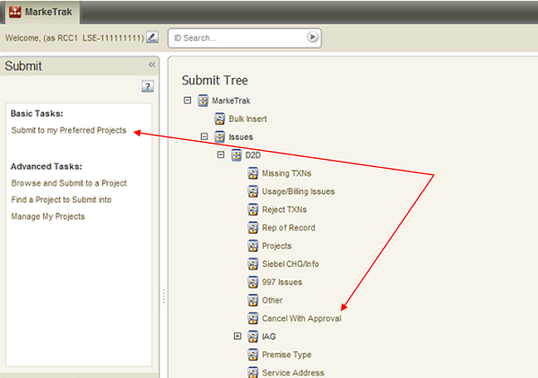

      - The following fields must be populated for successful submission of Day to Day issue sub type Cancel with Approval: (Fig 3.1.3.1b) (For this example, the TDSP is selected)
Assignee
ESI ID
Original Tran ID – BGN02 of the 814_01, 814_16 or the 814_24
Comments- recommended for rescission based issues: “Customer rescission-please process this issue per P.U.C. Subst. R. 25.474 (n).”

NOTE: The Assignee can be located by using the search feature through the ‘Find’ button by typing in all or part of the MPs name or DUNS number. The Comments field is optional, yet encouraged

      - Select OK.

Fig 3.1.3.1b
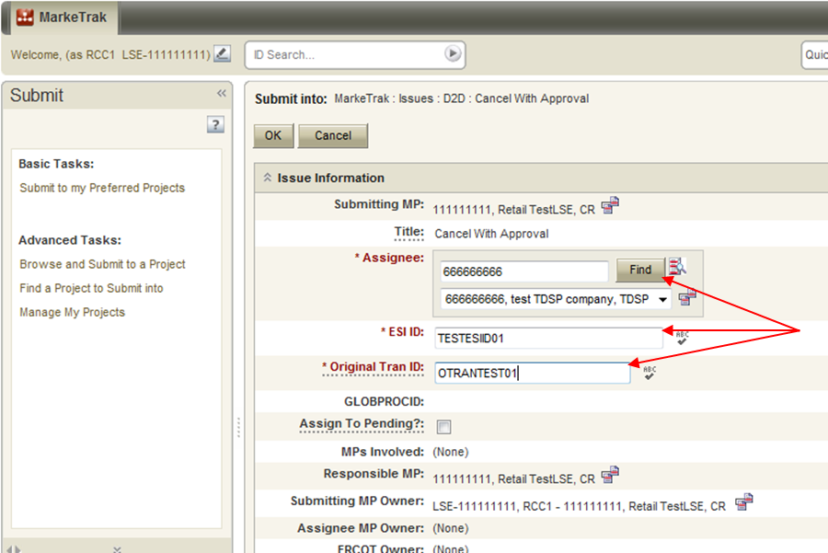

      - Validations added:
- MarkeTrak has added a validation to verify that the CR associated with the issue is the CR associated with the transaction being cancelled.
    - ERROR Message: “The ESI ID/Tran ID combination provided is not associated with this CR”
- MarkeTrak has added a validation to verify that the “Cancel With Approval” issue is being submitted within the Evaluation Window for the scheduled transaction.
  - If transaction type = 814_01(Switch) the Evaluation Window is 1 Retail Business Day prior to the SMRD
  - If transaction type = 814_16 (Move In) the Evaluation Window is 1 Retail Business Day prior to the SMRD
  - If transaction type = 814_24 (Move Out) the Evaluation Window is 1 Retail Business Day prior to the SMRD
  - MarkeTrak will automatically populate the applicable Tran Type to the issue.

Example: Texas SET transaction is scheduled for Wednesday, September 12, 2012. 814_08 cancellations will be accepted through end of Retail Business Day Tuesday , September 11th.

Please see Current Nodal Protocols, Section 15.1.8 for guidelines regarding use of the 814_08 transaction by CRs

Warning Message: “Issue is being submitted outside of the Evaluation Window and transaction should be canceled using an 814_08.”

      - By selecting OK, the issue is transitioned to the Assigned MP (TDSP) and is showing as New in the TDSP’s queue. The Submitter has the option to Withdraw the issue at any time until the Begin Working has been selected by someone other than the submitter. (Fig 3.1.3.1c)

Fig 3.1.3.1c
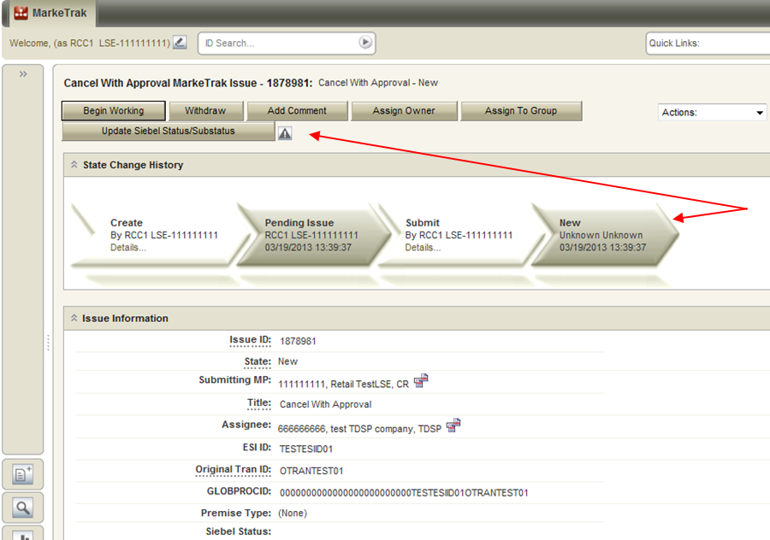

      - The TDSP becomes the Responsible MP.
      - The TDSP selects Begin Working. The issue becomes In Progress with the TDSP and the CR is no longer able to Withdraw the issue. (Fig 3.1.3.1d)

Fig 3.1.3.1d
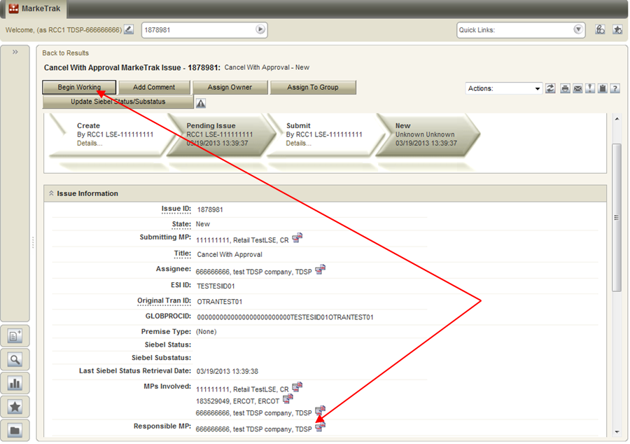

NOTE: After the initial “Begin Working” is selected and the “Withdraw” is not available or the issue is not in a “Complete” state, if the submitting MP feels a resolution is no longer needed, the “Close” button can be selected. Comments will be required with this transition. All work will stop on the issue at this point.

      - The TDSP reviews the issue then sends the 814_28 and selects TDSP Cancel. (Fig 3.1.3.1e)

Fig 3.1.3.1e
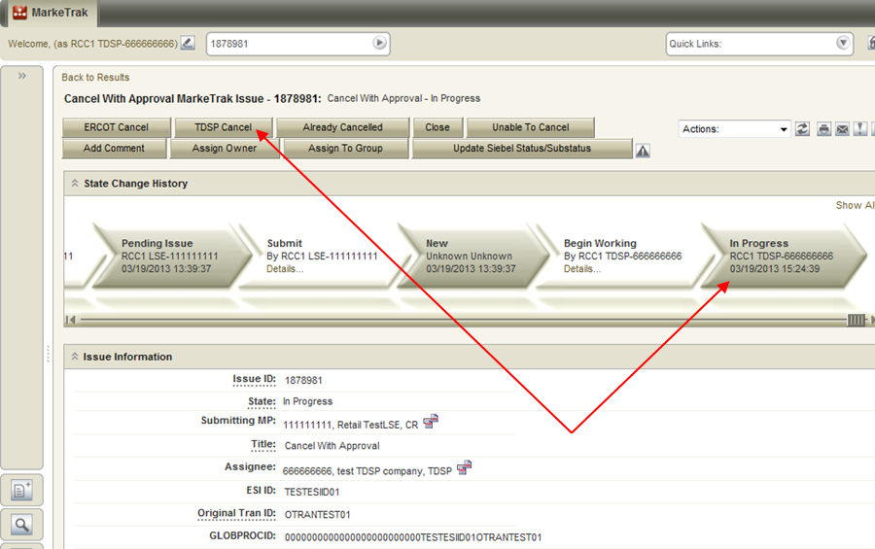

      - When the TDSP selects TDSP Cancel the issue is transitioned to a state of Cancelled (PC) (Fig 3.1.3.1f) with the CR as the responsible MP. The CR can select Complete to close the issue or the issue will auto complete once the “Siebel status/sub-status" shows it to be Cancelled in ERCOT system. . Complete (Fig 3.1.3.1g & 3.1.3.1h).

Fig 3.1.3.1f
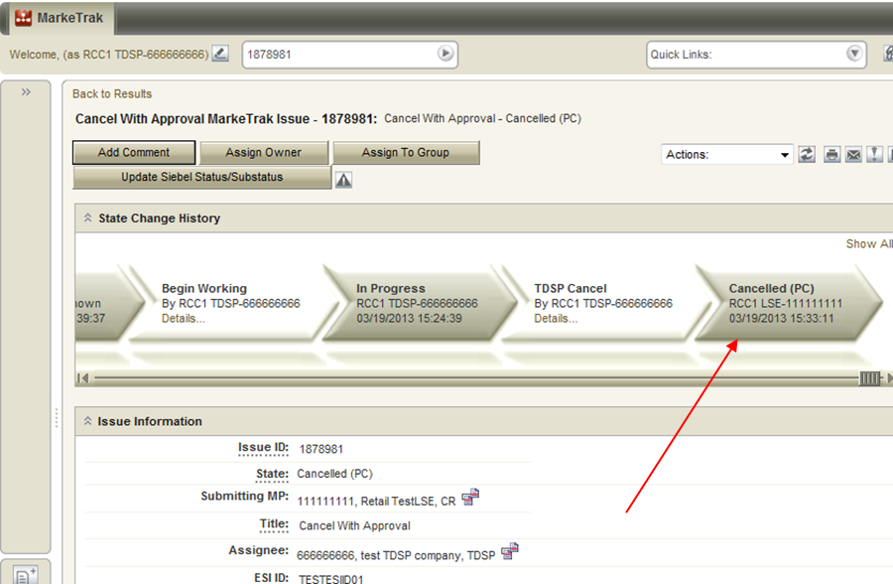

Fig 3.1.3.1g
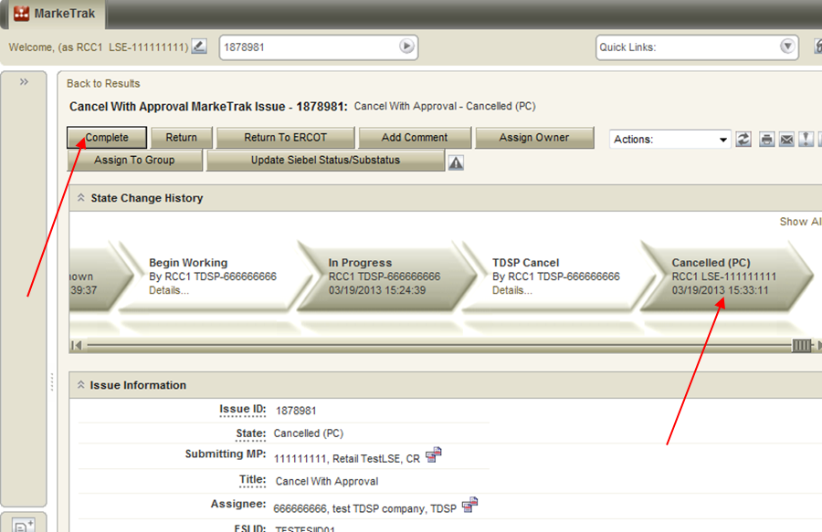

Fig 3.1.3.1h
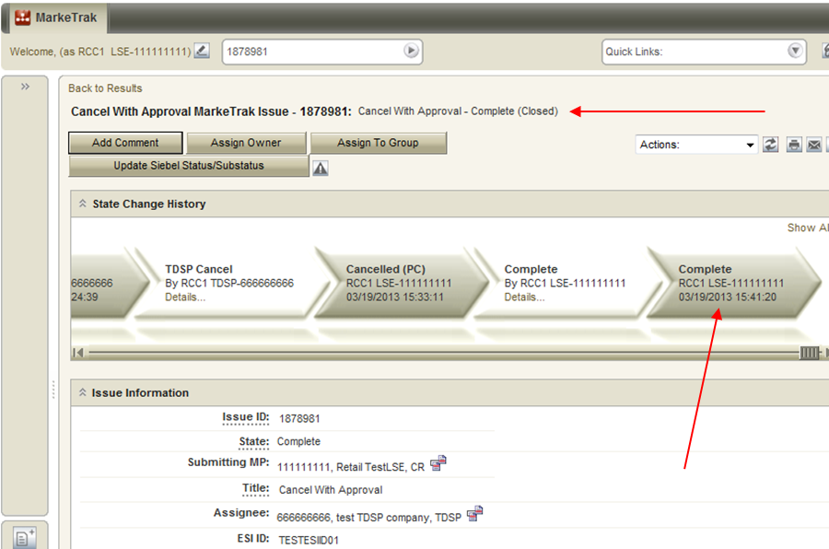

- Example: A CR submits a Cancel with Approval and TDSP selects ‘Unable to Cancel’

- Select “Submit to my Preferred Projects” under Basic Tasks under the Submit Icon. From the Submit Tree, select Cancel with Approval.
- The following fields must be populated for successful submission of Day to Day issue sub type Cancel with Approval: (For this example the TDSP is selected)
Assignee
ESI ID
Original Tran ID – BGN02 of the 814_01, 814_16 or the 814_24
Comments- recommended for rescission based issues: “Customer rescission-please process this issue per P.U.C. Subst. R. 25.474 (n).”

NOTE: The Assignee can be located by using the search feature through the Find button by typing in all or part of the MPs name or DUNS number. The Comments field is optional yet encouraged.

- Select OK. (Fig 3.1.3.2a)

Fig 3.1.3.2a
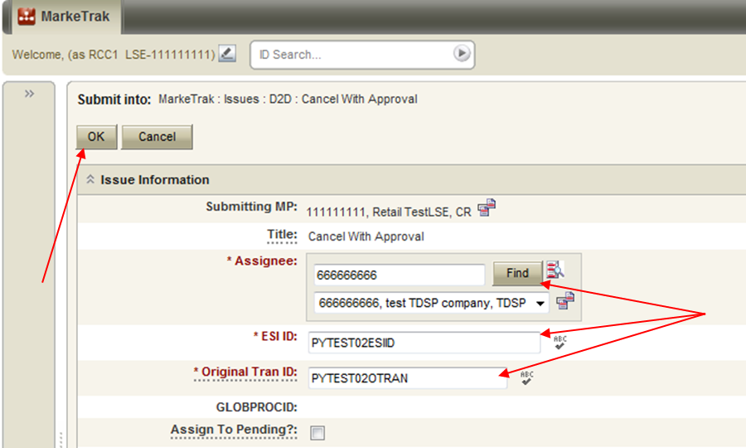

- By selecting OK, the issue is transitioned to the Assigned MP (TDSP) and is showing as New in the TDSP’s queue. The Submitter has the option to Withdraw the issue at this point.
- The TDSP becomes the Responsible MP.
- The TDSP selects Begin Working. The issue becomes In Progress with the TDSP and the Submitter is no longer able to Withdraw the issue.
- The TDSP reviews the issue. The TDSP has two negative path options: Already Cancelled or Unable to Cancel. (Fig 3.1.3.2b) A negative path always requires a comment in the comment field. For this example, the TDSP selects Already Cancelled, includes a comment and selects OK. (Fig 3.1.3.2c)

Fig 3.1.3.2b
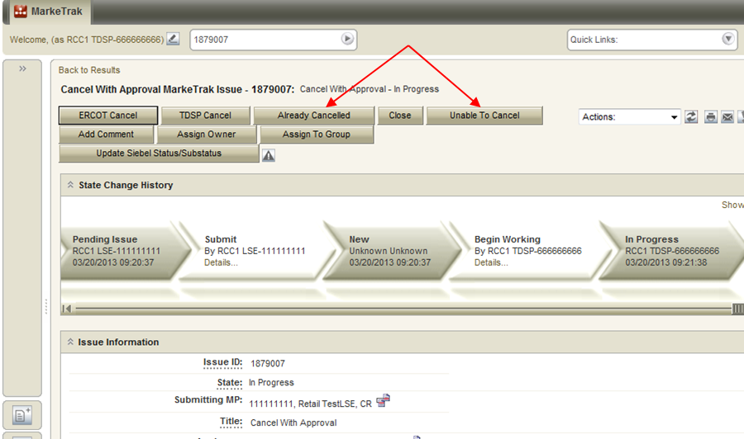

Fig 3.1.3.2c
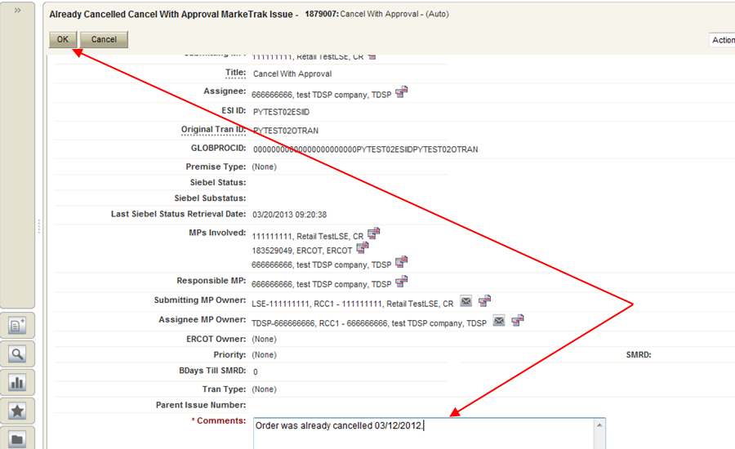

- By the TDSP selecting OK, the issue is transitioned to an Unable to Cancel (PC) state back to the Submitter. (Fig 3.1.3.2d)
- In this state, the Submitter has the option to close the issue by selecting Accept to transition to a state of Complete and close the issue. If the issue is not transitioned within 14 calendar days, on the 14th calendar day the item will automatically move to Auto Complete and close.

Fig 3.1.3.2d
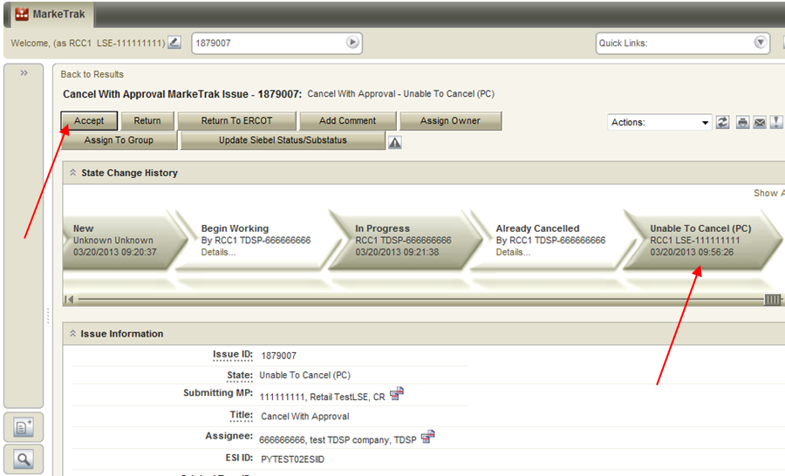

- Example: A CR submits a Cancel with Approval and TDSP asks ERCOT to cancel the transaction

- Select “Submit to my Preferred Projects” under Basic Tasks under the Submit Icon.
- From the Submit Tree, select Cancel with Approval (Fig 3.1.3.3a)

Fig 3.1.3.3a
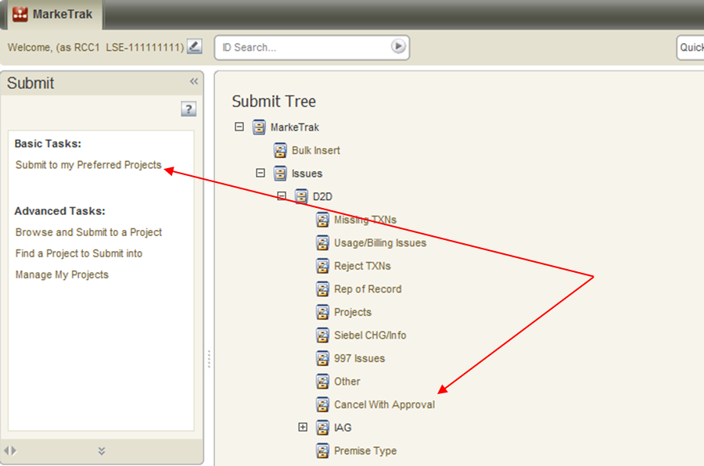

- The following fields must be populated for successful submission of Day to Day issue sub type Cancel with Approval: (Fig 3.1.3.3b) (For this example, the TDSP is selected)
Assignee
ESI ID
Original Tran ID – BGN02 of the 814_01, 814_16 or the 814_24
Comments- recommended for rescission based issues: “Customer rescission-please process this issue per P.U.C. Subst. R. 25.474 (n).”

NOTE: The Assignee can be located by using the search feature through the ‘Find’ button by typing in all or part of the MPs name or DUNS number. The Comments field is optional, yet encouraged.

- Select OK.

Fig 3.1.3.3b
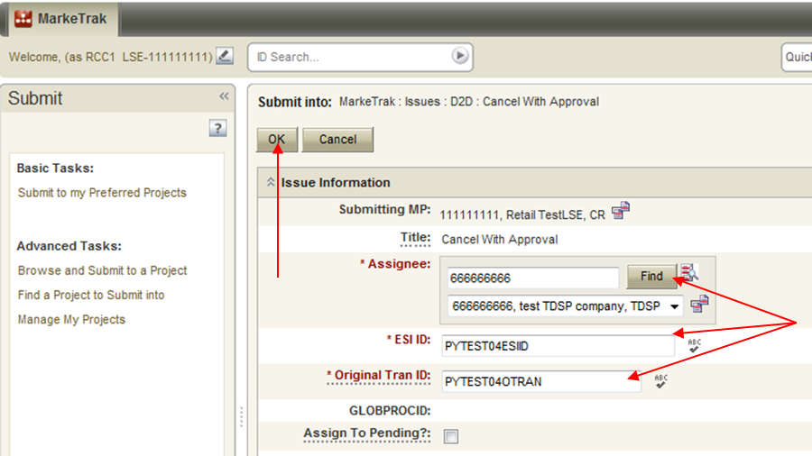

- Validations added:
- MarkeTrak has added a validation to verify that the CR associated with the issue is the CR associated with the transaction being cancelled.
    - Error Message: “The ESI ID/Tran ID combination provided is not associated with this CR”
- MarkeTrak has added a validation to verify that the “Cancel With Approval” issue is being submitted within the Evaluation Window for the scheduled transaction.
  - If transaction type = 814_01(Switch) the Evaluation Window is 1 Retail Business Day prior to the SMRD
  - If transaction type = 814_16 (Move In) the Evaluation Window is 1 Retail Business Day prior to the SMRD
  - If transaction type = 814_24 (Move Out) the Evaluation Window is 1 Retail Business Day prior to the SMRD
MarkeTrak will automatically populate the applicable Tran Type to the issue.
Example: Texas SET transaction is scheduled for Wednesday, September 12, 2012. 814_08 cancellations will be accepted through end of Retail Business Day Tuesday, September 11th.

Please see Current Nodal Protocols, Section 15.1.8 for guidelines regarding use of the 814_08 transaction by CRs

Warning Message: “Issue is being submitted outside of the Evaluation Window and transaction should be canceled using an 814_08.”

- By selecting OK, the issue is transitioned to the Assigned MP (TDSP) and is showing as New in the TDSP’s queue. The Submitter has the option to Withdraw the issue at this point. At any state a comment can be added by selecting the Add Comment button.

NOTE: After the initial “Begin Working” is selected and the “Withdraw” is not available or the issue is not in a “Complete” state, if the submitting MP feels a resolution is no longer needed, the “Close” button can be selected. Comments will be required with this transition. All work will stop on the issue at this point.

- The TDSP becomes the Responsible MP.
- The TDSP selects Begin Working. The issue becomes In Progress with the TDSP and the CR is no longer able to withdraw the issue. (Fig 3.1.3.3c)

Fig 3.1.3.3c
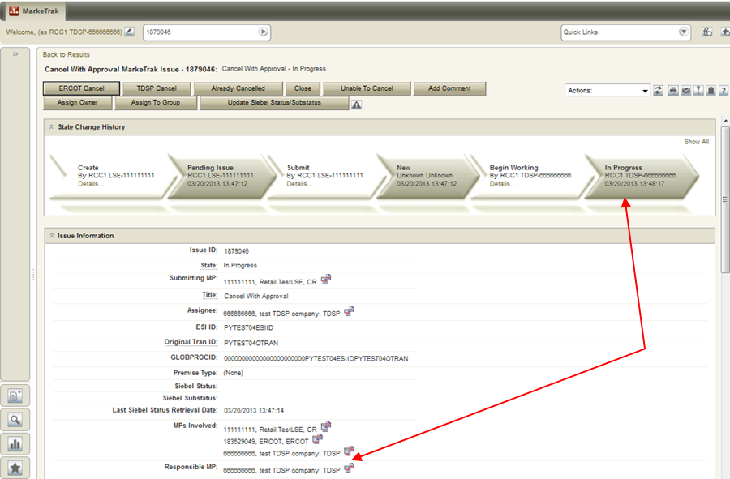

- The TDSP reviews the issue then requests that ERCOT cancel the transaction by selecting ERCOT Cancel. (Fig 3.1.3.3d & 3.1.3.3e)

Fig 3.1.3.3d
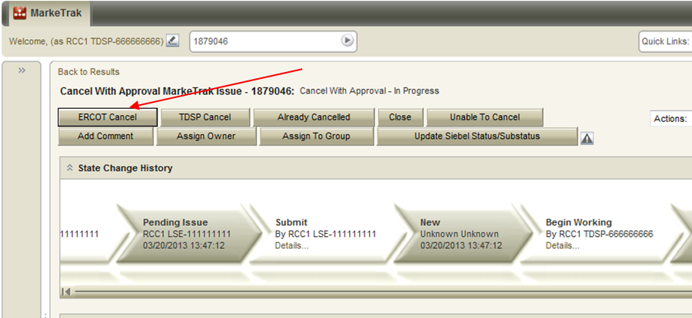

Fig 3.1.3.3e
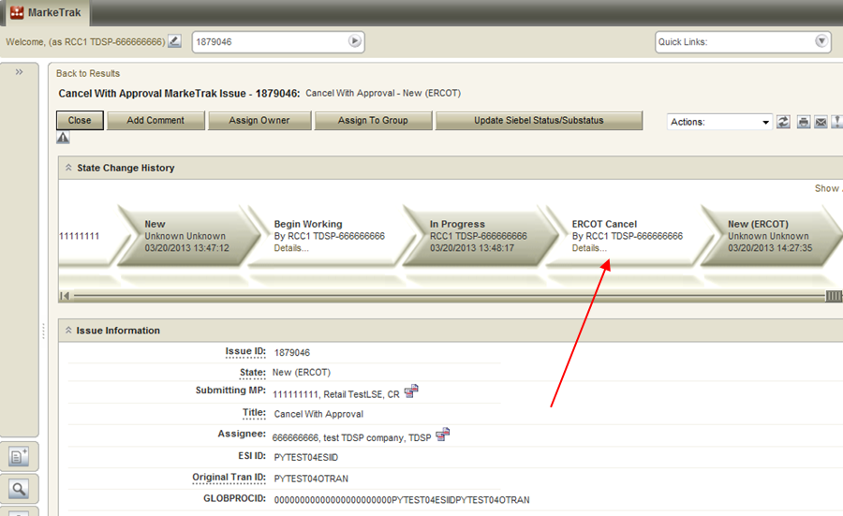
- When the TDSP selects ERCOT Cancel, the issue is transitioned to ERCOT and the order is cancelled and the 814_08 sent via ERCOT’s automated cancellation system. The issue then transitions back to the submitting MP in a state of Auto Complete. In the event ERCOT’s automated system is disabled, the issue will transition to ERCOT in a state of New (ERCOT) to be worked manually as illustrated in the following steps.. (Fig 3.1.3.3f)

Fig 3.1.3.3f
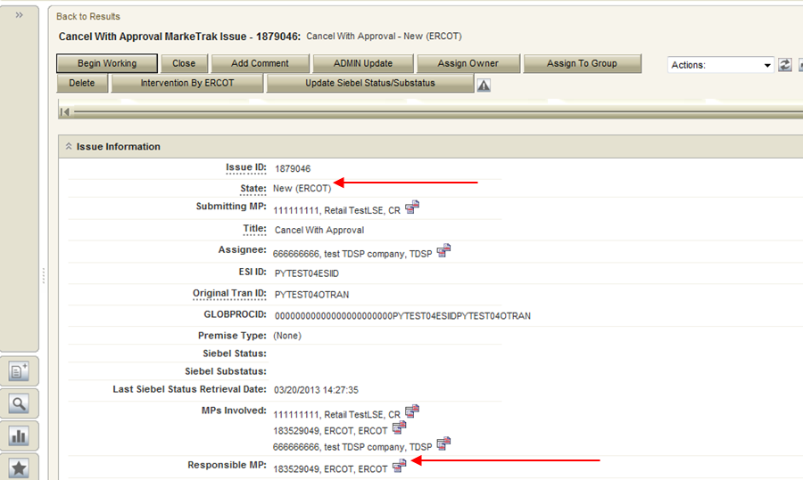

- ERCOT will select Begin Working. Once the button is selected, the issue becomes In Progress (ERCOT). (Fig 3.1.3.3g)

Fig 3.1.3.3g
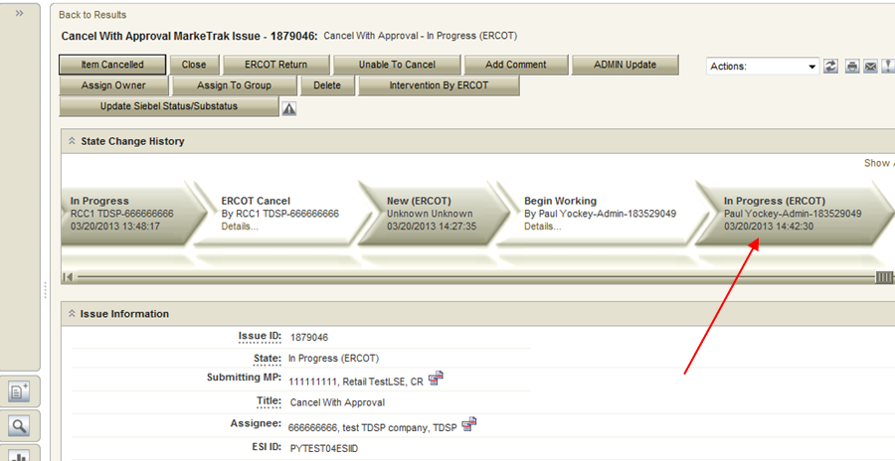

- ERCOT will review the issue and send the 814_08. ERCOT will select Item Cancelled. (Fig 3.1.3.3h)

Fig 3.1.3.3h
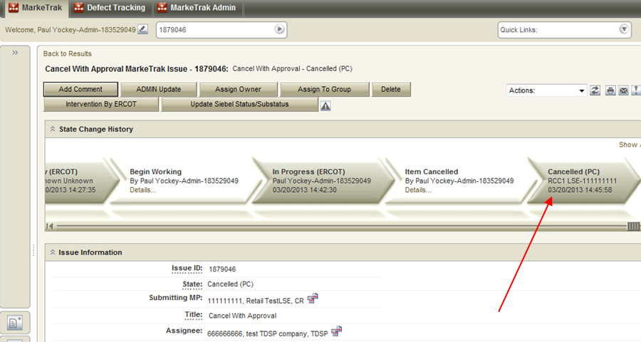

- By ERCOT selecting Item Cancelled the “Siebel status/sub-status” will automatically update.

- The MarkeTrak issue is returned to the CR with a Cancelled (PC) state and the CR will then select Complete to close the issue. (Fig 3.1.3.3i)

Fig 3.1.3.3i
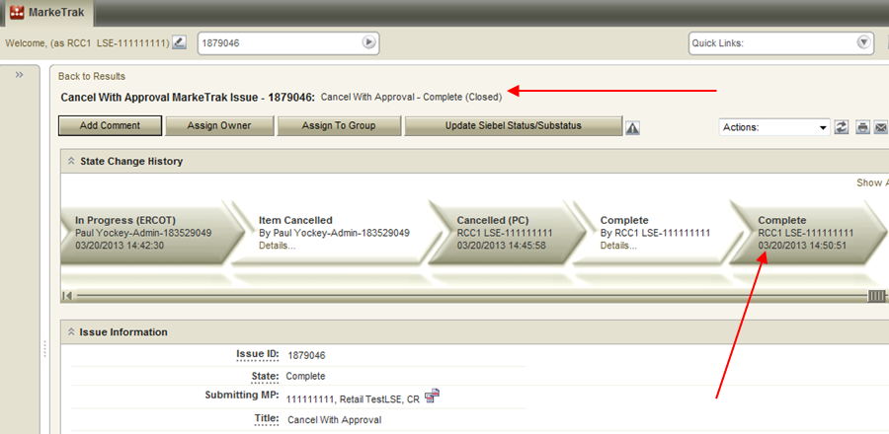

Day to Day (D2D) Issues – Cancel without Approval

3.2.1 Required fields for Cancel without Approval

Refer to Section 10 – Bulk Insert Appendix – D2D Issues

3.2.2 Definition of Cancel without Approval
MarkeTrak process used only by TDSPs to cancel a service order for market approved cancellation reasons where Competitive Retailer approval is not required.

  - TDSP Initiated Manual Cancellations on Pending Orders – Not Requiring CR Approval

- TDSPs must provide one of the following approved cancellation reasons (see chart below) for each pending service order.
- Standardized language will be provided along with the MarkeTrak number in the 814_08s sent to Market Participants (see chart below for standard language).
- This procedure is only applicable if the order is scheduled in Siebel and the meter read has not been sent.

TDSP Approved Cancellation Reasons | 814_08 Text
Scenario A  - Rep A submits a MVO  - Rep B submits MVI which precedes or is the same day as a scheduled MVO  - TDSPs can request cancel MVO, after MVI completed, thru MarkeTrak without CR approval. | MVO or MVO to CSA cancelled because MVI worked instead MT ________ (to be inserted by ERCOT)
Scenario B  - TDSP wants to cancel a switch because it received a safety net MVI before the switch effectuated.  - ERCOT will cancel the switch. | TDSP works a safety net move in instead of pending Drop or Switch MT ____________ (to be inserted by ERCOT)
Scenario C  - Expired (20 days) 814_28 PT transactions because 814_04 has not been received by ERCOT  - ERCOT will send a cancel with exception 814_08 on day 21 | Per TDSP request Order should have expired MIMO 23 MT ______________ (to be inserted by ERCOT)
Scenario D  - Service Order is unexecutable (e.g., when meter removed from a premise but no ESID retired)  - TDSP enters a MarkeTrak issue to request cancellation of Service Order  - ERCOT will cancel Service Order | Per TDSP request Unexecutable MT ____________ (to be inserted by ERCOT)
Scenario E  - Switch that is in a scheduled status. An event occurred prior to completion requiring the meter to be removed.  - TDSP enters a MarkeTrak issue to request cancellation of Switch  - ERCOT will cancel Switch | Per TDSP meter has been removed and switch can not be completed.

3.2.3 Submitting a Cancel without Approval

NOTE: Only the TDSP has access to submitting this sub type.

3.2.3.1 Example: A TDSP submits a Cancel without Approval and ERCOT Cancels

- The TDSP selects “Submit to my Preferred Projects” under Basic Tasks under the Submit Icon.
- From the Submit Tree, selects Cancel without Approval. (Fig 3.2.3.1a)

Fig 3.2.3.1a
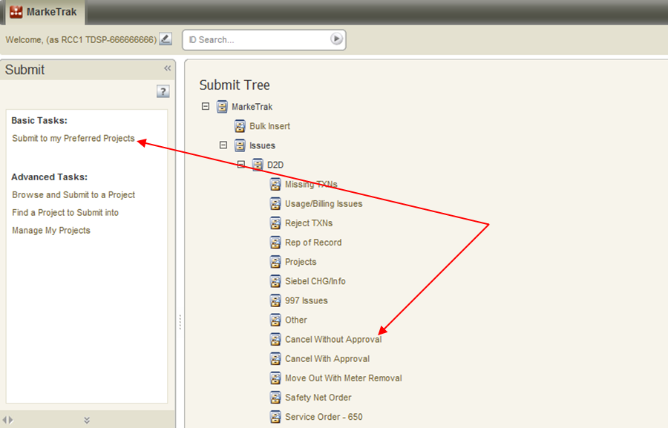

- The following fields must be populated for successful submission of Day to Day issue sub type Cancel without Approval: (Fig 3.2.3.1b)
ESIID
Original Tran ID - BGN06 of the 814_03/814_25

NOTE: Please include the TDSP Approved Cancellation Reason from Section 3.2.2.1 in the COMMENTS field. The Reason will need to be given in order for ERCOT to work the issue. If the reason not given, ERCOT will return the issue back to the TDSP.

- Select OK.

Fig 3.2.3.1b
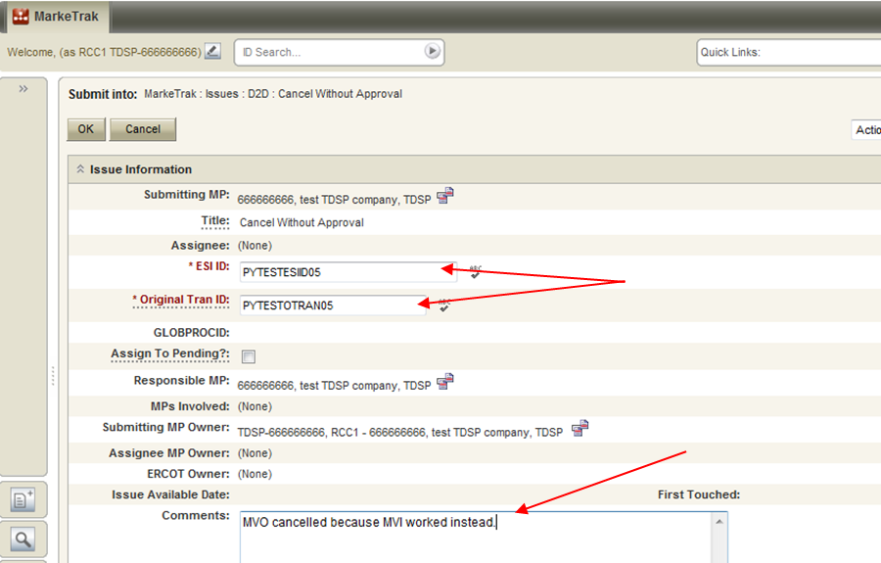

After selecting OK, a validation will be performed to check that the TDSP involved with the issue owns the issue. If the TDSP’s Duns does not match the following error message will appear - the ESI ID provided is not associated with the TDSP according to the ERCOT Registration System. Click Cancel.

By selecting OK, the issue is transitioned to ERCOT’s queue in the state of New and is visible only by the TDSP and ERCOT. The TDSP has the option to Withdraw the issue at this point. (Fig 3.2.3.1c)

Fig 3.2.3.1c
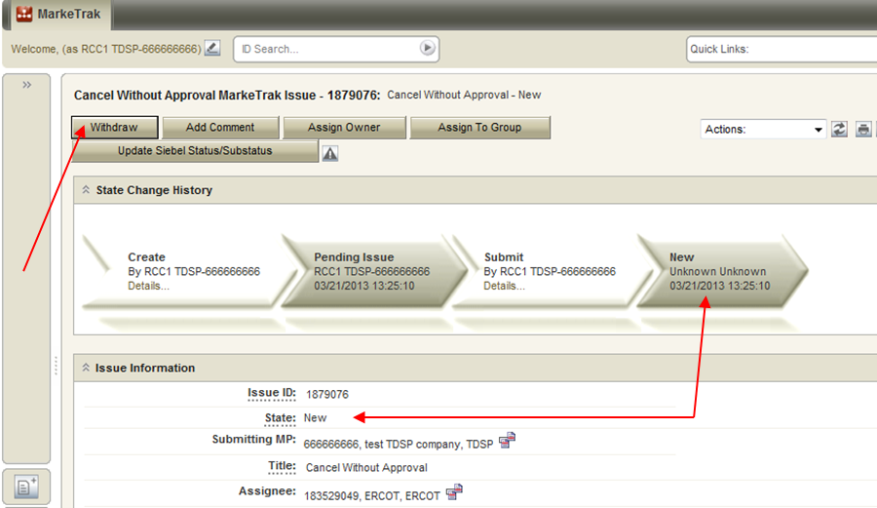

- ERCOT selects Begin Working. The TDSP is no longer able to Withdraw the issue. (Fig 3.2.3.1d)

NOTE: After the initial “Begin Working” is selected and the “Withdraw” is not available or the issue is not in a “Complete” state, if the submitting MP feels a resolution is no longer needed, the “Close” button can be selected. Comments will be required with this transition. All work will stop on the issue at this point.

Fig 3.2.3.1d
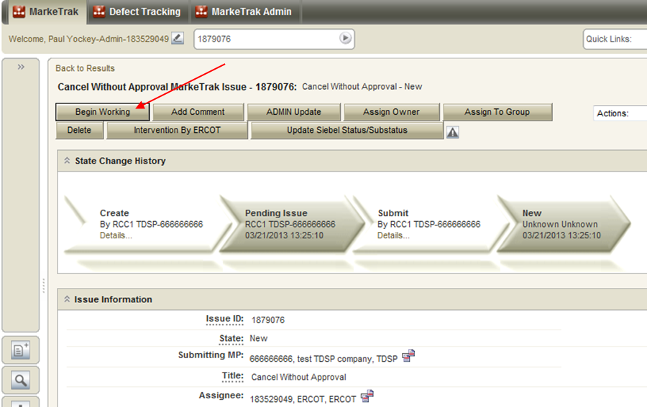

- ERCOT has the options to select Item Cancelled or Unable to Cancel. If ERCOT is able to cancel and the TDSP Cancellation Reason is included in the Comments field, ERCOT will manually cancel the Siebel service order and send 814_08s to all market participants involved. ERCOT selects Item Cancelled and has the option to add any comments by selecting Add Comment. (Fig 3.2.3.1e)

Fig 3.2.3.1e
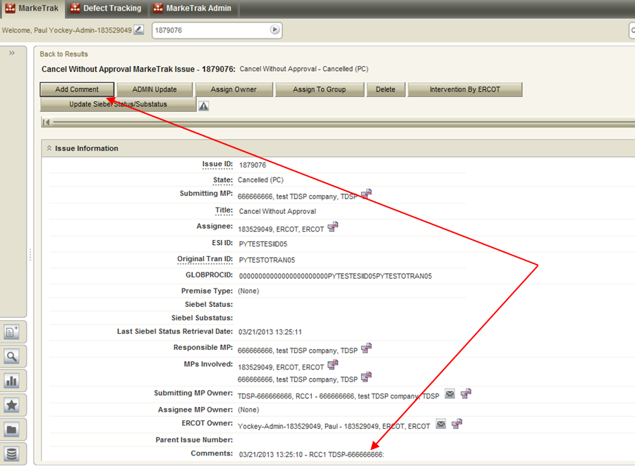

- The issue is now in a Cancelled(PC) (Pending Complete) state. The TDSP can select to Return to ERCOT (to return to state New ERCOT) or Complete to transition to a state of Complete and close the issue. If the issue is not transitioned for 14 calendar days, then the item will automatically move to Auto Complete and close. (Fig 3.2.3.1f)

Fig 3.2.3.1f
