PWG Meeting Notes – October 25th, 2017
WebEx 9:30 am

Attendees:
Lindsay Butterfield – ERCOT
Bill Boswell – ERCOT
Nikki McKenna – ERCOT
Sam Pak – Oncor
Sheri Wiegand – TXU
Diana Rehfeldt – TNMP
Carolyn Reed – CNP

- Approval of September 27th, 2017 meeting notes.

- Annual Validation Update
- 2017 Annual Validation process is officially complete with all TDUs completing at least 99% of submitted 814_20s
- Nikki will update the AV matrix of events to reflect completion
- Continued discussion regarding proposal for an ESI ID to retain a RESHIWR profile once proven to respond to cold temperatures. Nikki presented data the following data regarding # of ESI IDs
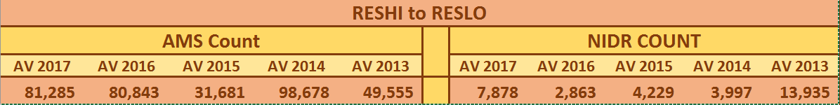

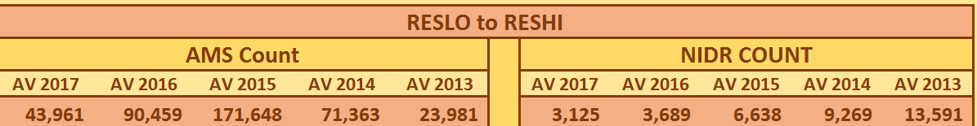

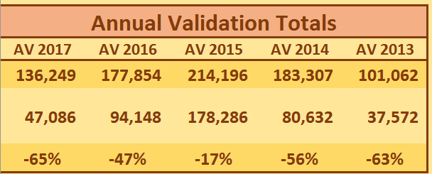
- Given the above data, the conclusion appears to be if this approach was adopted, an unrealistic number of ESI IDs would be profiled as RESHIWR and not reflect the approximate 50% electrically heated customers and 50% gas heated customers. Therefore, it was decided to pause on the proposed LPGRR language for any revisions.
- Another consideration based on earlier data, is mild winters are not testing “tight enough” to separate the electrically heated customers (those that respond to cold temps) . Another suggestion is to expand the review period and include 4 or 5 years of historical data to perform the validation. ACTION ITEM: ERCOT will re-run AV for 2017 using both a 4 year and 5 year review period to determine if this approach is more reflective of the true responders. The other request is to review the # of RESHI vs RESLO profiles by TDSP. Nikki and Bill were to review proposal with Calvin.
- One final option is to leave the criteria for review as is.

- Next meeting agenda items:
- Continued discussion of Annual Validation review – review period of 4 or 5 years
- Weather Sensitivity Report

