**ERCOT Digital Certificate Download Process**

**New Certificate Downloads**

1. Paste the download URL into a new browser and hit Enter.
2. Input the required information and click Login.

1. Verify User information and click “Generate Password”.

1. Acknowledge the pop-up message.

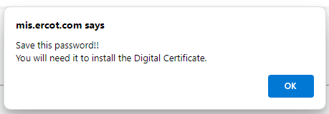

1. Copy or write down the randomly generated password and click “Click to Continue”.

1. You now have the option to either “Open” the certificate to begin the installation process, or “Save” the certificate to your machine.



In this example, the “Open” button was selected to begin the installation process.

**\*\*Select Current User\*\***

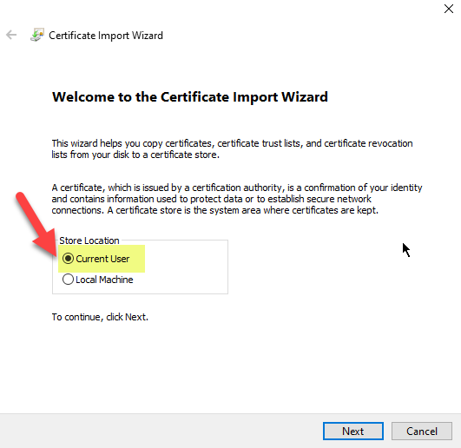

1. Click Next on the “File to Import” screen.

1. Type the randomly generated password created in Step 5 and check the “Mark this file as Exportable” checkbox to export this certificate for backup. Click Next.

1. Click Next on the “Certificate Store” screen.

1. Verify certificate information and click Finish.

1. You should get a Security Warning (shown below) confirming the installation of the Root Certificate. Click Yes. (If this window does not show up in the installation process, the Root Certificate was likely not installed.)

**If the current ERCOT_CA root certificate is already installed, this pop-up will not appear**

1. Click OK to Exit the Wizard.

