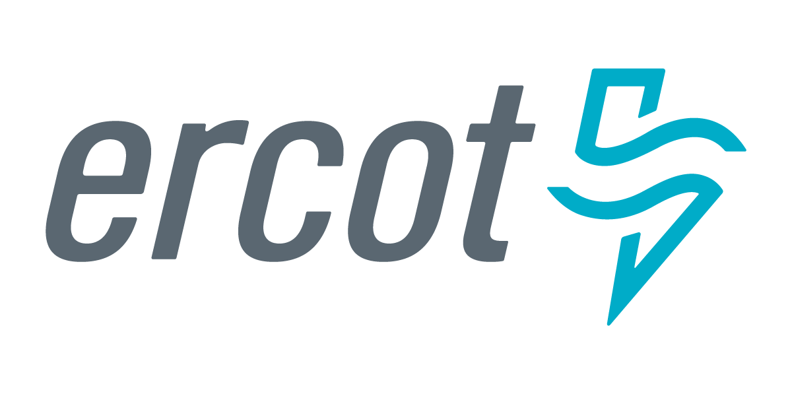 |  |  |  | System Planning
Monthly Status Report
October 2017

 |  | Report Highlights
- ERCOT is currently reviewing proposed transmission improvements with a total cost of $838.7 Million.
- Transmission Projects endorsed in 2017 total $598.1 Million.
- All projects (in engineering, routing, licensing and construction) total approximately $6.94 Billion as of Feb 1, 2017.
- Transmission Projects energized in 2017 total about $551.4 Million as of Feb 1, 2017.

Regional Planning Group Project Reviews

- Sharyland Utilities has submitted the South Plains Transmission project. This is a Tier 1 project that is estimated to cost $251 million. This project is currently under ERCOT independent review.

- Garland Power & Light and Oncor have jointly submitted the North Garland Reliability Infrastructure Project (N-GRIP). This is a Tier 1 project that is estimated to cost $78 million. The ERCOT independent review for this project is currently placed on hold per the request of GPL.

- CenterPoint Energy has submitted the Freeport Master Plan project. This is a Tier 1 project that is estimated to cost $246.7 million. This project is currently under ERCOT independent review.

- Brazos Electric Cooperative (BEC) & Rayburn Country Electric Cooperative (RCEC) have jointly submitted the Northeast Denton County & Celina/Prosper Transmission Improvement project. This is a Tier 1 project that is estimated to cost $72.9 million. This project is currently under ERCOT independent review.

- Brazos Electric Cooperative (BEC) has submitted the Kalgary Area Improvement project. This is a Tier 2 project that is estimated to cost $33 million. This project is currently under ERCOT independent review.

- Brazos Electric Cooperative (BEC) has submitted the South Denton County project. This is a Tier 2 project that is estimated to cost $42 million. This project is currently under ERCOT independent review.

- WETT has submitted the Bearkat Area Transmission Improvements project. This is a Tier 1 project that is estimated to cost $69.9 million. The ERCOT independent review for this project is currently placed on hold per the request of WETT.

- Oncor has submitted the Crockett Switching Station–Jewett Switching Station 138 kV Line project. This is a Tier 3 project that is estimated to cost $40 million. This project has completed the RPG review and ERCOT will prepare the RPG acceptance letter.

- LCRA has submitted the Wirtz-Johnson City-Mountain Top 69 kV transmission line Overhaul project. This project is initially classified as a Tier 3 project that is estimated to cost $25.2 million. . This project has been submitted for RPG comments. After the completion of RPG review, the project will be re-classified as a Tier 4 Neutral project.

- TNMP has submitted the IH20 SVC project. This is a Tier 3 project that is estimated to cost $20 million. This project has been submitted for RPG comments.

Planning Model Activities
The short term calendar of major planning model events is as follows:
- August 2, 2017 NMMS snapshot for 17SSWG Update 1
- October 15, 2017 Post 17SSWG Update 1 Base Cases
- October 31, 2017 Post Contingency definitions and Planning Data Dictionary
The following table shows interconnection projects that met Planning Guide section 6.9(1) and 6.9(2) and were modeled in the SSWG cases as either complete or as a simple model in accordance with Planning Guide section 6.9. The 6.9(2) Deadline shown in red have received a notification that the 60 day deadline has past and the set of planning data has not been received.
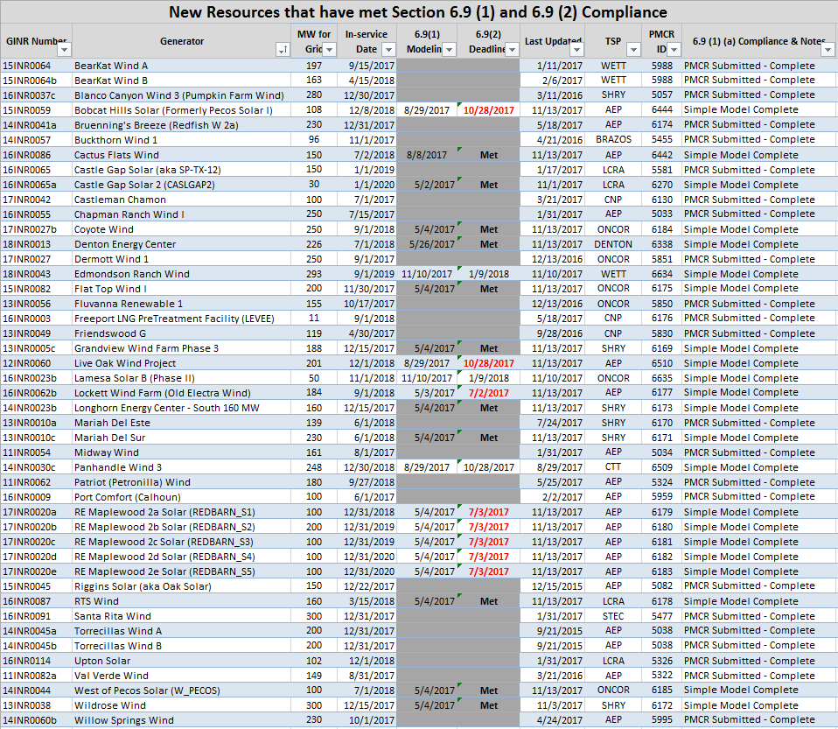

Permian Basin Oil Rig Count
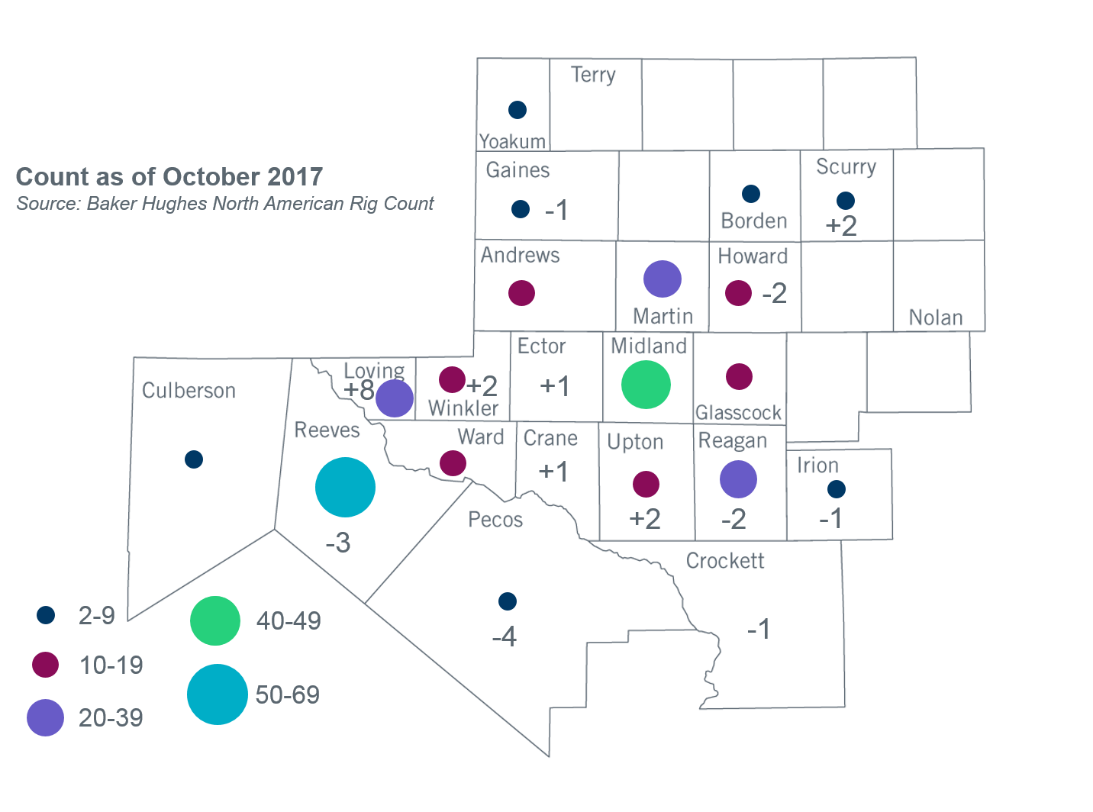
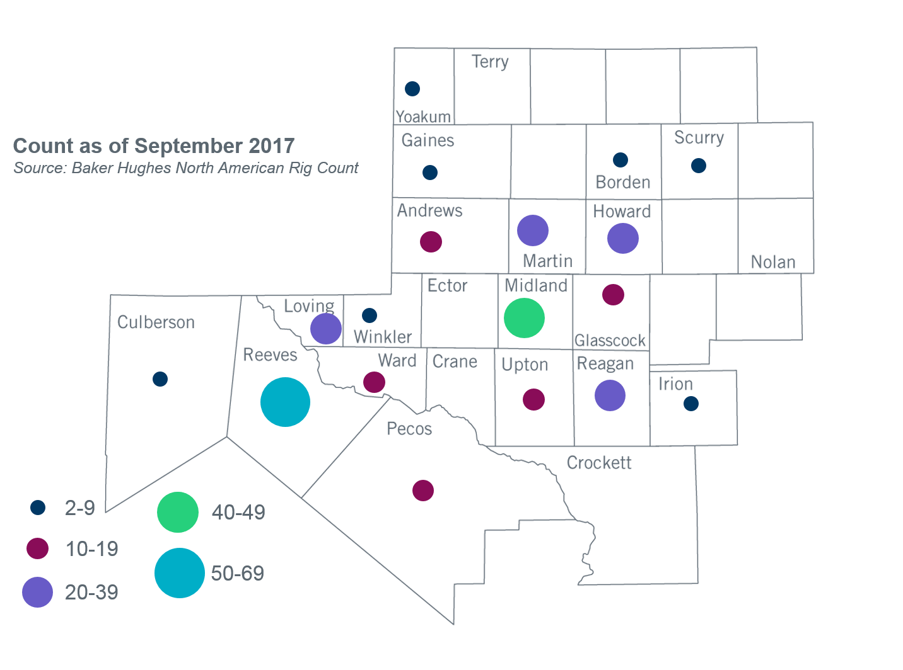

Other Notable Activities
- ERCOT is working on reliability analysis for the 2017 Regional Transmission Plan (RTP). ERCOT posted preliminary base reliability study results including study cases, reliability projects and Constraint Management Plans on the MIS Secure website on August 23, 2017. ERCOT continues to work on additional reliability analysis and economic analysis.
- ERCOT and over thirty members in attendance at the June RPG meeting participated in a scenario development workshop for the 2018 LTSA. This session was a follow-up of the LTSA scenario development workshop conducted at the May RPG meeting. In addition to the Current Trends scenario, three new scenarios were identified as a result of the workshop. ERCOT staff compiled the results of these workshops and presented the findings on scenario descriptions and assumptions that will be studied in the 2018 LTSA at the August RPG meeting.
- The SPWG has completed work on the 2017 FY base cases. ERCOT sent the final pass out to the group on 06/30/2017.

+/- symbol indicates the increase or decrease from the previous month in oil rigs present in each county. There is a total increase of two oil rigs in the Permian Basin from September-October 2017.

