September 2017 ERCOT Monthly Operations Report
Reliability and Operations Subcommittee Meeting
November 2nd, 2017

Table of Contents
1. Report Highlights 2
2. Frequency Control 3
2.1. Frequency Events 3
2.2. Responsive Reserve Events 4
2.3. Load Resource Events 4
3. Reliability Unit Commitment 5
4. Wind Generation as a Percent of Load 6
5. Congestion Analysis 6
5.1. Notable Constraints for September 6
5.2. Generic Transmission Constraint Congestion 10
5.3. Manual Overrides for September 10
5.4. Congestion Costs for Calendar Year 2017 10
6. System Events 11
6.1. ERCOT Peak Load 11
6.2. Load Shed Events 12
6.3. Stability Events 12
6.4. Notable PMU Events 12
6.5. DC Tie Curtailment 12
6.6. TRE/DOE Reportable Events 12
6.7. New/Updated Constraint Management Plans 12
6.8. New/Modified/Removed RAS 12
6.9. New Procedures/Forms/Operating Bulletins 12
7. Emergency Conditions 12
7.1. OCNs 12
7.2. Advisories 13
7.3. Watches 13
7.4. Emergency Notices 13
8. Application Performance 14
8.1. TSAT/VSAT Performance Issues 14
8.2. Communication Issues 14
8.3. Market System Issues 14
9. Model Updates 14
Appendix A: Real-Time Constraints 15

Report Highlights
- The unofficial ERCOT peak for September was 63,634 MW.
- There were eight frequency events in September. PMU data indicates the ERCOT system transitioned well in each case.
- There were five instances where Responsive Reserves were deployed, all of which were the result of frequency events.
- There were nine RUC commitments in September.
- The level of reportable SCED congestion increased in September. This congestion was mostly due to planned outages as well as high wind output. There were eighteen instances over 30 days on the Generic Transmission Constraints (GTCs) in September. There were eighteen days on the Panhandle GTC in September. There was no activity on the remaining GTCs during the Month.
- There were zero DC Tie curtailments in September.

Frequency Control

Frequency Events
The ERCOT Interconnection experienced eight frequency events in September, all of which resulted from Resource trips. The average event duration was approximately 0:05:05.

When analyzing frequency events, ERCOT evaluates PMU data according to industry standards. Events with an oscillating frequency of less than 1 Hz are considered to be inter-area, while higher frequencies indicate local events. Industry standards specify that damping ratio for inter-area oscillations should be 3.0% or greater. All events listed below indicate the ERCOT system met these standards and transitioned well after each disturbance.

Reported frequency events will include both frequency events where frequency was outside the range of 60±0.1 Hz as well as those determined to be Frequency Measurable Events (FME) as defined by BAL-001-TRE-1. Delta Frequency is defined as the difference between the pre-perturbation and post-perturbation frequency. The Duration of Event is defined as the time it takes for the frequency to recover to lesser/greater of the frequency at the time of the frequency event (t(0) or “A-point”) for low/high-frequency events, respectively. Further details on FMEs can be found in the MIS posted BAL-001-TRE-1 PDCWG Unit Performance reports. A summary of the frequency events is provided below:

Date and Time | Delta Frequency | Max/Min Frequency | Duration of Event | PMU Data |  | MW Loss | Load | Wind | Inertia
 | (Hz) | (Hz) |  | Oscillation Mode (Hz) | Damping Ratio |  | (MW) | % | (GW-s)
9/1/2017 16:56 | 0.045 | 59.89 | 0:05:02 | 0.89 | 16% | 456 | 57,078 | 6% | 320,749
9/1/2017 21:41 | 0.084 | 59.76 | 0:04:10 | 0.64 | 16% | 1,204 | 47,629 | 9% | 290,304
9/9/2017 12:09 | 0.044 | 59.89 | 0:03:23 | 0.70 | 8% | 525 | 42,197 | 6% | 247,802
9/15/2017 17:50 | 0.110 | 59.84 | 0:04:48 | 0.63 | 9% | 812 | 59,376 | 10% | 312,752
9/17/2017 16:13 | 0.042 | 59.94 | 0:03:55 | No PMU Report Created |  | 175 | 60,127 | 7% | 316,281
9/17/2017 17:40 | 0.048 | 59.93 | 0:06:48 | No PMU Report Created |  | 388 | 59,913 | 10% | 313,497
9/19/2017 23:43 | 0.044 | 59.89 | 0:03:34 | No PMU Report Created |  | 448 | 45,701 | 31% | 227,047
9/26/2017 15:05 | 0.050 | 59.96 | 0:08:59 | No PMU Report Created |  | 403 | 54,677 | 17% | 304,434
(Note: frequency events highlighted in blue have been identified as FMEs per BAL-001-TRE-1 and the Performance Disturbance Compliance Working group. PMU reports are typically generated when frequency drops below 59.9, but PMU data is available for other events.)

Currently, the Critical Inertia Level for ERCOT is approximately 100,000 MW-s (Source: link)
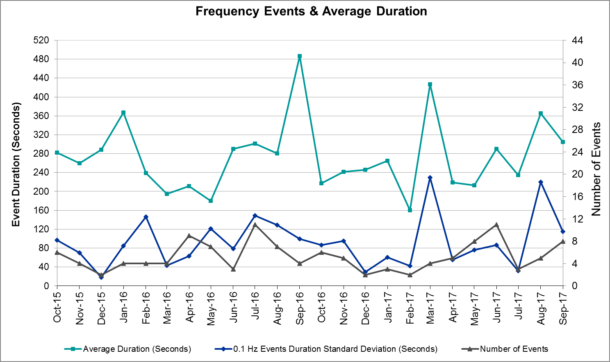
(Note: All data on this graph encompasses frequency event analysis based on BAL-001-TRE-1.)

Responsive Reserve Events
There were five events where Responsive Reserve MWs were released to SCED in September. The events highlighted in blue were related to frequency events reported in Section 2.1 above.

Date and Time Released to SCED | Date and Time Recalled | Duration of Event | Maximum MWs Released
9/1/2017 16:56:08 | 9/1/2017 16:59:26 | 0:03:12 | 440.82
9/1/2017 21:41:48 | 9/1/2017 21:44:21 | 0:02:27 | 1264.64
9/9/2017 12:09:40 | 9/9/2017 12:12:29 | 0:02:44 | 229.64
9/15/2017 17:50:47 | 9/15/2017 17:54:16 | 0:03:20 | 833.81
9/19/2017 23:43:56 | 9/19/2017 23:48:01 | 0:04:00 | 414.70

Load Resource Events
None.

Reliability Unit Commitment
ERCOT reports on Reliability Unit Commitments (RUC) on a monthly basis. Commitments are reported grouped by operating day and weather zone. The total number of hours committed is the sum of the hours for all the units in the specified region. Additional information on RUC commitments can be found on the MIS secure site at Grid Generation Reliability Unit Commitment.

There were no DRUC commitments in September.

There were nine HRUC commitments in September.

Resource Location | # of Resources | Operating Day | Total # of Hours Committed | Total MWhs | Reason For Commitment
Southern | 1 | 9/6/2017 | 6 | 3,874 | Local Congestion
Far West | 2 | 9/12/2017 | 4 | 269 | Local Congestion
North Central | 1 | 9/14/2017 | 8 | 976 | Local Congestion
North Central | 1 | 9/15/2017 | 8 | 976 | Local Congestion
North Central | 2 | 9/16/2017 | 16 | 1,920 | Local Congestion
North Central | 4 | 9/18/2017 | 15 | 3,387 | Local Congestion
North Central | 1 | 9/19/2017 | 8 | 976 | Local Congestion
North Central | 1 | 9/20/2017 | 1 | 435 | Local Congestion
Coast | 1 | 9/25/2017 | 4 | 312 | Local Congestion

Wind Generation as a Percent of Load
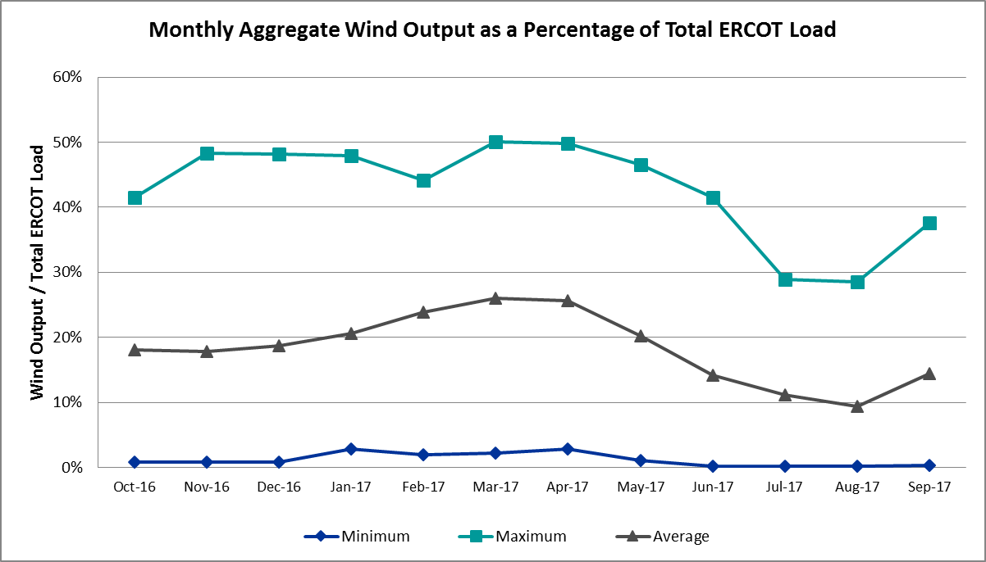

Congestion Analysis
The number of congestion events experienced by the ERCOT system increased in September. There were eighteen instances over 30 days on the Generic Transmission Constraints (GTCs) in September.

Notable Constraints for September
Nodal protocol section 3.20 specifies that ERCOT shall identify transmission constraints that are active or binding three or more times within a calendar month. As part of this process, ERCOT reports congestion that meets this criterion to ROS. In addition ERCOT also highlights notable constraints that have an estimated congestion rent exceeding $1,000,000 for a calendar month. These constraints are detailed in the table below. Rows highlighted in blue indicate the congestion was affected by one or more outages. For a list of all constraints activated in SCED for the month of September, please see Appendix A at the end of this report.

Contingency Name | Overloaded Element | # of Days Constraint Active | Congestion Rent | Transmission Project
Basecase | PNHNDL GTC | 18 | $10,247,697.97 | South Plains RPG Proposal
HCKSW-ALLNC&RNKSW 345kV | Blue Mound - Wagley Robertson 138kV | 14 | $10,071,720.58 | 6273
Jewet-Sng 345kV | Btu_Jack_Creek - Twin Oak Switch 345kV | 25 | $7,767,613.05 | Houston Import Project
Meadow to Oasis 345 KV | Angleton - Liverpool 138kV | 3 | $4,329,178.28
Monahans to Monahans Tap 2 ( | Moss Switch - Permian Basin Ses 138kV | 8 | $4,138,847.69 | Far West Texas Project
Elmcreek-Sanmigl 345kV | Pawnee Switching Station - Calaveras 345kV | 5 | $4,031,422.60
Jewet-Sng 345kV | Gibbons Creek - Singleton 345kV | 1 | $3,917,737.50 | Houston Import Project
NORTH PHARR to POLK AVENUE LIN 1 | North Mcallen - West Mcallen 138kV | 3 | $3,570,972.80 | 4493
MT ENTERPRISE to NACOGDOCHES SE LI | Stryker Creek Ses - Gresham Road Switch 138kV | 1 | $3,052,420.49 | 4257
Re Roserock Solar Plant to F | Barrilla - Fort Stockton Switch 69kV | 12 | $1,766,289.28 | Far West Texas Project
WEST LEVEE SWITCH TRX WLVEE_3_1 34 | Industrial Blvd - Compton Street 138kV | 1 | $1,719,859.26 | 13TPIT0059
ADDICKS to TH WHARTON LIN A | Lauder - North Belt 138kV | 2 | $1,624,225.94
Vensw-Ligsw 345kV | Sargent Road - Watermill Switch 345kV | 3 | $1,592,845.79
CITGO N OAK PARK to HIWAY 9 LIN 1 | Morris Street - Nueces Bay 138kV | 5 | $1,432,271.81
Monahans to Monahans Tap 2 ( | Andrews County South - Amoco Three Bar Tap 138kV | 7 | $1,376,285.16 | 5427
Monahans to Monahans Tap 2 ( | No Trees Switch - Cheyenne Tap 138kV | 7 | $1,212,046.25
Coleto Creek to Lon Hill 345 | Lon Hill - Pawnee Switching Station 345kV | 3 | $1,161,003.34
Lon_Hill-Coleto 345kV&Warburtn 138 | Lon Hill - Pawnee Switching Station 345kV | 4 | $1,142,874.88
BAKKE TAP to AMOCO MIDLAND FARMS T | Emma Tap - Holt Switch 69kV | 7 | $948,599.19
Asphalt Mines to Blewett (3) | Hamilton Road - Maverick 138kV | 11 | $879,103.26 | 5206
Chb-Kg & Cby-Jor 345kv | Channelview - Lynch 138kV | 4 | $825,897.84
Ci-Thw21 & Sa-Thw24 138kv | Fairbanks - Th Wharton 138kV | 6 | $712,078.00 | 3951
COLETO CREEK to VICTORIA LIN 1 | Coleto Creek - Victoria 138kV | 13 | $674,248.23
Elmcreek-Sanmigl 345kV | Blessing - Lolita 138kV | 4 | $604,182.08
Rns-Rtw & Sng-Tb 345kv | Singleton - Zenith 345kV | 12 | $558,800.12 | Houston Import Project
Mcses-Cdhsw 138kV | Cedar Crest Switch - Oak Cliff South 138kV | 8 | $524,106.48
Cby-Qnm & Rng 138kv | Channelview - Lynch 138kV | 3 | $484,439.64
Chb-Kg & Cby-Jor 345kv | Cedar Bayou - Cedar Bayou Plant 138kV | 3 | $428,983.59
BAKKE TAP to AMOCO MIDLAND FARMS T | Lamesa - Jim Payne Poi 138kV | 4 | $399,608.31 | 4239
LON HILL to PAWNEE SWITCHING STATI | Pettus - Normanna 69kV | 3 | $297,125.29
FORT STOCKTON PLANT TRX 69T1 138/6 | Solstice - Pig Creek Tap 138kV | 11 | $226,344.17 | Far West Texas Project
LAQUINTA to LOBO LIN 1 | Bruni Sub 138/69kV | 10 | $219,793.61
SNDSW-AUSTRO 345kV | Howard Lane Tap - Howard Lane Aen 138kV | 8 | $187,010.07 | 5945
Basecase | West Texas Solar - Tunas Creek 138kV | 14 | $167,985.99
COLETO CREEK GEN COLETOG1 | Blessing - Lolita 138kV | 6 | $154,432.64
Coleto Creek to Lon Hill 345 | Warburton Road Switching Station - Victoria 138kV | 4 | $154,375.08
SUN SWITCH to SCURRY SWITCH LIN 1 | Aspermont Aep 138/69kV | 9 | $120,335.84
PH ROBINSON TRX PHR_AT4 345/138 | Diamond Battleground - Moment 138kV | 4 | $116,558.17
SCURRY SWITCH to SALT CREEK BEPC L | Aspermont Aep 138/69kV | 10 | $104,744.22
Monahans to Monahans Tap 2 ( | Dollarhide - No Trees Switch 138kV | 5 | $97,987.90
Meadow to Ph Robinson 345 KV | Seminole Tnp - Friendswood Tnp 138kV | 6 | $91,697.24 | 4010
COLETO CREEK to VICTORIA LIN 1 | Coleto Creek - Victoria 138kV | 5 | $81,427.75
Gail Sub to Key Sub (3)138/1 | Buzzard Draw Switch - Gunsight Switch 138kV | 4 | $70,524.20
BRACKETTVILLE to HAMILTON ROAD LIN | Hamilton Road - Maverick 138kV | 3 | $54,156.08 | 5206
MCELMURRAY TAP SWITCHYARD to BUTMA | Eskota Switch - Trent 69kV | 4 | $16,461.52 | 6042
JARDIN to DILLEY SWITCH AEP LIN 1 | Dilley Switch Aep - Cotulla Sub 69kV | 4 | $14,529.50 | 5222
Elmcreek-Stp 345kv | Blessing - Lolita 138kV | 4 | $9,245.54
Fergus-Gilles & Horsba 138kV | Granite Mountain - Marble Falls 138kV | 3 | $3,581.13

Generic Transmission Constraint Congestion
There were eighteen days on the Panhandle GTC in September. There was no activity on the remaining GTCs during the Month.

Note: This is how many times a constraint has been activated to avoid exceeding a GTC limit, it does not imply an exceedance of the GTC occurred or that the GTC was binding.

Manual Overrides for September
None.

Congestion Costs for Calendar Year 2017
The following table represents the top twenty active constraints for the calendar year based on the estimated congestion rent attributed to the congestion. ERCOT updates this list on a monthly basis.

Contingency | Binding Element | # of 5-min SCED Intervals | Estimated Congestion Rent | Transmission Project
Basecase | PNHNDL GTC | 23,751 | 75,526,040.12 | South Plains RPG Proposal
HCKSW-ALLNC&RNKSW 345kV | Blue Mound - Wagley Robertson 138kV | 9,733 | 67,308,817.35 | 6273
Rns-Rtw & Sng-Tb 345kv | Singleton - Zenith 345kV | 17,103 | 64,699,015.07 | Houston Import Project
NORTH PHARR to POLK AVENUE LIN 1 | North Mcallen - West Mcallen 138kV | 2,541 | 32,283,806.21 | 4493
Rns-Rtw & Sng-Tb 345kv | Singleton - Zenith 345kV | 8,338 | 31,951,822.06 | Houston Import Project
Jewet-Sng 345kV | Btu_Jack_Creek - Twin Oak Switch 345kV | 16,464 | 28,612,604.00 | Houston Import Project
White_Pt-Mccampbe&Hecker 138 | Whitepoint - Rincon 138kV | 1,352 | 24,325,582.27 | 2979
CRLNW-LWSSW 345kV | Carrollton Northwest - Lakepointe Tnp 138kV | 6,300 | 23,917,330.89 | 5488
HCKSW-ALLNC&RNKSW 345kV | Wagley Robertson - Summerfield 138kV | 1,429 | 20,785,800.16 | 6273
Victoria-V_Dupsw 138kV | Formosa - Lolita 138kV | 2,081 | 17,352,082.06
NORTH PHARR to PHARR Magic Valley | North Mcallen - West Mcallen 138kV | 703 | 15,031,152.13 | 4493
Hecker_White_Pt 138kv | Whitepoint - Rincon 138kV | 1,447 | 14,822,421.12 | 2979
Nedin-Mv_Wedn4&Mv_Palm4 138k | Azteca Sub - Se Edinburg 138kV | 1,675 | 13,608,219.01
Jewet-Sng 345kV | Gibbons Creek - Twin Oak Switch 345kV | 306 | 10,861,578.84 | Houston Import Project
Jewet-Sng 345kV | Gibbons Creek - Singleton 345kV | 1,610 | 10,791,453.58 | Houston Import Project
White_Pt-Hecker&I_Dupsw 138k | Whitepoint - Rincon 138kV | 761 | 9,477,211.29 | 2979
NORTH EDINBURG TRX 1382 345/138 | North Edinburg 345/1kV | 390 | 8,193,272.01 | 5604
Elmcreek-Sanmigl 345kV | Pawnee Switching Station - Calaveras 345kV | 531 | 7,657,659.04
Jewet-Sng 345kV | Singleton - Gibbons Creek 345kV | 2,887 | 7,620,579.90 | Houston Import Project
Re Roserock Solar Plant to F | Barrilla - Fort Stockton Switch 69kV | 1,630 | 6,575,026.86 | Far West Texas Project

System Events

ERCOT Peak Load
The unofficial ERCOT peak load for the month was 63,634 MW and occurred on September 20th during hour ending 17:00.

Load Shed Events
None.

Stability Events
None.

Notable PMU Events
ERCOT analyzes PMU data for any significant system disturbances that do not fall into the Frequency Events category reported in section 2.1. The results are summarized in this section once the analysis has been completed.

There were no reportable events in September.

DC Tie Curtailment
None.

TRE/DOE Reportable Events
- ERCOT ISO submitted a NERC EOP-004 report on September 01, 2017 Reportable Event Type: Generation Loss.

New/Updated Constraint Management Plans
None.

New/Modified/Removed RAS
- ESKOTA RAS was approved to go back to its original activation settings on September 11th, 2017.
- Hicks Sw. – Roanoke Double Circuit 345 kV line RAP was updated to include an additional contingency on September 21st, 2017.

New Procedures/Forms/Operating Bulletins
ERCOT has revised the following procedure manuals, effective September 28, 2017.

Procedure Title | POB
DC Tie Desk | 806
Real Time Desk | 807
Reliability Risk Desk | 808
Reliability Unit Commitment Desk | 809
Scripts | 810
Shift Supervisor Desk | 811
Transmission and Security Desk | 812

Emergency Conditions

OCNs
None.

Advisories
Date and Time | Description
9/7/17 19:02 | Advisory issued for a geomagnetic disturbance K7 until Sept 8 2017 at 0100.
9/7/17 20:11 | Advisory issued for a geomagnetic disturbance of K-8 until Sept 08 2017 at 0100.
9/7/17 20:36 | Advisory issued for a geomagnetic disturbance K7 until Sept 8 2017 at 0100.
9/7/17 21:11 | Advisory issued for a geomagnetic disturbance moving from K-7 to K-8 until Sept 08 2017 at 0100.
9/8/17 9:00 | Advisory issued for a geomagnetic disturbance of K8/G4 until 10:00 CPT 9/8/2017.
9/8/17 12:19 | Advisory issued for a geomagnetic disturbance of K7/G3 until 13:00 CPT 9/8/2017.
9/9/17 14:53 | Advisory issued due to Physical Responsive Capability being below 3000 MW.
9/10/17 14:49 | Advisory issued due to Physical Responsive Capability being below 3000 MW.
9/15/17 16:07 | Advisory issued due to Physical Responsive Capability being below 3000 MW.
9/16/17 15:45 | Advisory issued due to Physical Responsive Capability being below 3000 MW.
9/25/17 16:00 | Advisory issued due to Physical Responsive Capability being below 3000 MW.
9/28/17 01:30 | Advisory issued for a geomagnetic disturbance of a K-7 level until 09/28/17 04:00.
9/30/17 14:27 | Advisory issued due to Physical Responsive Capability being below 3000 MW.

Watches
Date and Time | Description
9/19/17 09:51 | Watch issued due to HRUC not completing for HE11 due to failure/ timeline deviation.

Emergency Notices
None.

Application Performance

TSAT/VSAT Performance Issues
None.

Communication Issues
None.

Market System Issues
None.

Model Updates
The Downstream Production Change (DPC) process allows ERCOT to make changes in the on-line Network Operations Model without loading a completely new model. The purpose of this process is to allow for reliable grid operations as system conditions change between designated Network Operations Model database loads. The DPC process is limited in scope to just those items listed below, with equipment ratings updates being the most common. ERCOT has seen a rise in the use of the DPC process to make on-line updates to the Network Operations Model in recent years, instead of through the standard Network Operations Model Change Request process.

- Static Line ratings (Interim Update)
- Dynamic Line ratings (non-Interim Update)
- Autotransformer ratings (non-Interim Update)
- Breaker and Switch Normal status (Interim Update)
- Contingency Definitions (Interim Update)
- RAP and RAS changes or additions (Interim Update)
- Net Dependable and Reactive Capability (NDCRC) values (Interim Update)
- Impedance Updates (non-Interim)

Transmission Operator | Number of DPCs
ERCOT | 8
AEP | 5
CENTERPOINT | 4
ONCOR | 2
LCRA | 2
CPS | 1
LONE STAR | 1

Appendix A: Real-Time Constraints
The following is a complete list of constraints activated in SCED for the month of September. Full contingency descriptions can be found in the Standard Contingencies List located on the MIS secure site at Grid Generation Reliability Unit Commitment.

Contingency | Constrained Element | From Station | To Station | # of Days Constraint Active
DJEWSNG5 | JK_TOKSW_1 | TOKSW | JK_CK | 25
BASE CASE | PNHNDL | n/a | n/a | 18
DHCKRNK5 | 6270__C | WGROB | BLMND | 14
BASE CASE | TUNACR_SIRIUS_1 | SIRIUS | TUNACR | 14
SVICCO28 | COLETO_VICTOR2_1 | COLETO | VICTORIA | 13
DRNS_TB5 | SNGZEN99_A | SNG | ZEN | 12
SWCSBOO8 | BARL_FTSW1_1 | FTSW | BARL | 12
SBRAUVA8 | HAMILT_MAVERI1_1 | HAMILTON | MAVERICK | 11
XFTS89 | PIGTAP_SOLSTI1_1 | PIGTAP | SOLSTICE | 11
XFTS89 | PIGTAP_SOLSTI1_1 | SOLSTICE | PIGTAP | 11
SLAQLOB8 | BRUNI_69_1 | BRUNI | BRUNI | 10
SSPUMW18 | ASPM_69T1 | ASPM | ASPM | 10
SSCUSU28 | ASPM_69T1 | ASPM | ASPM | 9
DAUSSND5 | HWRDLN_1 | HWRDTP | HWRDLN | 8
DMCSCDH8 | 3160__A | CDCSW | OKCLS | 8
SMNHODE8 | 6485__A | MOSSW | PBSES | 8
SMNHODE8 | 6101__A | NOTSW | CHEYT | 7
SBAKHL48 | 6596__F | HLTSW | EMATP | 7
SMNHODE8 | 6100__G | ACSSW | AMTBT | 7
DCI_SA_8 | FR_THW81_A | THW | FR | 6
SMDOPHR5 | G138_10C_1 | FRDSWOOD | SEMINOLE | 6
UCOLCOL1 | BLESSI_LOLITA1_1 | BLESSING | LOLITA | 6
DELMSAN5 | PAWNEE_SPRUCE_1 | CALAVERS | PAWNEE | 5
SMNHODE8 | 6100__F | DHIDE | NOTSW | 5
SVICCOL8 | COLETO_VICTOR1_1 | COLETO | VICTORIA | 5
SHIWCIT8 | MORRIS_NUECES1_1 | NUECES_B | MORRIS | 5
XPH3R58 | DIBMNT21_A | DIB | MNT | 4
SMCEABS8 | 6585__A | ESKSW | TRNT | 4
SJARDIL8 | DIL_COTU_1 | DILLEYSW | COTULAS | 4
DELMSAN5 | BLESSI_LOLITA1_1 | BLESSING | LOLITA | 4
SKEYWLV8 | 6137__A | GUNSW | BUZSW | 4
DELMTEX5 | BLESSI_LOLITA1_1 | BLESSING | LOLITA | 4
DCHBJOR5 | CV_LH_03_A | LH | CV | 4
DLONWAR5 | LONHILL_PAWNEE_1 | PAWNEE | LON_HILL | 4
SBAKHL48 | 6095__D | LMESA | JPPOI | 4
SCOLLON5 | VICTO_WARBU_1A_1 | VICTORIA | WARBURTN | 4
SCOLLON5 | LONHILL_PAWNEE_1 | PAWNEE | LON_HILL | 3
DVENLIG5 | 216__A | WTRML | SARRD | 3
SPAWLON5 | NORMAN_PETTUS1_1 | PETTUS | NORMANNA | 3
SPOLPHA8 | GCB_100_1 | N_MCALLN | W_MCALLN | 3
DCBYRN28 | CV_LH_03_A | LH | CV | 3
SBRAHAM8 | HAMILT_MAVERI1_1 | HAMILTON | MAVERICK | 3
DFERHOR8 | 342T195_1 | GRANMO | MARBFA | 3
DCHBJOR5 | CBYCD_84_A | CBY | CD | 3
SMDOOAS5 | AE_LV_04_A | AE | LV | 3
SADKTHW5 | LA_NB_95_A | NB | LA | 2
XTWI258 | REDCREEK_T1H | REDCREEK | REDCREEK | 2
DEMSPKR5 | 6270__C | WGROB | BLMND | 2
DGBY_KG5 | GBYPW_94_A | GBY | PW | 2
DGBY_KG5 | LHMPSA08_A | LHM | PSA | 2
DTRCELK5 | 1760__A | SHBSW | TYLNW | 2
DAUSSND5 | 211T147_1 | GILLCR | MCNEIL_ | 2
DGIBSNG5 | 240__A | JEWET | SNG | 2
SBBSNA55 | 60__A | BBSES | NAVARRO | 2
SALAN_28 | AIRLIN_CABANI1_1 | AIRLINE | CABANISS | 2
SWCSBOO8 | FTST_69T1 | FTST | FTST | 2
DELMSAN5 | POT_OAKS_1 | OAKS9 | POTEETS | 2
SWOORI38 | TNAF_TNFS_1 | TNAF | 16TH_ST | 2
DHUTGEA8 | 211T147_1 | GILLCR | MCNEIL_ | 2
DVICV_D8 | FORMOS_LOLITA1_1 | LOLITA | FORMOSA | 2
SMGPBRN8 | HAS_XFM2 | HAS | HAS | 2
SOXYIN28 | I_DUPP_I_DUPS1_1 | I_DUPP1 | I_DUPSW | 2
XBLE58 | SAR_FRAN_1 | FRANKC | SARGNTS | 2
BASE CASE | 6100__G | ACSSW | AMTBT | 2
SPHRCTR5 | ATKRIN87_A | RIN | ATK | 2
SCOLLON5 | FANNIN_VICTOR1_1 | VICTORIA | FANNINS | 2
XSA2N58 | SANMIGL_ATAH | SANMIGL | SANMIGL | 2
DGBY_KG5 | BCVPSA03_A | PSA | BCV | 2
SMDOOAS5 | BCVPSA03_A | PSA | BCV | 2
DGIBSNG5 | 260_A_1 | JEWET | SNG | 2
DFERSTA8 | 38T365_1 | WIRTZ | FLATRO | 1
SLCSTH25 | 505__A | THSES | SAMSW | 1
BASE CASE | BURNS_RIOHONDO_1 | RIOHONDO | MV_BURNS | 1
DFPPHOL5 | FAYETT_AT2L | FAYETT | FAYETT | 1
DBIGKEN5 | FRIR_ROCKSP1_1 | FRIR | ROCKSPRS | 1
DBI_GT_8 | HR_NS_91_A | HR | NS | 1
DQABSRB8 | JFSSC_06_A | SC | JFS | 1
SDELLAR8 | LARDVN_MILO1_1 | LARDVNTH | MILO | 1
XTWI258 | PAULAN_SANORT1_1 | PAULANN | SANORTH | 1
DB_DPHA8 | B_DAVI_RODD_F1_1 | B_DAVIS | RODD_FLD | 1
SWRDYN8 | EL_CAM_LANCTY1_1 | LANCTYPM | EL_CAMPO | 1
SYOACUE8 | 101T158_1 | ZORN | POOLRO | 1
DENTSCS5 | 1170__A | NCDSE | HNRSW | 1
DCPSJON5 | 6017__A | MBDSW | DCSES | 1
DSC_SL28 | CO_WAS84_A | CO | WAS | 1
DCHB_NB5 | CV_LH_03_A | LH | CV | 1
DFRAPAR8 | F4_Z4_1 | Z4 | F4 | 1
SJNSWNT8 | OLK_WHTN_1 | LKWHITNY | OLSEN | 1
BASE CASE | REROCK_TLINE_1 | REROCK | LINTERNA | 1
DVENLIG5 | 1310__D | CDHSW | MFTPN | 1
DEMSSAG8 | 6265__A | EMSES | MRSDO | 1
SPAWCAL5 | COLETO_KENEDS1_1 | COLETO | KENEDSW | 1
DCBYATK8 | EXNLH_03_A | EXN | LH | 1
DNAVWTR5 | 35030__A | NAVARRO | VENSW | 1
SHCKRNK5 | 6270__C | WGROB | BLMND | 1
SWRDYN8 | AE_WC_04_A | WC | AE | 1
SPAUSAR8 | BENFIC_REDCRE1_1 | REDCREEK | BENFICKL | 1
SCRDLOF9 | BOW_FMR1 | BOW | BOW | 1
SPHRCTR5 | CV_LH_03_A | LH | CV | 1
SBRAHAM8 | EAGLHY_MAVERI1_1 | MAVERICK | EAGLHYTP | 1
SPHRCTR5 | EXNLH_03_A | EXN | LH | 1
BASE CASE | N_SHARPE_PS3 | N_SHARPE | N_SHARPE | 1
SNORODE5 | PIGTAP_SOLSTI1_1 | SOLSTICE | PIGTAP | 1
DBIGKEN5 | SONR_69-1 | SONR | SONR | 1
SNCDTRS5 | 11010__A | SCSES | GRDSW | 1
XWL2V58 | 3130__B | INDST | CMPST | 1
DGREBOW5 | 6560__B | MRKLY | RICSW | 1
XGRS58 | 6560__B | MRKLY | RICSW | 1
SPKRDES8 | 930__A | DESSW | PKRVL | 1
DFERGRA8 | BURNET_AT3 | BURNET | BURNET | 1
XCLE58 | CLEASP_AT2H | CLEASP | CLEASP | 1
SMDOOAS5 | IR_SO_05_A | IR | SO | 1
SWOORI38 | RIOPEC_WOODW21_1 | WOODWRD2 | RIOPECOS | 1
DJEWSNG5 | SNGXGC99_1 | GIBCRK | SNG | 1
XMCS89 | 3160__A | CDCSW | OKCLS | 1
SMARZOR5 | 419T419_1 | CLEASP | MARION | 1
SPHRCTR5 | AZ_QNM85_A | QNM | AZ | 1
SKENCO28 | BEEVIL_NORMAN1_1 | BEEVILLE | NORMANNA | 1
SPHRCTR5 | BENJOR86_A | JOR | BEN | 1
DLONWAR5 | BONIVI_RINCON1_1 | RINCON | BONIVIEW | 1
SBRAHAM8 | EAGLHY_ESCOND1_1 | EAGLHYTP | ESCONDID | 1
XBOM358 | 6558__B | FSHSW | WFALS | 1
SAVMBSP8 | 6610__A | BUZSW | CHATP | 1
SMCEABS8 | 6780__A | ESKSW | LONGWRTH | 1
SRDODES8 | 940__C | ENWSW | WXHCH | 1
DCHBJOR5 | BRNLAN86_A | LAN | BRN | 1
DNORBAL8 | CKT_811_1 | MCNEIL | JUSTINLN | 1
SZEPCMN8 | HLD_FMR1 | HLD | HLD | 1
SMCEABS8 | MKLT_TRNT1_1 | TRNT | MKLT | 1
DHILMAR5 | P4_E5_1_1 | ELMCREEK | SKYLINE | 1

