2017 Responsive Reserve Service (RRS) Study
For Determining 2018 Ancillary Service RRS Requirements

Operations Analysis Group
ERCOT

Report Date: Sep. 30, 2017

Executive Summary
ERCOT uses Responsive Reserve Service (RRS) to arrest and recover frequency during large frequency deviations (typically triggered by Generation Resource trips). In 2015, a major revision was made to the Ancillary Service methodology that ERCOT uses to determine the minimum RRS requirements. As a part of this revision RRS requirements were modified to account for historical system inertia condition. In 2015, ERCOT had conducted a dynamic study (2015 RRS Study) to determine RRS requirements for under frequency events. According to the historical operation conditions in 2013 and 2014, total of thirteen study cases that represent a wide range of inertia conditions were included in 2015 RRS study. The results of the 2015 RRS study have since been used to compute the minimum RRS requirements in 2015, 2016 and 2017.

Considering the evolution of the system, in terms of the transmission topology, generation addition, and load growth, an updated study is needed to take into account all the changes to assess if the 2015 RRS study results are still applicable. ERCOT is initiating a revision of the RRS study used for determining the minimum RRS quantities for under-frequency events (2017 RRS Study). The 2017 RRS study used historical conditions from 2013 to 2017 to identify levels of inertia that best represent expected operating conditions and also reduced the incremental steps between consecutive conditions. ERCOT will utilize the results from the 2017 RRS Study to determine the minimum RRS quantities for 2018.

Table of Contents
Executive Summary 1
1. Background 2
2. 2015 RRS Study - Summary 3
3. 2017 RRS Study – Case Setup & Study Methodology 5
3.1. Case Selection 5
3.2. Additional Modelling Assumptions 6
3.2.1. Modeling load resources that provide minimum PFR 6
3.2.2. Modeling Load Resources that provide RRS 7
3.2.3. Load Damping 7
3.3. Study Methodology 7
4. 2017 RRS Study Results 8
4.1. Case Study Result 8
4.2. RRS Requirement 8
5. Conclusion 11

Background
ERCOT procures minimum RRS quantities to arrest and recover frequency during large frequency deviations (typically triggered by Generation Resource trips). As a part of BAL-003, the North American Electric Reliability Corporation (NERC) assigns an Interconnection Frequency Response Obligation (IFRO) to all Balancing Authorities/Frequency Reserve Sharing Groups – this IFRO represents the minimum Frequency Response required for reliable operations of an Interconnection. This IFRO is based on the region’s Resource Contingency Criteria (2750 MW for ERCOT) and the first-stage triggering frequency of Under-Frequency Load Shed (UFLS) Program (59.3 Hz for ERCOT). ERCOT is establishing 1150 MW of PFR as a minimum quantity needed to provide continuous governor response between 60 Hz and 59.70 Hz. Historically, ERCOT studies have used minimum 1150 MW of RRS from generators providing governor response. The minimum 1150 MW of RRS from generators providing governor response allows ERCOT to sufficiently perform above its IFRO obligation.

To meet NERC’s criteria for Frequency Response, ERCOT conducted dynamic studies at varying inertia levels that simulate the simultaneous trip of 2750 MW to determine the quantities of RRS (from Generation & Load Resources) needed to respond and arrest the frequency such that the frequency nadir stays at/or above 59.40 Hz (~0.1 Hz margin prior to the first-stage UFLS trip).The latest set of studies to determine RRS requirements was conducted in 2015 (2015 RRS Study). Section 2 provides a brief summary of the 2015 RRS Study and discusses the need to revise the study for future Ancillary Service determination. ERCOT has completed 2017 RRS study – this study includes the most updated system information and models more aligned with the recent system operations to determine RRS quantities. Sections 3 and 4 describe the study process, methodology and results from the 2017 RRS Study.

2015 RRS Study - Summary
System inertia is a key factor in determining how much RRS is needed and it varies with different net-load levels. In the 2015 RRS study, historical data between June 2013 and May 2014 was used to cluster system inertia into ten representative net-load levels ranging from 15 GW to 65 GW, as shown in Figure 1. At each net-load range, the medium inertia condition was selected as the representative condition to be studied and the corresponding real-time TSAT case was retrieved for dynamic simulations. Apart from these ten cases, three extreme cases – one maximum and two minimum inertia conditions, were also created to represent the potential future extreme scenarios. The minimum inertia conditions case - Case1 with inertia at 100GW·s, simulated an operating condition with extremely low inertia coinciding with high wind and low load. Case 1 was built from the previous lowest inertia case (i.e. Case 2) by decreasing loads and turning off some of the existing on-line synchronous generators. In total, thirteen cases were selected to represent a wide range of system inertia for RRS studies.

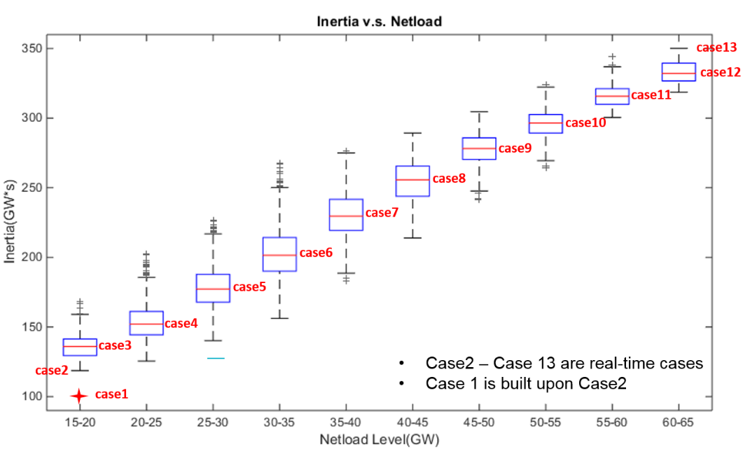
Figure 1 Thirteen cases with different system inertia used in 2015 RRS study

Dynamic simulations were performed for each of the thirteen cases to identify the minimum RRS requirement; the results of this study are summarized in Table 1.

Table 1 RRS Requirement for different Inertia Conditions (2015 RRS Study)
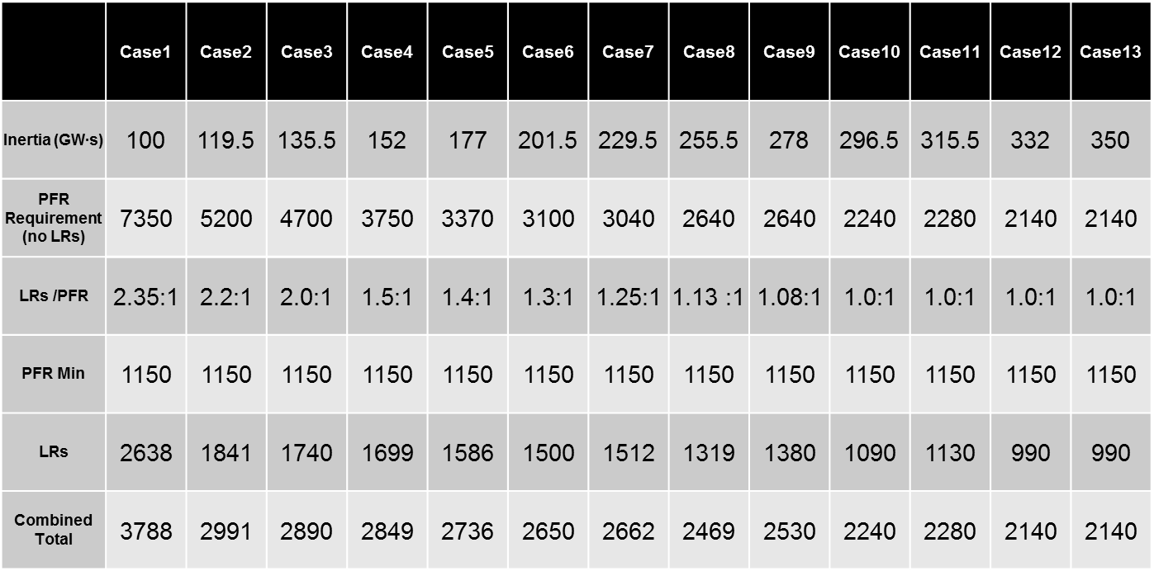

While the selected thirteen Cases represent operational history prior to 2014, the ERCOT grid has evolved since the completion of 2015 RRS study (ERCOT has added as much as 7.5 GW of wind generation since 2014) and consequently, generation scheduled and dispatched online to serve demand has changed. As a result the large steps in inertia between consecutive cases used in the 2015 RRS study may lead to inefficiencies in determining the RRS requirements to meet actual operational needs. Considering the evolution of the system, in terms of generation addition and load growth, an updated study is needed to take into account all the changes to assess if the 2015 RRS study results are still applicable for the current and future system conditions.

2017 RRS Study – Case Setup & Study Methodology
The 2017 RRS Study was designed to use recent cases with varying inertia levels to represent a wide range of expected inertia conditions for future years and to increase the granularity of representative system inertia conditions – this will enhance the efficacy of determining RRS requirements to meet actual operational needs. The following two subsections describe the case selection process and the study methodology for 2017 RRS Study.

Case Selection
Recent real-time cases between 2013 and 2017 with inertia levels varying between 134 GW·s thru 380 GW·s were used in the 2017 RRS study. Figure 2 shows a duration curve for historical ERCOT system inertia from 1/1/2013 to 4/1/2017. Inertia conditions targeted for the 2017 RRS study are marked with orange squares in Figure 2. The lowest system inertia condition that ERCOT has experienced is 134 GW·s (Feb 10, 2017 1:00 a.m. - 3:00 a.m.). A 130 GW·s case (Case 1) was built from the 134 GW·s real time TSAT case by turning off some of the on-line generators and reducing loads. In all the 2017 RRS Study used a total of sixteen cases representing sixteen different inertia conditions to determine the corresponding RRS requirements. Detailed information of the sixteen cases is summarized in Table 2.

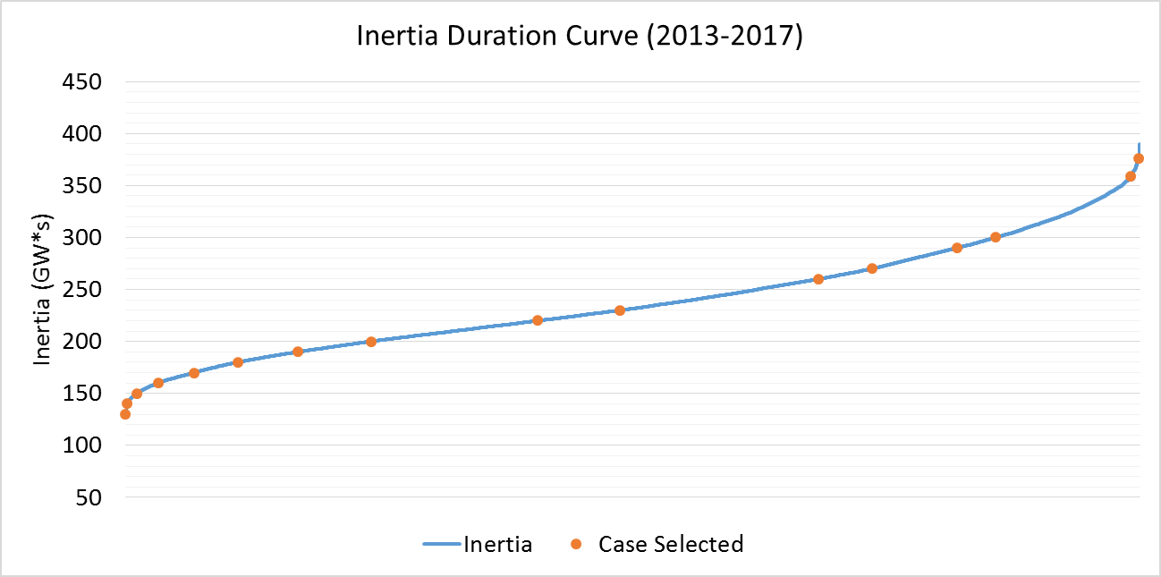
Figure 2 Sixteen cases with different system inertia to be used in 2017 RRS study

Table 2 Information for the cases selected to be included in the 2017 RRS Study
Case No. | Time | Inertia (GW*s)
Case1 | 02/10/17 01:00:00 | 130
Case2 | 03/31/14 02:00:00 | 140
Case3 | 03/21/14 02:00:00 | 150
Case4 | 10/23/16 00:00:00 | 160
Case5 | 11/20/16 01:00:00 | 170
Case6 | 10/28/13 00:00:00 | 180
Case7 | 02/23/16 23:00:00 | 190
Case8 | 11/24/16 15:00:00 | 200
Case9 | 04/02/14 10:00:00 | 220
Case10 | 01/18/17 11:00:00 | 230
Case11 | 10/05/13 18:00:00 | 260
Case12 | 06/01/16 22:00:00 | 270
Case13 | 05/28/14 18:00:00 | 290
Case14 | 08/11/16 05:00:00 | 300
Case15 | 09/03/13 18:00:00 | 359
Case16 | 08/07/13 17:00:00 | 376

Additional Modelling Assumptions
In this study initial conditions including but not limited to Generation Resources with online governors, Load Resource trip settings and tripped resource were setup consistently across all sixteen Cases. The following modelling assumptions were utilized in the studies.

Modeling load resources that provide minimum PFR
In each of the sixteen Cases, governors were activated for those Generation Resources that were needed to provide the minimum PFR of 1150 MW. The response from each Generation Resource that was used to contribute to the minimum PFR was limited to 20% of its High Sustained Limit (i.e. this assumes that the governors have 5% droop). Governors for all other Generation Resources which do not provide PFR were disabled. In Cases where total inertia was lower than 250 GW·s, approximately 30% of the minimum PFR responsibility was provided by coal units and in Cases with an inertia greater than or equal to 250 GW·s, approximately 15% of the minimum PFR responsibility was provided by coals units. The remaining PFR responsibility was provided by gas units. This configuration is consistent with recent trends observed in the system operations.

Modeling Load Resources that provide RRS
In these studies, it was assumed that all Load Resources providing RRS will trip at 59.7 Hz, with a delay of 0.416 s (relay delay = 0.333 s; breaker action = 0.083 s). Nodal Operating Guide section 2.3.1.2(6) requires Load Resources providing RRS to set up the initiation/pickup setting of under-frequency relay to be no lower than 59.70 Hz and similarly time delay for the relay to be no more than 20 cycles (~ 0.333 s). In practice, some of the under-frequency relays for Load Resources providing RRS are setup to respond slightly earlier and/or slightly faster than these requirements. That said, in analyzing the pickup and time delay settings for the current Load Resources that provide RRS, under-frequency relay pickup settings for two-thirds of the current Load Resources that provide RRS is at 59.7 Hz. Similarly, time delay settings for two-thirds of the current Load Resources that provide RRS is between 14.5 cycles and 20 cycles. Thus the trip setting assumptions in simulation ensure that a response simulated from Load Resources that provide RRS is conservative relative to their actual behavior.

Load Damping
Load damping factor was assumed to be 2% at the system level, consistent with Dynamics Working Group (DWG) flat start cases.

Study Methodology
The following study methodology was followed on each of the sixteen TSAT Cases to identify the minimum RRS requirement.

- Trip 2750 MW of generation simultaneously.
- Identify the minimum amount of LRs with a PFR of 1150 MW required to ensure that the frequency nadir remains at/or above 59.40 Hz in response to the loss of 2750 MW of generation.
- Repeat Step 1 and Step 2 with varying minimum PFR amounts to identify LRs/PFR Equivalency Ratio. This Equivalency Ratio will then be used to compare the effectiveness of 1 MW of LRs relative to 1 MW of PFR in arresting the frequency decline in the response to 2750 MW generation loss.

2017 RRS Study Results
In the 2017 RRS study, future RRS requirement was determined based on an empirical function of system inertia derived from extensive dynamic simulations. The following two subsections summarize raw results from dynamic simulations and RRS requirement derived from the empirical functions that were thus developed.

Case Study Result
Table 3 below summarizes the simulations results for all sixteen cases used in 2017 RRS study obtained from TSAT dynamic simulations.

Table 3 Dynamic Simulation Results in the 2017 RRS Study
Case No. | Inertia (GW·s) | PFR (MW) | LR (MW) | LR/PFR | PFR (No LR)  (MW)
Case1 | 130 | 1150 | 1900 | 2.39 | 5691
Case2 | 140 | 1150 | 1800 | 2.17 | 5056
Case3 | 150 | 1150 | 1750 | 1.85 | 4388
Case4 | 160 | 1150 | 1700 | 1.85 | 4295
Case5 | 170 | 1150 | 1700 | 2.00 | 4550
Case6 | 180 | 1150 | 1650 | 1.71 | 3972
Case7 | 190 | 1150 | 1500 | 1.53 | 3445
Case8 | 200 | 1150 | 1450 | 1.43 | 3224
Case9 | 220 | 1150 | 1500 | 1.55 | 3475
Case10 | 230 | 1150 | 1400 | 1.30 | 2970
Case11 | 260 | 1150 | 1450 | 1.10 | 2745
Case12 | 270 | 1150 | 1300 | 1.10 | 2580
Case13 | 290 | 1150 | 1300 | 1.00 | 2450
Case14 | 300 | 1150 | 1250 | 1.20 | 2650
Case15 | 359 | 1150 | 1150 | 1.00 | 2300
Case16 | 376 | 1150 | 1050 | 1.00 | 2085

RRS Requirement
Figure 3 shows a plot of PFR (No LR) quantities that were determined using dynamic simulations in the 2017 Study (Table 3) as a function of inertia. Note the strong correlation between PFR (No LR) and inertia. Using this observation, a power function was derived to fit the data and then used to determine PFR (No LR) requirement based on a given inertia. Likewise in Figure 4, a similar trend for LR/PFR equivalency ratio related to inertia can be observed. A different power function was also derived to determine LR/PFR equivalency ratio as a function of inertia. The two equations thus derived are shown below:
$PFR \left(No LR\right)=399275×{Inertia}^{-0.890}$ (1)
$LR/PFR=173.28×{Inertia}^{-0.892}$ (2)

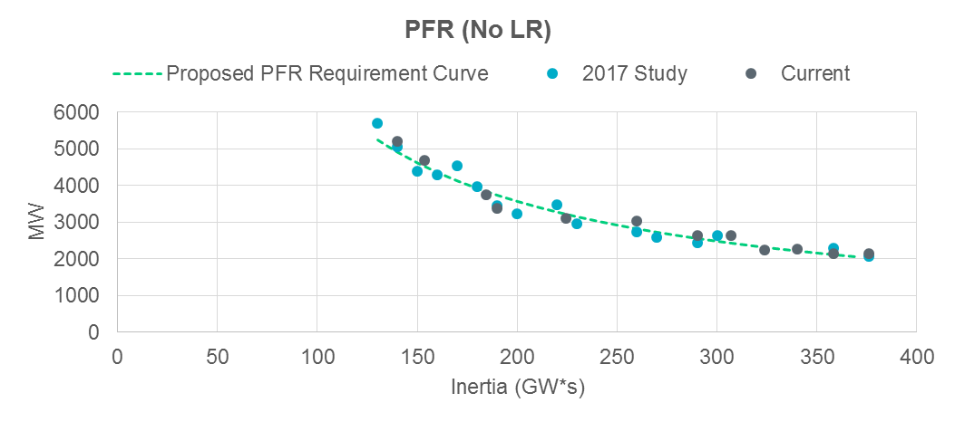
Figure 3 PFR (No LR) vs. Inertia

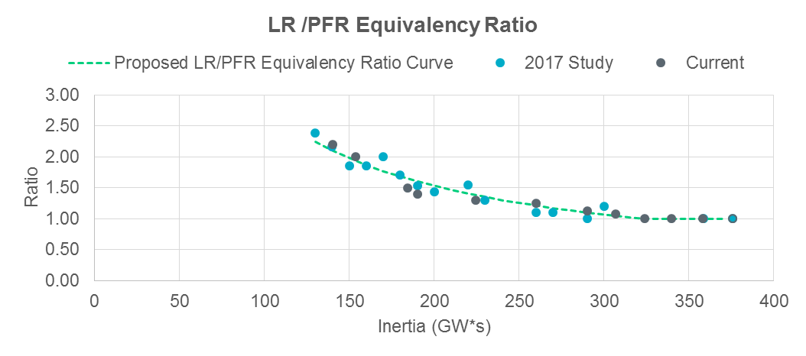
Figure 4 LR/PFR vs. Inertia

Table 4 provides a summary of the quantities for PFR (No LR), LR/PFR ratio and RRS for various inertia conditions between 130 GW·s and 370 GW·s at an incremental step of 10 GW·s (which results in a total of 25 inertia scenarios). In Table 4, the quantities in red identify scenarios when the amount of RRS needed is less than 2300 MW; per Nodal Operating Guides, a floor of 2300 MW is in effect when determining RRS requirements.

Table 4 RRS Table (2017 Study)
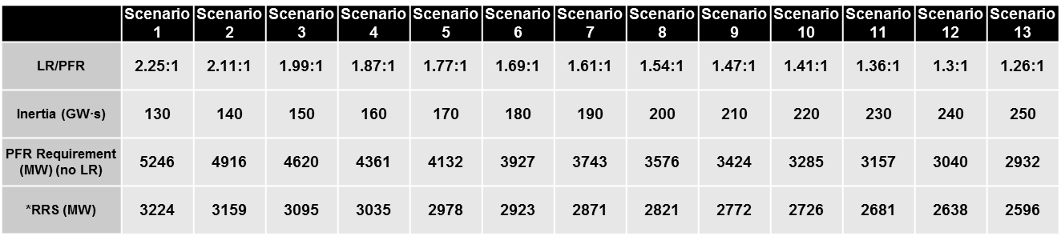
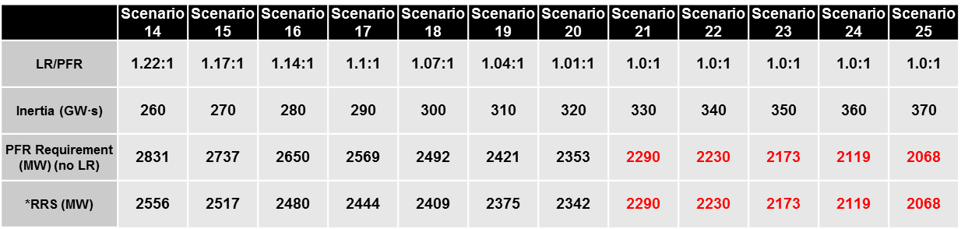

The calculation of PFR (No LR), LR/PFR and RRS for a given inertia condition in Table 4 was performed based on equations (1) and (2). Note that in this table RRS has been calculated with a 50% limit on LRs providing RRS. The calculation uses the following steps:
- For a given inertia level, determine its PFR (No LR) and LR/PFR ratio through (1) and (2)
- Calculate LRs needed assuming 1150 MW of PFR: ${LR}_{1150}=(PFR \left(No LR\right)-1150)/ (LR/PFR ratio)$
- Check if LRs exceed 50% limit of total RRS:
  - If ${LR}_{1150}>1150 MW, RRS=2×PFR (No LR)/ (1+LR/PFR ratio)$
  - If ${LR}_{1150}≤1150 MW, RRS={LR}_{1150}+1150$

Conclusion
The methodology of determining the relationship between RRS requirement and inertia remained unchanged in the 2017 RRS study. The main difference between 2015 RRS study and its 2017 counterpart is that more cases were studied in 2017 RRS study and as a result, the 2017 RRS table was updated to accommodate more inertia scenarios with small, uniform increments in inertia levels. This update will better align RRS requirements with actual operational inertia, thus leading to improved operational efficiency.

Note that the dynamic models and the initial power flow condition for generation dispatch and load for Case 2 thru Case 13 are taken from actual historical TSAT cases.
July 2017 Generator Interconnection Status Report
Note that the cases listed in Table 2 may be subject to modification based on inertia conditions. In cases wherein there was a need to reduce inertia to match the target value as listed in the third column of Table 2, some of the on-line generators were turned off or treated as a constant power source with no inertial contribution similar to how wind generators are modeled.
PFR (No LR) = PFR + LR * LR/ PFR

