**TEMPLATE for Handbook Graphical**

Each charge type will be supported by a graphical equation that will be represented with the following structure:

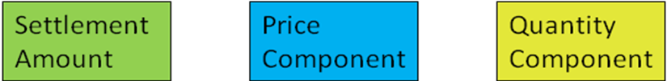

Each equation will include this structure to better define the components that make up the calculation. In some cases the Price Component and Quantity Component will require pre-calculations of other determinants to arrive at the final quantity or price. In these cases, each pre-calculation that is required for a complex settlement charge type will follow the same structure as indicated above.

Each charge type will also contain a bill determinant grid to define bill determinants. Each bill determinant grid will identify for each equation the ERCOT bill determinant name, unit of measure, description, interval frequency, data extract source and whether the determinant is capable of being shadowed. Any pre-calculations that are conducted using other determinants will also be included in each charge type grid.

**$/MWh**

