TDTMS Meeting
September 20, 2017 09:30 AM

Agenda
1. | Antitrust Admonition
2. | Introductions  In Person:  Sheri Wiegand – TXU  Kathy Scott – CNP  Dave Pagliai – ERCOT  Kyle Patrick – NRG  Lindsay Butterfield – ERCOT  Jim Lee – AEP  Carolyn Reed – CNP  Sam Pak – Oncor  Rebecca Reed – NRG  Monica Jones - NRG  WebEx:  Cheryl Franklin – AEP  Diana Rehfeldt – TNMP  Kaci Jacobs – TXU  Leo Angele – ERCOT  Tomas Fernandez – NRG  Tammy Stewart - ERCOT
3. | Last Month Meeting Notes – August 2017
4. | ERCOT System Instances & MarkeTrak Monthly Performance Review  - MarkeTrak Performance: Updated SLA for 2018 will go October RMS for initial review with updated Release schedule for 2018.  - Digital Certificate Download Process Update:  - Users have to download an actual file (which is the certificate) and are provided with instructions to install into the browser.  - ERCOT will develop a step-by-step process for users  - ERCOT to communicate at Subcommittee level (RMS and COPS)  - ERCOT to host market calls (& WEBEX) for Q&A: proposing Wed 10/18 1-2pm and Wed 11/15 1-2pm (ERCOT will look at expanding WebEx/Confernce Call to allow for Q&A)  - To discuss changes in the R6 release  - ERCOT to list a Q&A/FAQ document received on 1st call available for 2nd call  - MPs can send Dave Pagliai questions beforehand  - TDTMS to include an agenda item to call into the Conference Call in November  - ERCOT to implement in a “phased approach” – timeline?  - Will be communicated once 2018 Release schedule is set  - Changes currently scheduled to occur in the MOTE (Mkt Operations Test Environment) on 11/6/17  - Production change currently scheduled for R6 release (12/5/17 - 12/7/17)  - Target audience: IT teams & USAs  - Compatible with IE8 and 11  - 2018 System Change Roadmap (Agenda item #8)  - IT to IT webex meeting (before end of year): Date TBD  - Focus on Retail Road Map and projects planned for the next 2 years  - Troy Anderson will continue to present to Stakeholders the PPL progress
5. | RMS Workshop – NPRR778
New proposed date – 10/19/17 9am – 12pm
- Joint TXSET/TDTMS meeting 10/19 afternoon : 1:30 – 4pm
- TDSPs will discuss “off ramp” period extension and bring back feedback to 10/10 RMS
New timeline for market communications
- (if approved by RMS): TDTMS leadership to send out market notice on 10/13 of workshop on 10/19
Agenda items (for 10/19 workshop) – include in TDTMS update to RMS on 10/10
- Background/history and purpose of NPRR778
- Voluntary testing, not required, highly encouraged.
- Round robin testing
- Registration deadline to conduct end-to-end testing: Nov 10th
- Connectivity to RMTE & Q&A (if applicable)
- Testing Scripts – activities & timelines
- Discontinuing of CWA via MT (date of discontinuation TBD)
- FAQ
- Q&A
- Follow-up/Kick-Off Market Call on Nov 13th
 | Other?
6. | NPRR778/RMGRR139 – Prep work for Release 5 go-live (Oct 29-31)
 | A. Review discussion from Market Call: [completed in August]
 | Testing window begins 10/16/17
 | Testing will not be coordinated via ERCOT
 | MPs must coordinate testing with each other via RMTE
 | B. Review any action items from RMS: [completed in August]
 | Coordinate w/ TXSET re: market communications
 | Stress obligation for CRs to use transactions (TDSPs will not support daily use of CWA MTs beyond the ‘off-ramp’ period)
 | C. Review any action items from TXSET: [completed in August]
 | What coordinated testing activities w/ TXSET are needed? (testing partners, activities, timeline, etc.)
 | Review progress of test scripts
 | Clearly define SUCCESS CRITERIA when testing scripts in the RMTE
 | Step-by-step how MPs will successfully execute test scripts in the RMTE
D. Review any action items from RMTTF: [to take up in September]

- Coordinate with RMTTF leadership to update the MT UG in November.
- Jim will work with Sheri/Tomas to look at the UG section first and provide any edits to TDTMS in November.
 | Update MT User Guide language for CWA subtype to align language with NPRR778/RMGRR139
 | Does MarkeTrak tool itself execute any validations?
 | What is the code logic behind the pop-up reminder MPs get, in regards to the evaluation window when submitting a CWA issue, when the MP can actually submit an 814_08 transaction?
 | LUNCH
7. | MarkeTrak Subtype Analysis "Gameplan"  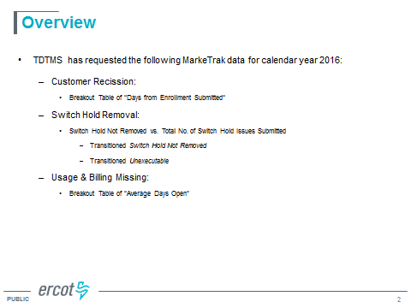
 | Review data feedback from June TDTMS request:
Rescission: Breakout table of "Days from Enrollment Submitted"
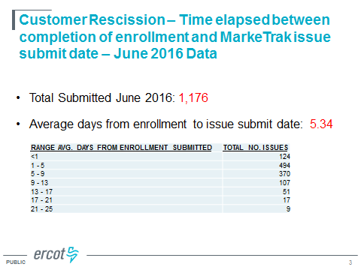
- 618 out of 1176 = 52.5% (submitted within 5 days of enrollment)
- MPs feel that it is acceptable that most are submitted within 5 days, and currently no appetite to reduce the 25 day submission window
Switch Hold Removal: Switch Hold Not Removed vs. Total # of Switch Hold Requests
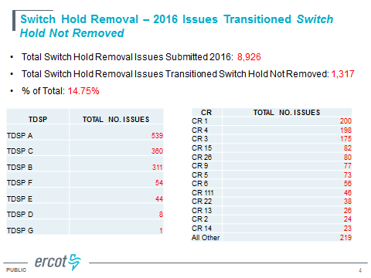
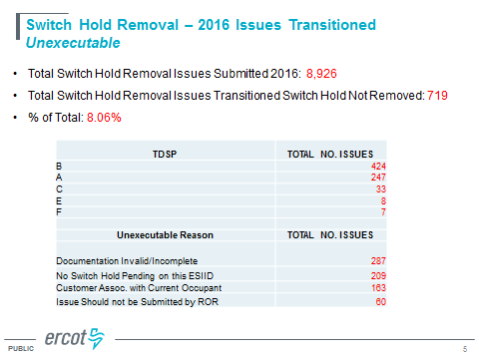
Usage/Billing Missing: Breakout table of "Avg Days Open"
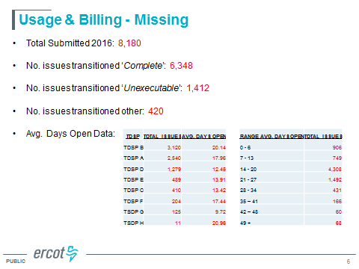
- CRs observed that when a TDSP closes this type of issue, the missing trxn is usually sent same day or next day
- Assumption that Unexecutable volume is mostly in the 0-6 range.

**Ask ERCOT to look at Cancel w/ Approval volumes in 2018, post NPRR778**

- TDTMS leadership to include this as part of the RMS update in October (year over year volumes)
 | Missing Enrollment
8. | 2018 System Change Roadmap – discuss ERCOT NAESB upgrade
9. | Other Business
10. | Adjourn

