Generator Model Verification
for
ABC Generator 1, 2, & 3
NERC MOD-026-1 and MOD-027-1

Cole Dietert, P.E.
LCRA TSC
Dynamics and VAR Planning
October 9, 2017

ABC Generator Units 1, 2, & 3 Model Verification
Generator test reports and dynamic models for ABC Generator Units 1, 2, & 3 were sent to LCRA TSC on MM/DD/YYYY in compliance with NERC Reliability Standards MOD-026-1 and MOD-027-1. The LCRA TSC’s Dynamics and VAR Planning group examined the reports and performed the following analysis to verify that the ABC Generator Units 1, 2, & 3 dynamic models are usable.
In accordance with MOD-026-1 R6:
6.1. The excitation control system or plant volt/var control function model initializes to compute modeling data without error,
6.2. A no-disturbance simulation results in negligible transients, and
6.3. For an otherwise stable simulation, a disturbance simulation results in the excitation control and plant volt/var control function model exhibiting positive damping.

In accordance with MOD-027-1 R5:
5.1. The turbine/governor and load control or active power/frequency control function model initializes to compute modeling data without error,
5.2. A no-disturbance simulation results in negligible transients, and
5.3. For an otherwise stable simulation, a disturbance simulation results in the turbine/governor and load control or active power/frequency control model exhibiting positive damping.

Generator Models
The following dynamic models were provided by the Resource Entity. The models were loaded into the ERCOT DWG Near-Term 2019 Dynamic Flat Start Case published on March 6, 2017.
ABC Generator Unit 1 Dynamic Models:
XXXXXXXXXXXX
ABC Generator Unit 2 Dynamic Models:
XXXXXXXXXXXX
ABC Generator Unit 3 Dynamic Models:
XXXXXXXXXXXX

Results
The generator models for ABC Generator Units 1, 2, & 3 initialized in the dynamic flat start case without errors.
A no-disturbance simulation was run, and no transients were seen for ABC Generator Units 1, 2, & 3. Plots of the ABC Generator Units 1, 2, & 3 generator angles are shown below in Figure 1 to confirm.

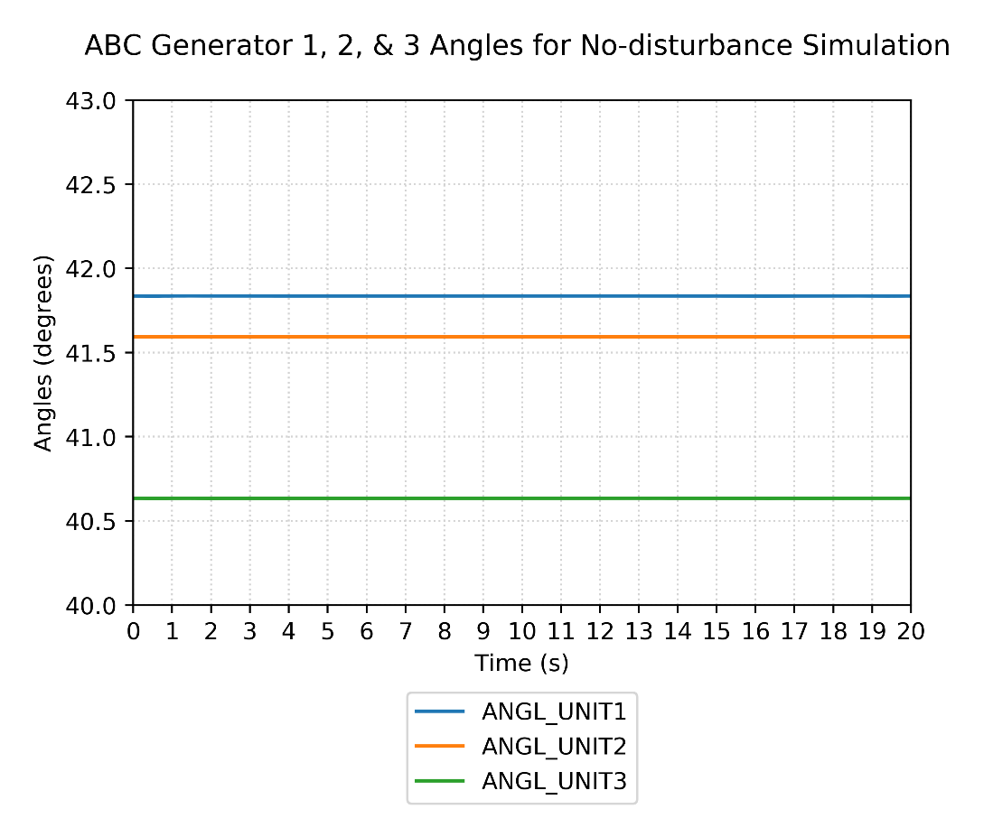
Figure 1: No-disturbance test results.

Dynamic contingencies located near ABC Generator Units 1, 2, & 3 were simulated in the dynamic flat start case to verify the stability of the units after a disturbance. Waveforms of each generator’s angle, real power output, reactive power output, terminal voltage, EFD, and mechanical power as well as the system frequency were monitored to verify positive damping and stability for each contingency. The following plots demonstrate generator stability and positive damping of the real and reactive power output during the dynamic contingency simulations.

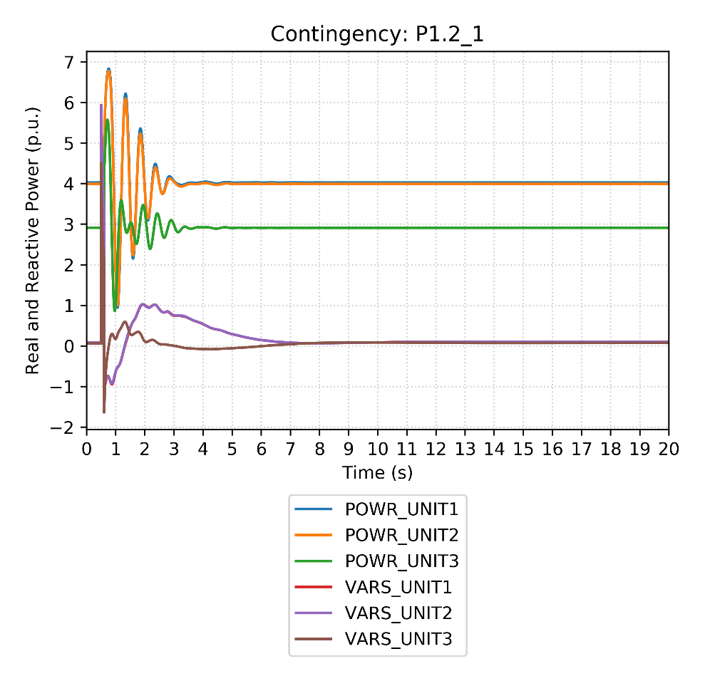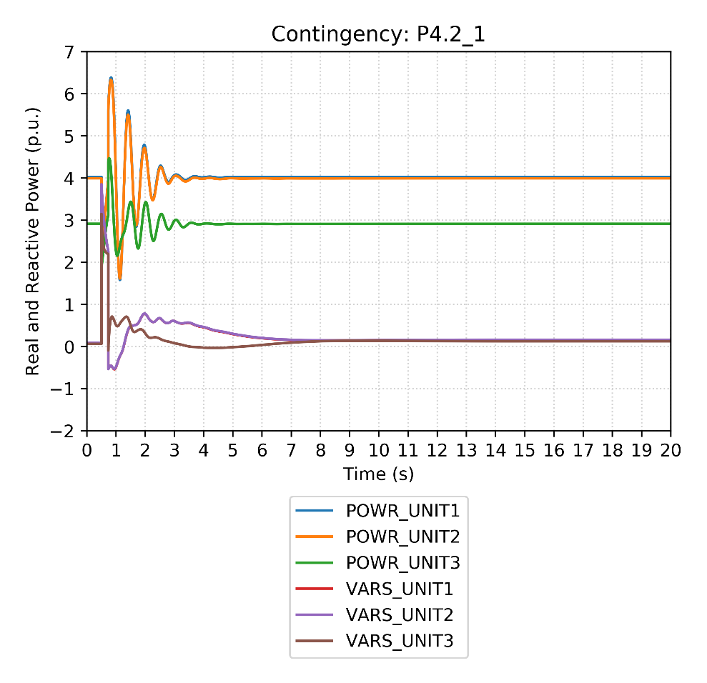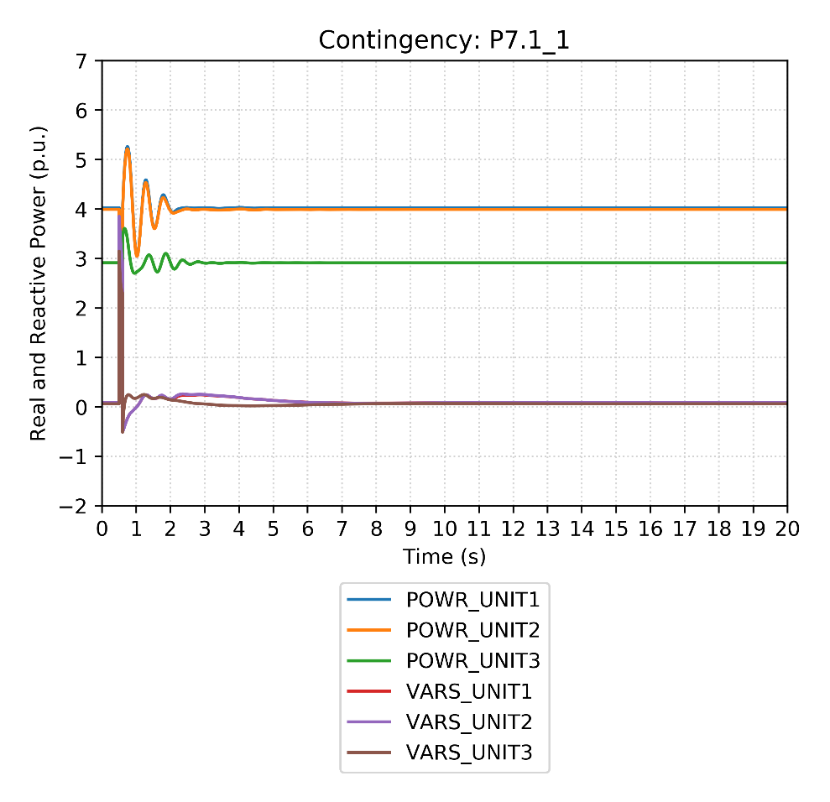
Conclusion
The dynamic models for ABC Generator Units 1, 2, & 3 are usable according to the requirements in MOD-026-1 and MOD-027-1.

