NPRR Number | 849 | NPRR Title | Clarification of the Range of Voltage Set Points at a Generation Resource’s POI
Date |  | October 5, 2017
Submitter’s Information
Name |  | John Palen
E-mail Address |  | john.palen@nrg.com
Company |  | NRG Texas Power LLC
Phone Number |  | 713-537-3706
Cell Number |  | 713-545-3415
Market Segment |  | Independent Generator

Comments

NRG appreciates the opportunity to comment on the language changes proposed by ERCOT in Nodal Protocol Revision Request (NPRR) 849. ERCOT’s proposed changes recognize the meaningful impact that grid voltage has on the ability of a Generation Resource to either produce or absorb reactive power. However, NRG believes that the proposed changes fall short in addressing the physical realities of generator construction, and the ability to maintain maximum dynamic response on Generation Resources.

Modern Generation Resources are rated at a given power factor as a function of the Generation Resource in isolation. In other words, the rated power factors represent gross values, with no accounting for impacts from auxiliary loads, Generator Step-Up (GSU) transformer impendences, or other factors that impact reactive capability before the Point of Interconnection (POI). When factoring in these impacts, net power factors can be significantly less than the gross “Rated Reactive Capability”. The on-going disconnect within the current reactive requirements is perpetuated by ignoring the effect that grid voltage plays in reducing the reactive capability of Generation Resources.

In NERC’s white paper on the FERC Reactive Power Requirements NOPR [Docket RM16-1-000], NERC agrees that “…generation may not, and should not necessarily, be required to provide full capability range at all operating voltages (e.g., a generator should not be required to provide full reactive power consumption when low voltage conditions are occurring at the POI).”

The language originally proposed in the NPRR requires that the 0.95 pf leading capability be maintained at grid voltages down to 0.98 p.u. of nominal system voltage, and lagging capability, up to 1.04 p.u. In effect, this will require that Generation Resources be able to maintain this capability in order to boost system voltage at a time when it is already within 1% of normal voltage limits (358.8kV on a 345 kV system, and 143.5 kV on the 138 kV system). NRG fails to understand a scenario where it would be desirable to increase voltage up to, and possibly beyond, normal voltage limits. Even though some relief to the existing requirement is provided in this NPRR, it fails to go far enough in addressing the actual capabilities of Generation Resources. Simply put, Generation Resources are not designed to provide the range of reactive power considered by such requirements.

NRG proposes to utilize more reasonable limits identified in the NERC white paper, which was sourced from CAISO’s “Reactive Power Requirements and Financial Compensation – Revised Straw Proposal”, dated October 8, 2015.

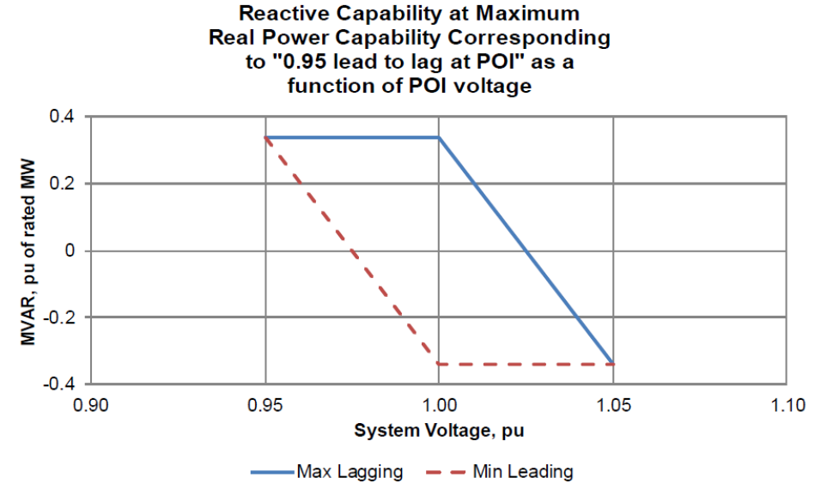
In addition to the changes mentioned above, the NPRR also seeks to allow Transmission Service Providers (TSPs) or their agents, to direct Resources to provide additional reactive support up to the “Reactive Power capability”, a term not defined in the Protocols that is open to different interpretations. Current Protocols define the Corrected Unit Reactive Limit (CURL) as a single reactive power value starting at High Sustained Limit (HSL), which is applicable all the way down to Low Sustained Limit (LSL). For most units, actual reactive capability is higher than that value when the unit’s output is lower than HSL. While the need to operate outside of the CURL during abnormal or pre-contingency situations may be needed, the Protocols reserve the authority to direct operations beyond a Generation Resources’ CURL solely with ERCOT (paragraph (2) of Section 6.5.7.7, Voltage Support Service) and such action requires ERCOT to issue of a Voltage Support Service (VSS) Dispatch Instruction, an ability that the Transmission and/or Distribution Service Providers (TDSPs) do not possess. By allowing the TDSPs to direct such activities, it would bypass the compensation mechanism afforded in the Protocols.

Revised Cover Page Language
None
Revised Proposed Protocol Language

3.15 Voltage Support
(1) ERCOT, in coordination with the Transmission Service Providers (TSPs), shall establish and update, as necessary, the ERCOT System Voltage Profile and shall post it on the Market Information System (MIS) Secure Area. ERCOT, the interconnecting TSP, or that TSP’s agent, may modify the Voltage Set Point described in the Voltage Profile based on current system conditions.
(2) All Generation Resources (including self-serve generating units) that have a gross generating unit rating greater than 20 MVA or those units connected at the same Point of Interconnection (POI) that have gross generating unit ratings aggregating to greater than 20 MVA, that supply power to the ERCOT Transmission Grid, shall provide Voltage Support Service (VSS).
(3) Each Generation Resource required to provide VSS shall comply with the following Reactive Power Requirements:
(a) An over-excited (lagging or producing) power factor capability proportionate to the grid voltage as identified in the chart below, determined at the generating unit's maximum net power to be supplied to the ERCOT Transmission Grid and measured at the POI;
(b) An under-excited (leading or absorbing) power factor capability proportionate to the grid voltage as identified in the chart below, determined at the generating unit's maximum net power to be supplied to the ERCOT Transmission Grid and proportionate to the grid voltage as identified in the chart below, measured at the POI;
(c) Reactive Power capability shall be available at all MW output levels and may be met through a combination of the Generation Resource’s Unit Reactive Limit (URL), which is the generating unit’s dynamic leading and lagging operating capability, and/or dynamic VAr capable devices. This Reactive Power profile is depicted graphically as a rectangle. For Intermittent Renewable Resources (IRRs), the Reactive Power requirements shall be available at all MW output levels at or above 10% of the IRR’s nameplate capacity. When an IRR is operating below 10% of its nameplate capacity and is unable to support voltage at the POI, ERCOT may require an IRR to disconnect from the ERCOT System for purposes of maintaining reliability; and
(d) As part of the technical Resource testing requirements prior to the Resource Commissioning Date, all Generation Resources must conduct an engineering study, or demonstrate through performance testing, compliance with the Reactive Power capability requirements of this section. Any study or testing results must be accepted by ERCOT prior to the Resource Commissioning Date.

(4) Wind-powered Generation Resources (WGRs) that commenced operation on or after February 17, 2004, and have a signed Standard Generation Interconnection Agreement (SGIA) on or before December 1, 2009 (“Existing Non-Exempt WGRs”), must be capable of producing a defined quantity of Reactive Power to maintain a set point in the Voltage Profile established by ERCOT in accordance with the Reactive Power requirements established in paragraph (3) above, except in the circumstances described in paragraph (a) below.
(a) Existing Non-Exempt WGRs whose current design does not allow them to meet the Reactive Power requirements established in paragraph (3) above must conduct an engineering study using the Summer/Fall 2010 on-peak/off-peak Voltage Profiles, or conduct performance testing to determine their actual Reactive Power capability. Any study or testing results must be accepted by ERCOT. The Reactive Power requirements applicable to these Existing Non-Exempt WGRs will be the greater of: the leading and lagging Reactive Power capabilities established by the Existing Non-Exempt WGR’s engineering study or testing results; or Reactive Power proportional to the real power output of the Existing Non-Exempt WGR (this Reactive Power profile is depicted graphically as a triangle) sufficient to provide an over-excited (lagging) power factor capability of 0.95 or less and an under-excited (leading) power factor capability of 0.95 or less, both determined at the WGR’s set point in the Voltage Profile established by ERCOT, and both measured at the POI.
(i) Existing Non-Exempt WGRs shall submit the engineering study results or testing results to ERCOT no later than five Business Days after its completion.
(ii) Existing Non-Exempt WGRs shall update any and all Resource Registration data regarding their Reactive Power capability documented by the engineering study results or testing results.
(iii) If the Existing Non-Exempt WGR’s engineering study results or testing results indicate that the WGR is not able to provide Reactive Power capability that meets the triangle profile described in paragraph (4)(a) above, then the Existing Non-Exempt WGR will take steps necessary to meet that Reactive Power requirement depicted graphically as a triangle by a date mutually agreed upon by the Existing Non-Exempt WGR and ERCOT. The Existing Non-Exempt WGR may meet the Reactive Power requirement through a combination of the WGR’s URL and/or automatically switchable static VAr capable devices and/or dynamic VAr capable devices. No later than five Business Days after completion of the steps to meet that Reactive Power requirement, the Existing Non-Exempt WGR will update any and all Resource Registration data regarding its Reactive Power and provide written notice to ERCOT that it has completed the steps necessary to meet its Reactive Power requirement.
(iv) For purposes of measuring future compliance with Reactive Power requirements for Existing Non-Exempt WGRs, results from performance testing or the Summer/Fall 2010 on-peak/off-peak Voltage Profiles utilized in the Existing Non-Exempt WGR’s engineering study shall be the basis for measuring compliance, even if the Voltage Profiles provided to the Existing Non-Exempt WGR are revised for other purposes.
(b) Existing Non-Exempt WGRs whose current design allows them to meet the Reactive Power requirements established in paragraph (3) above (depicted graphically as a rectangle) shall continue to comply with that requirement. ERCOT, with cause, may request that these Existing Non-Exempt WGRs provide further evidence, including an engineering study, or performance testing, to confirm accuracy of Resource Registration data supporting their Reactive Power capability.
(5) Qualified Renewable Generation Resources (as described in Section 14, State of Texas Renewable Energy Credit Trading Program) in operation before February 17, 2004, required to provide VSS and all other Generation Resources required to provide VSS that were in operation prior to September 1, 1999, whose current design does not allow them to meet the Reactive Power requirements established in paragraph (3) above, will be required to maintain a Reactive Power requirement as defined by the Generation Resource’s URL that was submitted to ERCOT and established per the criteria in the ERCOT Operating Guides.
(6) New generating units connected before May 17, 2005, whose owners demonstrate to ERCOT’s satisfaction that design and/or equipment procurement decisions were made prior to February 17, 2004, based upon previous standards, whose design does not allow them to meet the Reactive Power requirements established in paragraph (3) above, will be required to maintain a Reactive Power requirement as defined by the Generation Resource’s URL that was submitted to ERCOT and established per the criteria in the Operating Guides.
(7) For purposes of meeting the Reactive Power requirements in paragraphs (3) through (6) above, multiple generation units including IRRs shall, at a Generation Entity’s option, be treated as a single Generation Resource if the units are connected to the same transmission bus.
(8) Generation Entities may submit to ERCOT specific proposals to meet the Reactive Power requirements established in paragraph (3) above by employing a combination of the URL and added VAr capability, provided that the added VAr capability shall be automatically switchable static and/or dynamic VAr devices. A Generation Resource and TSP may enter into an agreement in which the proposed static VAr devices can be switchable using Supervisory Control and Data Acquisition (SCADA). ERCOT may, at its sole discretion, either approve or deny a specific proposal, provided that in either case, ERCOT shall provide the submitter an explanation of its decision.
(9) A Generation Resource and TSP may enter into an agreement in which the Generation Resource compensates the TSP to provide VSS to meet the Reactive Power requirements of paragraph (3) above in part or in whole. The TSP shall certify to ERCOT that the agreement complies with the Reactive Power requirements of paragraph (3).
(10) Unless specifically approved by ERCOT, no unit equipment replacement or modification at a Generation Resource shall reduce the capability of the unit below the Reactive Power requirements that applied prior to the replacement or modification.
(11) Generation Resources shall not reduce high reactive loading on individual units during abnormal conditions without the consent of ERCOT unless equipment damage is imminent.
(12) All WGRs must provide a Real-Time SCADA point that communicates to ERCOT the number of wind turbines that are available for real power and/or Reactive Power injection into the ERCOT Transmission Grid. WGRs must also provide two other Real-Time SCADA points that communicate to ERCOT the following:
(a) The number of wind turbines that are not able to communicate and whose status is unknown; and
(b) The number of wind turbines out of service and not available for operation.
(13) All PhotoVoltaic Generation Resources (PVGRs) must provide a Real-Time SCADA point that communicates to ERCOT the capacity of PhotoVoltaic (PV) equipment that is available for real power and/or Reactive Power injection into the ERCOT Transmission Grid. PVGRs must also provide two other Real-Time SCADA points that communicate to ERCOT the following:
(a) The capacity of PV equipment that is not able to communicate and whose status is unknown; and
(b) The capacity of PV equipment that is out of service and not available for operation.
(14) For the purpose of complying with the Reactive Power requirements under this Section 3.15, Reactive Power losses that occur on privately-owned transmission lines behind the POI may be compensated by automatically switchable static VAr capable devices.

http://www.nerc.com/FilingsOrders/us/NERC%20Filings%20to%20FERC%20DL/NERC_NOPR_Comments_01272016_RM16-1.pdf

