August 2017 ERCOT Monthly Operations Report
Reliability and Operations Subcommittee Meeting
October 5th, 2017

Table of Contents
1. Report Highlights 2
2. Frequency Control 3
2.1. Frequency Events 3
2.2. Responsive Reserve Events 4
2.3. Load Resource Events 4
3. Reliability Unit Commitment 4
4. Wind Generation as a Percent of Load 5
5. Congestion Analysis 5
5.1. Notable Constraints for August 6
5.2. Generic Transmission Constraint Congestion 7
5.3. Manual Overrides for August 7
5.4. Congestion Costs for Calendar Year 2017 7
6. System Events 8
6.1. ERCOT Peak Load 8
6.2. Load Shed Events 8
6.3. Stability Events 8
6.4. Notable PMU Events 8
6.5. DC Tie Curtailment 8
6.6. TRE/DOE Reportable Events 9
6.7. New/Updated Constraint Management Plans 9
6.8. New/Modified/Removed RAS 10
6.9. New Procedures/Forms/Operating Bulletins 10
7. Emergency Conditions 10
7.1. OCNs 10
7.2. Advisories 10
7.3. Watches 11
7.4. Emergency Notices 11
8. Application Performance 11
8.1. TSAT/VSAT Performance Issues 11
8.2. Communication Issues 12
8.3. Market System Issues 12
9. Model Updates 12
Appendix A: Real-Time Constraints 13

Report Highlights
- The unofficial ERCOT peak for August was 67,873 MW.
- There were five frequency events in August. PMU data indicates the ERCOT system transitioned well in each case.
- There were two instances where Responsive Reserves were deployed, all of which were the result of frequency events.
- There were twelve RUC commitments in August.
- The level of reportable SCED congestion increased in August. This congestion was mostly due to planned outages as well as high wind output. There were nine instances over 31 days on the Generic Transmission Constraints (GTCs) in August. There were seven days on the Panhandle GTC, one day on the Pomelo GTC and one day on the Valley Import GTC in August. There was no activity on the remaining GTCs during the Month.
- There were fourteen DC Tie curtailments in August.
- A category 4 hurricane made a landfall near Rockport on August 25th and an official report will be posted to the ROS meeting site when completed.

Frequency Control

Frequency Events
The ERCOT Interconnection experienced five frequency events in August, all of which resulted from Resource trips. The average event duration was approximately 0:06:05.

When analyzing frequency events, ERCOT evaluates PMU data according to industry standards. Events with an oscillating frequency of less than 1 Hz are considered to be inter-area, while higher frequencies indicate local events. Industry standards specify that damping ratio for inter-area oscillations should be 3.0% or greater. All events listed below indicate the ERCOT system met these standards and transitioned well after each disturbance.

Reported frequency events will include both frequency events where frequency was outside the range of 60±0.1 Hz as well as those determined to be Frequency Measurable Events (FME) as defined by BAL-001-TRE-1. Delta Frequency is defined as the difference between the pre-perturbation and post-perturbation frequency. The Duration of Event is defined as the time it takes for the frequency to recover to lesser/greater of the frequency at the time of the frequency event (t(0) or “A-point”) for low/high-frequency events, respectively. Further details on FMEs can be found in the MIS posted BAL-001-TRE-1 PDCWG Unit Performance reports. A summary of the frequency events is provided below:

Date and Time | Delta Frequency | Max/Min Frequency | Duration of Event | PMU Data |  |  | MW Loss | Load | Wind | Inertia
 | (Hz) | (Hz) |  | Oscillation Mode (Hz) |  | Damping Ratio |  | (MW) | % | (GW-s)
8/4/2017 13:50 | 0.035 | 59.91 | 0:02:05 | No PMU Report Created |  |  | 345 | 62,165 | 1% | 352,412
8/5/2017 18:31 | 0.057 | 59.93 | 0:11:56 | No PMU Report Created |  |  | 434 | 61,615 | 15% | 321,514
8/9/2017 18:33 | 0.111 | 59.87 | 0:06:09 | 0.62 | 9% |  | 700 | 61,952 | 5% | 345,357
8/23/2017 12:51 | 0.099 | 59.85 | 0:04:13 | 0.60 | 1100% |  | 797 | 58,507 | 1% | 346,334
8/28/2017 15:47 | 0.033 | 59.91 | 0:06:04 | No PMU Report Created |  |  | 440 | 44,690 | 18% | 260,183
(Note: frequency events highlighted in blue have been identified as FMEs per BAL-001-TRE-1 and the Performance Disturbance Compliance Working group. PMU reports are typically generated when frequency drops below 59.9, but PMU data is available for other events.)

Currently, the Critical Inertia Level for ERCOT is approximately 100,000 MW-s (Source: link)
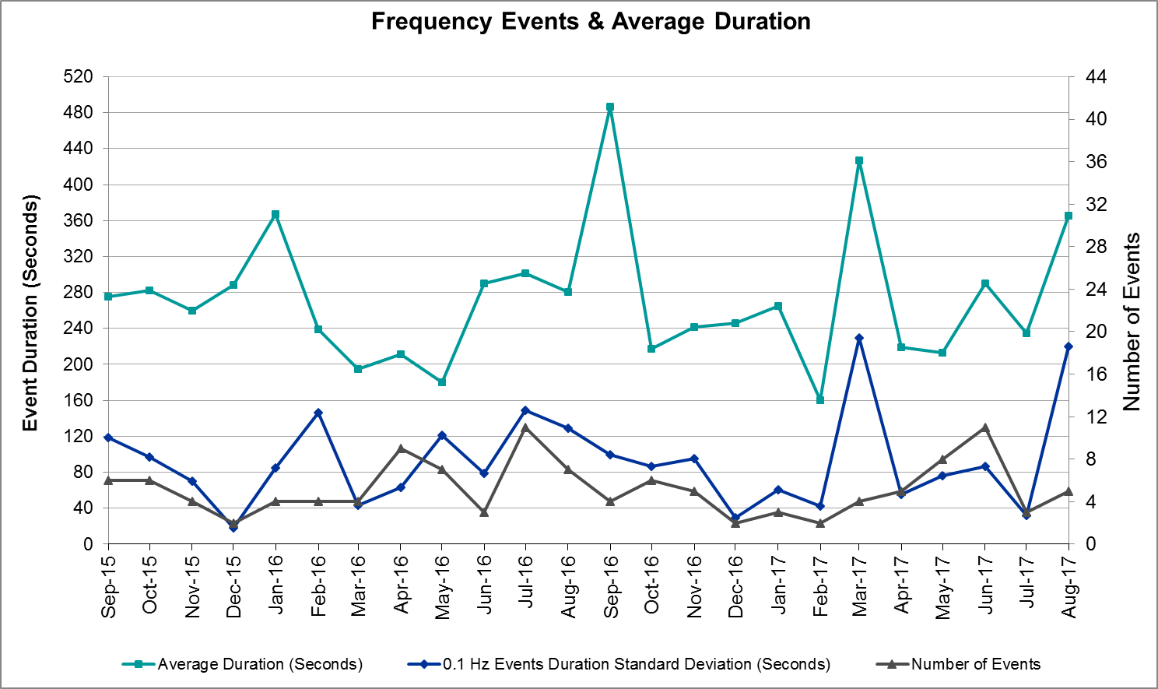
(Note: All data on this graph encompasses frequency event analysis based on BAL-001-TRE-1.)

Responsive Reserve Events
There were two events where Responsive Reserve MWs were released to SCED in August. The events highlighted in blue were related to frequency events reported in Section 2.1 above.

Date and Time Released to SCED | Date and Time Recalled | Duration of Event | Maximum MWs Released
8/9/2017 18:33:57 | 8/9/2017 18:39:06 | 0:05:00 | 530.89
8/23/2017 12:51:28 | 8/23/2017 12:55:31 | 0:03:56 | 714.18

Load Resource Events
None.

Reliability Unit Commitment
ERCOT reports on Reliability Unit Commitments (RUC) on a monthly basis. Commitments are reported grouped by operating day and weather zone. The total number of hours committed is the sum of the hours for all the units in the specified region. Additional information on RUC commitments can be found on the MIS secure site at Grid Generation Reliability Unit Commitment.

There were no DRUC commitments in August.

There were twelve HRUC commitments in August.

Resource Location | # of Resources | Operating Day | Total # of Hours Committed | Total MWhs | Reason for Commitment
North Central | 1 | 8/4/2017 | 5 | 2,175 | Capacity
South Central | 2 | 8/5/2017 | 14 | 4,740 | Capacity
North Central | 1 | 8/5/2017 | 4 | 1,740 | Capacity
Coastal | 1 | 8/5/2017 | 4 | 652 | Local Congestion
East | 1 | 8/6/2017 | 4 | 2,008 | Capacity
South Central | 1 | 8/6/2017 | 10 | 4,120 | Capacity
North Central | 1 | 8/6/2017 | 5 | 2,175 | Capacity
Coastal | 1 | 8/15/2017 | 11 | 2,632 | Local Congestion
Coastal | 1 | 8/17/2017 | 6 | 1,428 | Local Congestion
Coastal | 1 | 8/18/2017 | 6 | 1,428 | Local Congestion
Southern | 1 | 8/26/2017 | 11 | 5,115 | Voltage Stability
Southern | 1 | 8/27/2017 | 24 | 15,480 | Voltage Stability

Wind Generation as a Percent of Load
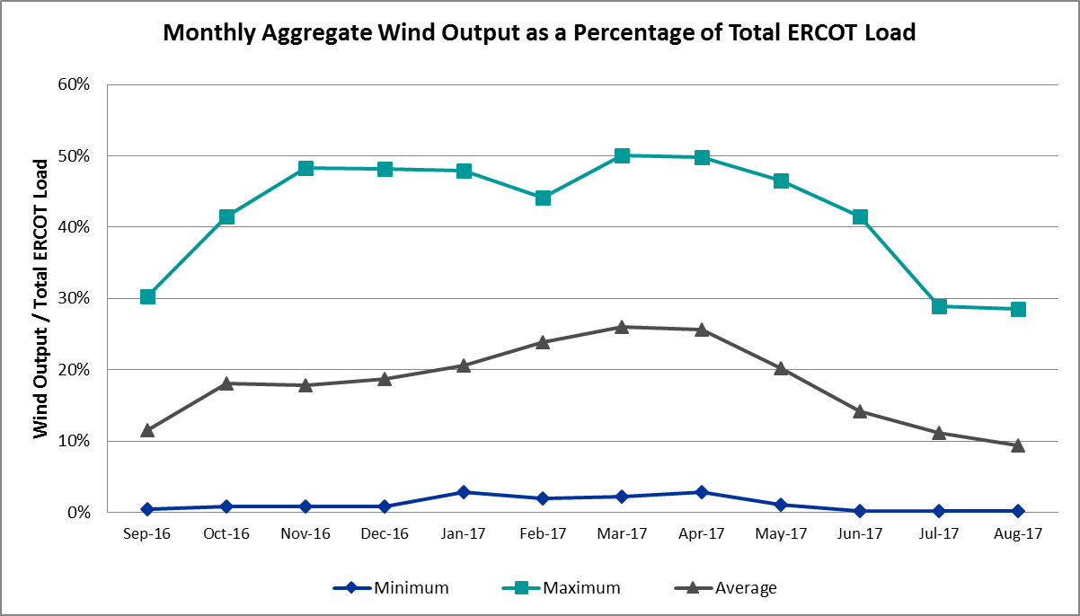

Congestion Analysis
The number of congestion events experienced by the ERCOT system increased in August. There were nine instances over 31 days on the Generic Transmission Constraints (GTCs) in August.

Notable Constraints for August
Nodal protocol section 3.20 specifies that ERCOT shall identify transmission constraints that are active or binding three or more times within a calendar month. As part of this process, ERCOT reports congestion that meets this criterion to ROS. In addition ERCOT also highlights notable constraints that have an estimated congestion rent exceeding $1,000,000 for a calendar month. These constraints are detailed in the table below. Rows highlighted in blue indicate the congestion was affected by one or more outages. For a list of all constraints activated in SCED for the month of August, please see Appendix A at the end of this report.

Contingency Name | Overloaded Element | # of Days Constraint Active | Congestion Rent | Transmission Project
NORTH PHARR to POLK AVENUE LIN 1 | North Mcallen - West Mcallen 138kV | 14 | $5,787,308.32 | 4493
HCKSW-ALLNC&RNKSW 345kV | Blue Mound - Wagley Robertson 138kV | 12 | $5,007,131.68 | 6273
Coleto Creek to Lon Hill 345 | Lon Hill - Pawnee Switching Station 345kV | 2 | $3,500,323.98
Elmcreek-Sanmigl 345kV | Pawnee Switching Station - Calaveras 345kV | 3 | $2,381,099.50
SKYLINE-CALAVERS 345KV | Braunig - Cagnon 345kV | 1 | $1,916,725.84
Jewet-Sng 345kV | Btu_Jack_Creek - Twin Oak Switch 345kV | 23 | $1,854,392.60 | Houston Import Project
Basecase | PNHNDL GTC | 7 | $1,615,315.62 | South Plains RPG Proposal
Meadow to Oasis 345 KV | Angleton - Liverpool 138kV | 3 | $1,559,606.88
Dpw-Srb&South Channel 69kv | Genral - University 69kV | 1 | $1,374,911.07
NORTH MCALLEN to NORTH EDINBURG LI | North Edinburg - Mccoll Road 138kV | 5 | $1,277,606.81 | 4493
Rns-Rtw & Sng-Tb 345kv | Singleton - Zenith 345kV | 19 | $1,217,842.16 | Houston Import Project
Cby-Qnm & Rng 138kv | Exxon - Lynch 138kV | 8 | $1,187,004.66
Meadow to Ph Robinson 345 KV | Seminole Tnp - Friendswood Tnp 138kV | 4 | $1,172,397.86 | 4010
Basecase | Burns Sub - Rio Hondo 138kV | 6 | $766,381.52
Cby-Qnm & Rng 138kv | Channelview - Lynch 138kV | 3 | $759,598.28
LAQUINTA to LOBO LIN 1 | Bruni Sub 138/69kV | 18 | $563,910.90
FORT STOCKTON PLANT TRX 69T1 138/6 | Solstice - Pig Creek Tap 138kV | 27 | $486,372.83 | Far West Texas Project
Coleto Creek to Lon Hill 345 | Warburton Road Switching Station - Victoria 138kV | 6 | $382,594.15
GENERAL TIRE SWITCH to SOUTHWESTER | Moss Switch - Permian Basin Ses 138kV | 3 | $251,624.86 | Far West Texas Project
TWR (345) WHITE_PT-LON_HILL & STP | Pettus - Normanna 69kV | 3 | $189,139.44
Asphalt Mines to Blewett (3) | Hamilton Road - Maverick 138kV | 6 | $165,916.72 | 5206
NORTH McCAMEY to ODESSA EHV SWITCH | Solstice - Pig Creek Tap 138kV | 4 | $110,479.17 | Far West Texas Project
JARDIN to DILLEY SWITCH AEP LIN 1 | Dilley Switch Aep - Cotulla Sub 69kV | 4 | $79,969.01 | 5222
TWR (345) WHITE_PT-LON_HILL & STP | Blessing - Lolita 138kV | 5 | $71,562.88
Marion to Zorn 345 KV | Marion - Clear Springs 345kV | 3 | $50,011.56 | 4473
COLETO CREEK to PAWNEE SWITCHING S | Kenedy Switch - Coleto Creek 138kV | 8 | $36,446.43 | 16TPIT0034
SAN MIGUEL 345_138 KV SWITCHYARDS | San Miguel 345_138 Kv Switchyards 345/1kV | 6 | $32,727.28 | 5218
NORTH CARBIDE to SEADRIFT SUB LIN | North Carbide - Port Lavaca Tap 69kV | 5 | $15,187.05 | 6166
BOSQUE SWITCH to ELM MOTT LIN 1 | Bosque Switch - Rogers Hill Bepc 138kV | 3 | $6,355.96
Gibcrk-Sng 345 Kv | Jewett - Singleton 345kV | 13 | $4,943.91 | Houston Import Project

Generic Transmission Constraint Congestion
There were seven days on the Panhandle GTC, one day on the Pomelo GTC and one day on the Valley Import GTC in August. There was no activity on the remaining GTCs during the Month.

Note: This is how many times a constraint has been activated to avoid exceeding a GTC limit, it does not imply an exceedance of the GTC occurred or that the GTC was binding.

Manual Overrides for August
None.

Congestion Costs for Calendar Year 2017
The following table represents the top twenty active constraints for the calendar year based on the estimated congestion rent attributed to the congestion. ERCOT updates this list on a monthly basis.

Contingency | Binding Element | # of 5-min SCED Intervals | Estimated Congestion Rent | Transmission Project
Rns-Rtw & Sng-Tb 345kv | Singleton - Zenith 345kV | 16,365 | 64,180,438.53 | Houston Import Project
Basecase | PNHNDL GTC | 21,278 | 63,950,863.41 | South Plains RPG Proposal
HCKSW-ALLNC&RNKSW 345kV | Blue Mound - Wagley Robertson 138kV | 7,590 | 57,312,981.60 | 6273
Rns-Rtw & Sng-Tb 345kv | Singleton - Zenith 345kV | 8,338 | 31,951,822.06 | Houston Import Project
NORTH PHARR to POLK AVENUE LIN 1 | North Mcallen - West Mcallen 138kV | 2,409 | 28,712,833.41 | 4493
White_Pt-Mccampbe&Hecker 138 | Whitepoint - Rincon 138kV | 1,352 | 24,325,582.27 | 2979
CRLNW-LWSSW 345kV | Carrollton Northwest - Lakepointe Tnp 138kV | 6,300 | 23,917,330.89 | 5488
HCKSW-ALLNC&RNKSW 345kV | Wagley Robertson - Summerfield 138kV | 1,429 | 20,785,800.16 | 6273
Jewet-Sng 345kV | Btu_Jack_Creek - Twin Oak Switch 345kV | 13,566 | 16,195,479.75 | Houston Import Project
NORTH PHARR to PHARR Magic Valley | North Mcallen - West Mcallen 138kV | 703 | 15,031,152.13 | 4493
Hecker_White_Pt 138kv | Whitepoint - Rincon 138kV | 1,447 | 14,822,421.12 | 2979
Nedin-Mv_Wedn4&Mv_Palm4 138k | Azteca Sub - Se Edinburg 138kV | 1,675 | 13,608,219.01
Victoria-V_Dupsw 138kV | Formosa - Lolita 138kV | 1,896 | 11,071,428.56
Jewet-Sng 345kV | Gibbons Creek - Twin Oak Switch 345kV | 306 | 10,861,578.84 | Houston Import Project
White_Pt-Hecker&I_Dupsw 138k | Whitepoint - Rincon 138kV | 761 | 9,477,211.29 | 2979
NORTH EDINBURG TRX 1382 345/138 | North Edinburg 345/1kV | 390 | 8,193,272.01 | 5604
Jewet-Sng 345kV | Singleton - Gibbons Creek 345kV | 2,887 | 7,620,579.90 | Houston Import Project
Jewet-Sng 345kV | Gibbons Creek - Singleton 345kV | 1,604 | 6,873,716.08 | Houston Import Project
FORMOSA GEN FORMOSG12 | Formosa - Lolita 138kV | 77 | 5,518,567.35
Re Roserock Solar Plant to F | Barrilla - Fort Stockton Switch 69kV | 869 | 4,808,737.58 | Far West Texas Project

System Events

ERCOT Peak Load
The unofficial ERCOT peak load for the month was 67,873 MW and occurred on August 16th during hour ending 17:00.

Load Shed Events
None.

Stability Events
None.

Notable PMU Events
ERCOT analyzes PMU data for any significant system disturbances that do not fall into the Frequency Events category reported in section 2.1. The results are summarized in this section once the analysis has been completed.

There were no reportable events in August.

DC Tie Curtailment
There were fourteen DC Tie curtailments in August.
Date | Curtailing Period | # of Curtailments (Tags) | Curtailment Reason
8/1/2017 | HE7-HE9 | 2 | Eagle Pass DC Tie Trip
8/17/2017 | HE17-HE24 | 2 | Laredo DC Tie Trip
8/18/2017 | HE1-HE21 | 2 | Laredo DC Tie Trip
8/24/2017 | HE15 | 2 | Laredo DC Tie Trip
8/24/2017 | HE17 | 2 | Laredo DC Tie Trip
8/25/2017 | HE21-HE24 | 2 | Transmission Watch
8/26/2017 | HE21-HE24 | 2 | Eagle Pass DC Tie Trip

TRE/DOE Reportable Events
- ERCOT will provide a comprehensive report on Hurricane Harvey, which will be released in a later date.
- ERCOT ISO submitted a DOE OE-417 report on August 25, 2017 for Loss of electric service to more than 50,000 customers for 1 hour or more.
- AEP submitted a NERC EOP-004 report on August 25, 2017 Reportable Event Type: Loss of Transmission.
- AEP submitted a DOE OE-417 report on August 25, 2017 for Loss of electric service to more than 50,000 customers for 1 hour or more.
- ERCOT ISO submitted a DOE OE-417 report on August 26, 2017 for Electrical system separation (Islanding).
- AEP submitted a DOE OE-417 report on August 26, 2017 for Electrical system separation (Islanding).
- CenterPoint submitted a DOE OE-417 report on August 26, 2017 for Loss of electric service to more than 50,000 customers for 1 hour or more.
- CenterPoint submitted a DOE OE-417 report on August 27, 2017 for Loss of electric service to more than 50,000 customers for 1 hour or more.

New/Updated Constraint Management Plans
- MP_2017_12 – Mitigates the contingency ID SIH2PEC9 and has been developed to address congestion associated with the contingency.
- MP_2017_11 – Mitigates the contingency ID XWL2V58 and has been developed to address congestion in the Dallas area around the West Levee Switch station.
- MP_2017_10 – Mitigates the contingency IDs DLONWAR5, SCOLLON5, SSIGSAN8 and DWH_STP5 and has been designed to mitigate congestion associated with these contingencies.
- MP_2017_07 – Mitigates the contingency ID SPOLPHA8 and has been updated with a new study case, a new percent overload, and a new MVA emergency rating.

New/Modified/Removed RAS
B_Davis RAS, updated to include the new 138 kV line from B_Davis to Naval Base, was activated on August 31st, 2017.

New Procedures/Forms/Operating Bulletins
ERCOT has revised the following procedure manuals, effective August 31, 2017.

Procedure Title | POB
Scripts | 804
Transmission and Security Desk | 805

Emergency Conditions

OCNs
Date and Time | Description
8/3/17 14:15 | OCN issued for projected Reserve Capacity shortage for HE 1600-2300
8/4/17 08:41 | OCN issued for projected Reserve Capacity shortage for HE 1400-2000
8/5/17 08:24 | OCN issued for projected Reserve Capacity shortage for HE 1400-2000
8/6/17 03:18 | OCN issued for projected Reserve Capacity shortage for HE 1400-2000
8/23/17 10:32 | OCN issued for future tropical storm Harvey
8/24/17 16:28 | OCN issued for developing a new Generic Transmission Constraint in the Pomelo area
8/30/17 12:03 | OCN issued for unplanned transmission outages that may impact reliability

Advisories
Date and Time | Description
8/3/17 14:43 | Advisory issued due to Physical Responsive Capability being below 3000 MW
8/8/17 15:50 | Advisory issued due to Physical Responsive Capability being below 3000 MW
8/9/17 13:23 | Advisory issued due to Physical Responsive Capability being below 3000 MW
8/16/17 16:42 | Advisory issued due to Physical Responsive Capability being below 3000 MW
8/19/17 15:07 | Advisory issued due to Physical Responsive Capability being below 3000 MW
8/22/17 18:27 | Advisory issued due to Physical Responsive Capability being below 3000 MW
8/24/17 08:00 | Advisory issued for Tropical Storm Harvey in the Gulf of Mexico projecting an impact to the ERCOT Region
8/24/17 14:14 | Advisory issued due to Physical Responsive Capability being below 3000 MW
8/29/17 17:08 | Advisory issued due to Physical Responsive Capability being below 3000 MW
8/30/17 16:32 | Advisory issued due to Physical Responsive Capability being below 3000 MW
8/30/17 18:32 | Advisory issued due to ERCOT's Voltage Security Assessment Tool unavailability

Watches
Date and Time | Description
8/1/17 09:25 | Watch issued due to the Eagle Pass DC Tie tripping
8/17/17 16:06 | Watch issued due to the Laredo DC Tie tripping
8/24/17 11:03 | Watch issued for Hurricane Harvey in the Gulf of Mexico expecting landfall near the Corpus Christi area
8/24/17 15:14 | Watch issued due to the Laredo DC Tie tripping
8/25/17 20:49 | Watch issued for the Eagle Pass DC Tie due to reliability issues

Emergency Notices
Date and Time | Description
8/25/17 17:04 | Emergency Notice issued due to Hurricane Harvey having an adverse impact on the ERCOT System due to transmission line outages

Application Performance

TSAT/VSAT Performance Issues
ERCOT’s VSAT tool was not able to solve for about an hour on August 30, 2017.

Communication Issues
None.

Market System Issues
None.

Model Updates
The Downstream Production Change (DPC) process allows ERCOT to make changes in the on-line Network Operations Model without loading a completely new model. The purpose of this process is to allow for reliable grid operations as system conditions change between designated Network Operations Model database loads. The DPC process is limited in scope to just those items listed below, with equipment ratings updates being the most common. ERCOT has seen a rise in the use of the DPC process to make on-line updates to the Network Operations Model in recent years, instead of through the standard Network Operations Model Change Request process.

- Static Line ratings (Interim Update)
- Dynamic Line ratings (non-Interim Update)
- Autotransformer ratings (non-Interim Update)
- Breaker and Switch Normal status (Interim Update)
- Contingency Definitions (Interim Update)
- RAP and RAS changes or additions (Interim Update)
- Net Dependable and Reactive Capability (NDCRC) values (Interim Update)
- Impedance Updates (non-Interim)

Transmission Operator | Number of DPCs
CENTERPOINT | 13
ERCOT | 8
ONCOR | 2

Appendix A: Real-Time Constraints
The following is a complete list of constraints activated in SCED for the month of August. Full contingency descriptions can be found in the Standard Contingencies List located on the MIS secure site at Grid Generation Reliability Unit Commitment.

Contingency | Constrained Element | From Station | To Station | # of Days Constraint Active
XFTS89 | PIGTAP_SOLSTI1_1 | SOLSTICE | PIGTAP | 27
XFTS89 | PIGTAP_SOLSTI1_1 | PIGTAP | SOLSTICE | 27
DJEWSNG5 | JK_TOKSW_1 | TOKSW | JK_CK | 23
DRNS_TB5 | SNGZEN99_A | SNG | ZEN | 19
SLAQLOB8 | BRUNI_69_1 | BRUNI | BRUNI | 18
SPOLPHA8 | GCB_100_1 | N_MCALLN | W_MCALLN | 14
DGIBSNG5 | 260_A_1 | JEWET | SNG | 13
DHCKRNK5 | 6270__C | WGROB | BLMND | 12
SCOLPAW5 | COLETO_KENEDS1_1 | COLETO | KENEDSW | 8
DCBYRN28 | EXNLH_03_A | EXN | LH | 8
BASE CASE | PNHNDL | n/a | n/a | 7
SCOLLON5 | VICTO_WARBU_1A_1 | VICTORIA | WARBURTN | 6
SBRAUVA8 | HAMILT_MAVERI1_1 | HAMILTON | MAVERICK | 6
XSA2N58 | SANMIGL_ATAH | SANMIGL | SANMIGL | 6
BASE CASE | BURNS_RIOHONDO_1 | RIOHONDO | MV_BURNS | 6
DWH_STP5 | BLESSI_LOLITA1_1 | BLESSING | LOLITA | 5
SPORNCA9 | NCARBI_PV_TAP1_1 | NCARBIDE | PV_TAP | 5
SN_MNED8 | MCOLL__NEDIN1_1 | NEDIN | MCOLL_RD | 5
DVICEDN8 | LOOP_VICTORIA_1 | VICTORIA | L_463S | 4
SNORODE5 | PIGTAP_SOLSTI1_1 | SOLSTICE | PIGTAP | 4
SMDOPHR5 | G138_10C_1 | FRDSWOOD | SEMINOLE | 4
SJARDIL8 | DIL_COTU_1 | DILLEYSW | COTULAS | 4
DWH_STP5 | NORMAN_PETTUS1_1 | PETTUS | NORMANNA | 3
DELMSAN5 | PAWNEE_SPRUCE_1 | CALAVERS | PAWNEE | 3
BASE CASE | BURNS_HEIDLBRG_1 | MV_BURNS | MV_HBRG4 | 3
SMDOOAS5 | AE_LV_04_A | AE | LV | 3
SSNDPB48 | 6485__A | MOSSW | PBSES | 3
SBOSELM5 | 1030__B | BOSQUESW | RGH | 3
BASE CASE | RANDAD_ZAPATA1_1 | RANDADO | ZAPATA | 3
DCBYRN28 | CV_LH_03_A | LH | CV | 3
SMARZOR5 | 419T419_1 | CLEASP | MARION | 3
DFPPFAY5 | 101T158_1 | ZORN | POOLRO | 2
SPAWLON5 | BEEVIL_THREE_1_1 | THREE_RI | BEEVILLE | 2
SWCSBOO8 | BARL_FTSW1_1 | FTSW | BARL | 2
XESK289 | ESKSW_FMR1 | ESKSW | ESKSW | 2
DRIOHAR5 | HAINE__LA_PAL1_1 | LA_PALMA | HAINE_DR | 2
SLOBSA25 | LONHILL_PAWNEE_1 | PAWNEE | LON_HILL | 2
SLOLBLE8 | NCARBI_PV_TAP1_1 | NCARBIDE | PV_TAP | 2
SMDLODE5 | PIGTAP_SOLSTI1_1 | SOLSTICE | PIGTAP | 2
DTRCELK5 | 1760__A | SHBSW | TYLNW | 2
DTOKJK_5 | 260_A_1 | JEWET | SNG | 2
XWL2V58 | 3130__B | INDST | CMPST | 2
DPBSHLT8 | 6100__G | ACSSW | AMTBT | 2
SSIGSAN8 | NCA_SMTP_1 | SANMTAP | NCALHMS | 2
SNCAJOS8 | PV_TAP_P_LAVA1_1 | PV_TAP | P_LAVACA | 2
SFORJOS8 | NCARBI_PV_TAP1_1 | NCARBIDE | PV_TAP | 2
SECTPBS8 | 6485__A | MOSSW | PBSES | 2
DAUSSND5 | HWRDLN_1 | HWRDTP | HWRDLN | 2
SCOLLON5 | LONHILL_PAWNEE_1 | PAWNEE | LON_HILL | 2
DPBSHLT8 | PIGTAP_SOLSTI1_1 | SOLSTICE | PIGTAP | 2
SGIBSN25 | SNGXGC75_1 | GIBCRK | SNG | 2
SRDODES8 | 940__C | ENWSW | WXHCH | 2
DAUSDUN8 | CKT_972_1 | HWRDLN | MCNEIL | 2
SMDOPHR5 | G138_12_1 | ALVIN | FRWYPARK | 2
DWAP_BI5 | JN_WAP64_A | WAP | JN | 2
XNED258 | NEDIN_138H | NEDIN | NEDIN | 2
UCOLCOL1 | VAN_VNDB_1 | VANBLTSS | VANBLT69 | 2
SSCLWF28 | 6560__B | MRKLY | RICSW | 1
DHECWHI8 | RINCON_WHITE_2_1 | RINCON | WHITE_PT | 1
XKEN289 | BEEVIL_THREE_1_1 | THREE_RI | BEEVILLE | 1
SLOBSA25 | BRUNI_69_1 | BRUNI | BRUNI | 1
DCI_SA_8 | FR_THW81_A | THW | FR | 1
XWO58 | LA_NB_95_A | NB | LA | 1
DELMSAN5 | NORMAN_PETTUS1_1 | PETTUS | NORMANNA | 1
DELMSAN5 | VND_PLCE_1 | VANBLT69 | PLCEDOS | 1
SALAN_28 | B_DAVI_WOOLRI1_1 | B_DAVIS | WOOLRIDG | 1
SCOLPAW5 | COLETO_VICTOR1_1 | COLETO | VICTORIA | 1
DDPW_SC9 | GF_UN_12_A | UN | GF | 1
DFPPFAY5 | 192T175_1 | SMITHV | WINCHE | 1
DHUTGEA8 | 211T147_1 | GILLCR | MCNEIL_ | 1
DMCSCDH8 | 3160__A | CDCSW | OKCLS | 1
DFERCOR8 | 342T195_1 | GRANMO | MARBFA | 1
DWIRSTA8 | 342T195_1 | GRANMO | MARBFA | 1
SSKYSB28 | 6820__C | SBYSW | PCKTP | 1
DWH_STP5 | AIRCO4_RINCON1_1 | AIRCO4 | RINCON | 1
SADKTHW5 | LA_NB_95_A | NB | LA | 1
DELMSAN5 | SANMIGL_ATAH | SANMIGL | SANMIGL | 1
DFERHOR8 | 342T195_1 | GRANMO | MARBFA | 1
SENSENW8 | 943__A | ENWSW | ENSSW | 1
SADEDU38 | AZTECA_HEC1_1 | HEC | AZTECA | 1
DB_DPHA8 | HOLLY4_RODD_F1_1 | RODD_FLD | HOLLY4 | 1
SI_DI_48 | I_DUPP_I_DUPS2_1 | I_DUPP1 | I_DUPSW | 1
DLONWAR5 | LONHILL_PAWNEE_1 | PAWNEE | LON_HILL | 1
DSKYCAL5 | R5_U3_1 | BRAUNIG | CAGNON | 1
BASE CASE | REROCK_TLINE_1 | REROCK | LINTERNA | 1
XSA2N58 | SANMIGL_ATAL | SANMIGL | SANMIGL | 1
SLAGMAR8 | 469T469_1 | WHITES | BLOCKH | 1
SMATBEE9 | BEEVIL_THREE_1_1 | THREE_RI | BEEVILLE | 1
SMGPBRN8 | DOW_RISN_1 | DOWNING | RISNGSTR | 1
SSALFPP5 | FAYETT_AT2H | FAYETT | FAYETT | 1
DELMSAN5 | BLESSI_LOLITA1_1 | BLESSING | LOLITA | 1
SZEPCMN8 | DOW_RISN_1 | DOWNING | RISNGSTR | 1
DWH_STP5 | FANNIN_VICTOR1_1 | VICTORIA | FANNINS | 1
SZEPCMN8 | HLD_FMR1 | HLD | HLD | 1
DBI_GT_8 | HR_NS_91_A | HR | NS | 1
SCOLPAW5 | LOOP_VICTORIA_1 | VICTORIA | L_463S | 1
BASE CASE | POMELO | n/a | n/a | 1
SI_DWHI8 | RINCON_WHITE_2_1 | RINCON | WHITE_PT | 1
BASE CASE | VALIMP | n/a | n/a | 1
DELMSAN5 | VAN_VNDB_1 | VANBLTSS | VANBLT69 | 1
SLCSTH25 | 505__A | THSES | SAMSW | 1
DELMSAN5 | BEEVIL_NORMAN1_1 | NORMANNA | BEEVILLE | 1
DSTEXP12 | BLESSI_LOLITA1_1 | LOLITA | BLESSING | 1
DB_DPHA8 | B_DAVI_RODD_F1_1 | B_DAVIS | RODD_FLD | 1
MCI_ADK8 | DH_WO_81_A | WO | DH | 1
SP5CAG8 | E1_R2_1 | E1 | R2 | 1
SCOLPAW5 | LOOP_VICTORIA_1 | L_463S | VICTORIA | 1
SHIWCIT8 | MORRIS_NUECES0_1 | NUECES_B | MORRIS | 1
DRNS_TB5 | SNGZEN98_A | SNG | ZEN | 1
SMCEABS8 | 6585__A | ESKSW | TRNT | 1
BASE CASE | BR_HOC09_A | BR | HOC | 1
SWOOAIR8 | B_DAVI_RODD_F1_1 | B_DAVIS | RODD_FLD | 1
SDOWMOO8 | DOWNIES_AX1H | DOWNIES | DOWNIES | 1
SCITNUE8 | MORRIS_NUECES0_1 | NUECES_B | MORRIS | 1
SGEOSIG8 | BEEVIL_THREE_1_1 | THREE_RI | BEEVILLE | 1

