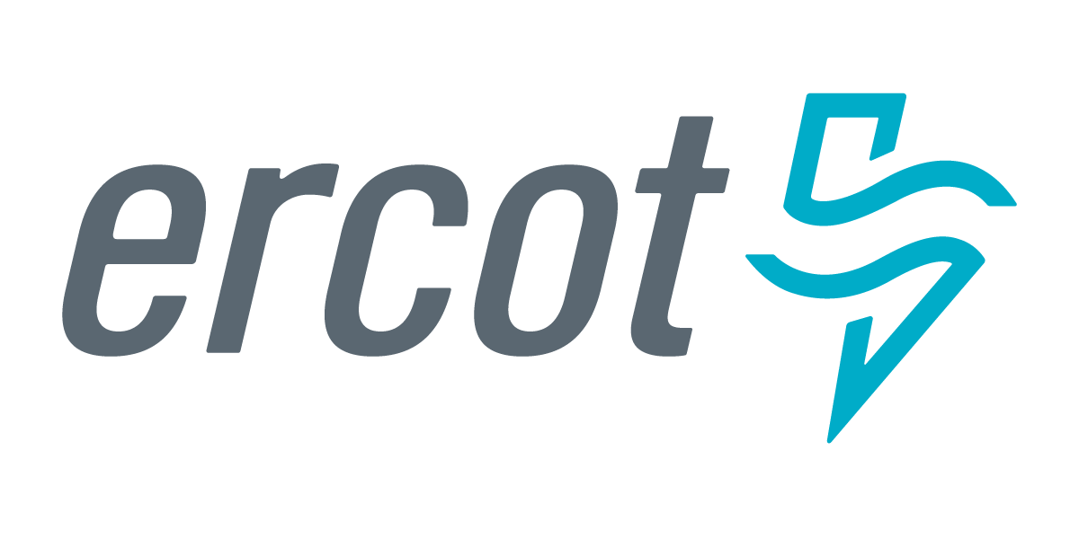 |  |  |  | System Planning
Monthly Status Report
July 2017

 |  | Report Highlights
- ERCOT is currently reviewing proposed transmission improvements with a total cost of $892.7 Million.
- Transmission Projects endorsed in 2017 total $536.2 Million.
- All projects (in engineering, routing, licensing and construction) total approximately $6.94 Billion as of Feb 1, 2017.
- Transmission Projects energized in 2017 total about $551.4 Million as of Feb 1, 2017.

Regional Planning Group Project Reviews

- Sharyland Utilities has submitted the South Plains Transmission project. This is a Tier 1 project that is estimated to cost $251 million. This project is currently under ERCOT independent review.

- LCRA TSC has submitted the Mountain Home substation and transmission line addition project. This is a Tier 1 project that is estimated to cost $77.3 million. This project is currently under ERCOT independent review.

- Garland Power & Light and Oncor have jointly submitted the North Garland Reliability Infrastructure Project (N-GRIP). This is a Tier 1 project that is estimated to cost $78 million. This project is currently under ERCOT independent review.

- CenterPoint Energy has submitted the Freeport Master Plan project. This is a Tier 1 project that is estimated to cost $246.7 million. This project is currently under ERCOT independent review.

- Brazos Electric Cooperative (BEC) & Rayburn Country Electric Cooperative (RCEC) have jointly submitted the Northeast Denton County & Celina/Prosper Transmission Improvement project. This is a Tier 1 project that is estimated to cost $72.9 million. This project is currently under ERCOT independent review.

- Brazos Electric Cooperative (BEC) has submitted the Kalgary Area Improvement project. This is a Tier 2 project that is estimated to cost $33 million. This project is currently under ERCOT independent review.

- Brazos Electric Cooperative (BEC) has submitted the South Denton County project. This is a Tier 2 project that is estimated to cost $42 million. This project is currently under ERCOT independent review.

- LCRA TSC has submitted the Fayette Area Transmission Line Upgrades project. This is a Tier 3 project that is estimated to cost $24.4 million. This project has completed the RPG review and ERCOT will prepare the RPG acceptance letter.

- AEPSC has submitted the Carrizo-Crystal Transmission project. This is a Tier 3 project that is estimated to cost $21.9 million. This project has been submitted for RPG comments.

- WETT has submitted the Bearkat Area Transmission Improvements project. This is a Tier 1 project that is estimated to cost $69.9 million. This project has been submitted for RPG comments.

Planning Model Activities
The short term calendar of major planning model events is as follows:
- July 1, 2017 Post 17SSWG SSWG Base Cases
- July 14, 2017 Post Contingency definitions and Planning Data Dictionary
- August 2, 2017 NMMS snapshot for 17SSWG Update 1
The following table shows interconnection projects that met Planning Guide section 6.9(1)(a) – 6.9(1)(d) and were modeled in the SSWG cases as either complete or as a simple model or those that were not modeled in SSWG cases due to lack of RARF data in accordance with Planning Guide section 6.9. This categorization refers to data needed only for the Steady State model and is not the complete set of data marked Required for Planning in the Resource Registration Glossary.
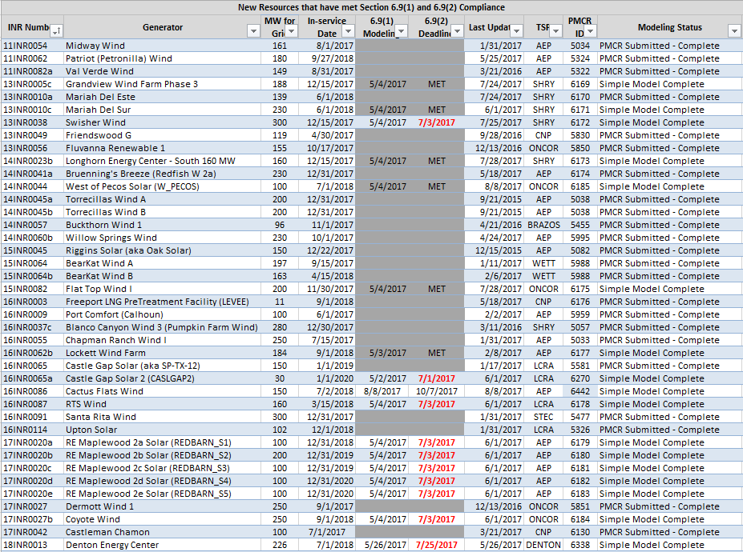

Permian Basin Oil Rig Count

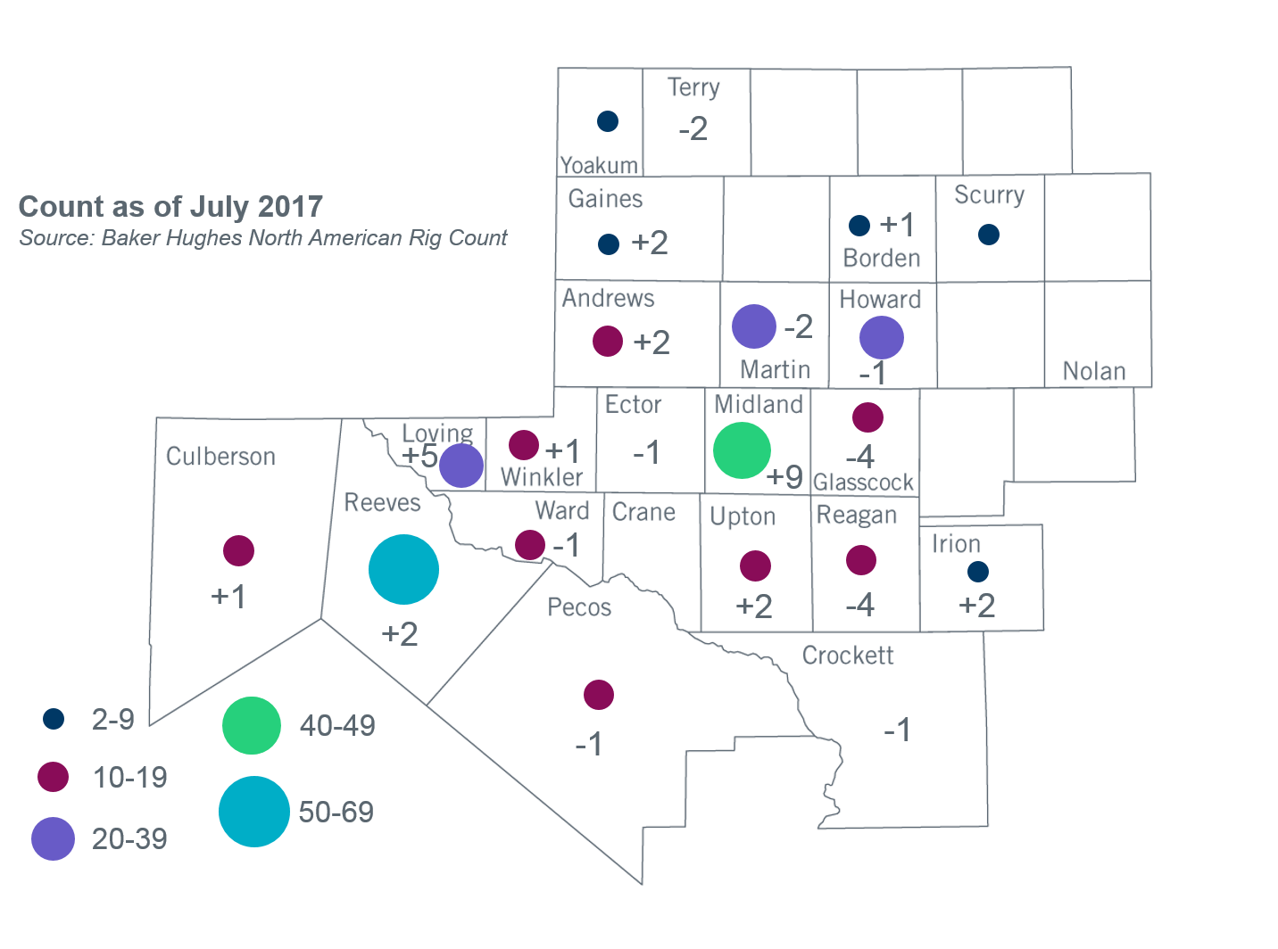
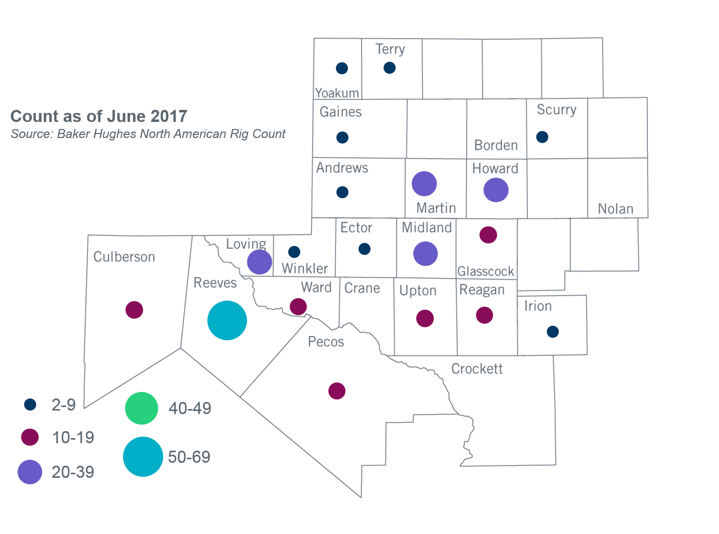

Other Notable Activities
- ERCOT is working on reliability analysis for the 2017 Regional Transmission Plan (RTP). ERCOT posted results of its N-1 reliability analysis along with a preliminary list of transmission projects and cases on the MIS Secure website on June 26, 2017. ERCOT continues to perform a load review for the Far West weather zone.
- ERCOT and over thirty members in attendance at the June RPG meeting participated in a scenario development workshop for the 2018 LTSA. This session was a follow-up of the LTSA scenario development workshop conducted at the May RPG meeting. In addition to the Current Trends scenario, three new scenarios were identified as a result of the workshop. ERCOT staff will compile the results of the workshops and present the findings on scenario descriptions and assumptions that will be studied in the 2018 LTSA at the August RPG meeting.
- The SPWG has completed work on the 2017 FY base cases. ERCOT sent the final pass out to the group on 06/30/2017.

+/- symbol indicates the increase or decrease from the previous month in oil rigs present in each county. There is a total increase of 10 oil rigs in the Permian Basin from June-July 2017.

