July 2017 ERCOT Monthly Operations Report
Reliability and Operations Subcommittee Meeting
September 7th, 2017

Table of Contents
1. Report Highlights 2
2. Frequency Control 3
2.1. Frequency Events 3
2.2. Responsive Reserve Events 4
2.3. Load Resource Events 4
3. Reliability Unit Commitment 4
4. Wind Generation as a Percent of Load 5
5. Congestion Analysis 5
5.1. Notable Constraints for July 6
5.2. Generic Transmission Constraint Congestion 7
5.3. Manual Overrides for July 7
5.4. Congestion Costs for Calendar Year 2017 7
6. System Events 8
6.1. ERCOT Peak Load 8
6.2. Load Shed Events 8
6.3. Stability Events 8
6.4. Notable PMU Events 8
6.5. TRE/DOE Reportable Events 8
6.6. New/Updated Constraint Management Plans 8
6.7. New/Modified/Removed RAS 8
6.8. New Procedures/Forms/Operating Bulletins 9
7. Emergency Conditions 9
7.1. OCNs 9
7.2. Advisories 9
7.3. Watches 9
7.4. Emergency Notices 9
8. Application Performance 10
8.1. TSAT/VSAT Performance Issues 10
8.2. Communication Issues 10
8.3. Market System Issues 10
9. Model Updates 10
Appendix A: Real-Time Constraints 11

Report Highlights
- The unofficial ERCOT peak for July was 69,695 MW.
- There were three frequency events in July. PMU data indicates the ERCOT system transitioned well in each case.
- There were three instances where Responsive Reserves were deployed, two of which were the result of frequency events.
- There were eight RUC commitments in July.
- The level of reportable SCED congestion decreased in July. This congestion was mostly due to planned outages as well as high wind output. There were eighteen instances over 31 days on the Generic Transmission Constraints (GTCs) in July. There were seventeen days on the Panhandle GTC and one day on the North to Houston GTC in July. There was no activity on the remaining GTCs during the Month.

Frequency Control

Frequency Events
The ERCOT Interconnection experienced three frequency events in July, all of which resulted from Resource trips. The average event duration was approximately 0:03:55.

When analyzing frequency events, ERCOT evaluates PMU data according to industry standards. Events with an oscillating frequency of less than 1 Hz are considered to be inter-area, while higher frequencies indicate local events. Industry standards specify that damping ratio for inter-area oscillations should be 3.0% or greater. All events listed below indicate the ERCOT system met these standards and transitioned well after each disturbance.

Reported frequency events will include both frequency events where frequency was outside the range of 60±0.1 Hz as well as those determined to be Frequency Measurable Events (FME) as defined by BAL-001-TRE-1. Delta Frequency is defined as the difference between the pre-perturbation and post-perturbation frequency. The Duration of Event is defined as the time it takes for the frequency to recover to lesser/greater of the frequency at the time of the frequency event (t(0) or “A-point”) for low/high-frequency events, respectively. Further details on FMEs can be found in the MIS posted BAL-001-TRE-1 PDCWG Unit Performance reports. A summary of the frequency events is provided below:

Date and Time | Delta Frequency | Max/Min Frequency | Duration of Event | PMU Data |  |  | MW Loss | Load | Wind | Inertia
 | (Hz) | (Hz) |  | Oscillation Mode (Hz) |  | Damping Ratio |  | (MW) | % | (GW-s)
7/2/2017 00:19 | 0.076 | 59.87 | 0:03:29 | No PMU Data Available. |  |  | 596 | 42,776 | 21% | 243,506
7/7/2017 00:27 | 0.055 | 59.93 | 0:04:30 | 0.64 | 7% |  | 425 | 44,204 | 8% | 289,155
7/26/2017 14:30 | 0.099 | 59.85 | 0:03:45 | 0.72/0.61 | 12%/10% |  | 702 | 66,543 | 11% | 348,450
(Note: frequency events highlighted in blue have been identified as FMEs per BAL-001-TRE-1 and the Performance Disturbance Compliance Working group.)

Currently, the Critical Inertia Level for ERCOT is approximately 100,000 MW-s (Source: link)
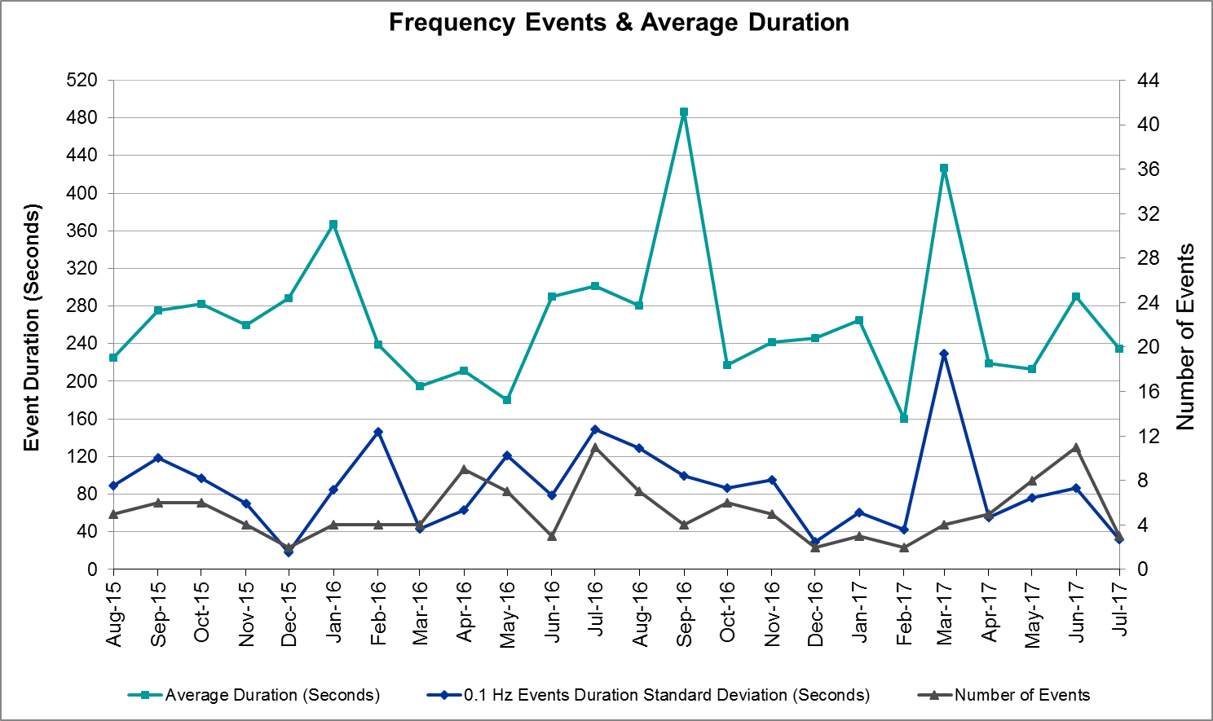
(Note: All data on this graph encompasses frequency event analysis based on BAL-001-TRE-1.)

Responsive Reserve Events
There were three events where Responsive Reserve MWs were released to SCED in July. The events highlighted in blue were related to frequency events reported in Section 2.1 above.
Date and Time Released to SCED | Date and Time Recalled | Duration of Event | Maximum MWs Released
7/2/2017 0:19:38 | 7/2/2017 0:22:11 | 0:02:28 | 491.02
7/17/2017 10:05:55 | 7/17/2017 10:09:00 | 0:03:05 | 488.98
7/26/2017 14:30:42 | 7/26/2017 14:33:53 | 0:03:04 | 627.51

Load Resource Events
None.

Reliability Unit Commitment

ERCOT reports on Reliability Unit Commitments (RUC) on a monthly basis. Commitments are reported grouped by operating day and weather zone. The total number of hours committed is the sum of the hours for all the units in the specified region. Additional information on RUC commitments can be found on the MIS secure site at Grid Generation Reliability Unit Commitment.

There were no DRUC commitments in July.

There were eight HRUC commitments in July.

Resource Location | # of Resources | Operating Day | Total # of Hours Committed | Total MWhs | Reason for Commitment
Coastal | 2 | 7/6/2017 | 11 | 1,859 | N_to_H
Coastal | 2 | 7/7/2017 | 10 | 1,620 | Local Congestion
North Central | 1 | 7/17/2017 | 3 | 1,176 | Capacity
Coastal | 1 | 7/20/2017 | 6 | 1,428 | Local Congestion
Coastal | 1 | 7/24/2017 | 8 | 4,296 | Local Congestion
Coastal | 2 | 7/25/2017 | 10 | 2,060 | Local Congestion
Coastal | 2 | 7/26/2017 | 12 | 4,928 | Local Congestion
Southern | 1 | 7/29/2017 | 8 | 2,400 | Local Congestion

Wind Generation as a Percent of Load
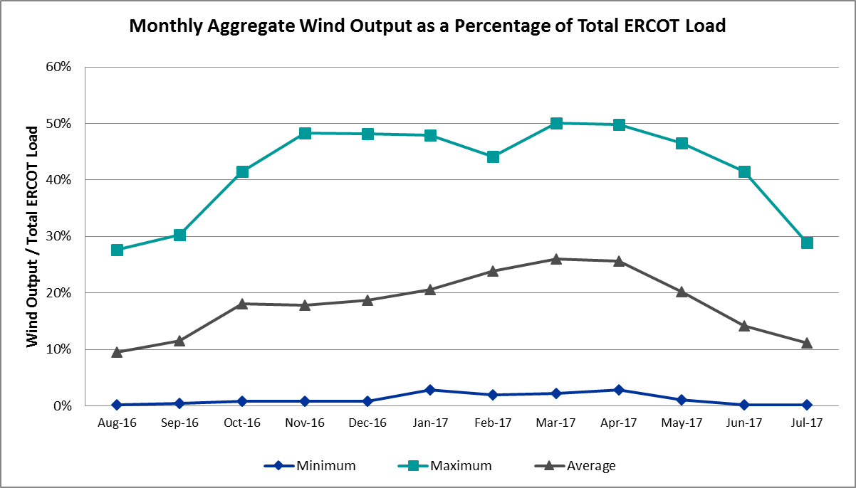

Congestion Analysis
The number of congestion events experienced by the ERCOT system decreased in July. There were eighteen instances over 31 days on the Generic Transmission Constraints (GTCs) in July.

Notable Constraints for July
Nodal protocol section 3.20 specifies that ERCOT shall identify transmission constraints that are active or binding three or more times within a calendar month. As part of this process, ERCOT reports congestion that meets this criterion to ROS. In addition ERCOT also highlights notable constraints that have an estimated congestion rent exceeding $1,000,000 for a calendar month. These constraints are detailed in the table below. Rows highlighted in blue indicate the congestion was affected by one or more outages. For a list of all constraints activated in SCED for the month of July, please see Appendix A at the end of this report.

Contingency Name | Overloaded Element | # of Days Constraint Active | Congestion Rent | Transmission Project
HCKSW-ALLNC&RNKSW 345kV | Blue Mound - Wagley Robertson 138kV | 19 | $6,591,045.57 | 15TPIT0085
Basecase | PNHNDL GTC | 17 | $5,735,187.46
Rns-Rtw & Sng-Tb 345kv | Singleton - Zenith 345kV | 27 | $4,694,316.64 | Houston Import Project
Jewet-Sng 345kV | Btu_Jack_Creek - Twin Oak Switch 345kV | 28 | $2,528,063.46 | Houston Import Project
TWR (345) WAP-BI50 & SMITHERS-BI98 | Wa Parish - Jeanetta 345kV | 7 | $2,058,135.12 | 5550
NORTH EDINBURG TRX 1382 345/138 | North Edinburg 345/1kV | 1 | $1,731,575.56 | 5604
MCCARTY LANE to REDWOOD LIN 1 | Mccarty Lane - Ranch Road 12 138kV | 6 | $1,145,533.66
FORT STOCKTON PLANT TRX 69T1 138/6 | Solstice - Pig Creek Tap 138kV | 28 | $920,379.06 | Far West Texas Project
LAQUINTA to LOBO LIN 1 | Bruni Sub 138/69kV | 22 | $468,054.84
Basecase | Burns Sub - Rio Hondo 138kV | 3 | $445,294.44
Brenham to Salem Lcra 138 KV | Highway 36 - Salem Lcra 138kV | 3 | $241,765.94
NORTH McCAMEY to ODESSA EHV SWITCH | Solstice - Pig Creek Tap 138kV | 6 | $167,821.09 | Far West Texas Project
Meadow to Ph Robinson 345 KV | Seminole Tnp - Friendswood Tnp 138kV | 5 | $102,793.37 | 4010
Fppyd1-Salem & Fayett 345kV | Sim Gideon - Winchester 138kV | 6 | $74,176.95 | 5267
ESKOTA SWITCH TRX FMR2 138/69 | Eskota Switch 138/69kV | 7 | $67,588.80
SAN MIGUEL 345_138 KV SWITCHYARDS | San Miguel 345_138 Kv Switchyards 345/1kV | 5 | $63,788.53 | 5218
FAYETTE PLANT 1 to SALEM LCRA LIN | Fayetteville 138/1kV | 6 | $42,780.33
Fppyd1-Salem & Fayett 345kV | Smithville - Winchester 138kV | 11 | $28,232.91 | 5950
ARANSAS PASS TRX 69A1 138/69 | Gregory - Rincon 69kV | 4 | $26,272.22 | 2979
MCAN_SW TO RIOP 138 KV | Solstice - Pig Creek Tap 138kV | 3 | $20,825.68 | Far West Texas Project
Chb-Kg & Cby-Jor 345kv | Brine - Langston 138kV | 5 | $16,521.14
MERCERS GAP SW to COMANCHE SWITCH | Camp Bowie (Oncor) - Brownwood Switch 138kV | 5 | $13,707.49
Gibcrk-Sng 345 Kv | Jewett - Singleton 345kV | 18 | $13,235.62 | Houston Import Project
Scotland to Scotland (Oncor) | Anarene - Navy Kickapoo Switch 69kV | 4 | $8,828.95
SKYWEST to SPRABERRY SWITCH LIN 1 | Peck Tap - Spraberry Switch 69kV | 3 | $3,810.24
DESOTO SWITCH to ENNIS SWITCH LIN | Ennis West Switch - Waxahachie 138kV | 3 | $3,425.47
Basecase | Re Roserock Solar Plant - Linterna 138kV | 8 | $1,383.49

Generic Transmission Constraint Congestion
There were seventeen days on the Panhandle GTC and one day on the North to Houston GTC in July. There was no activity on the remaining GTCs during the Month.

Note: This is how many times a constraint has been activated to avoid exceeding a GTC limit, it does not imply an exceedance of the GTC occurred or that the GTC was binding.

Manual Overrides for July
None.

Congestion Costs for Calendar Year 2017
The following table represents the top twenty active constraints for the calendar year based on the estimated congestion rent attributed to the congestion. ERCOT updates this list on a monthly basis.

Contingency | Binding Element | # of 5-min SCED Intervals | Estimated Congestion Rent | Transmission Project
Rns-Rtw & Sng-Tb 345kv | Singleton - Zenith 345kV | 14,049 | 62,986,611.93 | Houston Import Project
Basecase | PNHNDL GTC | 20,803 | 62,240,072.51
HCKSW-ALLNC&RNKSW 345kV | Blue Mound - Wagley Robertson 138kV | 6,562 | 52,229,965.09 | 15TPIT0085
Rns-Rtw & Sng-Tb 345kv | Singleton - Zenith 345kV | 8,337 | 31,951,822.06 | Houston Import Project
White_Pt-Mccampbe&Hecker 138 | Whitepoint - Rincon 138kV | 1,352 | 24,325,582.27 | 2979
CRLNW-LWSSW 345kV | Carrollton Northwest - Lakepointe Tnp 138kV | 6,300 | 23,917,330.89 | 5488
NORTH PHARR to POLK AVENUE LIN 1 | North Mcallen - West Mcallen 138kV | 1,740 | 23,113,831.71 | 4493
HCKSW-ALLNC&RNKSW 345kV | Wagley Robertson - Summerfield 138kV | 1,429 | 20,785,800.16
NORTH PHARR to PHARR Magic Valley | North Mcallen - West Mcallen 138kV | 703 | 15,031,152.13 | 4493
Hecker_White_Pt 138kv | Whitepoint - Rincon 138kV | 1,447 | 14,822,421.12 | 2979
Jewet-Sng 345kV | Btu_Jack_Creek - Twin Oak Switch 345kV | 10,602 | 14,098,973.64 | Houston Import Project
Nedin-Mv_Wedn4&Mv_Palm4 138k | Azteca Sub - Se Edinburg 138kV | 1,675 | 13,608,219.01
Victoria-V_Dupsw 138kV | Formosa - Lolita 138kV | 1,896 | 11,071,428.56
Jewet-Sng 345kV | Gibbons Creek - Twin Oak Switch 345kV | 306 | 10,861,578.84 | Houston Import Project
White_Pt-Hecker&I_Dupsw 138k | Whitepoint - Rincon 138kV | 761 | 9,477,211.29 | 2979
NORTH EDINBURG TRX 1382 345/138 | North Edinburg 345/1kV | 367 | 8,173,743.87 | 5604
Jewet-Sng 345kV | Singleton - Gibbons Creek 345kV | 2,887 | 7,620,579.90 | Houston Import Project
Jewet-Sng 345kV | Gibbons Creek - Singleton 345kV | 1,604 | 6,873,716.08 | Houston Import Project
FORMOSA GEN FORMOSG12 | Formosa - Lolita 138kV | 77 | 5,518,567.35
Re Roserock Solar Plant to F | Barrilla - Fort Stockton Switch 69kV | 776 | 4,771,324.14 | Far West Texas Project

System Events

ERCOT Peak Load
The unofficial ERCOT peak load for the month was 69,496 MW and occurred on July 28th during hour ending 17:00.

Load Shed Events
None.

Stability Events
None.

Notable PMU Events
ERCOT analyzes PMU data for any significant system disturbances that do not fall into the Frequency Events category reported in section 2.1. The results are summarized in this section once the analysis has been completed.

There were no reportable events in July.

TRE/DOE Reportable Events
None.

New/Updated Constraint Management Plans
- MP_2017_01 – Mitigates the contingency IDs DGILFR89, XGIL89 SLIVGIL9, and XFRE89 has been updated due to new overloaded element

New/Modified/Removed RAS
None.

New Procedures/Forms/Operating Bulletins
ERCOT has revised the following procedure manuals, effective July 27, 2017

Procedure Title | POB
Real Time Desk | 800
Reliability Risk Desk | 801
Resource Desk | 802
Transmission and Security Desk | 803

Emergency Conditions

OCNs
Date and Time | Description
7/7/17 07:29 | OCN issued for projected Reserve Capacity shortage for HE 1400-2000
7/17/17 06:08 | OCN issued for projected Reserve Capacity shortage for HE 1400-2000
7/30/17 09:35 | OCN issued for projected Reserve Capacity shortage for HE 1500-1900

Advisories
Date and Time | Description
7/5/17 16:01 | Advisory issued due to Physical Responsive Capability being below 3000 MW
7/16/17 15:28 | Advisory issued due to Physical Responsive Capability being below 3000 MW
7/20/17 17:43 | Advisory issued due to Physical Responsive Capability being below 3000 MW
7/31/17 15:39 | Advisory issued due to Physical Responsive Capability being below 3000 MW

Watches
None.

Emergency Notices
None.

Application Performance

TSAT/VSAT Performance Issues
None.

Communication Issues
None.

Market System Issues
None.

Model Updates
The Downstream Production Change (DPC) process allows ERCOT to make changes in the on-line Network Operations Model without loading a completely new model. The purpose of this process is to allow for reliable grid operations as system conditions change between designated Network Operations Model database loads. The DPC process is limited in scope to just those items listed below, with equipment ratings updates being the most common. ERCOT has seen a rise in the use of the DPC process to make on-line updates to the Network Operations Model in recent years, instead of through the standard Network Operations Model Change Request process.

- Static Line ratings (Interim Update)
- Dynamic Line ratings (non-Interim Update)
- Autotransformer ratings (non-Interim Update)
- Breaker and Switch Normal status (Interim Update)
- Contingency Definitions (Interim Update)
- RAP and RAS changes or additions (Interim Update)
- Net Dependable and Reactive Capability (NDCRC) values (Interim Update)
- Impedance Updates (non-Interim)

Transmission Operator | Number of DPCs
AEP | 3
DENTON | 1
ERCOT | 3
ONCOR | 12
STEC | 2
CNP | 2

Appendix A: Real-Time Constraints
The following is a complete list of constraints activated in SCED for the month of July. Full contingency descriptions can be found in the Standard Contingencies List located on the MIS secure site at Grid Generation Reliability Unit Commitment.

Contingency | Constrained Element | From Station | To Station | # of Days Constraint Active
DJEWSNG5 | JK_TOKSW_1 | TOKSW | JK_CK | 28
XFTS89 | PIGTAP_SOLSTI1_1 | SOLSTICE | PIGTAP | 28
XFTS89 | PIGTAP_SOLSTI1_1 | PIGTAP | SOLSTICE | 28
DRNS_TB5 | SNGZEN99_A | SNG | ZEN | 27
SLAQLOB8 | BRUNI_69_1 | BRUNI | BRUNI | 22
DHCKRNK5 | 6270__C | WGROB | BLMND | 19
DGIBSNG5 | 260_A_1 | JEWET | SNG | 18
BASE CASE | PNHNDL | n/a | n/a | 17
DFPPFAY5 | 192T175_1 | SMITHV | WINCHE | 11
BASE CASE | REROCK_TLINE_1 | REROCK | LINTERNA | 8
XESK289 | ESKSW_FMR1 | ESKSW | ESKSW | 7
DWAP_BI5 | JN_WAP64_A | WAP | JN | 7
SSALFPP5 | FAYETT_AT2L | FAYETT | FAYETT | 6
SNORODE5 | PIGTAP_SOLSTI1_1 | SOLSTICE | PIGTAP | 6
DFPPFAY5 | 190T152_1 | GIDEON | WINCHE | 6
SREDMCC8 | 102T375_1 | MCCALA | RNRD12 | 6
SMDOPHR5 | G138_10C_1 | FRDSWOOD | SEMINOLE | 5
SZEPCMN8 | 670__B | BRNSW | CMPBW | 5
DCHBJOR5 | BRNLAN86_A | LAN | BRN | 5
XSA2N58 | SANMIGL_ATAH | SANMIGL | SANMIGL | 5
SSCLWF28 | 6840__B | NVKSW | ANARN | 4
XARA89 | GREGOR_RINCON1_1 | RINCON | GREGORY | 4
DNLALAR8 | DEL_MA_LAREDO1_1 | LAREDO | DEL_MAR | 4
SRDODES8 | 940__C | ENWSW | WXHCH | 3
BASE CASE | BURNS_RIOHONDO_1 | RIOHONDO | MV_BURNS | 3
DMCARIO8 | PIGTAP_SOLSTI1_1 | SOLSTICE | PIGTAP | 3
SBRESAL8 | 105T105_1 | SALEM | HIGH36 | 3
SSKYSB28 | 6820__C | SBYSW | PCKTP | 3
DWH_STP5 | BLESSI_LOLITA1_1 | BLESSING | LOLITA | 2
SGILHIW8 | GILA_MORRIS1_1 | GILA | MORRIS | 2
DAUSLOS5 | AUSTRO_AT2H | AUSTRO | AUSTRO | 2
SHOLWES8 | ARCADI_SOUTH_1_1 | ARCADIA | SOUTH_SI | 2
DPBSHLT8 | PIGTAP_SOLSTI1_1 | SOLSTICE | PIGTAP | 2
SWLFYUC8 | PIGTAP_SOLSTI1_1 | SOLSTICE | PIGTAP | 2
SROSE38 | PLESNTN_TORDLO_1 | TORDILLO | PLSNTOS | 2
SFORGIL8 | FRPHIL_GILLES1_1 | GILLES | FRPHILLT | 2
DPRSVLY5 | 1530__C | BRTNT | BLPOI | 2
SMARZOR5 | 419T419_1 | CLEASP | MARION | 2
DMARZOR5 | 428T428_1 | SEGUIN | SEGUWE | 2
SHCKRNK5 | 6270__C | WGROB | BLMND | 2
SECTPBS8 | 6485__A | MOSSW | PBSES | 2
SCOLPAW5 | COLETO_KENEDS1_1 | COLETO | KENEDSW | 2
DLYTZOR5 | 144T132_1 | FLATON | HALLET | 1
DALNRYS5 | 568__A | RYSSW | NEVADA | 1
BASE CASE | N_TO_H | n/a | n/a | 1
DENTSCS5 | 1170__A | NCDSE | HNRSW | 1
DSTPWHI5 | BLESSI_LOLITA1_1 | BLESSING | LOLITA | 1
DMERSOM8 | KARNES_KENEDS1_1 | KENEDSW | KARNESCI | 1
SLONWI39 | M_69_D1_1 | WINK | TNBNSPRT | 1
DALNRYS5 | 1627__A | APOLLO | REAST | 1
SSCLWF28 | 6560__B | MRKLY | RICSW | 1
SMDOOAS5 | AE_LV_04_A | AE | LV | 1
BASE CASE | BURNS_HEIDLBRG_1 | MV_BURNS | MV_HBRG4 | 1
SMDLODE5 | PIGTAP_SOLSTI1_1 | SOLSTICE | PIGTAP | 1
XBLE58 | SAR_FRAN_1 | FRANKC | SARGNTS | 1
DPBSHLT8 | 6101__A | NOTSW | CHEYT | 1
SKOCNU28 | GILA_HIWAY_1_1 | GILA | HIWAY_9 | 1
SSALFPP5 | 192T175_1 | SMITHV | WINCHE | 1
DCBYRN28 | CV_LH_03_A | LH | CV | 1
SSALFPP5 | FAYETT_AT2H | FAYETT | FAYETT | 1
DBRNBR28 | KARNES_KENEDS1_1 | KENEDSW | KARNESCI | 1
SBELHIG8 | 215T215_1 | HIGH36 | BRENNO | 1
XWL2V58 | 3130__B | INDST | CMPST | 1
SBAKHL48 | 6596__F | HLTSW | EMATP | 1
SWCSBOO8 | BARL_FTSW1_1 | FTSW | BARL | 1
SBRAUVA8 | HAMILT_MAVERI1_1 | HAMILTON | MAVERICK | 1
DNEDPAL8 | ADERHO_HEC1_1 | HEC | ADERHOLD | 1
SSPNDEN9 | HIC_LOCU_1 | LOCUST_D | HICKRY_D | 1
SLOCSPN9 | SPE_DEN_1 | SPNCER | DENTON | 1
DWTRTRC5 | 1750__B | SGOVL | KLBTP | 1
SNEWFAY8 | 199T199_1 | SALEM | BRENHA | 1
SMCCBND5 | 568__A | RYSSW | NEVADA | 1
XBRK89 | 6635__B | LENSW | ESTTP | 1
DCHBJOR5 | BRNWIN86_A | BRN | WIN | 1
DCBYRN28 | EXNLH_03_A | EXN | LH | 1
XNED258 | NEDIN_138H | NEDIN | NEDIN | 1
SHSAPB38 | PBSES_MR1L | PBSES | PBSES | 1
BASE CASE | RANDAD_ZAPATA1_1 | RANDADO | ZAPATA | 1

