ERCOT STEADY STATE WORKING GROUP (SSWG)

## June 2017 Report to ROS

### Recent Meetings

SSWG met Thursday June 8th, 2017 at ERCOT. 30 Participants.

### 17SSWG Case Build (Years 2017 – 2024)

During the month of June, the TSPs and ERCOT have worked on tuning and making the final adjustments to the new power flow cases. TSPs also met in person June 6th-8thand performed two tuning passes as a group. The build process is complete, and the new 17SSWG cases have been posted to the MIS site.

* + The dispatch methodology was modified to utilize historical operations data in conjunction with an economic-simulation software to build the generation dispatch in the 17SSWG cases.
  + There were a total of 16 generators added to the new cases as a “Simple Model” that met the requirements for Planning Guide 6.9 (1). The complete list of generators met a portion of Planning Guide 6.9 and were included in the 17SSWG cases shown below.

Additionally, ERCOT is working contacting the generators reminding them to complete and send the additional RARF data requirements in accordance of Planning Guide the 6.9(2).

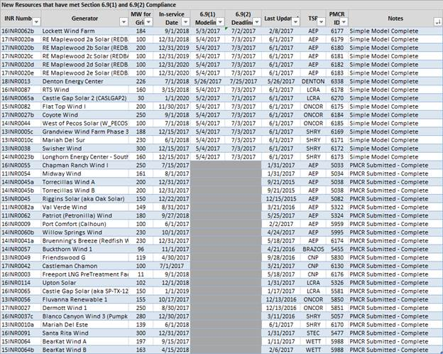

### NOMCR Pending PMCR initiative

### The group has progressed well on reducing the amount of NOMCR pending PMCRs in MOD. SSWG plans are to continually monitor this item to keep the volume of these PMCRs down.

### Topology Processor Update

During the business meeting, ERCOT staff presented updates to the topology processor based on the NMMS upgrade. Changes include updating the way topology processor filters several data attributes such as: Voltage set points, Load Records, Ownerships, Transformers, and Ratings from the Operations model into the cases. ERCOT will provide SSWG the documentation and the output file from the new topology processor for further review and feedback.

### Current Items

The TSPs are working to update the contingency definitions and planning data dictionary files that relate to the latest 17SSWG power flow cases. This data is updated after each power flow case build.

### Future Planned Meetings

### SSWG has plans to meet on July 12th by WebEx.