May 2017 ERCOT Monthly Operations Report
Reliability and Operations Subcommittee Meeting
July 13th, 2017

Table of Contents
1. Report Highlights 2
2. Frequency Control 3
2.1. Frequency Events 3
2.2. Responsive Reserve Events 4
2.3. Load Resource Events 4
3. Reliability Unit Commitment 4
4. Wind Generation as a Percent of Load 6
5. Congestion Analysis 6
5.1. Notable Constraints for May 6
5.2. Generic Transmission Constraint Congestion 8
5.3. Manual Overrides for May 8
5.4. Congestion Costs for Calendar Year 2017 8
6. System Events 9
6.1. ERCOT Peak Load 9
6.2. Load Shed Events 10
6.3. Stability Events 10
6.4. Notable PMU Events 10
6.5. TRE/DOE Reportable Events 10
6.6. New/Updated Constraint Management Plans 10
6.7. New/Modified/Removed RAS 10
6.8. New Procedures/Forms/Operating Bulletins 10
7. Emergency Conditions 11
7.1. OCNs 11
7.2. Advisories 11
7.3. Watches 11
7.4. Emergency Notices 11
8. Application Performance 12
8.1. TSAT/VSAT Performance Issues 12
8.2. Communication Issues 12
8.3. Market System Issues 12
9. Model Updates 12
Appendix A: Real-Time Constraints 13

Report Highlights
- The unofficial ERCOT peak for May was 59,244 MW.
- There were eight frequency events in May. PMU data indicates the ERCOT system transitioned well in each case.
- There were four instances where Responsive Reserves were deployed, all of which were the result of frequency events.
- There were nine RUC commitments in May.
- The level of reportable SCED congestion increased in May. This congestion was mostly due to planned outages as well as high wind output. There were fifty-eight instances over 31 days on the Generic Transmission Constraints (GTCs) in May. There were twenty-eight days on the Panhandle GTC, one day on the North – Houston GTC, and three days on the Bakersfield GTC in May. There was no activity on the remaining GTCs during the Month.
- ERCOT’s TSAT/VSAT system was unavailable for 4 hours and 18 minutes on May 5, 2017 due to loss of telemetry from a large TSP which sent incorrect telemetry to ERCOT.

Frequency Control

Frequency Events
The ERCOT Interconnection experienced five frequency events in May, all of which resulted from Resource trips. The average event duration was approximately 0:03:33.

When analyzing frequency events, ERCOT evaluates PMU data according to industry standards. Events with an oscillating frequency of less than 1 Hz are considered to be inter-area, while higher frequencies indicate local events. Industry standards specify that damping ratio for inter-area oscillations should be 3.0% or greater. All events listed below indicate the ERCOT system met these standards and transitioned well after each disturbance.

Date and Time | Delta Frequency | Max/Min Frequency | Duration of Event | PMU Data |  | MW  Loss | Load | Wind | Inertia
 | (Hz) | (Hz) |  | Oscillation Mode (Hz) | Damping Ratio |  | (MW) | % | (GW-s)
5/10/2017 20:38 | 0.053 | 59.91 | 0:02:43 | No PMU Data Available. |  | 381 | 38,363 | 14% | 214,605
5/11/2017 14:53 | 0.059 | 59.92 | 0:02:45 | No PMU Data Available. |  | 487 | 29,849 | 36% | 178,651
5/16/2017 22:25 | 0.012 | 59.90 | 0:02:12 | No PMU Data Available. |  | 190 | 45,611 | 22% | 218,907
5/19/2017 17:00 | 0.038 | 59.90 | 0:03:10 | No PMU Data Available. |  | 340 | 48,063 | 16% | 250,027
5/19/2017 19:25 | 0.066 | 59.92 | 0:04:09 | No PMU Data Available. |  | 416 | 44,953 | 11% | 255,457
5/21/2017 18:25 | 0.065 | 59.90 | 0:06:00 | 0.28, 0.70 | 54.0%, 4.0% | 448 | 26,879 | 44% | 160,904
5/23/2017 13:59 | 0.044 | 59.92 | 0:02:48 | No PMU Data Available. |  | 215 | 43,645 | 31% | 218,905
5/30/2017 15:39 | 0.031 | 59.94 | 0:04:38 | No PMU Data Available. |  | 638 | 54,742 | 12% | 276,872
Reported frequency events will include both frequency events where frequency was outside the range of 60±0.1 Hz as well as those determined to be Frequency Measurable Events (FME) as defined by BAL-001-TRE-1. Delta Frequency is defined as the difference between the pre-perturbation and post-perturbation frequency. The Duration of Event is defined as the time it takes for the frequency to recover to lesser/greater of the frequency at the time of the frequency event (t(0) or “A-point”) for low/high-frequency events, respectively. Further details on FMEs can be found in the MIS posted BAL-001-TRE-1 PDCWG Unit Performance reports. A summary of the frequency events is provided below:
(Note: frequency events highlighted in blue have been identified as FMEs per BAL-001-TRE-1 and the Performance Disturbance Compliance Working group.)

Currently, the Critical Inertia Level for ERCOT is approximately 100,000 MW-s (Source: link)
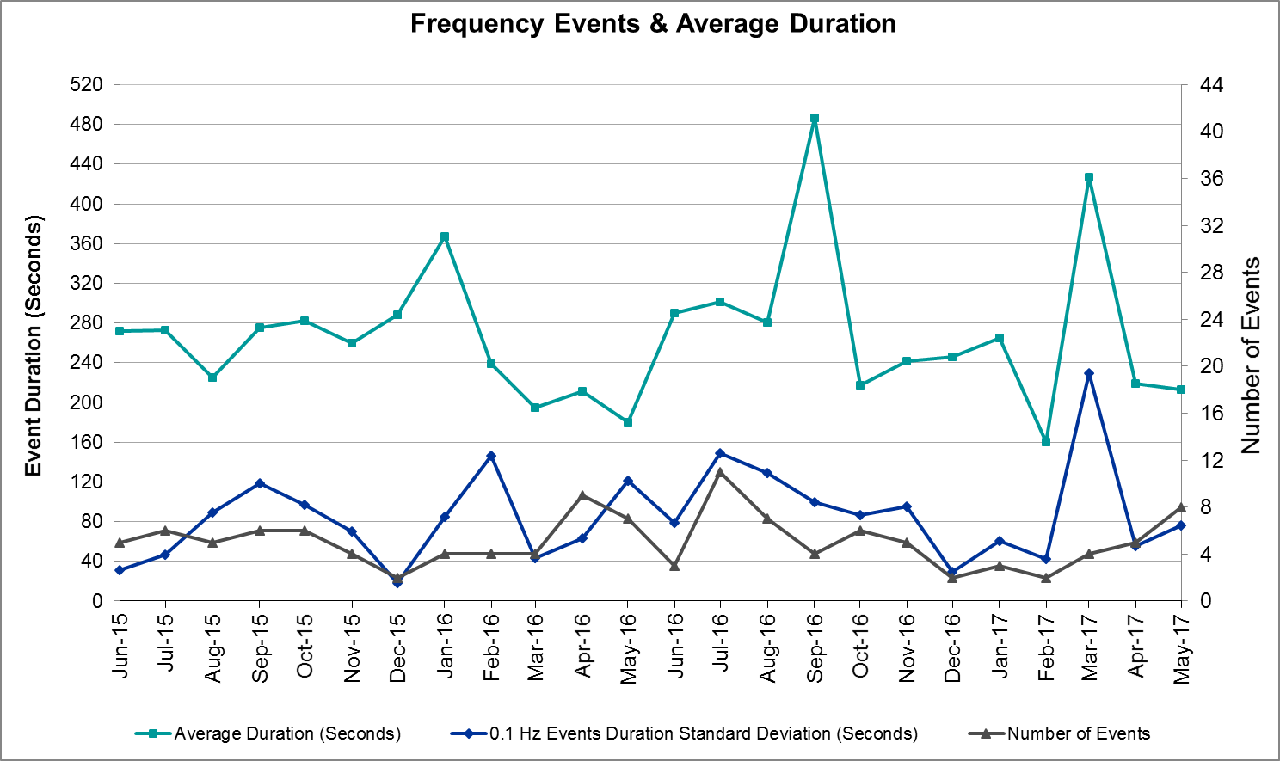
(Note: All data on this graph encompasses frequency event analysis based on BAL-001-TRE-1.)

Responsive Reserve Events
There were four events where Responsive Reserve MWs were released to SCED in May. The events highlighted in blue were related to frequency events reported in Section 2.1 above.

Date and Time Released to SCED | Date and Time Recalled | Duration of Event | Maximum MWs Released
5/10/2017 20:38:49 | 5/10/2017 20:40:41 | 0:01:52 | 181.05
5/16/2017 22:25:29 | 5/16/2017 22:29:17 | 0:03:48 | 519.53
5/19/2017 17:00:04 | 5/19/2017 17:01:35 | 0:01:31 | 284.54
5/21/2017 18:25:03 | 5/21/2017 18:29:11 | 0:04:08 | 294.10

Load Resource Events
None.

Reliability Unit Commitment
ERCOT reports on Reliability Unit Commitments (RUC) on a monthly basis. Commitments are reported grouped by operating day and weather zone. The total number of hours committed is the sum of the hours for all the units in the specified region. Additional information on RUC commitments can be found on the MIS secure site at Grid Generation Reliability Unit Commitment.

There were no DRUC commitments in May.

There were eight HRUC commitments in May.

Resource Location | # of Resources | Operating Day | Total # of Hours Committed | Total MWhs | Reason for Commitment
COAST | 1 | 5/1/2017 | 8 | 5,992 | Local Congestion
SOUTHERN | 1 | 5/4/2017 | 1 | 550 | Local Congestion
NORTH_CENTRAL | 1 | 5/19/2017 | 4 | 1,740 | Local Congestion
COAST | 1 | 5/23/2017 | 8 | 4,136 | Local Congestion
COAST | 1 | 5/24/2017 | 8 | 4,136 | Local Congestion
COAST | 1 | 5/28/2017 | 6 | 1,428 | Local Congestion
SOUTH_CENTRAL | 1 | 5/30/2017 | 8 | 3,280 | Capacity
NORTH_CENTRAL | 1 | 5/30/2017 | 6 | 2,610 | Capacity
NORTHERN | 1 | 5/30/2017 | 6 | 1,423 | Capacity

Wind Generation as a Percent of Load
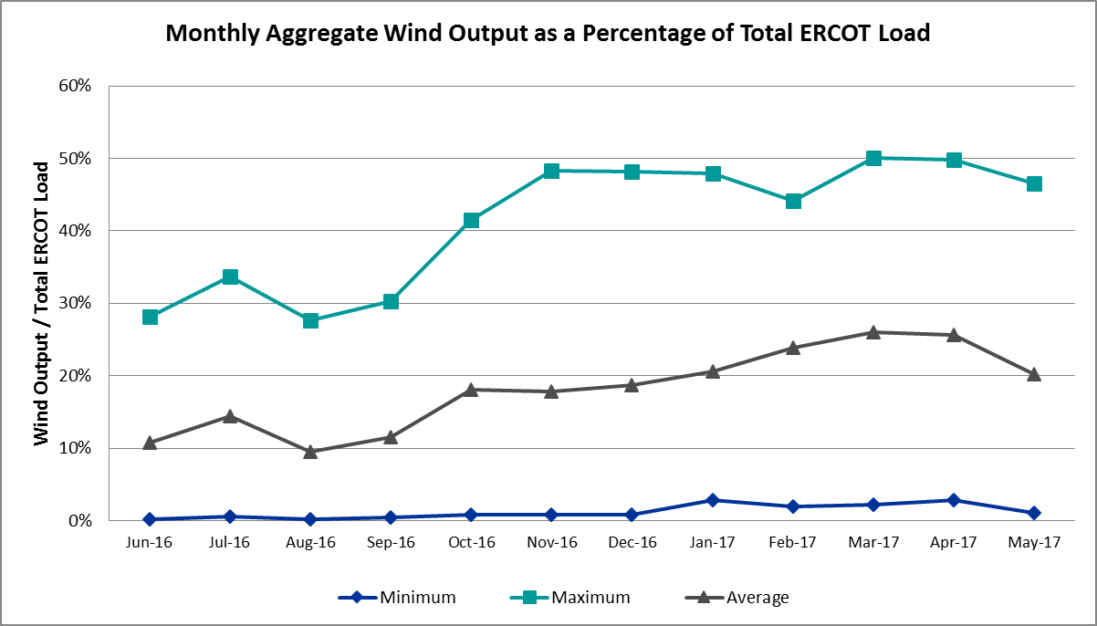

Congestion Analysis
The number of congestion events experienced by the ERCOT system increased in May. There were thirty-two instances over 31 days on the Generic Transmission Constraints (GTCs) in May.

Notable Constraints for May
Nodal protocol section 3.20 specifies that ERCOT shall identify transmission constraints that are active or binding three or more times within a calendar month. As part of this process, ERCOT reports congestion that meets this criterion to ROS. In addition ERCOT also highlights notable constraints that have an estimated congestion rent exceeding $1,000,000 for a calendar month. These constraints are detailed in the table below. Rows highlighted in blue indicate the congestion was affected by one or more outages. For a list of all constraints activated in SCED for the month of May, please see Appendix A at the end of this report.

Contingency Name | Overloaded Element | # of Days Constraint Active | Congestion Rent | Transmission Project
Rns-Rtw & Sng-Tb 345kv | Singleton - Zenith 345kV | 19 | $27,870,477.54 | Houston Import Project
HCKSW-ALLNC&RNKSW 345kV | Blue Mound - Wagley Robertson 138kV | 20 | $21,764,952.38 | 15TPIT0085
Rns-Rtw & Sng-Tb 345kv | Singleton - Zenith 345kV | 7 | $12,763,160.71 | Houston Import Project
Basecase | PNHNDL GTC | 28 | $9,983,382.23
Nedin-Mv_Wedn4&Mv_Palm4 138k | Azteca Sub - Se Edinburg 138kV | 14 | $8,466,792.28
NORTH PHARR to PHARR Magic Valley | North Mcallen - West Mcallen 138kV | 6 | $7,759,995.59
Jewet-Sng 345kV | Btu_Jack_Creek - Twin Oak Switch 345kV | 15 | $5,379,748.35 | Houston Import Project
Victoria-V_Dupsw 138kV | Blessing - Lolita 138kV | 6 | $3,301,103.11
Meadow to Ph Robinson 345 KV | Seminole Tnp - Friendswood Tnp 138kV | 4 | $2,297,839.38 | 4010
MITCHELL BEND SWITCH to COMANCHE P | Wolf Hollow 345 Switch - Comanche Peak Ses 345kV | 1 | $2,047,032.05
Victoria-V_Dupsw 138kV | Formosa - Lolita 138kV | 6 | $2,039,774.86
Gibcrk-Sng 345 Kv | Jewett - Singleton 345kV | 7 | $1,539,395.23 | Houston Import Project
MERCERS GAP SW to COMANCHE SWITCH | Holder 138/69kV | 29 | $1,344,786.77 | 5713
Chb-Kg & Cby-Jor 345kv | Channelview - Lynch 138kV | 1 | $1,336,528.46
Cagnon-Calavers&Braunig 345k | Skyline - Calaveras 345kV | 12 | $1,305,117.41
NORTH PHARR to POLK AVENUE LIN 1 | North Mcallen - West Mcallen 138kV | 3 | $1,291,241.17
CRLNW-LWSSW 345kV | Carrollton Northwest - Lakepointe Tnp 138kV | 10 | $1,195,248.88 | 5488
Ci-Thw21 & Sa-Thw24 138kv | Fairbanks - Th Wharton 138kV | 1 | $1,133,846.97 | 3951
NORTH McCAMEY to ODESSA EHV SWITCH | Solstice - Pig Creek Tap 138kV | 16 | $1,025,554.07 | Far West Texas Project
Fppyd1-Salem & Fayett 345kV | Sim Gideon - Winchester 138kV | 1 | $1,004,722.16 | 5267
Jewet-Sng 345kV | Gibbons Creek - Singleton 345kV | 3 | $975,546.84 | Houston Import Project
Victoria-V_Dupsw 138kV | Greenlake - Weaver Road 69kV | 8 | $927,337.05
FORT STOCKTON PLANT TRX 69T1 138/6 | Solstice - Pig Creek Tap 138kV | 28 | $871,600.99 | Far West Texas Project
Nlarsw-Asherton&Lardvnth 138 | Del Mar - Laredo Plant 138kV | 4 | $858,433.83 | 6011
Mgses-Qalsw&Lngsw-Mdssw 345k | Lamesa - Jim Payne Poi 138kV | 7 | $828,745.05 | 4239
Riohondo-Nedin 345kV&Harlnsw 138kV | Burns Sub - Rio Hondo 138kV | 3 | $780,855.07
KLEBERG AEP to LOYOLA SUB LIN 1 | Loyola Sub 138/69kV | 16 | $686,997.93
LAQUINTA to LOBO LIN 1 | Bruni Sub 138/69kV | 16 | $681,719.66
SANDOW SWITCH TRX SNDSW_3_1 345/13 | Sandow Switch 345/1kV | 5 | $653,086.06
DMTSW-SCOSW 345KV | Knapp - Scurry Chevron 138kV | 8 | $351,145.42
Asphalt Mines to Blewett (3) | Hamilton Road - Maverick 138kV | 10 | $243,496.80 | Maverick County Project
Sc-Pir&Sl 138kv | Conial - Waburn 138kV | 7 | $205,369.22
Cagnon-Calavers&Braunig 345k | Kenedy Switch - Coleto Creek 138kV | 4 | $168,390.30 | 15tpit0067
Cobb Switching Station to Ja | Rice Switch - Markley (Oncor) 138kV | 6 | $157,451.97 | 6028
ENNIS CREEK SWITCH TRX FMR1 138/69 | Morgan Creek Ses - Sun Switch 138kV | 8 | $155,617.99
NORTH EDINBURG TRX 1382 345/138 | North Edinburg 345/1kV | 3 | $125,913.37
Gby-Gable And Hardy-Crocket | Polk - Midtown 138kV | 4 | $111,657.87
COLETO CREEK to VICTORIA LIN 1 | Coleto Creek - Victoria 138kV | 7 | $107,762.82
Scotland to Scotland (Oncor) | Navy Kickapoo Switch 138/69kV | 6 | $107,276.40
Cagnon-Calavers&Braunig 345k | Pawnee Switching Station 345/138kV | 6 | $81,920.97
Meadow to Oasis 345 KV | Angleton - Liverpool 138kV | 3 | $65,229.21 | 3938-A,B,C,D
VICTORIA CC1 Train | Coleto Creek - Victoria 138kV | 3 | $65,221.58
TWR (345) WHITE_PT-LON_HILL & STP | Blessing - Lolita 138kV | 8 | $49,905.81
Scotland to Scotland (Oncor) | Anarene - Navy Kickapoo Switch 69kV | 8 | $48,886.70
BLUFF CREEK TRX BLUF_CRK_3_1 345/1 | Nicole - Orient 138kV | 4 | $38,020.26
Fergus-Gilles & Horsba 138kV | Granite Mountain - Marble Falls 138kV | 11 | $35,551.08 | 4465
JARDIN to DILLEY SWITCH AEP LIN 1 | Dilley Switch Aep - Cotulla Sub 69kV | 3 | $32,356.18 | 5222
FAYETTE PLANT 1 to SALEM LCRA LIN | Fayetteville 138/1kV | 3 | $26,599.17
GRSES-GRVSW (345KV) & BOMSW (138KV | Rice Switch - Markley (Oncor) 138kV | 7 | $8,931.29
Basecase | Wkn_Bkr - Ena Snyder Wind 69kV | 3 | $6,196.94
Basecase | BKRSFL GTC | 3 | $5,094.91

Generic Transmission Constraint Congestion
There were twenty-eight days on the Panhandle GTC, one day on the North – Houston GTC, and three days on the Bakersfield GTC in May. The Bakersfield GTC was retired on May 4th after ERCOT performed additional stability assessments in the area and determined that the previously determined voltage stability limits were no longer needed. There was no activity on the remaining GTCs during the Month.

Note: This is how many times a constraint has been activated to avoid exceeding a GTC limit, it does not imply an exceedance of the GTC occurred or that the GTC was binding.

Manual Overrides for May
None.

Congestion Costs for Calendar Year 2017
The following table represents the top twenty active constraints for the calendar year based on the estimated congestion rent attributed to the congestion. ERCOT updates this list on a monthly basis.

Contingency | Binding Element | # of 5-min SCED Intervals | Estimated Congestion Rent | Transmission Project
Rns-Rtw & Sng-Tb 345kv | Singleton - Zenith 345kV | 7,362 | $40,682,905.23 | Houston Import Project
Basecase | Panhandle GTC | 16,600 | $40,370,473.34
Rns-Rtw & Sng-Tb 345kv | Singleton - Zenith 345kV | 8,327 | $31,951,822.06 | Houston Import Project
Hcksw-Allnc&Rnksw 345kv | Blue Mound - Wagley Robertson 138kV | 3,375 | $28,377,295.67 | 15TPIT0085
White_Pt-Mccampbe&Hecker 138 | Whitepoint - Rincon 138kV | 1,352 | $24,325,582.27
Crlnw-Lwssw 345kv | Carrollton Northwest - Lakepointe Tnp 138kV | 6,171 | $23,376,805.53 | 5488
Hcksw-Allnc&Rnksw 345kv | Wagley Robertson - Summerfield 138kV | 1,429 | $20,785,800.16 | 15TPIT0085
North Pharr to Pharr Magic Valley 138 KV | North Mcallen - West Mcallen 138kV | 703 | $15,031,152.13 | 4493
Hecker to Whitepoint 138 kV | Whitepoint - Rincon 138kV | 1,447 | $14,822,421.12
Nedin-Mv_Wedn4&Mv_Palm4 138kv | Azteca Sub - Se Edinburg 138kV | 1,675 | $13,608,219.01
Jewet-Sng 345kv | Gibbons Creek - Twin Oak Switch 345kV | 298 | $10,861,578.84 | Houston Import Project
White_Pt-Hecker&I_Dupsw 138kv | Whitepoint - Rincon 138kV | 761 | $9,477,211.29
Victoria-V_Dupsw 138kv | Formosa - Lolita 138kV | 1,226 | $8,950,371.96
Jewet-Sng 345kv | Singleton - Gibbons Creek 345kV | 2,887 | $7,620,579.90 | Houston Import Project
Jewet-Sng 345kv | Gibbons Creek - Singleton 345kV | 1,604 | $6,873,716.08 | Houston Import Project
Jewet-Sng 345kv | Btu_Jack_Creek - Twin Oak Switch 345kV | 2,968 | $5,865,971.62
Formosa Unit Formosg12 | Formosa - Lolita 138kV | 77 | $5,518,567.35
Roserock Solar to Fort Stockton 138 kV | Barrilla - Fort Stockton Switch 69kV | 719 | $4,768,320.64 | Far West Texas Project
Sng-Tb&Rns 345kv | Singleton - Zenith 345kV | 3,030 | $4,377,884.85 | Houston Import Project
Rns-Rtw & Sng-Tb 345kv | Bellville South - Peters 138kV | 334 | $3,772,431.71

System Events

ERCOT Peak Load
The unofficial ERCOT peak load for the month was 59,244 MW and occurred on May 26th during hour ending 17:00.

Load Shed Events
None.

Stability Events
None.

Notable PMU Events
ERCOT analyzes PMU data for any significant system disturbances that do not fall into the Frequency Events category reported in section 2.1. The results are summarized in this section once the analysis has been completed.

There were no reportable events in May.

TRE/DOE Reportable Events
ERCOT ISO submitted a NERC EOP-004 report on May 4, 2017 due to TSP loss of Transmission Management System for 7 hours and 55 minutes. This caused ERCOT’s State Estimator (SE), Real Time Contingency Analysis (RTCA), and Voltage Security Assessment Tool (VSAT) to be unavailable for approximately 4 hours and 18 minutes.

New/Updated Constraint Management Plans
- RAP_2017_01 – Hicks Sw. – Roanoke Double Circuit 345 kV Line

New/Modified/Removed RAS
None.

New Procedures/Forms/Operating Bulletins
ERCOT has revised the following procedure manuals, effective June 31, 2017

Procedure Title | POB
Communications Protocols | 784
DC Tie Desk | 785
Real Time Desk | 786
Reliability Risk Desk | 787
Reliability Unit Commitment Desk | 788
Resource Desk | 789
Scripts | 790
Shift Supervisor Desk | 791
Transmission and Security Desk | 792

Emergency Conditions

OCNs
Date and Time | Description
5/30/17 06:00 | OCN issued for Capacity Insufficiency

Advisories
Date and Time | Description
5/04/17 19:18 | One Advisory issued due to ERCOT’s SE/RTCA unavailable
5/04/17 19:21 | One Advisory issued due to ERCOT’s VSAT tool unavailable
5/06/17 16:15 | Advisory issued due to Physical Responsive Capability being below 3000 MW.
5/14/17 15:50 | Advisory issued due to Physical Responsive Capability being below 3000 MW.
5/27/17 23:30 | Advisory issued due to K-7 Index Level Geomagnetic Disturbance Alert
5/29/17 14:37 | Advisory issued due to Physical Responsive Capability being below 3000 MW.

Watches
Date and Time | Description
5/22/17 9:08 | Watch issued for the de-rate of the Railroad DC Tie Transfer capability
5/22/17 19:30 | Watch issued for the de-rate of the Railroad DC Tie Transfer capability
5/23/17 19:52 | Watch issued for the de-rate of the Railroad DC Tie Transfer capability
5/25/17 12:53 | Watch issued for the DC_S (Eagle Pass) Tie Tripped
5/25/17 21:46 | Watch issued for the de-rate of the Railroad DC Tie Transfer capability

Emergency Notices
None.

Application Performance

TSAT/VSAT Performance Issues
ERCOT’s TSAT/VSAT system was unavailable for 4 hours and 18 minutes on May 5, 2017 due to due to loss of telemetry from a large TSP which sent incorrect telemetry to ERCOT.

Communication Issues
None.

Market System Issues
None.

Model Updates
The Downstream Production Change (DPC) process allows ERCOT to make changes in the on-line Network Operations Model without loading a completely new model. The purpose of this process is to allow for reliable grid operations as system conditions change between designated Network Operations Model database loads. The DPC process is limited in scope to just those items listed below, with equipment ratings updates being the most common. ERCOT has seen a rise in the use of the DPC process to make on-line updates to the Network Operations Model in recent years, instead of through the standard Network Operations Model Change Request process.

- Static Line ratings (Interim Update)
- Dynamic Line ratings (non-Interim Update)
- Autotransformer ratings (non-Interim Update)
- Breaker and Switch Normal status (Interim Update)
- Contingency Definitions (Interim Update)
- RAP and RAS changes or additions (Interim Update)
- Net Dependable and Reactive Capability (NDCRC) values (Interim Update)
- Impedance Updates (non-Interim)

Transmission Operator | Number of DPCs
AEP | 5
CNP | 3
ONCOR | 5
TMPA | 1
ERCOT | 17

Appendix A: Real-Time Constraints
The following is a complete list of constraints activated in SCED for the month of May. Full contingency descriptions can be found in the Standard Contingencies List located on the MIS secure site at Grid Generation Reliability Unit Commitment.

Contingency | Constrained Element | From Station | To Station | # of Days Constraint Active
SZEPCMN8 | HLD_FMR1 | HLD | HLD | 29
XFTS89 | PIGTAP_SOLSTI1_1 | PIGTAP | SOLSTICE | 28
XFTS89 | PIGTAP_SOLSTI1_1 | SOLSTICE | PIGTAP | 28
BASE CASE | PNHNDL | n/a | n/a | 28
DHCKRNK5 | 6270__C | WGROB | BLMND | 20
DRNS_TB5 | SNGZEN99_A | SNG | ZEN | 19
SNORODE5 | PIGTAP_SOLSTI1_1 | SOLSTICE | PIGTAP | 16
SLAQLOB8 | BRUNI_69_1 | BRUNI | BRUNI | 16
SKLELOY8 | LOYOLA_69_1 | LOYOLA | LOYOLA | 16
SNORODE5 | PIGTAP_SOLSTI1_1 | PIGTAP | SOLSTICE | 16
DJEWSNG5 | JK_TOKSW_1 | TOKSW | JK_CK | 15
DNEDPAL8 | AZTECA_SE_EDI1_1 | AZTECA | SE_EDINB | 14
DCAGBRA5 | N5_P4_2_1 | CALAVERS | SKYLINE | 12
DFERHOR8 | 342T195_1 | GRANMO | MARBFA | 11
SBRAUVA8 | HAMILT_MAVERI1_1 | HAMILTON | MAVERICK | 10
DCRLLSW5 | 591__A | LKPNT | CRLNW | 10
DWH_STP5 | BLESSI_LOLITA1_1 | BLESSING | LOLITA | 8
SSCLWF28 | 6840__B | NVKSW | ANARN | 8
DMTSCOS5 | 6437__F | SCRCV | KNAPP | 8
DVICV_D8 | GREENL_WEAVER1_1 | WEAVERRD | GREENLK | 8
SSCLWF28 | 6840__B | ANARN | NVKSW | 8
SKNADM28 | 6474__A | SUNSW | MGSES | 8
SVICCO28 | COLETO_VICTOR2_1 | COLETO | VICTORIA | 7
DSNG_TB5 | SNGZEN99_A | SNG | ZEN | 7
DRNS_TB5 | SNGZEN98_A | SNG | ZEN | 7
DMGSQAL5 | 6095__D | LMESA | JPPOI | 7
DGIBSNG5 | 260_A_1 | JEWET | SNG | 7
DGREBOW5 | 6560__B | MRKLY | RICSW | 7
DSC_SL28 | CO_WAS84_A | CO | WAS | 7
DVICV_D8 | FORMOS_LOLITA1_1 | LOLITA | FORMOSA | 6
SPHAPHA8 | GCB_100_1 | N_MCALLN | W_MCALLN | 6
DCAGBRA5 | PAWNEE_XF1 | PAWNEE | PAWNEE | 6
DVICV_D8 | BLESSI_LOLITA1_1 | BLESSING | LOLITA | 6
SBOMJC25 | 6560__B | MRKLY | RICSW | 6
SSCLWF28 | NVKSW_FMR1 | NVKSW | NVKSW | 6
XSND58 | SNDSW_MR2H | SNDSW | SNDSW | 5
DSNG_TB5 | SNGZEN98_A | SNG | ZEN | 4
SMDOPH25 | G138_10C_1 | FRDSWOOD | SEMINOLE | 4
XBL2U58 | NICOLE_ORNT1_1 | NICOLE | ORNT | 4
DMARZOR5 | CLEASP_AT2H | CLEASP | CLEASP | 4
DNLALAR8 | DEL_MA_LAREDO1_1 | LAREDO | DEL_MAR | 4
DGBY_GS8 | PK_MID90_A | MID | PK | 4
DCAGBRA5 | COLETO_KENEDS1_1 | COLETO | KENEDSW | 4
BASE CASE | SNYDER_WKN_BK1_1 | ENAS | WKN_BKR | 3
XNED258 | NEDIN_138H | NEDIN | NEDIN | 3
SGIBSN25 | SNGXGC75_1 | GIBCRK | SNG | 3
SSALFPP5 | FAYETT_AT2L | FAYETT | FAYETT | 3
SPOLPHA8 | GCB_100_1 | N_MCALLN | W_MCALLN | 3
DJEWSNG5 | SNGXGC99_1 | GIBCRK | SNG | 3
SMDOOAS5 | AE_LV_04_A | AE | LV | 3
BASE CASE | BKRSFL | n/a | n/a | 3
DRIOHAR5 | BURNS_RIOHONDO_1 | RIOHONDO | MV_BURNS | 3
DCC1_VIC | COLETO_VICTOR2_1 | COLETO | VICTORIA | 3
SJARDIL8 | DIL_COTU_1 | DILLEYSW | COTULAS | 3
DSC_SL28 | CRNJFS94_A | JFS | CRN | 2
DAUSLOS5 | NAD_ELCM_1 | NADAS | ELCMPOS | 2
DAUSSND5 | 1665__B | TAYLR | TLRWT | 2
SSANFER8 | 31T106_1 | BUCHAN | CTECBU | 2
SFAICOR8 | 342T195_1 | GRANMO | MARBFA | 2
SDELLAR8 | LARDVN_MILO1_1 | LARDVNTH | MILO | 2
BASE CASE | REROCK_TLINE_1 | REROCK | LINTERNA | 2
SMCEABS8 | ROBY_RONDTP1_1 | ROBY | RONDTPT | 2
XFRI89 | SONR_69-1 | SONR | SONR | 2
SSCLWF28 | 6840__A | ANARN | CRDSW | 2
SABMAB38 | ABSO_WTGULF1_1 | ABSO | WTGULFTA | 2
DMGSQAL5 | KOCHTAP_VEALM_1 | VEALMOOR | KOCHTAP | 2
DMTSCOS5 | 6474__A | SUNSW | MGSES | 2
SSCUSU28 | ASPM_SPUR1_1 | SPUR | ASPM | 2
SLGDSAP8 | BGLK_PHBL_T1_1 | BGLK | PHBL_TAP | 2
DRIOHAR5 | HAINE__LA_PAL1_1 | LA_PALMA | HAINE_DR | 2
SFTLMES8 | PHBL_T_STRS1_1 | PHBL_TAP | STRS | 2
BASE CASE | RANDAD_ZAPATA1_1 | RANDADO | ZAPATA | 2
BASE CASE | REROCK_TLINE_1 | LINTERNA | REROCK | 2
DAUSSND5 | HWRDLN_1 | HWRDTP | HWRDLN | 2
DCALCAG5 | PAWNEE_XF1 | PAWNEE | PAWNEE | 2
UCOLCOL1 | BLESSI_LOLITA1_1 | BLESSING | LOLITA | 2
BASE CASE | BURNS_RIOHONDO_1 | RIOHONDO | MV_BURNS | 2
DCAGBRA5 | PAWNEE_SPRUCE_1 | CALAVERS | PAWNEE | 2
SARMRA38 | RAYMND_RAYMON1_1 | RAYMND2 | RAYMOND1 | 2
SARMRA38 | RAYMND_RAYMON1_1 | RAYMOND1 | RAYMND2 | 2
DFPPFAY5 | 190T152_1 | GIDEON | WINCHE | 1
BASE CASE | N_TO_H | n/a | n/a | 1
DTRSENT5 | 970__C | ELKTN | LLPOI | 1
XSAR58 | WLVEE_MR2L | WLVEE | WLVEE | 1
DTRSENT5 | 1255__B | SCSES | STCKY | 1
DFERHOR8 | 223T180_1 | LAKEWY | MARSFO | 1
XPLV89 | 6945__A | LKWSW | WFALS | 1
SCAGKEN5 | 74T148_1 | COMFOR | CICO | 1
DMLSENT5 | ELKTN_MR3L | ELKTN | ELKTN | 1
DBIGKEN5 | FRIR_ROCKSP1_1 | FRIR | ROCKSPRS | 1
DGBY_GS8 | GT_MID90_A | GT | MID | 1
XBLE58 | NAD_ELCM_1 | NADAS | ELCMPOS | 1
DSTEXP12 | VICTOR_V_DUPS1_1 | VICTORIA | V_DUPSW | 1
DAUSLOS5 | 144T132_1 | FLATON | HALLET | 1
SMOUFLA8 | 144T132_1 | FLATON | HALLET | 1
DFERGRA8 | 318T313_1 | WIRTZ | JOHNCI | 1
XLOB58 | FREER_SAN_DI1_1 | SAN_DIEG | FREER | 1
DZORSEG8 | LULING_AT1 | LULING | LULING | 1
DFPPFAY5 | 192T175_1 | SMITHV | WINCHE | 1
SILLFTL8 | OZNR_OZONA1_1 | OZONA | OZNR | 1
SABSBLU8 | ABEC_ABNTHW2_1 | ABNTHWST | ABEC | 1
SQABSRB8 | BBPBYU79_A | BYU | BBP | 1
XRIO358 | BURNS_RIOHONDO_1 | RIOHONDO | MV_BURNS | 1
SVICCOL8 | COLETO_VICTOR1_1 | COLETO | VICTORIA | 1
XLOB58 | DILLEY_JARDIN1_1 | DILLEYSW | JARDIN | 1
SLCDYN8 | SE_WA_65_A | WA | SE | 1
SGIBSN65 | SNGXGC75_1 | GIBCRK | SNG | 1
SLOLFOR8 | VICTOR_V_DUPS1_1 | VICTORIA | V_DUPSW | 1
SBOSELM5 | 1030__B | BOSQUESW | RGH | 1
DMGSQAL5 | 14040__A | PCTSW | RBPOI | 1
DAUSSND5 | 211T147_1 | GILLCR | MCNEIL_ | 1
MGIBSNG5 | 260_A_1 | JEWET | SNG | 1
SNORODE5 | 6332__A | YUCSW | GASPAD | 1
SCRDLOF9 | BOW_FMR1 | BOW | BOW | 1
DAUSLOS5 | FAYETT_AT2H | FAYETT | FAYETT | 1
XSND58 | SNDSW_MR2L | SNDSW | SNDSW | 1
SDCSCPS5 | 151__A | CPSES | WOFHO | 1
DFERHOR8 | 32T311_1 | BURNET | BERTRA | 1
SMYRSPR8 | BOW_FMR1 | BOW | BOW | 1
SBUZLME8 | BUZSW_AXF1 | BUZSW | BUZSW | 1
DFERGRA8 | CORONA_AT4 | CORONA | CORONA | 1
DCHBJOR5 | CV_LH_03_A | LH | CV | 1
DCALCAG5 | PAWNEE_SPRUCE_1 | CALAVERS | PAWNEE | 1
DFERHOR8 | 223T180_1 | MARSFO | LAKEWY | 1
BASE CASE | 38T365_1 | WIRTZ | FLATRO | 1
DFERGRA8 | 38T365_1 | WIRTZ | FLATRO | 1
SASPPAI8 | ASPM_69T1 | ASPM | ASPM | 1
SFTLMES8 | BGLK_PHBL_T1_1 | BGLK | PHBL_TAP | 1
DCI_SA_8 | FR_THW81_A | THW | FR | 1
DGILHOR8 | 342T195_1 | GRANMO | MARBFA | 1

