 |  |  |  | System Planning
Monthly Status Report
May 2017

 |  | Report Highlights
- ERCOT is currently reviewing proposed transmission improvements with a total cost of $1.24 Billion.
- Transmission Projects endorsed in 2017 total $175.8 Million.
- All projects (in engineering, routing, licensing and construction) total approximately $6.91 Billion as of Feb 1, 2017.
- Transmission Projects energized in 2017 total about $3.71 Million as of Feb 1, 2017.

Regional Planning Group Project Reviews

- AEPSC and Oncor have jointly submitted the Far West Texas project. This is a Tier 1 project that is estimated to cost $423 million. ERCOT has completed the independent review and the project was endorsed by TAC on May 25. ERCOT will present the recommendation for Board endorsement on June 13.

- LCRA TSC has submitted the Cooks Point substation project. This is a Tier 1 project that is estimated to cost $52 million. This project is currently under ERCOT independent review.

- Sharyland Utilities has submitted the South Plains Transmission project. This is a Tier 1 project that is estimated to cost $251 million. This project is currently under ERCOT independent review.

- LCRA TSC has submitted the Mountain Home substation and transmission line addition project. This is a Tier 1 project that is estimated to cost $77.3 million. This project is currently under ERCOT independent review.

- Garland Power & Light and Oncor have jointly submitted the North Garland Reliability Infrastructure Project (N-GRIP). This is a Tier 1 project that is estimated to cost $78 million. This project is currently under ERCOT independent review.

- AEPSC has submitted the Refugio County Transmission project. This is a Tier 3 project that is estimated to cost $24 million. This project has completed the RPG review, and ERCOT will prepare the RPG acceptance letter.

- CenterPoint Energy has submitted the Freeport Master Plan project. This is a Tier 1 project that is estimated to cost $246.7 million. This project is currently under ERCOT independent review.

- Brazos Electric Cooperative (BEC) & Rayburn Country Electric Cooperative (RCEC) have jointly submitted the Northeast Denton County & Celina/Prosper Transmission Improvement project. This is a Tier 1 project that is estimated to cost $72.9 million. This project is currently under study mode.

- Oncor has submitted the Watermill - Camp Wisdom 138 kV Line Upgrade project. This is a Tier 3 project that is estimated to cost $16.5 million. This project has completed the RPG review, and ERCOT will prepare the RPG acceptance letter.

- Oncor has submitted the Payne - Anna 138 kV Line Upgrade project. This is a Tier 3 project that is estimated to cost $24.6 million. This project has completed the RPG review, and ERCOT will prepare the RPG acceptance letter.

- Brazos Electric Cooperative (BEC) has submitted the South Denton County project. This is a Tier 2 project that is estimated to cost $42 million. This project had been submitted for RPG comments.

Planning Model Activities
The short term calendar of major planning model events is as follows:
- July 1, 2017 Post 17SSWG SSWG Base Cases
- July 14, 2017 Post Contingency definitions and Planning Data Dictionary
- August 2, 2017 NMMS snapshot for 17SSWG Update 1
The following table shows interconnection projects that met Planning Guide section 6.9(1)(a) – 6.9(1)(d) and were modeled in the SSWG cases as either complete or as a simple model or those that were not modeled in SSWG cases due to lack of RARF data in accordance with Planning Guide section 6.9. This categorization refers to data needed only for the Steady State model and is not the complete set of data marked Required for Planning in the Resource Registration Glossary.

Permian Basin Oil Rig Count
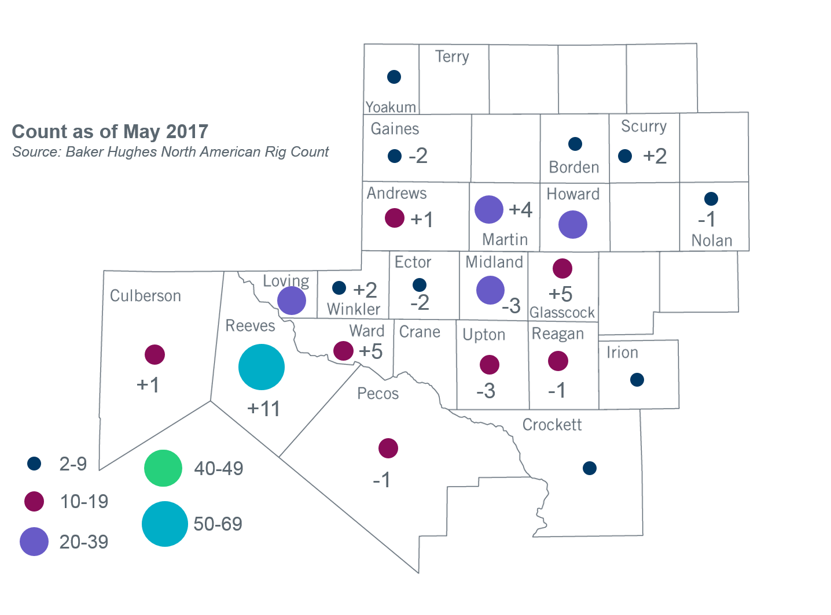
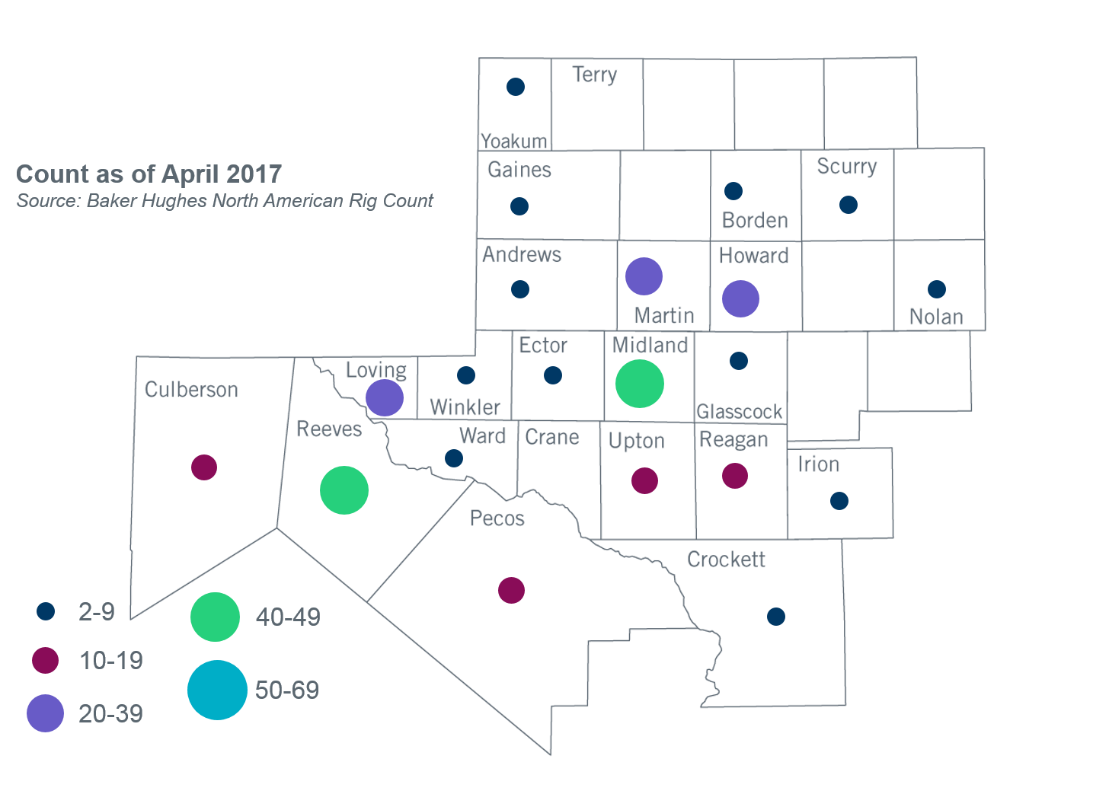

Other Notable Activities
- ERCOT is working on reliability analysis for the 2017 Regional Transmission Plan (RTP). ERCOT posted the initial start cases to be used in the 2017 RTP on the MIS Secure website on April 26, 2017. ERCOT continues to perform a load review for the Far West weather zone.
- ERCOT shared an initial scope and process document for the 2018 LTSA with the RPG for feedback during the March RPG meeting. The LTSA Scenario development was kicked off in the May RPG meeting with a follow up workshop planned for the June RPG meeting. Following the May workshop stakeholders provided valuable feedback which will be used to develop scenarios and assumptions for 2018 LTSA. At the June RPG meeting, ERCOT plans to finalize the scenarios and assumptions that will be used to conduct the 2018 LTSA.
- On July 19, 2016, Public Utility Commission of Texas (PUCT) Chairman Nelson filed a memo in docket 45633 addressing the proposed move of the Lubbock Power and Light (LP&L) system from the Southwest Power Pool (SPP) grid into the Electric Reliability Council of Texas (ERCOT) grid. The memo included a recommendation for analyses to be performed by SPP and ERCOT. ERCOT presented the study results to TAC in May and will share the results with the Board in June.
- ERCOT presented the Rayburn Load Integration Study results and the ERCOT recommendation to stakeholders at the March RPG meeting. ERCOT presented the study results to TAC in May and will share the results with the Board in June.
- The SPWG is continuing work on their 2017 FY base cases. ERCOT sent Pass 3 out to the group on 06/02/2017 and the TSPs are to submit their changes to Pass 3 by 06/09/2017. Cases will be completed and posted by 6/30/2017.

+/- symbol indicates the increase or decrease from the previous month in oil rigs present in each county. There is a total increase of 17 oil rigs in the Permian Basin from April-May 2017.

