NPRR Number | 815 | NPRR Title | Revise the Limitation of Load Resources Providing Responsive Reserve (RRS) Service
Date |  | June 14, 2017
Submitter’s Information
Name |  | Michael J. Jewell
E-mail Address |  | michael@jewellandassociates.com
Company |  | On behalf of EnerNOC
Phone Number |  | 512.423.4065
Cell Number |  | 512.423.4065
Market Segment |  | Independent Retail Electric Providers

Comments
EnerNOC respectfully recommends that PRS support NPRR815 as filed for reasons consistent with ERCOT’s comments filed on February 24, 2017.
On April 10, 2017, LCRA filed their second set of comments opposing NPRR815, contending that the proposed changes would reduce ERCOT system reliability as well as system inertia. In response, ERCOT has continued to support NPRR815 and has worked with stakeholders at ROS and PDCWG to address concerns over system inertia.
EnerNOC supports NPRR815 as written. NPRR815 would allow Load RRS to provide more than the current 50% limit. In current ERCOT market clearing reports, it is apparent that Load RRS offers often are being prorated by around 20% of their offered MW. The below graphic shows proration for March 31, 2017, as a sample day. Average proration across hours for this day amount to awarding 82% of MW offered by Load for RRS.
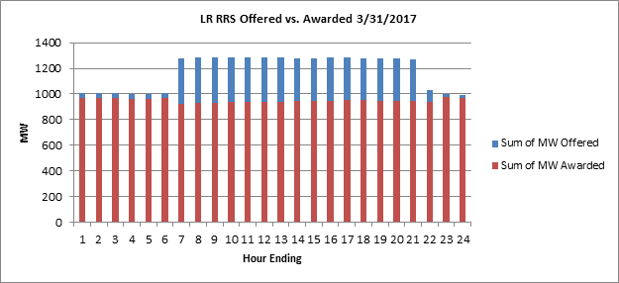
In addition, the following table from the Potomac Economic Report demonstrates that the offers to provide RRS from load are exceeding the cap, resulting in prorations of awards. The graph shows that the trend of prorating load offers to provide RRS is increasing in frequency and magnitude, year-over-year.
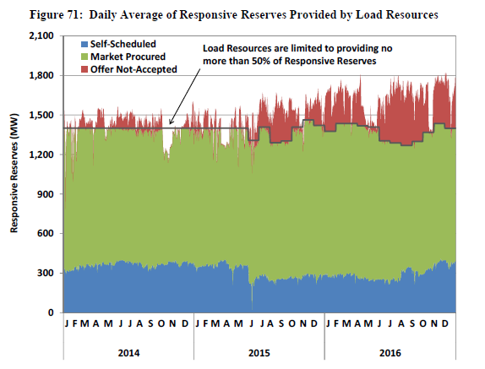
As a new market entrant to providing RRS in ERCOT, and for any new market entrant providing RRS, EnerNOC is concerned that the proration of awards may be a deterrent to participation by loads. Loads are registered with a specific capability in terms of responding to the need to modulate frequency. Rationing the contribution that load can make may be difficult if the customer has provided certain capabilities that will be reduced within the short amount of time required for a response – in other words, there are “blocks” of load available to be deployed, but not portions of those blocks. In such instances, QSEs will not have the ability to throttle up or down those specific response capabilities of an individual customer participant. Also, aggregators and customers make investments in metering equipment and technologies to enable customer participation and readiness to meet ERCOT requirements. Rationing awards may reduce the economic viability of customer participation and return on these investments for those customers.
As stated by ERCOT in their February 24 comments in support of NPRR815:
“ERCOT supports NPRR815 as proposed because there is no technical basis for 50% limit imposed on Load Resources. Dynamic studies performed by ERCOT have consistently supported removal of the 50% limit. ERCOT also supports this NPRR because once approved, this NPRR will allow ERCOT to procure exact quantities of RRS that it needs without making upward adjustments due to 50% limit.”
With the passage of NPRR815, ERCOT would not have to make upward adjustments of Generation RRS or proration adjustments of Load RRS, for in their own words “no technical basis.” ERCOT will be able to procure the exact quantities of RRS that the market needs.
LCRA additionally proposed in their April 10 comments that generation RRS and Load Resource RRS services be offered and procured independent of each other in split offer stacks. EnerNOC opposes this suggestion and reiterates ERCOT’s argument that the split offer stack discussion is not within the scope of NPRR815. EnerNOC believes that NPRR815 should stand alone as written.
NPRR815 provides a release of the 50% limit imposed on Load Resources. This changes the constraint on ERCOT from procuring a maximum amount of Load RSS to the procuring a required minimum MW of load generation, which would encourage appropriate ancillary market signals without the need for split offer stacks.

Revised Cover Page Language
None
Revised Proposed Protocol Language
None.

