April 2017 ERCOT Monthly Operations Report
Reliability and Operations Subcommittee Meeting
June 8th, 2017

Table of Contents
1. Report Highlights 2
2. Frequency Control 3
2.1. Frequency Events 3
2.2. Responsive Reserve Events 4
2.3. Load Resource Events 4
3. Reliability Unit Commitment 4
4. Wind Generation as a Percent of Load 5
5. Congestion Analysis 6
5.1. Notable Constraints for April 6
5.2. Generic Transmission Constraint Congestion 8
5.3. Manual Overrides for April 8
5.4. Congestion Costs for Calendar Year 2017 8
6. System Events 9
6.1. ERCOT Peak Load 9
6.2. Load Shed Events 9
6.3. Stability Events 9
6.4. Notable PMU Events 10
6.5. TRE/DOE Reportable Events 10
6.6. New/Updated Constraint Management Plans 10
6.7. New/Modified/Removed RAS 10
6.8. New Procedures/Forms/Operating Bulletins 10
7. Emergency Conditions 10
7.1. OCNs 10
7.2. Advisories 10
7.3. Watches 10
7.4. Emergency Notices 10
8. Application Performance 11
8.1. TSAT/VSAT Performance Issues 11
8.2. Communication Issues 11
8.3. Market System Issues 11
9. Model Updates 11
Appendix A: Real-Time Constraints 12

Report Highlights
- The unofficial ERCOT peak for April was 53,420 MW.
- There were five frequency events in April. PMU data indicates the ERCOT system transitioned well in each case.
- There were five instances where Responsive Reserves were deployed, four of which were the result of frequency events.
- There were six RUC commitments in April.
- The level of reportable SCED congestion decreased in April. This congestion was mostly due to planned outages as well as high wind output. There were fifty-eight instances over 30 days on the Generic Transmission Constraints (GTCs) in April. There were twenty-eight days on the Panhandle GTC, one day on the North – Houston GTC, and twenty-nine days on the Bakersfield GTC in April. There was no activity on the remaining GTCs during the Month.
- There were no significant system events for the month of April.
- ERCOT Applications performed well throughout the month. There were no ERCOT related application performance issues.

Frequency Control

Frequency Events
The ERCOT Interconnection experienced five frequency events in April, all of which resulted from Resource trips. The average event duration was approximately 0:03:39.

When analyzing frequency events, ERCOT evaluates PMU data according to industry standards. Events with an oscillating frequency of less than 1 Hz are considered to be inter-area, while higher frequencies indicate local events. Industry standards specify that damping ratio for inter-area oscillations should be 3.0% or greater. All events listed below indicate the ERCOT system met these standards and transitioned well after each disturbance.

Reported frequency events will include both frequency events where frequency was outside the range of 60±0.1 Hz as well as those determined to be Frequency Measurable Events (FME) as defined by BAL-001-TRE-1. Delta Frequency is defined as the difference between the pre-perturbation and post-perturbation frequency. The Duration of Event is defined as the time it takes for the frequency to recover to lesser/greater of the frequency at the time of the frequency event (t(0) or “A-point”) for low/high-frequency events, respectively. Further details on FMEs can be found in the MIS posted BAL-001-TRE-1 PDCWG Unit Performance reports. A summary of the frequency events is provided below:

Date and Time | Delta Frequency |  | Max/Min Frequency |  | Duration of Event |  | PMU Data |  |  |  | Load | Wind | Inertia¹
 | (Hz) |  | (Hz) |  |  |  | Oscillation Mode (Hz) |  | Damping Ratio |  | (MW) | % | (MW-s)
4/10/2017 3:25 |  | 0.070 |  | 59.90 |  | 0:03:23 |  | No PMU Data Available. |  |  | 29,849 | 36% | 178,651
4/13/2017 9:14 |  | 0.112 |  | 59.86 |  | 0:03:49 |  | 0.74 |  | 9% | 35,681 | 8% | 200,473
4/16/2017 8:47 |  | 0.075 |  | 59.91 |  | 0:02:13 |  | No PMU Data Available. |  |  | 32,111 | 24% | 181,529
4/26/2017 18:29 |  | 0.039 |  | 59.90 |  | 0:04:32 |  | No PMU Data Available. |  |  | 44,953 | 11% | 255,457
4/30/2017 5:31 |  | 0.032 |  | 59.91 |  | 0:04:19 |  | No PMU Data Available. |  |  | 26,879 | 44% | 160,904
(Note: frequency events highlighted in blue have been identified as FMEs per BAL-001-TRE-1 and the Performance Disturbance Compliance Working group.)

Currently, the Critical Inertia Level for ERCOT is approximately 100,000 MW-s (Source: link)
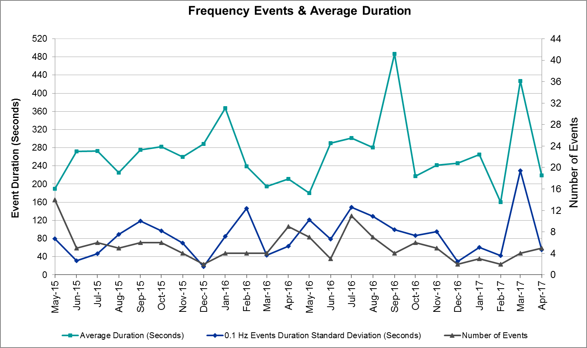
(Note: All data on this graph encompasses frequency event analysis based on BAL-001-TRE-1.)

Responsive Reserve Events
There were five events where Responsive Reserve MWs were released to SCED in April. The events highlighted in blue were related to frequency events reported in Section 2.1 above.

Date and Time Released to SCED | Date and Time Recalled | Duration of Event | Maximum MWs Released
4/10/2017 3:25:54 | 4/10/2017 3:28:10 | 0:02:16 | 261.68
4/13/2017 9:14:36 | 4/13/2017 9:18:00 | 0:03:24 | 627.47
4/14/2017 8:57:29 | 4/14/2017 8:59:30 | 0:02:01 | 113.70
4/16/2017 8:47:55 | 4/16/2017 8:49:15 | 0:01:20 | 128.98
4/26/2017 18:29:26 | 4/26/2017 18:33:54 | 0:04:28 | 488.98

Load Resource Events
None.

Reliability Unit Commitment
ERCOT reports on Reliability Unit Commitments (RUC) on a monthly basis. Commitments are reported grouped by operating day and weather zone. The total number of hours committed is the sum of the hours for all the units in the specified region. Additional information on RUC commitments can be found on the MIS secure site at Grid Generation Reliability Unit Commitment.

There were no DRUC commitments in April.

There were six HRUC commitments in April.

Resource Location | # of Resources | Operating Day | Total # of Hours Committed | Total MWhs | Reason for Commitment
Coast | 2 | 4/14/2017 | 22 | 9,920 | Local Congestion
Southern | 1 | 4/22/2017 | 1 | 40 | Voltage Support
Southern | 1 | 4/25/2017 | 5 | 1,650 | Local Congestion
Southern | 1 | 4/26/2017 | 8 | 2,640 | Local Congestion
Coast | 1 | 4/28/2017 | 2 | 1,498 | Local Congestion
Coast | 2 | 4/29/2017 | 9 | 6,675 | Local Congestion

Wind Generation as a Percent of Load
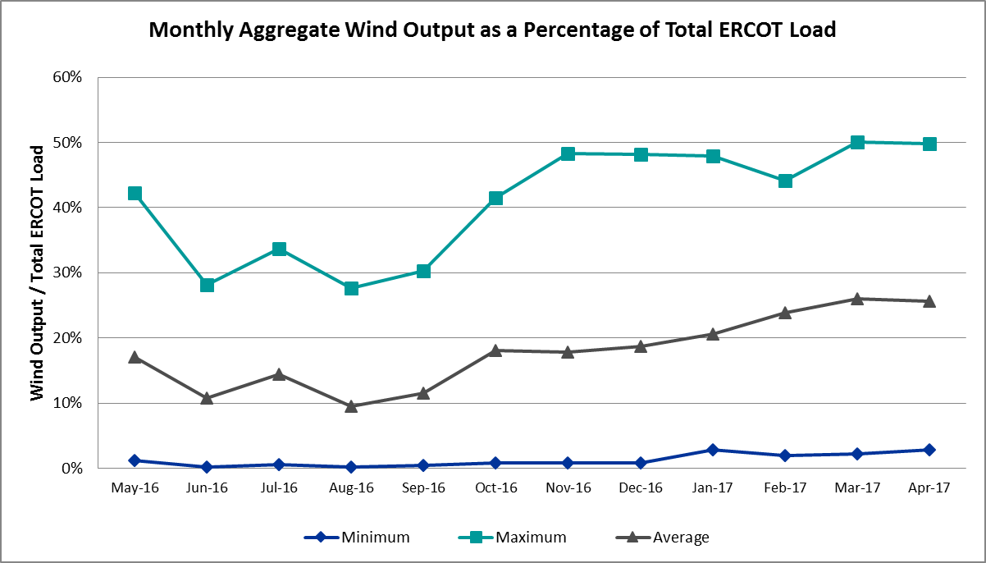

Congestion Analysis
The number of congestion events experienced by the ERCOT system decreased in April. There were fifty-eight instances over 30 days on the Generic Transmission Constraints (GTCs) in April.

Notable Constraints for April
Nodal protocol section 3.20 specifies that ERCOT shall identify transmission constraints that are active or binding three or more times within a calendar month. As part of this process, ERCOT reports congestion that meets this criterion to ROS. In addition ERCOT also highlights notable constraints that have an estimated congestion rent exceeding $1,000,000 for a calendar month. These constraints are detailed in the table below. Rows highlighted in blue indicate the congestion was affected by one or more outages. For a list of all constraints activated in SCED for the month of April, please see Appendix A at the end of this report.

Contingency Name | Overloaded Element | # of Days Constraint Active | Congestion Rent | Transmission Project
Basecase | PNHNDL GTC | 28 | $15,857,860.87
Hecker- WhitePoint 138 kV | Whitepoint - Rincon 138 kV | 7 | $14,822,421.12
Jewett - Singleton 345 kV | Gibbons Creek - Twin Oak Switch 345 kV | 1 | $10,804,684.83 | Houston Import Project
Roans Prairie - Rothwood & Singleton – Tomball 345 kV | Singleton - Zenith 345 kV | 12 | $10,511,799.44 | Houston Import Project
North Pharr - Pharr Magic Valley 138 kV | North Mcallen - West Mcallen 138 kV | 7 | $7,271,156.54
Jewett – Singleton 345 kV | Singleton - Gibbons Creek 345 kV | 11 | $7,054,315.84 | Houston Import Project
Hicks Switch – Alliance & Roanoke 345 kV | Blue Mound - Wagley Robertson 138 kV | 11 | $6,518,320.10
Jewett - Singleton 345 kV | Gibbons Creek - Singleton 345 kV | 4 | $4,795,661.53 | Houston Import Project
Cedar Bayou Plant - Quanum & Strange 138 kV | Channelview - Lynch 138 kV | 2 | $3,308,412.94
Carrollton Northwest – Lewisville Switch 345 kV | Carrollton Northwest - Lakepointe Tnp 138 kV | 13 | $3,063,824.73 | 5488
Roans Prairie - Rothwood & Singleton - Tomball 345 kV | Singleton - Zenith 345 kV | 3 | $2,601,096.69 | Houston Import Project
Jones Street Tnp to Lewisville Swithc 138 kV | Ti Tnp - West Tnp 138 kV | 4 | $2,451,766.27
Lon Hill 69a1 138/69 kV | Koch Up River 138/69 kV | 2 | $1,688,035.40
Trinidad – Richland Chambers 345 kV | Big Brown Ses - Jewett 345 kV | 1 | $1,617,200.02
Eagle Mountain – Saginaw Switch 138 kV | Eagle Mountain Ses - Morris Dido 138 kV | 1 | $1,563,242.27
Mercers Gap Sw - Comanche Switch 138 kV | Holder 138/69 kV | 27 | $1,558,584.57
Bellaire - Smithers 345 kV | Bellaire - Wa Parish 345 kV | 4 | $1,388,113.17
Chevron Has - Ward Gulf Tap | Permian Basin Ses 138/1kV | 1 | $1,326,224.51
Fort Stockton Plant 138_69t1 | Solstice - Pig Creek Tap 138kV | 28 | $1,178,364.44 | 3705
Rio Hondo – North Endinburg 345 kV & Harlingen Switch | Burns Sub - Rio Hondo 138kV | 8 | $1,127,827.55
Coleto Creek 345_138h 345/138 kV | Coleto Creek - Victoria 138 kV | 1 | $1,101,562.04
Greens Bayou - Gable & Hardy – Crocket 138 kV | Midtown - Garrott 138 kV | 1 | $1,067,290.23
Asphalt Mines – Blewett 138 kV | Hamilton Road - Maverick 138 kV | 14 | $967,783.87 | 16TPIT0024
North Mccamey - Odessa Ehv 345 kV | Solstice - Pig Creek Tap 138 kV | 12 | $498,881.51 | 3705
Big Hill - Kendal 345 kV | Hamilton Road - Maverick 138 kV | 9 | $428,105.14 | 16TPIT0024
Ajo to Rio Hondo 345 kV | Raymondville 1 - Raymondville 2 69 kV | 7 | $293,169.17 | 5169,
Jardin - Cotulla Sub 138 kV | Dilley Switch Aep - Cotulla Sub 69 kV | 3 | $283,972.18 | 5222
Carrollton Northwest – Lewisville Switch 345 kV | Lewisville Switch - Jones Street Tnp 138 kV | 5 | $274,596.95
Victoria-Victoria DuPont Switch 138kv | Greenlake - Weaver Road 69kV | 3 | $253,914.01
Abilene South to Bluff Creek | Abilene Elmcreek - Abilene Northwest 69kV | 3 | $253,858.05
Cobb Switching Station to Jacksboro Switching 345 kV | Rice Switch - Markley (Oncor) 138kV | 9 | $247,350.85
WhitePoint - Lon_Hill & South Texas Project 345 kV | Beeville - Normanna 69kV | 3 | $238,698.08
Armstrong Aep to Yturria Sub | Raymondville 1 - Raymondville 2 69kV | 10 | $221,258.28
Basecase | Burns Sub - Rio Hondo 138kV | 3 | $158,481.03
Laquinta to Lobo 138 KV | Bruni Sub 138/69kV | 8 | $130,917.59 | 5529
Jewett - Singleton 345kv | Btu_Jack_Creek - Twin Oak Switch 345kV | 3 | $114,278.38 | Houston Import Project
Tri Corner – Tyler Grande & Martin Lake - Elkton 345 kV | Tyler West 138/1kV | 4 | $63,510.89
Basecase | Flat Rock Lcra - Wirtz 138kV | 3 | $38,672.86 | 4465
Basecase | BKRSFL GTC | 29 | $30,553.96
Ajo to Nelson Sharpe 345 KV | Harlingen Switch - Raymondville 1 69kV | 3 | $18,818.99 | 5169
Cottonwood Road Switch to Loftin 69 kV | Bowie 138/69kV | 7 | $7,686.69
Big Hill - Kendal 345 kV | Rocksprings - Friess Ranch 69kV | 7 | $6,819.37
Cagnon – Calaveras & Braunig 345kV | Skyline - Calaveras 345kV | 5 | $6,350.75
Big Hill to Twin Buttes 345 kV | Rocksprings - Friess Ranch 69kV | 3 | $3,802.82
North Edinburg –Wed Ednburg & Palmhurst 138 kV | Azteca Sub - Se Edinburg 138kV | 4 | $1,721.83

Generic Transmission Constraint Congestion
There were twenty-eight days on the Panhandle GTC, one day on the North – Houston GTC, and twenty-nine days on the Bakersfield GTC in April. There was no activity on the remaining GTCs during the Month.

Note: This is how many times a constraint has been activated to avoid exceeding a GTC limit, it does not imply an exceedance of the GTC occurred or that the GTC was binding.

Manual Overrides for April
None.

Congestion Costs for Calendar Year 2017
The following table represents the top twenty active constraints for the calendar year based on the estimated congestion rent attributed to the congestion. ERCOT updates this list on a monthly basis.

Contingency | Binding Element | # of 5-min SCED Intervals | Estimated Congestion Rent | Transmission Project
Basecase | Panhandle GTC | 13,143 | $30,453,930.46 | Panhandle Upgrade
White point - McCambell & Hecker 138 kV | Whitepoint - Rincon 138kV | 1,352 | $24,325,582.27
Carrollton Northwest – Lewisville Switch 345 kV | Carrollton Northwest - Lakepointe Tnp 138kV | 5,482 | $22,181,556.65 | 5488
Hicks Switch – Alliance & Roanoke Switch 345kv | Wagley Robertson - Summerfield 138kV | 1,429 | $20,785,800.16
Roans Prairie - Rothwood & Singleton - Tomball 345 kV | Singleton - Zenith 345kV | 6,920 | $19,188,661.35 | Houston Import Project
Hecker to Whitepoint 138 kV | Whitepoint - Rincon 138kV | 1,447 | $14,822,421.12
Roans Prairie - Rothwood & Singleton - Tomball 345 kV | Singleton - Zenith 345kV | 3,615 | $11,831,066.09 | Houston Import Project
Jewett - Singleton 345 kV | Gibbons Creek - Twin Oak Switch 345kV | 298 | $10,861,578.84 | Houston Import Project
White point - Hecker & Dupont Switch - Ingleside 138 kV | Whitepoint - Rincon 138kV | 761 | $9,477,211.29
Jewett - Singleton 345 kV | Singleton - Gibbons Creek 345kV | 2,887 | $7,620,579.90 | Houston Import Project
North Pharr to Pharr Magic Valley 138 KV | North Mcallen - West Mcallen 138kV | 389 | $7,271,156.54
Jewett - Singleton 345 kV | Gibbons Creek - Singleton 345kV | 1,409 | $6,765,164.68 | 3937, Houston Import Project
Hicks Switch – Alliance & Roanoke Switch 345kv | Blue Mound - Wagley Robertson 138kV | 817 | $6,612,343.29
Victoria – Victoria Dupont Switch 138 kV | Formosa - Lolita 138kV | 249 | $5,906,733.06
Formosa Unit Formosg12 | Formosa - Lolita 138kV | 77 | $5,518,567.35
Roserock Solar to Fort Stockton 138 kV | Barrilla - Fort Stockton Switch 69kV | 719 | $4,768,320.64
Singleton – Tomball & Roans Prairie 345 kV | Singleton - Zenith 345kV | 2,206 | $4,377,884.85 | Houston Import Project
Roans Prairie - Rothwood & Singleton - Tomball 345 kV | Bellville South - Peters 138kV | 334 | $3,772,431.71
Big Brown SES -Jewett 345 kV | Trinidad Ses - Richland Chambers 345kV | 31 | $3,672,664.11 | 5480
North Edinburg 345_1382 345/138 KV | Burns Sub - Rio Hondo 138kV | 305 | $3,495,286.45

System Events

ERCOT Peak Load
The unofficial ERCOT peak load for the month was 53,420 MW and occurred on April 28th during hour ending 17:00.

Load Shed Events
None.

Stability Events
None.

Notable PMU Events
ERCOT analyzes PMU data for any significant system disturbances that do not fall into the Frequency Events category reported in section 2.1. The results are summarized in this section once the analysis has been completed.

There were no reportable events in April.

TRE/DOE Reportable Events
None.

New/Updated Constraint Management Plans
None.

New/Modified/Removed RAS
None.

New Procedures/Forms/Operating Bulletins
ERCOT has revised the following procedure manuals, effective April 04, 2017

Procedure Title | POB
Real-Time Desk | 779

ERCOT has revised the following procedure manuals, effective April 06, 2017

Procedure Title | POB
DC Tie Desk | 780
Real-Time Desk | 781
Scripts | 782
Transmission & Security Desk | 783

Emergency Conditions

OCNs
None.

Advisories
Date and Time | Description
4/13/17 09:20 | Advisory issued due to Physical Responsive Capability being below 3000 MW.

Watches
None.

Emergency Notices
None.

Application Performance

TSAT/VSAT Performance Issues
None.

Communication Issues
None.

Market System Issues
None.

Model Updates
The Downstream Production Change (DPC) process allows ERCOT to make changes in the on-line Network Operations Model without loading a completely new model. The purpose of this process is to allow for reliable grid operations as system conditions change between designated Network Operations Model database loads. The DPC process is limited in scope to just those items listed below, with equipment ratings updates being the most common. ERCOT has seen a rise in the use of the DPC process to make on-line updates to the Network Operations Model in recent years, instead of through the standard Network Operations Model Change Request process.

- Static Line ratings (Interim Update)
- Dynamic Line ratings (non-Interim Update)
- Autotransformer ratings (non-Interim Update)
- Breaker and Switch Normal status (Interim Update)
- Contingency Definitions (Interim Update)
- RAP and RAS changes or additions (Interim Update)
- Net Dependable and Reactive Capability (NDCRC) values (Interim Update)
- Impedance Updates (non-Interim)

Transmission Operator | Number of DPCs
STEC | 1
Oncor | 2
AEP | 6

Appendix A: Real-Time Constraints
The following is a complete list of constraints activated in SCED for the month of April. Full contingency descriptions can be found in the Standard Contingencies List located on the MIS secure site at Grid Generation Reliability Unit Commitment.

Contingency | Constrained Element | From Station | To Station | # of Days Constraint Active
BASE CASE | BKRSFL | n/a | n/a | 29
XFTS89 | PIGTAP_SOLSTI1_1 | SOLSTICE | PIGTAP | 28
BASE CASE | PNHNDL | n/a | n/a | 28
SZEPCMN8 | HLD_FMR1 | HLD | HLD | 27
SBRAUVA8 | HAMILT_MAVERI1_1 | MAVERICK | HAMILTON | 14
SBRAUVA8 | HAMILT_MAVERI1_1 | HAMILTON | MAVERICK | 14
DCRLLSW5 | 591__A | LKPNT | CRLNW | 13
DRNS_TB5 | SNGZEN98_A | SNG | ZEN | 12
SNORODE5 | PIGTAP_SOLSTI1_1 | SOLSTICE | PIGTAP | 12
DHCKRNK5 | 6270__C | WGROB | BLMND | 11
DJEWSNG5 | SNGXGC75_1 | GIBCRK | SNG | 11
SARMRA38 | RAYMND_RAYMON1_1 | RAYMOND1 | RAYMND2 | 10
SARMRA38 | RAYMND_RAYMON1_1 | RAYMND2 | RAYMOND1 | 10
DBIGKEN5 | HAMILT_MAVERI1_1 | HAMILTON | MAVERICK | 9
SBOMJC25 | 6560__B | MRKLY | RICSW | 9
DRIOHAR5 | BURNS_RIOHONDO_1 | RIOHONDO | MV_BURNS | 8
SLAQLOB8 | BRUNI_69_1 | BRUNI | BRUNI | 8
SAJORI25 | RAYMND_RAYMON1_1 | RAYMND2 | RAYMOND1 | 7
SCRDLOF9 | BOW_FMR1 | BOW | BOW | 7
SPHAPHA8 | GCB_100_1 | N_MCALLN | W_MCALLN | 7
DBIGKEN5 | FRIR_ROCKSP1_1 | FRIR | ROCKSPRS | 7
DHECWHI8 | RINCON_WHITE_2_1 | WHITE_PT | RINCON | 7
DCRLLSW5 | 590__A | LWSSW | LWVJS | 5
DCAGBRA5 | N5_P4_2_1 | CALAVERS | SKYLINE | 5
SBISMI5 | BI_WAP50_A | WAP | BI | 4
DNEDPAL8 | AZTECA_SE_EDI1_1 | AZTECA | SE_EDINB | 4
DTRCTYG5 | TYWST_MR1H | TYWST | TYWST | 4
BASE CASE | RANDAD_ZAPATA1_1 | RANDADO | ZAPATA | 4
DJEWSNG5 | SNGXGC99_1 | GIBCRK | SNG | 4
SBRAUVA8 | EAGLHY_MAVERI1_1 | MAVERICK | EAGLHYTP | 4
SLWVLWS8 | 588_A_1 | LWSVW | LWVTI | 4
SABSBLU8 | ABEC_ABNTHW2_1 | ABNTHWST | ABEC | 3
DJEWSNG5 | JK_TOKSW_1 | TOKSW | JK_CK | 3
DRNS_TB5 | SNGZEN99_A | SNG | ZEN | 3
SASPPAI8 | ASPM_69T1 | ASPM | ASPM | 3
DWH_STP5 | BEEVIL_NORMAN1_1 | NORMANNA | BEEVILLE | 3
SJARDIL8 | DIL_COTU_1 | DILLEYSW | COTULAS | 3
SBIGTWI5 | FRIR_ROCKSP1_1 | FRIR | ROCKSPRS | 3
DSNG_TB5 | SNGZEN98_A | SNG | ZEN | 3
BASE CASE | BURNS_RIOHONDO_1 | RIOHONDO | MV_BURNS | 3
SN_SAJO5 | HARLNS_RAYMON1_1 | HARLNSW | RAYMOND1 | 3
DJFSCGR8 | JFSSC_06_A | JFS | SC | 3
BASE CASE | 38T365_1 | WIRTZ | FLATRO | 3
DVICV_D8 | GREENL_WEAVER1_1 | WEAVERRD | GREENLK | 3
DLWSRNK5 | 570_B_1 | POCKRUSC | CRNTH | 3
SFAICOR8 | 342T195_1 | GRANMO | MARBFA | 2
XNED258 | NEDIN_138H | NEDIN | NEDIN | 2
DVICEDN8 | VND_PLCE_1 | PLCEDOS | VANBLT69 | 2
DGILHOR8 | 342T195_1 | GRANMO | MARBFA | 2
SCTHHA38 | HAMILT_MAVERI1_1 | HAMILTON | MAVERICK | 2
DWH_STP5 | REFUG_VICTO_1C_1 | VICTORIA | OCONNOR | 2
XNED358 | BURNS_RIOHONDO_1 | RIOHONDO | MV_BURNS | 2
SBUZLME8 | BUZSW_AXF1 | BUZSW | BUZSW | 2
DCBYRN28 | CV_LH_03_A | LH | CV | 2
DVICV_D8 | FORMOS_LOLITA1_1 | LOLITA | FORMOSA | 2
SSPUASP8 | ROTN_WOLFGA1_1 | WOLFGANG | ROTN | 2
SMYRSPR8 | BOW_FMR1 | BOW | BOW | 2
XLON589 | KOCH_UP_69A1 | KOCH_UP | KOCH_UP | 2
XMDS58 | MGSES_MR4H | MGSES | MGSES | 2
SADALA28 | 663__A | MGPSW | CMNSW | 2
XLOB58 | ASHERT_CATARI1_1 | ASHERTON | CATARINA | 2
DCHB_NB5 | BCVPSA03_A | PSA | BCV | 2
SDELNED5 | RAYMND_RAYMON1_1 | RAYMND2 | RAYMOND1 | 2
SBBSNA55 | 60__A | BBSES | NAVARRO | 2
SL_4RAY8 | RAYBURN_69_2 | RAYBURN | RAYBURN | 2
SBOSELM5 | 1030__B | BOSQUESW | RGH | 1
DFERGRA8 | 38T365_1 | WIRTZ | FLATRO | 1
SMCEABS8 | 6585__A | ESKSW | TRNT | 1
SCOLLON5 | VICTO_WARBU_1A_1 | VICTORIA | WARBURTN | 1
DWH_STP5 | AIRCO4_RINCON1_1 | AIRCO4 | RINCON | 1
DGBY_GS8 | GT_MID90_A | GT | MID | 1
SARMRA38 | HARLNS_RAYMON1_1 | HARLNSW | RAYMOND1 | 1
SDELLAR8 | LARDVN_MILO1_1 | LARDVNTH | MILO | 1
SKLELOY8 | LOYOLA_69_1 | LOYOLA | LOYOLA | 1
SHSAPB38 | PBSES_MR1H | PBSES | PBSES | 1
SDOWMOO8 | UVALDE_W_BATE1_1 | UVALDE | W_BATESV | 1
DMARPA_8 | 32T311_1 | BURNET | BERTRA | 1
DSALHUT5 | 421__A | BCESW | SNDSW | 1
DAUSLOS5 | FAYETT_AT2H | FAYETT | FAYETT | 1
BASE CASE | LGD_SANTIA1_1 | LGD | SANTIAGO | 1
DVICEDN8 | NUR_FORT_1 | NURSRYS | FORTRSW | 1
SFAILAG8 | 38T365_1 | WIRTZ | FLATRO | 1
DTRSRCH5 | 40__A | BBSES | JEWET | 1
SFTLMES8 | BGLK_PHBL_T1_1 | BGLK | PHBL_TAP | 1
XCOL58 | COLETO_VICTOR2_1 | COLETO | VICTORIA | 1
SSCUSU28 | ROTN_WOLFGA1_1 | WOLFGANG | ROTN | 1
DFERPAL8 | 32T311_1 | BURNET | BERTRA | 1
SFAICOR8 | 38T365_1 | WIRTZ | FLATRO | 1
DEMSSAG8 | 6265__A | EMSES | MRSDO | 1
SVICCO28 | COLETO_VICTOR2_1 | COLETO | VICTORIA | 1
SMCEABS8 | ABEC_ABNTHW2_1 | ABNTHWST | ABEC | 1
DGBYCRN8 | BCVPSA03_A | PSA | BCV | 1
SPAWLON5 | BEEVIL_NORMAN1_1 | NORMANNA | BEEVILLE | 1
DDILCOT8 | DIL_COTU_1 | DILLEYSW | COTULAS | 1
SBRAUVA8 | EAGLHY_ESCOND1_1 | EAGLHYTP | ESCONDID | 1
SKOCNU28 | GILA_MORRIS1_1 | GILA | MORRIS | 1
BASE CASE | N_TO_H | n/a | n/a | 1
SL_4VIC8 | RAYBURN_69_2 | RAYBURN | RAYBURN | 1
DLONWAR5 | REFUG_VICTO_1C_1 | VICTORIA | OCONNOR | 1
DJEWSNG5 | 256_A_1 | TOKSW | GIBCRK | 1
DFERHOR8 | 342T195_1 | GRANMO | MARBFA | 1
SSCLWF28 | 6560__B | MRKLY | RICSW | 1
DLONWAR5 | BEEVIL_NORMAN1_1 | NORMANNA | BEEVILLE | 1
SCOLLON5 | COLETO_VICTOR2_1 | COLETO | VICTORIA | 1
SZEPCMN8 | DOW_RISN_1 | RISNGSTR | DOWNING | 1
SNADRIC8 | NAD_ELCM_1 | NADAS | ELCMPOS | 1
DSNG_TB5 | SNGZEN99_A | SNG | ZEN | 1
SWINPBS8 | 6101__A | NOTSW | CHEYT | 1
SHWRWEL8 | 921T163_1 | MCNEIL_ | HWRDTP | 1
SBIWAP5 | BI_SMR98_A | SMITHERS | BI | 1
DCC1_VIC | COLETO_VICTOR1_1 | COLETO | VICTORIA | 1
XCO2L58 | COLETO_VICTOR2_1 | COLETO | VICTORIA | 1
SODLBRA8 | HAMILT_MAVERI1_1 | HAMILTON | MAVERICK | 1
DWISALV8 | JACKCNTY_BLSRA_1 | JACKCNTY | BLSRA | 1
BASE CASE | SNYDER_WKN_BK1_1 | ENAS | WKN_BKR | 1

