March 2017 ERCOT Monthly Operations Report
Reliability and Operations Subcommittee Meeting
May 4th, 2017

Table of Contents
1. Report Highlights 2
2. Frequency Control 3
2.1. Frequency Events 3
2.2. Responsive Reserve Events 4
2.3. Load Resource Events 4
3. Reliability Unit Commitment 4
4. Wind Generation as a Percent of Load 5
5. Congestion Analysis 5
5.1. Notable Constraints for March 6
5.2. Generic Transmission Constraint Congestion 8
5.3. Manual Overrides for March 8
5.4. Congestion Costs for Calendar Year 2017 8
6. System Events 9
6.1. ERCOT Peak Load 9
6.2. Load Shed Events 9
6.3. Stability Events 9
6.4. Notable PMU Events 9
6.5. TRE/DOE Reportable Events 9
6.6. New/Updated Constraint Management Plans 10
6.7. New/Modified/Removed SPS 10
6.8. New Procedures/Forms/Operating Bulletins 10
7. Emergency Conditions 10
7.1. OCNs 10
7.2. Advisories 10
7.3. Watches 10
7.4. Emergency Notices 10
8. Application Performance 11
8.1. TSAT/VSAT Performance Issues 11
8.2. Communication Issues 11
8.3. Market System Issues 11
9. Model Updates 11
Appendix A: Real-Time Constraints 12

Report Highlights
- The unofficial ERCOT peak for March was 47,094 MW.
- There were four frequency events in March. PMU data indicates the ERCOT system transitioned well in each case.
- There were five instances where Responsive Reserves were deployed, four of which were the result of frequency events.
- There were three RUC commitments in March.
- The level of reportable SCED congestion increased in March. This congestion was mostly due to planned outages as well as high wind output. There were sixty instances over 31 days on the Generic Transmission Constraints (GTCs) in March. There were twenty-nine days on the Panhandle GTC, one day on the Valley Import GTC, and thirty days on the Bakersfield GTC in March. There was no activity on the remaining GTCs during the Month.
- The Liston GTC was removed on March 8.
- An advisory was issued due to the unavailability of ERCOT’s Voltage Security Assessment Tool (VSAT).

Frequency Control

Frequency Events
The ERCOT Interconnection experienced four frequency events in March, all of which resulted from Resource trips. The average event duration was approximately 0:07:07.

When analyzing frequency events, ERCOT evaluates PMU data according to industry standards. Events with an oscillating frequency of less than 1 Hz are considered to be inter-area, while higher frequencies indicate local events. Industry standards specify that damping ratio for inter-area oscillations should be 3.0% or greater. All events listed below indicate the ERCOT system met these standards and transitioned well after each disturbance.

Reported frequency events will include both frequency events where frequency was outside the range of 60±0.1 Hz as well as those determined to be Frequency Measurable Events (FME) as defined by BAL-001-TRE-1. Delta Frequency is defined as the difference between the pre-perturbation and post-perturbation frequency. The Duration of Event is defined as the time it takes for the frequency to recover to lesser/greater of the frequency at the time of the frequency event (t(0) or “A-point”) for low/high-frequency events, respectively. Further details on FMEs can be found in the MIS posted BAL-001-TRE-1 PDCWG Unit Performance reports. A summary of the frequency events is provided below:

Date and Time | Delta Frequency |  | Max/Min Frequency |  | Duration of Event | PMU Data |  |  | Load | Wind | Inertia¹
 | (Hz) |  | (Hz) |  |  | Oscillation Mode (Hz) | Damping Ratio |  | (MW) | % | (MW-s)
3/9/2017 18:36 |  | 0.099 |  | 59.80 | 0:04:19 | 0.68 | 10% | 39,825 |  | 7% | 231,878
3/14/2017 22:20 |  | 0.055 |  | 59.88 | 0:03:22 | 0.76 | 18% | 33,222 |  | 31% | 177,897
3/15/2017 1:36 |  | 0.119 |  | 59.79 | 0:09:53 | 0.81 | 15% | 27,933 |  | 32% | 153,186
3/29/2017 19:54 |  | 0.080 |  | 59.80 | 0:10:53 | 0.71 | 13% | 41,950 |  | 20% | 214,412
(Note: frequency events highlighted in blue have been identified as FMEs per BAL-001-TRE-1 and the Performance Disturbance Compliance Working group.)

Currently, the Critical Inertia Level for ERCOT is approximately 100,000 MW-s (Source: link)
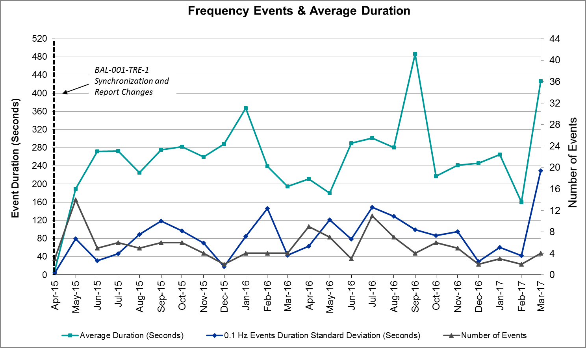
(Note: All data on this graph encompasses frequency event analysis based on BAL-001-TRE-1.)

Responsive Reserve Events
There were four events where Responsive Reserve MWs were released to SCED in March. The events highlighted in blue were related to frequency events reported in Section 2.1 above.

Date and Time Released to SCED | Date and Time Recalled | Duration of Event | Maximum MWs Released
3/9/2017 18:36:50 | 3/9/2017 18:40:25 | 0:03:35 | 955.31
3/14/2017 22:20:58 | 3/14/2017 22:24:14 | 0:03:16 | 490.77
3/15/2017 1:36:21 | 3/15/2017 1:45:37 | 0:09:16 | 1407.48
3/24/2017 8:11:13 | 3/24/2017 8:13:24 | 0:02:11 | 256.40
3/29/2017 19:54:27 | 3/29/2017 20:05:31 | 0:11:04 | 1211.97

Load Resource Events
None.

Reliability Unit Commitment
ERCOT reports on Reliability Unit Commitments (RUC) on a monthly basis. Commitments are reported grouped by operating day and weather zone. The total number of hours committed is the sum of the hours for all the units in the specified region. Additional information on RUC commitments can be found on the MIS secure site at Grid Generation Reliability Unit Commitment.

There were no DRUC commitments in March.

There were three HRUC commitments in March.

Resource Location | # of Resources | Operating Day | Total # of Hours Committed | Total MWhs | Reason for Commitment
Coast | 1 | 3/17/2017 | 3 | 615 | Local Congestion
North Central | 2 | 3/24/2017 | 10 | 4,310 | Local Congestion
Coast | 2 | 3/27/2017 | 2 | 112 | Houston Import

Wind Generation as a Percent of Load
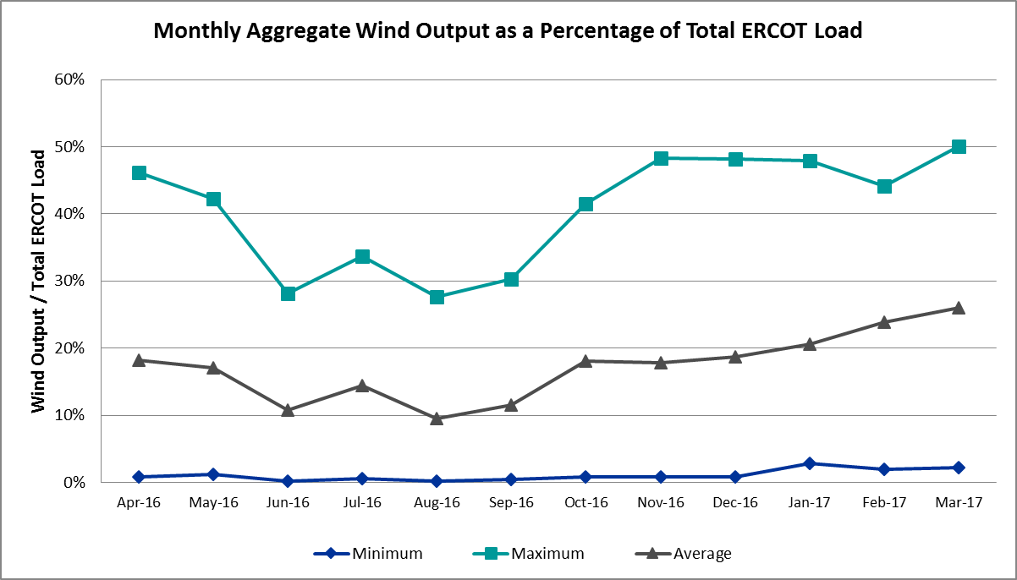

Congestion Analysis
The number of congestion events experienced by the ERCOT system increased in March. There were sixty instances over 31 days on the Generic Transmission Constraints (GTCs) in March.

Notable Constraints for March
Nodal protocol section 3.20 specifies that ERCOT shall identify transmission constraints that are active or binding three or more times within a calendar month. As part of this process, ERCOT reports congestion that meets this criterion to ROS. In addition ERCOT also highlights notable constraints that have an estimated congestion rent exceeding $1,000,000 for a calendar month. These constraints are detailed in the table below. Rows highlighted in blue indicate the congestion was affected by one or more outages. For a list of all constraints activated in SCED for the month of March, please see Appendix A at the end of this report.

Contingency Name | Overloaded Element | # of Days Constraint Active | Congestion Rent | Transmission Project
White point - McCambell & Hecker 138 kV | Whitepoint - Rincon 138 kV | 5 | $24,325,582.27
White point - Hecker & Dupont Switch - Ingleside 138 kV | Whitepoint - Rincon 138 kV | 4 | $9,477,211.29
Basecase | Panhandle GTC | 29 | $9,440,022.62
Carrollton Northwest – Lewisville Switch 345 kV | Carrollton Northwest - Lakepointe Tnp 138 kV | 20 | $7,135,460.12 | 5488
Formosa Unit FORMOSG12 | Formosa - Lolita 138 kV | 1 | $5,518,567.35
Roans Prairie - Rothwood & Singleton - Tomball 345 kV | Singleton - Zenith 345 kV | 11 | $5,252,899.75 | Houston Import Project
Roans Prairie - Rothwood & Singleton - Tomball 345 kV | Singleton - Zenith 345 kV | 9 | $4,530,508.71 | Houston Import Project
Roans Prairie - Rothwood & Singleton - Tomball 345 kV | Bellville South - Peters 138 kV | 2 | $3,772,431.71
Lwssw-Krwsw&Rnksw 345kv | Corinth (Oncor) - Pockrus Substation 138kV | 4 | $2,078,472.77
Singleton – Tomball & Roans Prairie 345 kV | Singleton - Zenith 345kV | 9 | $1,836,813.68 | Houston Import Project
Basecase | BKRSFL GTC | 30 | $1,607,684.31
Btu_Industrial_Park - Btu_N | Btu_East - Btu_Shady_Lane 69 kV | 1 | $1,310,633.78
Formosa Unit FORMOSG3 | Formosa - Lolita 138 kV | 1 | $1,250,064.96
Carrollton Northwest – Lewisville Switch 345 kV | Lewisville Switch - Jones Street Tnp 138 kV | 8 | $1,142,172.72
Nelson Sharpe - Ajo 345 kV | Raymondville 2 - Yturria Sub 138 kV | 5 | $1,121,615.42
Jones Street Tnp - Lewisville | Ti Tnp - West Tnp 138 kV | 1 | $1,031,542.33
Laquinta - Lobo 138 kV | Bruni Sub 138/69 kV | 15 | $618,349.21 | 5529
Mercers Gap Sw - Comanche S | Holder 138/69 kV | 23 | $514,411.45
Asphalt Mines - Blewett | Hamilton Road - Maverick 138kV | 15 | $483,151.61 | 16TPIT0024
Jardin - Cotulla Sub 138 kV | Dilley Switch Aep - Cotulla Sub 69 kV | 6 | $442,880.72 | 5222
Jewett - Singleton 345 kV | Singleton - Gibbons Creek 345 kV | 6 | $418,080.25 | Houston Import Project
Loyola Sub - Kleberg Aep 138 kV | Loyola Sub 138/69 kV | 10 | $326,795.30
Decker Power Plant – Sand Hill Energy Ctr & Onion Creek 138 kV | Kingsbery - Bergstrom 138 kV | 4 | $321,728.93
Cagnon – Calaveras & Braunig 345 kV | Skyline - Calaveras 345 kV | 5 | $281,620.84
Fort Stockton Plant 138/69 kV | Solstice - Pig Creek Tap 138 kV | 23 | $255,922.94 | 3705
Rio Hondo – North Edinburg 345 kV & Harlingen Switch | Burns Sub - Rio Hondo 138kV | 3 | $252,176.27
North Mccamey - Odessa Ehv | Solstice - Pig Creek Tap 138 kV | 11 | $244,554.34 | 3705
Nada Sub - Ricebird 138 kV | Nada Sub - El Campo Sub 69 kV | 7 | $208,568.06
Pawnee Switching Station - Lon Hill 345 kV | Airco Aep - Rincon 138 kV | 7 | $188,449.76
Salt Creek Bepc - Salt Creek | Aspermont Aep 138/69kV | 9 | $154,548.37
Basecase | Randado Aep - Zapata 138 kV | 14 | $104,817.75
Big Hill - Twin Buttes 345 kV | Rocksprings - Friess Ranch 69 kV | 4 | $77,994.18
Scurry Switch - Sun Switch | Aspermont Aep 138/69 kV | 8 | $58,793.63
Bosque Switch - Elm Mott 345 kV | Bosque Switch - Rogers Hill Bepc 138 kV | 14 | $51,418.07
Bighill -Kendal 345 kV | Rocksprings - Friess Ranch 69 kV | 4 | $36,539.03
Basecase | Wkn_Bkr - Ena Snyder Wind 69 kV | 7 | $18,900.95
Adamsville - Evant 138/13.8 kV | Comanche Switch (Oncor) - Mercers Gap Sw 138 kV | 6 | $17,282.65
Mcelmurray Tap Switchyard to Abilene South 138 kV | Roby - Round Tree Tap 69 kV | 3 | $1,936.41

Generic Transmission Constraint Congestion
There were twenty-nine days on the Panhandle GTC, one day on the Valley Import GTC, and thirty days on the Bakersfield GTC in March. There was no activity on the remaining GTCs during the Month.

Note: This is how many times a constraint has been activated to avoid exceeding a GTC limit, it does not imply an exceedance of the GTC occurred or that the GTC was binding.

The Liston GTC was retired on March 8, 2017 due to an area wind farm commissioning its permanent point of interconnection.

Manual Overrides for March
None.

Congestion Costs for Calendar Year 2017
The following table represents the top twenty active constraints for the calendar year based on the estimated congestion rent attributed to the congestion. ERCOT updates this list on a monthly basis.

Contingency | Binding Element | # of 5-min SCED Intervals | Estimated Congestion Rent | Transmission Project
White point - McCambell & Hecker 138 kV | Whitepoint - Rincon 138kV | 1,352 | $24,325,582.27
Hicks Switch – Alliance & Roanoke Switch 345kv | Wagley Robertson - Summerfield 138kV | 1,429 | $20,785,800.16
Carrollton Northwest – Lewisville Switch 345 kV | Carrollton Northwest - Lakepointe Tnp 138kV | 4,389 | $19,117,731.92 | 5488
Basecase | Panhandle GTC | 9,101 | $14,833,581.09 | Panhandle Upgrade
White point - Hecker & Dupont Switch - Ingleside 138 kV | Whitepoint - Rincon 138kV | 761 | $9,477,211.29
Roans Prairie - Rothwood & Singleton - Tomball 345 kV | Singleton - Zenith 345kV | 3,375 | $9,229,969.40 | Houston Import Project
Roans Prairie - Rothwood & Singleton - Tomball 345 kV | Singleton - Zenith 345kV | 4,636 | $9,164,909.61 | Houston Import Project
Victoria – Victoria Dupont Switch 138 kV | Formosa - Lolita 138kV | 222 | $5,906,733.06
Formosa Unit FORMOSG12 | Formosa - Lolita 138kV | 77 | $5,518,567.35
Roserock Solar - Fort Stockton 138 kV | Barrilla - Fort Stockton Switch 69kV | 719 | $4,768,320.64
Singleton – Tomball & Roans Prairie 345 kV | Singleton - Zenith 345kV | 2,132 | $4,377,884.85 | Houston Import Project
Roans Prairie - Rothwood & Singleton - Tomball 345 kV | Bellville South - Peters 138kV | 334 | $3,772,431.71
Big Brown SES -Jewett 345 kV | Trinidad Ses - Richland Chambers 345kV | 31 | $3,672,664.11 | 5480
North Edinburg 345/138 kV | Burns Sub - Rio Hondo 138kV | 305 | $3,495,286.45
Carrollton Northwest - Lewisville 345 kV | Lewisville Switch - Jones Street Tnp 138kV | 851 | $3,164,094.54
Basecase | Bakersfield GTC | 4,233 | $2,763,284.44
Lewisville – Krum West Switch & Roanoke Switch 345 kV | Corinth (Oncor) - Pockrus Substation 138kV | 574 | $2,307,313.34
Twin Buttes AT2H 345/138 kV | San Angelo Red Creek T1H 345/13.2/138kV | 46 | $2,061,790.34 | 3664
Btu_Industrial_Park to Btu_North 69 KV | Btu_East - Btu_Shady_Lane 69kV | 85 | $1,310,633.78
Formosa Unit FORMOSG3 | Formosa - Lolita 138kV | 18 | $1,250,064.96

System Events

ERCOT Peak Load
The unofficial ERCOT peak load for the month was 47,094 MW and occurred on March 20th during hour ending 18:00.

Load Shed Events
None.

Stability Events
None.

Notable PMU Events
ERCOT analyzes PMU data for any significant system disturbances that do not fall into the Frequency Events category reported in section 2.1. The results are summarized in this section once the analysis has been completed.

There were no reportable events in March.

TRE/DOE Reportable Events
ERCOT ISO submitted a NERC EOP-004 report on March 15, 2017 due to multiple generation resources tripped within one minute totaling ~1,354 MWs of generation. Please see section 2.1 Frequency Events and the 3/15/2017 01:36 event for additional information. This event meets the criteria of a NERC DCS event for ERCOT.

New/Updated Constraint Management Plans
None.

New/Modified/Removed SPS
None.

New Procedures/Forms/Operating Bulletins
ERCOT has revised the following procedure manuals, effective March 31, 2017.

Procedure Title | POB
DC Tie Desk | 771
Real-Time Desk | 772
Reliability Risk Desk | 773
Reliability Unit Commitment Desk | 774
Resource Desk | 775
Scripts | 776
Shift Supervisor Desk | 777
Transmission & Security Desk | 778

Emergency Conditions

OCNs
None.

Advisories
Date and Time | Description
3/09/17 18:50 | Advisory issued due to Physical Responsive Capability being below 3000 MW.
3/11/17 10:41 | Advisory issued due to Physical Responsive Capability being below 3000 MW.
3/30/17 15:18 | Advisory issued due to VSAT being unavailable.

Watches
Date and Time | Description
3/27/17 16:04 | Watch issued due to North to Houston Interface.

Emergency Notices
None.

Application Performance

TSAT/VSAT Performance Issues
- 3/30/17 – An advisory was issued due to the unavailability of ERCOT’s Voltage Security Assessment Tool (VSAT).

Communication Issues
None.

Market System Issues
None.

Model Updates
The Downstream Production Change (DPC) process allows ERCOT to make changes in the on-line Network Operations Model without loading a completely new model. The purpose of this process is to allow for reliable grid operations as system conditions change between designated Network Operations Model database loads. The DPC process is limited in scope to just those items listed below, with equipment ratings updates being the most common. ERCOT has seen a rise in the use of the DPC process to make on-line updates to the Network Operations Model in recent years, instead of through the standard Network Operations Model Change Request process.

- Static Line ratings (Interim Update)
- Dynamic Line ratings (non-Interim Update)
- Autotransformer ratings (non-Interim Update)
- Breaker and Switch Normal status (Interim Update)
- Contingency Definitions (Interim Update)
- RAP and RAS changes or additions (Interim Update)
- Net Dependable and Reactive Capability (NDCRC) values (Interim Update)
- Impedance Updates (non-Interim)

Transmission Operator | Number of DPCs
ERCOT | 3
Denton | 1
AEP | 7
Oncor | 9
CPS | 1

Appendix A: Real-Time Constraints
The following is a complete list of constraints activated in SCED for the month of March. Full contingency descriptions can be found in the Standard Contingencies List located on the MIS secure site at Grid Generation Reliability Unit Commitment.

Contingency | Constrained Element | From Station | To Station | # of Days Constraint Active
BASE CASE | BKRSFL | n/a | n/a | 30
BASE CASE | PNHNDL | n/a | n/a | 29
SZEPCMN8 | HLD_FMR1 | HLD | HLD | 23
XFTS89 | PIGTAP_SOLSTI1_1 | PIGTAP | SOLSTICE | 23
XFTS89 | PIGTAP_SOLSTI1_1 | SOLSTICE | PIGTAP | 23
DCRLLSW5 | 591__A | LKPNT | CRLNW | 20
SLAQLOB8 | BRUNI_69_1 | BRUNI | BRUNI | 15
SBRAUVA8 | HAMILT_MAVERI1_1 | HAMILTON | MAVERICK | 15
BASE CASE | RANDAD_ZAPATA1_1 | RANDADO | ZAPATA | 14
SBOSELM5 | 1030__B | BOSQUESW | RGH | 14
SNORODE5 | PIGTAP_SOLSTI1_1 | SOLSTICE | PIGTAP | 11
DRNS_TB5 | SNGZEN99_A | SNG | ZEN | 11
SKLELOY8 | LOYOLA_69_1 | LOYOLA | LOYOLA | 10
SSPUMW18 | ASPM_69T1 | ASPM | ASPM | 9
DSNG_TB5 | SNGZEN99_A | SNG | ZEN | 9
DRNS_TB5 | SNGZEN98_A | SNG | ZEN | 9
SSCUSU28 | ASPM_69T1 | ASPM | ASPM | 8
DCRLLSW5 | 590__A | LWSSW | LWVJS | 8
SPAWLON5 | AIRCO4_RINCON1_1 | RINCON | AIRCO4 | 7
SNADRIC8 | NAD_ELCM_1 | NADAS | ELCMPOS | 7
BASE CASE | SNYDER_WKN_BK1_1 | ENAS | WKN_BKR | 7
DJEWSNG5 | SNGXGC75_1 | GIBCRK | SNG | 6
SJARDIL8 | DIL_COTU_1 | DILLEYSW | COTULAS | 6
SADALA28 | 663__A | MGPSW | CMNSW | 6
DWHIHEC8 | RINCON_WHITE_2_1 | WHITE_PT | RINCON | 5
SN_SAJO5 | MV_YUT_RAYMND1_1 | RAYMND2 | MV_YUTT | 5
DCAGBRA5 | N5_P4_2_1 | CALAVERS | SKYLINE | 5
DLWSRNK5 | 570_B_1 | POCKRUSC | CRNTH | 4
DWHII_D8 | RINCON_WHITE_2_1 | WHITE_PT | RINCON | 4
DBIGKEN5 | FRIR_ROCKSP1_1 | ROCKSPRS | FRIR | 4
DBIGKEN5 | FRIR_ROCKSP1_1 | FRIR | ROCKSPRS | 4
SBIGTWI5 | FRIR_ROCKSP1_1 | FRIR | ROCKSPRS | 4
DDECSAN8 | CKT_1021_1 | BERGSTRO | KINGSBER | 4
SMCEABS8 | ROBY_RONDTP1_1 | ROBY | RONDTPT | 3
DRIOHAR5 | BURNS_RIOHONDO_1 | RIOHONDO | MV_BURNS | 3
SSCUSU28 | ROTN_WOLFGA1_1 | WOLFGANG | ROTN | 3
DWH_STP5 | BEEVIL_THREE_1_1 | THREE_RI | BEEVILLE | 2
SLAQLOB8 | FRE_BRUN_1 | BRUNI | FREERS | 2
DAUSSND5 | HWRDLN_1 | HWRDTP | HWRDLN | 2
SN_SLON5 | LOYOLA_69_1 | LOYOLA | LOYOLA | 2
SSPUASP8 | ROTN_WOLFGA1_1 | WOLFGANG | ROTN | 2
DRNS_TB5 | 155T217_1 | BELLSO | PT | 2
SZEPCMN8 | 670__B | BRNSW | CMPBW | 2
DHCKRNK5 | 6270__C | WGROB | BLMND | 2
DJEWSNG5 | JK_TOKSW_1 | TOKSW | JK_CK | 2
SILLFTL8 | FRIR_ROCKSP1_1 | FRIR | ROCKSPRS | 2
DNEDPAL8 | AZTECA_SE_EDI1_1 | AZTECA | SE_EDINB | 2
DKG_RTW5 | LU_WF_66_A | LU | WF | 2
SN_SAJO5 | ARMSTR_LOYOLA1_1 | ARMSTRON | LOYOLA | 2
DVICEDN8 | FORMOS_JOSLIN1_1 | JOSLIN | FORMOSA | 2
SZEPCMN8 | 19T128_1 | GOLDTH | EVANT | 1
DJEWSNG5 | 256_A_1 | TOKSW | GIBCRK | 1
SLKTCGR9 | 6695__B | SNYDR | AMOTP | 1
SMCEABS8 | 6780__A | ESKSW | LONGWRTH | 1
SFORJOS8 | FORMOS_LOLITA1_1 | LOLITA | FORMOSA | 1
SFTLMES8 | HARGRO_TWINBU1_1 | TWINBU | HARGROVE | 1
SSHAEAS9 | NOR_IND_1 | NORTHBR | IND_PARK | 1
SLOBSA25 | SNMIG_AEPCHKCN_1 | SANMIGL | CHOKCNYN | 1
XLOB58 | UVALDE_W_BATE1_1 | UVALDE | W_BATESV | 1
SFORGIL8 | 31T106_1 | BUCHAN | CTECBU | 1
SMIDWHI9 | EDROY_SMITH1_1 | SMITH | EDROY | 1
SLVOSON8 | ELDO_LVOK1_1 | LVOK | ELDO | 1
SHOMI_D8 | GREGOR_RINCON1_1 | RINCON | GREGORY | 1
BASE CASE | VALIMP | n/a | n/a | 1
DMARZOR5 | 89T204_1 | ZORN | HENNE | 1
SZEPCMN8 | DOW_RISN_1 | RISNGSTR | DOWNING | 1
XFRI89 | SONR_69-1 | SONR | SONR | 1
SLWSCRL5 | 590__A | LWSSW | LWVJS | 1
XNED258 | BURNS_RIOHONDO_1 | RIOHONDO | MV_BURNS | 1
UFO0FOR1 | FORMOS_LOLITA1_1 | LOLITA | FORMOSA | 1
DHCKRNK5 | 6260__C | EMSES | EMMCP | 1
SCOLBAL8 | BALG_HUMBLT1_1 | BALG | HUMBLTAP | 1
SGUACUE8 | COLETO_VICTOR1_1 | COLETO | VICTORIA | 1
SVICCO28 | COLETO_VICTOR2_1 | COLETO | VICTORIA | 1
DDILCOT8 | DIL_COTU_1 | COTULAS | DILLEYSW | 1
UFO2FOR1 | FORMOS_LOLITA1_1 | LOLITA | FORMOSA | 1
DHUTGIL5 | HWRDLN_1 | HWRDTP | HWRDLN | 1
XCOL58 | AIRCO4_RINCON1_1 | RINCON | AIRCO4 | 1
XVIC89 | BONIVI_RINCON1_1 | RINCON | BONIVIEW | 1
SFORGIL8 | CORONA_AT4 | CORONA | CORONA | 1
SGILNU78 | GILA_MORRIS1_1 | GILA | MORRIS | 1
DELMSAN5 | PAWNEE_SPRUCE_1 | CALAVERS | PAWNEE | 1
SL_4RAY8 | RAYBURN_69_2 | RAYBURN | RAYBURN | 1
SINDNOR9 | SHA_EAST_1 | EAST | SHADY_LN | 1
SLWVLWS8 | 588_A_1 | LWSVW | LWVTI | 1
SSWDMGS8 | 6585__A | ESKSW | TRNT | 1
SVICCO28 | AIRCO4_RINCON1_1 | RINCON | AIRCO4 | 1
DSC_SL28 | CO_WAS84_A | CO | WAS | 1
SPAWLON5 | SNMIG_AEPCHKCN_1 | SANMIGL | CHOKCNYN | 1
SWHILON5 | WHITE_PT_345A | WHITE_PT | WHITE_PT | 1

