PWG Meeting Notes – April 26, 2017
WebEx 9:30 – 10:10 am

Attendees:
Kathy Scott– CNP
Lindsay Butterfield – ERCOT
Miguel Alvarado – Sharyland
Bill Boswell - ERCOT
Sam Pak – Oncor
Sheri Wiegand – TXU
Diana Rehfeldt – TNMP
Christopher Matos – PUCT
Jim Lee – AEP

- Approval of March 29th meeting notes.

- Weather Sensitivity Change Report
Bill presented the report from April 2nd. All outstanding issues have been resolved. Weather Sensitivity for 2016 is now complete.
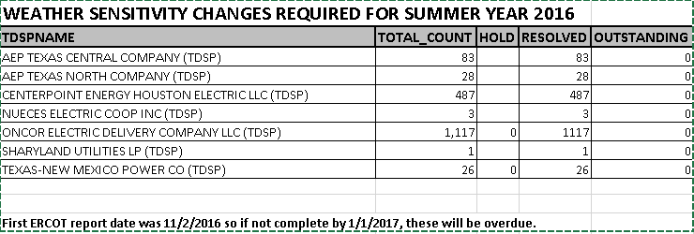

- Annual Validation Update
- Bill presented the attached slides for the 2017 AV update.
- Bill noted the market notice was distributed announcing CRs impacted ESIs lists were available. Many CRs requested their respective lists.
- Nikki had requested TDUs inform their ERCOT team of their intended schedule for sending the 814_20s to change profiles
  - AEP planned to integrate in their normal operations so as not to see any major spikes in the # of transactions sent
  - TNMP planned to perform the changes on normal cycle reads
  - CNP (in a follow up note) planned to send their ~43,000 transactions in May every two weeks likely transacting on Saturdays not to interrupt the normal volume
  - Oncor planned to send their ~50,000 transactions for residential next week ~15,000 per day; business changes are planned for mid-May
  - Sharyland is currently working on their plan and will report at next month’s meeting
- Kathy Scott asked the question about the continued volume of revisions and the necessity given the near full deployment of AMS meters. ACTION ITEM: Sheri will research an earlier slide presented on behalf of PWG by COPS to TAC on the importance of the load profiling guide.
- ACTION ITEM: Bill planned to research why the larger volume moving from RESHI to RESLO for the Coast region. This question and any others will be addressed each month at the update.

- Review Impact Analysis for LPGRR062 – Load Profiling Guide Revision Request Process
Working group approved upon consent the IA for LPGRR062. This will be considered for vote at the next COPS.

- Review language for LPGRR063 - Oil & Gas Profile Request Process
Working group approved language upon consent. The Impact Analysis will be reviewed at the next PWG meeting. LPGRR063 will likely be considered for a vote at the June COPS.

- Open ACTION ITEM: continued review of protocol language supporting “out of compliance” issues for Annual Validation or Weather Sensitivity activities. The working group will continue to research specific language.

- Next meeting will be WebEx May 31st, 9:30 am
Proposed Agenda:
- Review of LPGRR 63 impact analysis
- Update on Annual Validation
  - Address questions on spike in revisions, methodologies, and necessity for process

- Adjourn

