WECC AND OTHER ISO’S EXPERIENCE WITH USER-DEFINED MODELS
This report gathers information about the process overview of User-Defined Models (UDMs) in WECC region and other ISO’s. This information will help the Dynamic Model Taskforce at ERCOT to develop its own process overview. Lessons learned from using UDMs in the WECC region and other ISO’s is also documented and supporting information are backed up by references.
What are the lessons WECC has learned by using User-Defined Models (UDMs)?
From my research, WECC consider UDMs as very problematic.
Reference [1]
“In the early days of system studies, most dynamic models for wind and solar interconnection projects were user-defined models. These models, normally proprietary and distributed as object files, presented several challenges such as difficulty in model maintenance. Therefore, WECC has led a comprehensive effort to develop generic dynamic models for wind turbine generators (WTG) and Inverter based photovoltaic (PV) systems suitable for system analysis.”
Best Practices
“Wind/Solar power plant owners shall provide their plant models in accordance with WECC Wind/Solar Power Plant Power Flow Modeling Guidelines, WECC Wind/Solar Power Plant Dynamic Modeling Guidelines and WECC Data Preparation Manual. The dynamic models shall be WECC-approved models.”
What working group is responsible for Dynamic Models?
WECC Modeling and Validation Work Group (M&VWG).
What is WECC Modeling and Validation Work Group (M&VWG) process for User-Defined Models (UDMs)?
“Because of the problems with User Models, WECC only allows the use of Generic Equipment models”[2] see slide 23
What are other ISO’s process for User-Defined Models (UDMs)?
ISO-NE
“Only standardized component models (i.e. PSS/E models) and parameters can be proposed for powerflow and dynamics cases” [2] see slide 24
“User‐defined models are to be placed on a swift path to inclusion in the library of standardized models” [2] see slide 24
“For all Interconnection Studies commencing after January 1, 2017, all models must be standard library models in PSS/E or applicable applications
–After January 1, 2017, user-models will not be accepted” [2] see slide 31
What is NE ISO plan for User-Defined Models (UDMs) before enforced date of January 1, 2017?
“For all Interconnection Studies commencing before January 1, 2017, when no compatible PSS/E standard dynamics model(s) can be used to represent the dynamics of a device, accurate and appropriate user written models can be used, if accepted by ISO New England after testing.” [2] see slide 32
PJM
Does PJM still allow User-Defined Models (UDMs)?
Based on the following interconnections projects, I think PJM still allows User-Defined Models (UDMs) [3], [4].
MISO
What is MISO’s experience with User-Defined Models (UDMs)?
MISO considers UDMs has very problematic. “Looking at wind generation modeled with a UDM and assuming an equal amount of time is spent on each unique model means that MISO staff spends 28% of their time to model only 3% of the generation installed. In reality the situation is worse as UDMs require much more time than the generic models.”[5].
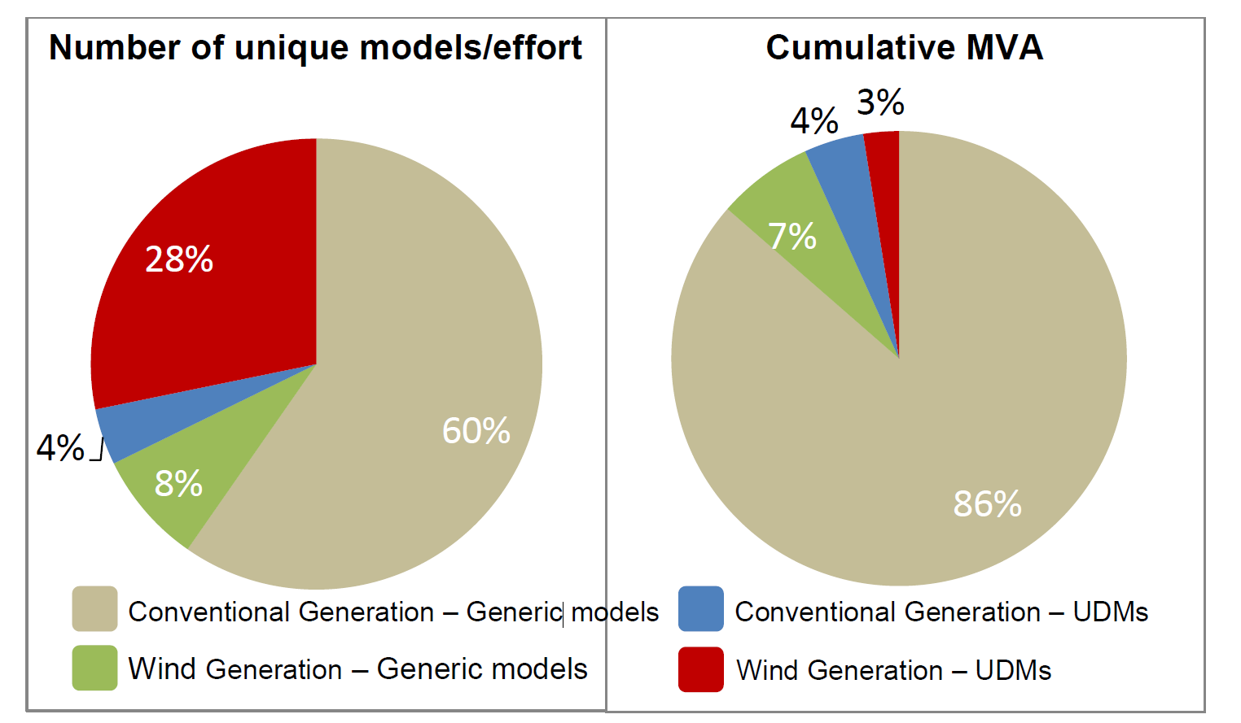
Figure 1: Comparison of unique generator models to generator size [5]

What is MISO’s plan to deal with this issue?
“The imbalance of effort required for UDMs compared to generic models is staggering but can be corrected by establishing a standard list of models”[5].

REFERENCES
[1] WECC “Variable Generation Interconnection Lessons Learned and Best Practices in the Western Interconnection” WECC Variable Generation Interconnection Task Force February 15, 2016. (Search for it online)
[2] http://renew-ne.org/wp-content/uploads/2016/08/2-ISO-NE-Equipment-Modeling-Requirements.pdf
[3] ftp://ftp.pjm.com/planning/project-queues/impact_studies/aa1103_imp.pdf
[4] ftp://www.pjm.com/planning/project-queues/impact_studies/x1109_imp.pdf
[5]https://www.misoenergy.org/Library/Repository/Meeting%20Material/Stakeholder/PSC/2013/20131217/20131217%20PSC%20Item%20XX%20Standard%20Component%20Dynamic%20list.pdf

