PWG Meeting Notes – March 28, 2017
ERCOT Met Center, 9:30 am

Attendees:
Carolyn Reed – CNP
Lindsay Butterfield – ERCOT
Miguel Alvarado – Sharyland
Nikki McKenna – ERCOT
Bill Boswell - ERCOT
Sam Pak – Oncor
Sheri Wiegand – TXU
Diana Rehfeldt – TNMP via WebEx
Jim Lee – AEP via WebEx
PUCT Staff via WebEx

- Approval of February 15th meeting notes and ACTION items.
OPEN ACTION ITEM: Working Group (WG) will continue to search for language in protocols to describe action for ‘out of compliance’ issues for Annual Validation and Weather Sensitivity activities.

- Review of PWG main web page on ERCOT.com
The WG reviewed the scope of PWG currently posted and agreed to revise as follows:
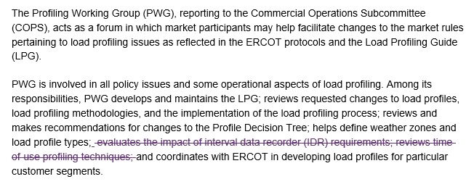
ACTION ITEM: Sheri will provide to Client Services for posting.

- Weather Sensitivity Change Report
Nikki presented the report from March 2nd. Sam Pak indicated he thought Oncor has addressed the two ESIs since the report and will follow up with his team.

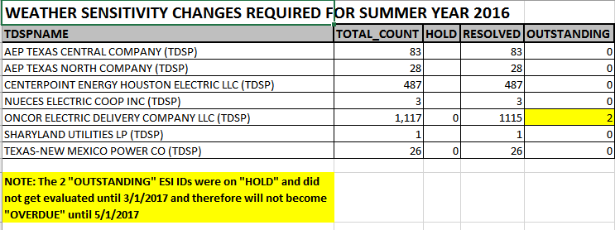
- Annual Validation timeline matrix
The WG reviewed the proposed the draft Annual Validation timeline matrix and revised the due dates reading 4/1/2017 to be changed to 3/30/2017 to align with the approved LPGRR061. The template will be used for COPS updates.
- Review DRAFT LPGRR - Oil & Gas Profile Request Process –Nikki and Lindsay provided revised language for the Business Case to now read…
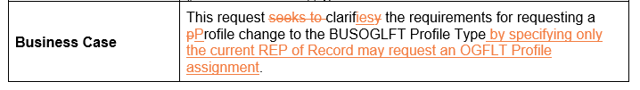
Schedule for DRAFT LPGRR will be:
Language review – PWG – April
Impact Analysis – PWG – May
Approval for COPS/TAC – June

- Review language for LPGRR062 – Load Profiling Guide Revision Request Process
Concerns were voiced about the removal of Profiling Working Group from the “revision process” since one of PWG’s primary responsibilities is the maintenance of the LPG and most LPGRRs would originate from PWG. Lindsay (Market Rules) explained PWG’s scope is described in Section 4 of the LPG and clearly states PWG is to review any revisions or modifications to the LPG, therefore their role in the process is still codified. The team added the following language to clarify that “the process” will originate with COPS differentiating from “the discussion and review” of a proposed LPGRR.
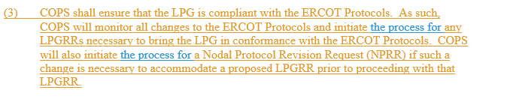
Schedule for LGPRR62 will be:
Impact Analysis – PWG- April
Approval for COPS/TAC – May
Lindsay also noted Market Rules was considering the removal of the “remand” portion of the process and the language for LPGRR062 and will report at the next meeting.

- Next meeting will be WebEx April 26th, 9:30 am
Proposed Agenda:
- Review of LPGRRs 62 and DRAFT- Oil & Gas Flat Profile Request 61 and associated IAs
- Updates on Annual Validation and Weather Sensitivity
- Adjourn

