TDTMS Meeting
March 22, 2017

Agenda
1. | Antitrust Admonition
2. | Introductions  Jim Lee – AEP  Monica Jones - NRG  Catherine Meiners – ERCOT  Dave Pagliai – ERCOT  Vikram Gupta – ERCOT  Kathy Scott – CNP  Kyle Patrick – NRG  Kaci Jacobs – TXU  Sheri Wiegand – TXU  Debbie McKeever – Oncor  Diana Rehfeldt – TNMP  Eileen Weaver – ERCOT  Lindsay Butterfield – ERCOT  Michael Glass – Sharyland  Stephen Wilson – Sharyland  Teresa Rodriguez – Stream  Carolyn Reed – CNP  Monsherra Blank – Oncor
3. | Last Month Meeting Notes – updates if any
4. | ERCOT System Instances & MarkeTrak Monthly Performance Review  Retail Transaction Processing (core hours) – 99.52% (did not meet 99.9% target)  MT API performance: Ambit energy using API now  NRG question for Dave P: Sharyland changed IP address and caused lost connectivity. Has ERCOT seen any issues from this?  - Sharyland response: vendor will provide IP changes so SU can send out Market Notices in the future.
March Retail outage discussion:

ERCOT will not need the outage – will go with the standard release window (3/25-3/26) as communicated via Market Notice.
RMS will ask for feedback on result of outage since it will occur before RMS.

5. | SCR786 Discussion:
Finalize SCR786 User Orientation – rename to "Cert Environment User Guide"? No. Rename to: “Retail Market Test Environment User Guide”

Regarding the RMTE ESIID list:
AI: ERCOT/Catherine/Dave to remove “Reserved for Flight” tab from Retail Market Testing Environment ESI IDs
AI: Rename column E “ESI ID_Type” to “ESI ID Premise Type”

ESIID Refresh/Update Schedule:
Coordinated refresh in conjunction with Flight Testing. ERCOT would update the column attributes and post a change log showing the date the attributes were refreshed.

Action Item: MPs to bring back additional columns to add to ESIID list (Jim will solicit feedback in market notice)
- Switch Hold Indicator
- Service Address (Street, City and Zip)
- Meter Read Cycle Number
- Meter Cycle by Day of the Month –(stored by ERCOT today?)
- Station ID
- Metered/Unmetered

New Section of User Orientation
– Continue developing new sections in April & May 2017.
Where to house User Orientation documentation?
- Figure out once near the end of development.
Update MT User Guide "Market Rule" subtype – show how testing requests should be submitted
– will complete this task once finished with the RMTE User’s Guide. ERCOT does not have a specific format/template needed from MPs (today) when submitting the “Market Rule” testing MarkeTrak.
Incorporate into Retail 101 training
– TDTMS leadership will coordinate with RMTTF leadership once RMTE User Guide has been finalized (probably not until Q3 2017).
Long term discussion – add new subtype or continue using "Market Rule"
- Further discussion TBD. Will need to see how the current process plays out before requiring a new Subtype within MarkeTrak.
6. | MarkeTrak Subtype Analysis "Gameplan"
 | Gather 2017 report requirements for:
- IAS – FYI: HB1475, proposes to make a misdemeanor for unauthorized enrollments
TDTMS to work jointly with TXSET to brainstorm possible opportunities that can help streamline the manual pieces of the IAG process needed at both REP and TDSP back offices.

- Rescission
What is the time elapsed REPs wait before submitting a Rescission issue?
Action item: take all of June 2016 Rescission issues, and break out the time elapsed between completion of Enrollment vs. submittal of MarkeTrak Rescission issue.

Next steps: analyze the March RMS IAG reports to see if same trending behavior for highest offending REPs. If so, will discuss how to address this issue to reduce overall Rescission volumes.
- Switch Hold Removal
ERCOT Action Item: Ask Tammy to break out by REP:
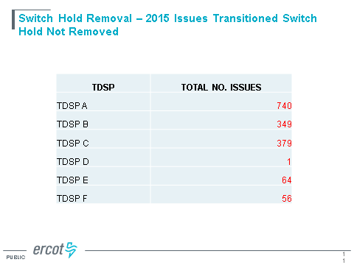

ERCOT Action Item: Ask Tammy to pull back refreshed 2016 data for this slide (both the TDSP and REP numbers)
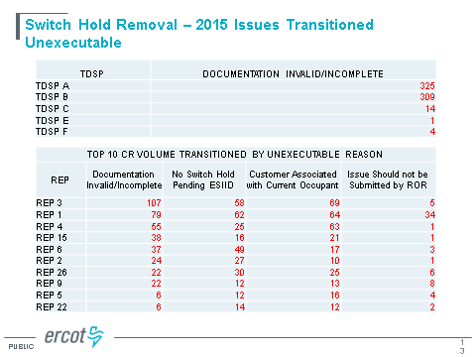
- U/B Missing:
ERCOT Action Item: Ask Tammy to pull 2016 numbers to match 2015 slide. In addition, break out “Data by Tran Type” by REP.
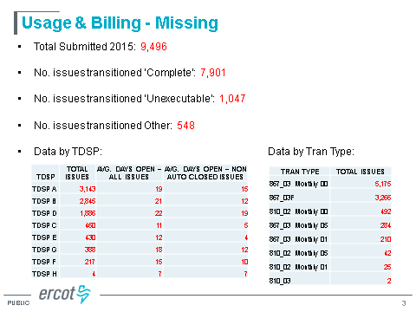

- Missing Enrollment:
Protocol Section 15: Transactional SLA – 3 business days for TDSPs to submit the 867_03/03F/04
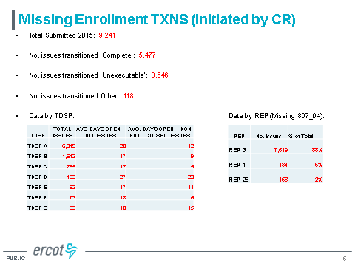
2017 Analysis:
ERCOT Action Item: It was agreed that since the majority of volume is caused by one CR to one TDSP, will ERCOT reach out and tap the CR to let them know of a process change?

Is the volume weighted towards one particular TDSP or one particular CR? Yes, see above slide.
How long should CRs allow the transaction to work? Retail101 training material suggests that CRs wait 5 Retail Business Days to receive transaction after the Scheduled Date before submitting Missing Enrollment for 867_04.
Next Steps: To bring forward awareness through market communications and Retail training. RMTTF has updated the training module already, so broadcasting to wider audience would help awareness.

7. | MarkeTrak Upgrade WebEx training
TDTMS work with ERCOT to develop training material for 2nd week in April 2017

- Go live: Monday, 3/27 @ 8am CT
- Training to start at 2pm CT during TDTMS on April 19th (Jim to add in market notice as reminder)
- If ERCOT/TDTMS receives any questions from the MT Upgraded version, ERCOT will include those in the training material.
- Note: On 3/27 (go-live) URL is same but bookmarked version may need to be refreshed. Solution: go out to ERCOT.com/MIS and re-access the new link. Bookmark again. If solution still does not work, reach out to ERCOT Help Desk and cc: Dave Michelsen.
8. | April meeting – WebEx, cancel, or keep the same? Keep the same meeting, face to face in Austin.
9. | Adjourn

