 |  |  |  | System Planning
Monthly Status Report
March 2017

 |  | Report Highlights
- ERCOT is currently reviewing proposed transmission improvements with a total cost of $1.15 Billion.
- Transmission Projects endorsed in 2017 total $110.7 Million.
- All projects (in engineering, routing, licensing and construction) total approximately $6.91 Billion as of Feb 1, 2017.
- Transmission Projects energized in 2017 total about $3.71 Million as of Feb 1, 2017.

Regional Planning Group Project Reviews

- AEPSC and Oncor have jointly submitted the Far West Texas project. This is a Tier 1 project that is estimated to cost $423 million. This project is currently under ERCOT independent review.

- LCRA TSC has submitted the Cooks Point substation project. This is a Tier 1 project that is estimated to cost $52 million. This project is currently under ERCOT independent review.

- Sharyland Utilities has submitted the South Plains Transmission project. This is a Tier 1 project that is estimated to cost $251 million. This project is currently under ERCOT independent review.

- LCRA TSC has submitted the Mountain Home substation and transmission line addition project. This is a Tier 1 project that is estimated to cost $77.3 million. This project is currently under ERCOT independent review.

- Garland Power & Light and Oncor have jointly submitted the North Garland Reliability Infrastructure Project (N-GRIP). This is a Tier 1 project that is estimated to cost $78 million. This project is currently under ERCOT independent review.

- AEPSC has submitted the Refugio County Transmission project. This is a Tier 3 project that is estimated to cost $24 million. This project had been submitted for RPG comments.

- CenterPoint Energy has submitted the Freeport Master Plan project. This is a Tier 1 project that is estimated to cost $246.7 million. This project had been submitted for RPG comments.

Planning Model Activities
The short term calendar of major planning model events is as follows:
- Mar 21, 2017 Incremental update of MOD database with NMMS snapshot
- July 1, 2017 Post 17SSWG SSWG Base Cases
The following table shows interconnection projects that met Planning Guide section 6.9(1)(a) – 6.9(1)(d) and were modeled in the SSWG cases as either complete or as a simple model or those that were not modeled in SSWG cases due to lack of RARF data in accordance with Planning Guide section 6.9. This categorization refers to data needed only for the Steady State model and is not the complete set of data marked Required for Planning in the Resource Registration Glossary.

Permian Basin Oil Rig Count
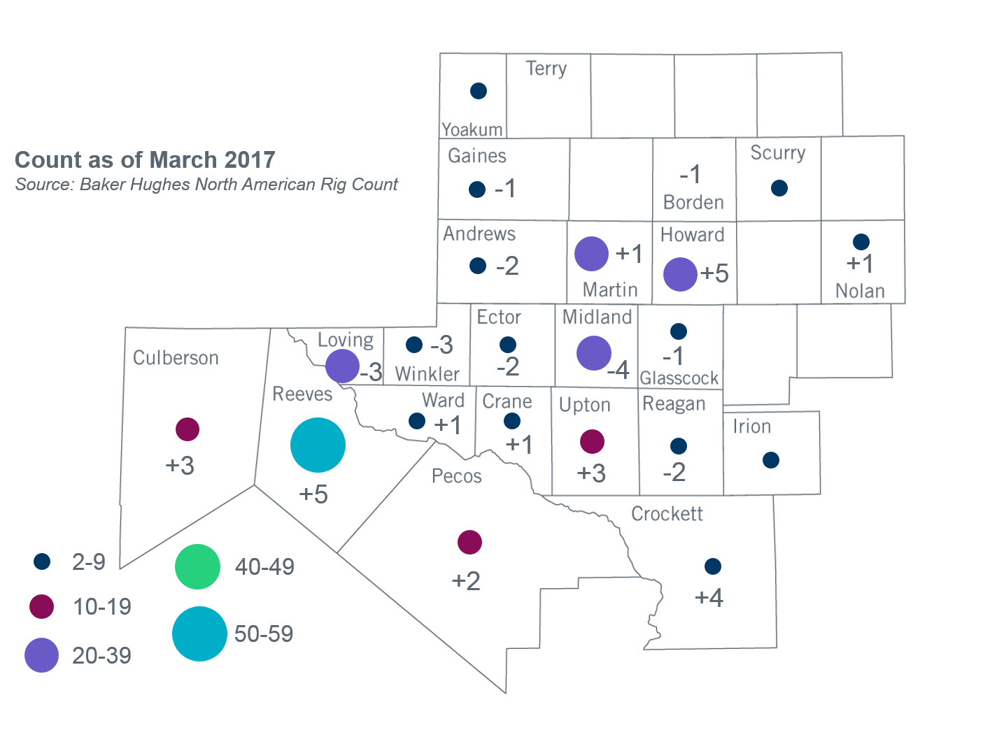
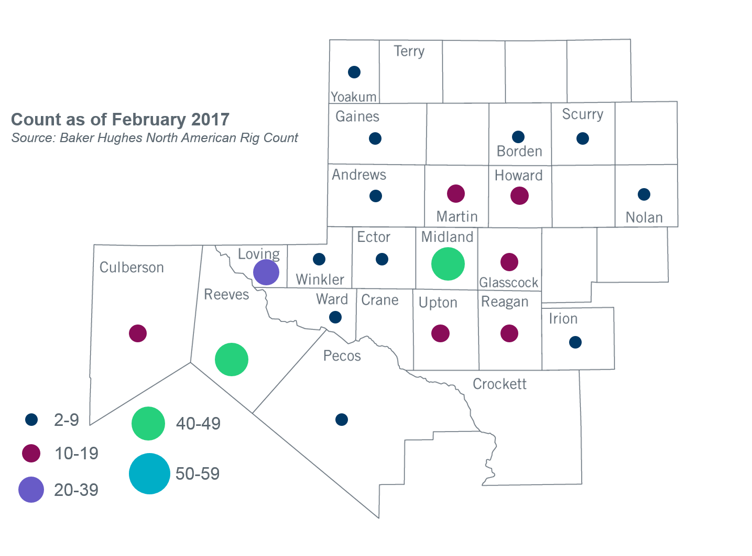

Other Notable Activities
- ERCOT shared an intial scope and process document for the 2017 RTP with the Regional Planning Group (RPG) for feedback and review on October 21, 2016. ERCOT is working on finalizing the input assumptions for the 2017 RTP. ERCOT and TDSPs are reviewing the 2017 RTP load forecast using the bounded higher-of methodology.
- ERCOT shared an initial scope and process document for the 2018 LTSA with the RPG for feedback during the March RPG meeting. The LTSA Scenario development workshops are currently planned for May and June RPG meetings. These workshops are opportunities for ERCOT’s stakeholder to provide feedback on scenarios, drivers and assumptions to be included in the 2018 LTSA.
- On July 19, 2016, Public Utility Commission of Texas (PUCT) Chairman Nelson filed a memo in docket 45633 addressing the proposed move of the Lubbock Power and Light (LP&L) system from the Southwest Power Pool (SPP) grid into the Electric Reliability Council of Texas (ERCOT) grid. The memo included a recommendation for analyses to be performed by SPP and ERCOT. ERCOT is currently working on the SPP-ERCOT Coordinated Lubbock ERCOT Integration Study.
- ERCOT presented the Rayburn Load Integration Study results and the ERCOT recommendation to stakeholders at the March RPG meeting. ERCOT will present study results and recommendation to the TAC in April and BOD in June.
- The SPWG has completed their 2017 Current Year base cases and have started working on their 2017 FY base cases. ERCOT sent Pass 0 out to the group on 04/07/2017.

+/- symbol indicates the increase or decrease from the previous month in oil rigs present in each county. There is a total increase of 9 oil rigs in the Permian Basin from February - March 2017.

