fMGRR Number | 0031 | MGRR Title | Add County requirement link to Substation
Date |  | 04/18/2017
Submitter’s Information
Name |  | Joe Weatherly
E-mail Address |  | Joe.Weatherly@ercot.com
Company |  | ERCOT
Phone Number |  | 512-248-6339
Cell Number
Market Segment

Comments

Addition of County linked to Substation will improve ERCOT’s analysis of data that is used in Pi History or Real-time Operator tools with a refined accuracy that is currently limited to large WeatherZones and/or LoadZones.

Overall NMMS User Benefit
Overall NMMS User Impact | One new instance “Location” under Network/ERCOT_COUNTIES/{county-name} needs to be created with same name of the substation. One new Link to the Location to the substation needs to be added. Expected 5 minutes of work time added for each time a new substation is created. ERCOT will attempt to create/modify Template(s) dealing with Substation additions/modifications to be able to automate modeling & reduce modeling time.
ERCOT Impact | More accurate line model in IMM because of enhanced line data validation using line length.

Revised Proposed Modeling Guidelines Language

- Modeling Substation
  - Modeling Approach
The ERCOT CIM model defines a Substation as collection of equipment for purposes other than generation or utilization, through which electric energy in bulk is passed for the purposes of switching or modifying its characteristics. ERCOT shall develop the naming convention with the assistance of the TSP and the approval of TAC.
A Substation is modeled under a SubGeographicalRegion. VoltageLevels, Transformers and Device types are modeled under the Substation along with generic equipment. The Substation serves as a container for these instances. Figure below shows a Substation modeled in the Information Model Manager model hierarchy with parent/child associations labeled. For more information on modeling VoltageLevels, Device Types, and PowerTransformers please see relevant sections.
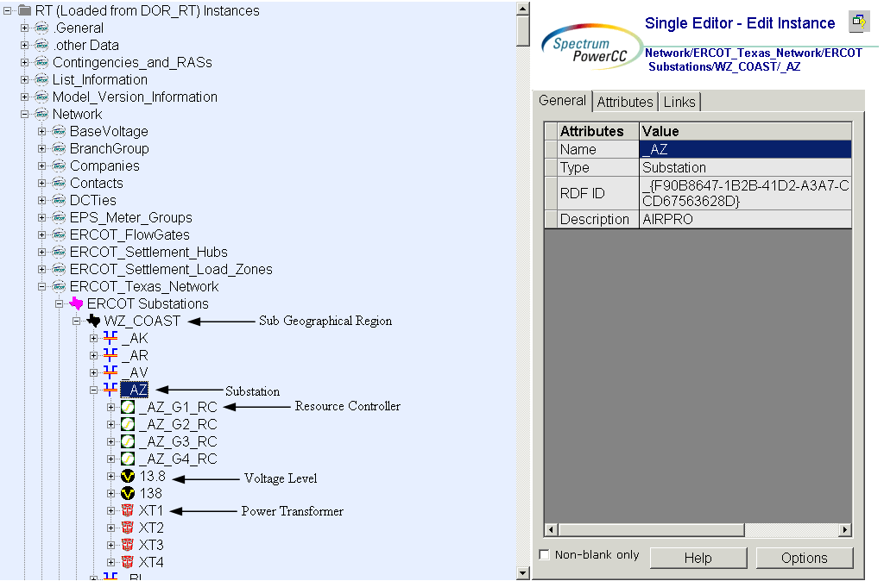
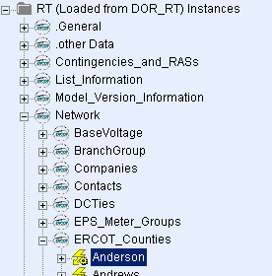
Figure 1 – Substation and ERCOT_Counties
  - Attributes
The attributes for a Substation are shown in the table below.

Attribute | Description | Data Type | Default value | Sample data
Name | Name of the instance of this class | String |  | CB_1
Teid | Transmission Element ID | Integer
abnormalForAlarm | This flag is used to cause alarm messages for abnormals to have their date/time displayed in black in the Alarm displays instead of red (assuming the HABITAT FG element set). | Boolean | FALSE
abnormalForSCADA | Setting this flag to true does not affect Alarm displays, but forces the record to appear Normal on SCADA displays. | Boolean | FALSE
alarmLocation | Alarm location | String
audibleTone | A flag indicating that notifications of alarm conditions via audible tones and horns will be suppressed. | Boolean | FALSE
Description (General Tab) | Free text name of the object or instance. | String |  | Salty Creek Plant
forNetwork | This flag is used to indicate this substation is used by Network application. | Boolean | TRUE
forScada | This flag is used to indicate this substation is used by SCADA application. | Boolean | TRUE
inhibitAbnormalForAlarm | Permanently Inhibit the flag of abnormalForAlarm . | Boolean | FALSE
inhibitAbnormalForSCADA | Permanently Inhibit the flag of abnormalForSCADA. | Boolean | FALSE
inhibitAudibleTone | Permanently Inhibit the flag of audibleTone. | Boolean | FALSE
inhibitLoggingAndAlarmList | Permanently Inhibit the flag of loggingAndAlarmList. | Boolean | FALSE
inhibitUnackAlarmList | Permanently Inhibit the flag of unacknowledgedAlarmList. | Boolean | FALSE
initiallyInhibit | A flag indicating that when the system first comes online, alarm indications for this SCADA entiry will initially be inhibited. | Boolean | FALSE
loggingAndAlarmList | A flag indicating that SCADA will issue neither an alarm nor an event. Therefore, entries will appear in the neither the alarm list nor the event logs. | Boolean | FALSE
overrideDefaultInhibitDef | A flag indicating that that the Operator Inhibit Definition overrides the Global Default Inhibit. | Boolean | FALSE
unacknowledgedAlarmList | A flag ndicating that SCADA will issue an event to the event log, but will not issue unacknowledged alarm indications to the alarm list. | Boolean | FALSE
Alias Name | Free text name of the object or instance. | String100
Latitude | Latitude coordinates. | Float
Local Name | The localName is a human readable name of the object. It is only used with objects organized in a naming hierarchy. The simplest naming hierarchy has just one parent (the root) giving a flat naming hierarchy. However, the naming hierarchy usually has seve | String30
Longitude | Longitude coordinates. | Float
Model Resource ID | A Model Authority issues mRIDs. Given that each Model Authority has a unique id and this id is part of the mRID, then the mRID is globally unique. | String100
Path Name | The pathname is a system unique name composed from all IdentifiedObject.names in a standard naming hierarchy path from the object to the root. | String500

  - Linkage
Below are the required links for a Substation.

Link Name | Description | Path Name
Operatorship | The Operatorship link is used for permission rights. The Operator of equipment has the right to edit the equipment. An operator can only be assigned by the creator or owner of the equipment. Creator is the person who is submitting the entry through PTC, who is associated with the company that owns the equipment. Ownership and Operatorship point to a company whereas a creator points to a userid. | Network/Companies
Ownership | The Ownership link is used for permission rights. The owner of equipment has editing and administrative rights. An owner can only be assigned by the creator of the equipment. | Network/Companies
LocationHasA PowerSystemResource | This Link is created in Network/ERCOT_Counties/{county-name}/{Location that matches Substation name} | Network/ERCOT_Texas_Network  /ERCOT Substations/{WZ_...}  /{Substation}
Note: Even though an entity might own the substation at 100 percent there might be equipment located in the station that the entity might not own, such as a switch.

