RMTTF Meeting

March 2, 2017
9:30 AM
ERCOT Met Center
Room 102

Tomas Fernandez, co-Chair of RMTTF chaired the meeting and read the antitrust statement.

Attending in Person
Carolyn Reed, Centerpoint
Sheri Wiegand, TXU
Kathy Scott, Centerpoint
Tomas Fernandez, NRG
Monica Jones, NRG
Sam Pak, Oncor
Ted Hailu, ERCOT

Attending via Call
Debbie McKeever, Oncor
Cheryl Franklin, AEP
Diana Rehfeldt, TNMP
Synetrick Haynes, Centerpoint
Dave Michelson, ERCOT

Meeting notes from February 2nd were approved with one revision – SCHEDULE for IAG Review was corrected from April 4th to April 6th for the Dry Run for presenters at the RMTTF mtg at Oncor offices in Dallas.

Agenda was revised to review the Reporting MarkeTrak online script at the April meeting as originally intended.

MarkeTrak On-line Modules
- Market notice announcing the release of the Email Module was sent on 2/14/17.
- Ted will provide Sheri the latest statistics for LMS MT on line users – initial reports indicate 619 total users, which is up from the last report of 597 users at the beginning of February.

LMS Functionality
- Tomas presented proposed instructions on registering in LMS for RMTTF/ERCOT training. The following revisions were suggested:
  - Add comment “for any issues or questions on training, contact training@ercot.com
  - Add a step after “See Schedule”
- Tomasonly will complete revisions and post to RMTTF main page
- These instructions may also be included in the market notices for training
- It is also suggested to add screen shots for directions on cancelling a class

Market Notice for Retail 101 & IGL Training
- Ted will correct the times on LMS for the upcoming training and provide a direct link to “cancel” registration on all future reminders
- It is suggested to add a deadline for classroom registration as Monday, May 1st for both classes
- Ted will check on reminders notices automatically generating from LMS one week out and 1 day out from scheduled class.
- Debbie/Sam to provide a map to Ted of the Oncor office area listing hotels and parking venues to be included in future market notices regarding the upcoming training

Retail 101 & IAG Training- Dallas Presenters
Sheri will provide an updated list of presenters for the upcoming training and provide to the team.
Presenters for the IAG Training are as follows:
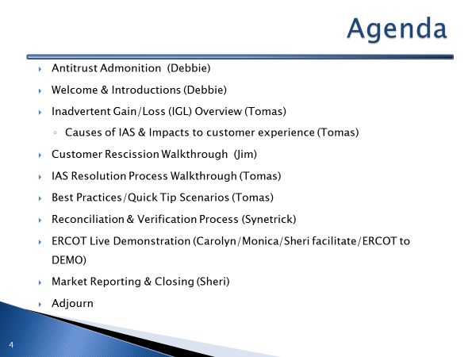

IAG Review
The deck was reviewed and edited as attached.

Sheri was to add graphs to the Reporting section once December IGL data was available.
FOLLOW UP: Attached is the revised deck with the following edits:
- Slide 5: updated “Current Training Topics” and “Future Training Topics” to include our MT online module series
- Slide 10: added a circle around Tomas’s graphic
- Slide 11: cleaned up the capitalization and modified first and second bullets under “Market” to read “Most used MT Subtype -represents over 40% of all MTs” to provide some additional clarity and “One of the longest MT issues to resolve”
- Slides 22, 23, 25, and 29: spelled out “ business day” instead of “BD”
- Slides 30 – 33: added full answers to the checkpoint questions
- Slide 43: created some space between the last reason “Authorized enrollment confirmed” and “Other” should not be used and moved to the middle for more visibility – didn’t want it to look like it belonged under (b)
- Slides 47 & 50: changed title from “key things to remember” to “key points to remember”
- Slide 51- 54: added full answers to checkpoint questions and added another beloved checkpoint question ☺ “A customer enrolled for service at the wrong apartment number. Their REP of choice should issue a MVO on the incorrect address and issue a MVI on the correct address.” ANSWER: “Generally speaking, FALSE, issuing a MVO on an active ESI will create a light out situation at the incorrect address. An Inadvertent Gain MT should be submitted to resolve the incorrect address.”
- Slides 57-61: put on correct template and revised some spelling and grammar nits
- Slides 76-78 – added graphs with data –Slide 70: reversed the order for the RMGRRs matrix
- Slides 81-85: changed the titles from “how do we get there?” to “how can we drive efficiency?”
- Slide 83: added “mailing address vs service address vs 911 address”
- Slide 84: added another bullet “Setting up personalized dashboard for multi-views”
- Slides 85 & 87 to align with verbiage on current ERCOT IGL reporting
- Slides 88-94: December 2016 IGL Market Reporting slides
- Slided 95-97: added full answers to checkpoint questions

IAG Training Schedule
FEB 15th- Tomas and Sheri to exchange slides
- FEB 22nd – all revised slides should be sent to Matt to compile
- FEB 28th – initial draft of the deck will be ready
- MAR 2nd – RMTTF meeting review flow and content of revised slides
- MAR 15th – revisions from 3/2 mtg are due to Matt
MAR 27th – revised deck from Matt will be available for presenters
APR 6th – Dry Run for presenters at RMTTF mtg held at Oncor in Dallas
APR 7th – Final revisions are due to Matt
APR 14th – revised deck will be available from Matt
APR 21st – final approval of deck due to Matt
APR 24th – deck goes to print for training
MAY 4th – IAG training in Dallas at Oncor offices

MARKET NOTICES FOR MAY TRAINING
- Special Market Notice for May training to be sent out March 20th - FOLLOW UP: original notice sent out March 15th
Second notice on April 3rd (30 day) promoting training
Final market notice on April 24th (1week) promoting training

Agenda for 4/6 RMTTF Meeting held at Oncor offices
- LMS Report from Matt – on line statistics
- Review of Reporting Script for On Line Module
- Update on market notice specifically for Retail 101 & IAG Training
  - Reminders, map, registration instructions, etc
- Presenters/Logistics for Retail 101 & IAG Training
- Review of revisions for IAG deck
- Dry Run for presenters – IAG Training

