Concept Paper on Data Product Change Management

Submitted to the Market Data Working Group on Month DD, YYYY.

Document Revisions
Date | Version | Description | Author(s)
MM/DD/YYYY | 1.0 |  | Kaci Jacobs(TXU), Daniel Spence (DME), Aubrey Hale (ERCOT), Susan Anthony (ERCOT)

Table of Contents
1 Executive Summary 4
2 Introduction 4
3 Problem Statements 4
4 Case Studies 5
4.1 Wind Report 5
4.2 Browser Upgrade to IE11 6
4.3 Public Dashboard Changes 6
5 Current Change Process 7
5.1 Initiation of Change 8
5.2 Release Coordination 8
5.3 Release Communication 10
5.4 Publishing End Points 11
6 Constraints to Current Process 12
6.1 Release Coordination 12
6.2 Release Communication 13
6.3 Publishing End Points 13
7 Gaps in Current Process 13
7.1 Release Coordination 13
7.2 Release Communication 13
7.3 Publishing End Points 14
8 How Others Approach 14
8.1 Peer Institutions 14
8.2 Other Industries 15
9 Solutions 16

Executive Summary
The objective of this White Paper is to describe a proposal for the development of a database establishing transparency for all internal ERCOT initiated projects, as well as Market driven projects initiated through the Market Stakeholder process.

Introduction
On March 31, 2016 concerns were expressed at the Technical Advisory Committee (TAC) by Market Participants regarding negative impacts experienced upon release of ERCOT driven initiatives due to the lack of timely notification. TAC recommended a data workshop be conducted as an appropriate forum to address Market Participant visibility into upcoming ERCOT initiated internal system or report changes.
The Market Data Workshop, hosted by ERCOT on May 20, 2016, identified the process in which Market changes are currently performed establishing the framework for dialogue regarding data changes, delivery methods and desires for a future communication state. The Market Data Working Group (MDWG) agreed to be the venue for gathering these discoveries.
Problem Statements were developed and agreed upon at MDWG whereby Market Participants would participate in a sub-working group to begin a deep dive exploring potential solutions to increase change transparency.
Need to update introduction to include high level recommendations.
- Developer Portal
- Process Change
- Content organization

Problem Statements
The following problem statements reflect impacts to consumers of ERCOT data products. Not all problem statements are present in all cases and don’t necessarily impact all stakeholders equally. The problem statements do not capture any constraints that may impact potential solutions to the problem statements.

- A 30-day notice of data product changes does not provide a sufficient window within which to assess and address Market Participant downstream technical impacts.
- Design, development, and testing efforts for Market Participants are hindered by a lack of accurate data definitions and sample data.
- There is no single location/repository for documentation of the drivers behind changes and affected reports and data elements.

- There is no single historical record of changes made to reports and data elements.

- The lack of a central repository for releases with details and links to change management discussions and approvals accessible to Market Participants makes it difficult to track status of changes.

- Impacts to Market Participant downstream system owners are not included in the Impact Analysis for proposed changes.

- Since changes with Market Participant downstream impacts often result in downtime and/or outages, maintenance/release windows for changes are too broad.

Case Studies

Wind Report
At the March 29 2016 Market Data Working Group (MDWG) meeting, ERCOT announced an upcoming 30 day notice for changes to two reports. The notice included changes to the Wind Power Production - Hourly Averaged Actual and Forecasted Values (report ID: 13028, EMIL ID: NP4-732-CD) and the Solar Power Production - Hourly Averaged Actual and Forecasted Values (report ID: 13483, EMIL ID: NP4-737-CD). Until the announcement, there had been no discussion in MDWG of the changes, the justifications, or benefits it could provide market participants or ERCOT. There was no discussion with Market Participants about potential impacts to their systems.
Trying to find details on the release proved difficult. There was not a central location to find information about the upcoming release or changes to the schema. To get the necessary information required reaching out to client services.
The modification to both reports dealt with the time series data. The time series originally had a timestamp format (see figure x-x).
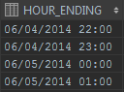 Figure x-x
The new format was in the “hour ending” format (see figure x-x).
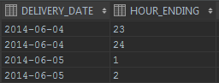 Figure x-x
The 30 day window did not provide sufficient time for impact analysis and development of a solution. The changes were more than superficial and modified how time is calculated and required patches to DME’s internal data warehouse and downstream applications. This resulted in 70-80 man hours to develop and deploy solutions costing DME thousands of dollars. Additionally, the release window was over several days and required close monitoring and had to wait for errors to surface in order to know when ERCOT deployed the changes.

Browser Upgrade to IE11
At the September 2014 Technical Data Transport Working Group (TDTWG) ERCOT noted an upcoming change to occur at the end of 2014, upgrading ERCOT’s current IE8 supported browser to IE11. For many in the room, this announcement came as a surprise. In the November 2014 TDTWG meeting numerous questions arose and concerns from Market Participants regarding the tight timeline for notice, implementation and lack of information. ERCOT noted that supported Internet Explorer versions and browsers would not be known until after March 2015. Market Participants requested more information be provided which could not be obtained until the following TDTMS meeting. Being made aware of this upcoming project earlier would have allowed all impacted MPs ample time for adequate preparations to systems and related dependencies. Fortunately, due to browser compatibility issues, ERCOT’s release of IE11 did not occur until September of 2015.

Public Dashboard Changes

Draft language in progress.

Current Change Process

Initiation of Change
The introduction of change to MIS Data Products primarily comes from new project requests which can originate from three primary sources:
- Regulatory Entities (Texas Legislature, PUCT, NERC, FERC, TRE, etc.)
- Market Participants
- ERCOT Staff

The following diagram is a high level overview of the flow of new project request into the project management process.
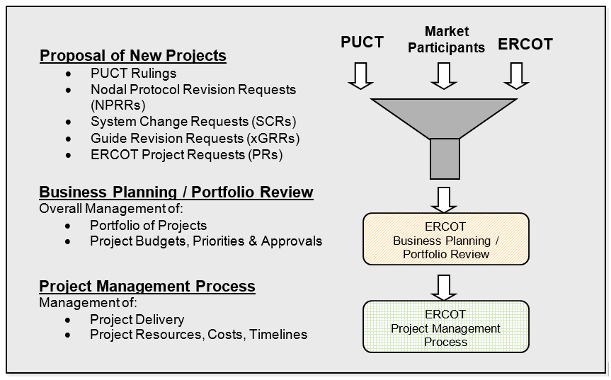
In addition to projects, MIS Data Product changes may occur from CEERs (ERCOT efficiency enhancement requests) or O&M changes.

Release Coordination
Once an effort has been approved and analysis of the scope of work has been completed, information technology change requests are submitted by ERCOT staff into an internally available release tracking application. Change requests describe the change, priority, impacted systems and whether or not the change is Market Facing.
Change requests are reviewed by the Change Advisory Board (CAB).
Release scheduled based on:
- Resource availability
- Priority
- Impacts to other scheduled changes
- CAB Process
Release Types:
  - On-Cycle – Follows standard process and schedule
  - Off-Cycle – Follows standard process and non-standard schedule
  - Exception – Follows highly accelerated process due to non-critical production issue
  - Emergency – Emergency, paperwork later release due to critical issue

Release Windows
  - Release window can span a few hours to a few days

Release Communication

Commercial Operations Market Guide
Communication about changes to Data Products follows the process outlined in Section 5: Market Notice Communication Process of the Commercial Operations Market Guide. Section 5.1.3.2 defines the parameters around planned releases.
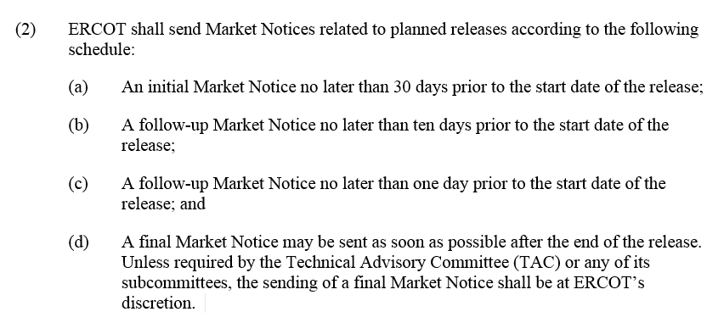
Figure 1 - Section 5.1.3.2 of the Commercial Operations Market Guide
Market Notice Lists
Market Notices are sent as emails to a number of different lists as outlined in Table 2 of Section 5.1.6.3 depending on the topic. Changes to extracts and reports will be sent to Notice_Extracts_Retail and Notice_Extracts_Wholesale. If the changes are part of a release, they are communicated to Notice_Release_Retail and Notice_Release_Wholesale and are identified as Market Facing changes. (However, release changes may also include Notice_Extracts_Retail and Notice_Extracts_Wholesale in the Market Notice distribution list.)

List | Description
NOTICE_CONTRACTS | Market Notices for Requests for Proposal and Requests for Information that are issued by ERCOT and contracted services such as Reliability Must Run and Black Start.
NOTICE_CREDIT | Market Notices concerning management of credit in the ERCOT market.
NOTICE_CRR | Market Notices concerning Congestion Revenue Rights.
NOTICE_EXTRACTS_RETAIL | Market Notices relating to Data Extracts and reports supporting Retail data transactions, including procedures, postings or changes.
NOTICE_EXTRACTS_WHOLESALE | Market Notices relating Data Extracts and reports supporting Wholesale data transactions, including procedures, postings or changes.
NOTICE_GENERAL | Market Notices of general nature intended for distribution to the ERCOT Market, but not applicable to any other specific mailing list.
NOTICE_GRIDCONDITION | Market Notices of Grid Emergency events in progress  ***Locked List This list requires approval from the entity authorized representative to enter ***
NOTICE_LEGAL_NOTIFICATIONS | Market Notices to the ERCOT Market of a legal nature.
NOTICE_OPERATIONS | Market Notices Concerning Power Operations and related Technical Issues at ERCOT.
NOTICE_OUTAGES_RETAIL | Market Notices concerning system outages, business process failures, service degradations and related issues that affect retail market functions.
NOTICE_OUTAGES_WHOLESALE | Market Notices concerning system outages, business process failures, service degradations and related issues that affect wholesale market functions.
NOTICE_PRR_SCR | Market Notices of System Change that include the implementation of Protocol Revision Requests or System Change Requests
NOTICE_RELEASE_RETAIL | Market Notices concerning system outages or upgrade releases and testing that affect retail market functions.
NOTICE_RELEASE_WHOLESALE | Market Notices concerning system outages or upgrade releases and testing that affect wholesale market functions.
NOTICE_RETAIL_PROCESSING | Market Notices concerning the processing of retail transactions.
NOTICE_SETTLEMENTS | Market Notices concerning the Wholesale Settlements issued by ERCOT that are public in nature.
NOTICE_TESTING_RETAIL | Market Notices concerning Market Participant testing with respect to Retail Test Flights and Retail Systems Testing.
NOTICE_TRAINING | Market Notices concerning ERCOT training events.

Sample Notice
NOTICE DATE: February 3, 2017
NOTICE TYPE: R-A020317-01 Retail
SHORT DESCRIPTION: Implementation of RMGRR134
INTENDED AUDIENCE: Existing Transmission Distribution Service Providers (TDSPs) utilizing data submissions via LSE file and potential users of new submittal process for TDSP-Read Non-Modeled Generators
DAY AFFECTED: March 7 - 9, 2017
LONG DESCRIPTION: ERCOT will implement changes associated with Retail Market Guide Revision Request (RMGRR) 134, Allow AMS Data Submittal Process for TDSP-Read Non-Modeled Generators, during the release period of March 7 – 9, 2017.
In association with allowing the submission of LSE files for ResourceID data using the Advanced Metering System (AMS), the following related documentation and forms must be updated.
Updated documentation will be posted in the Retail Section of the User Guides on the ERCOT website:
- Interval_Data_LSE_Error_Codes_v1.4_DRAFT – contains new error codes required for implementation
- Interval_Data_LSE_Activity_Report_v1.2_DRAFT – contains new columns added to accommodate ResourceID information
- 867_03_Error_Codes_Document_v1.2_DRAFT – contains a new error code required for implementation
The updated TDSP Read Generation form will be posted in Key Documents on the Transmission/Distribution Service Providers page of the Registration and Qualification section of the ERCOT website. The form contains new fields required for requesting ResourceID meter data submittal via LSE file. An updated form must be submitted to ERCOT if a Market Participant wishes to begin submitting Resource ID data via LSE file.
ACTION REQUIRED: The following DDLs located on the ERCOT website at http://www.ercot.com/services/mdt/ddls required updates due to implementation of RMGRR134. These are currently posted as draft versions and will replace the current documents upon system implementation:
- PRDE Extract_20161221_DRAFT_RMGRR134.txt
- PRDE_Extract_XSD_20161222_DRAFT_RMGRR134.xml
ADDITIONAL INFORMATION:
- Interval_Data_LSE_Error_Codes_v1.4_DRAFT - Please note that the Interval_Data_LSE_Error_Codes_v1.3 document has been updated since its presentation at RMS on January 10, 2017. Previously, there were 16 error messages planned for release. However, one error (15) was found to be unnecessary and was removed. All these documents will be posted and marked as DRAFT until the go-live date mentioned above.
- All extracts and reports mentioned above remain on the same generation and posting schedules.
CONTACT: If you have any questions, please contact your ERCOT Account Manager. You may also call the general ERCOT Client Services phone number at (512) 248-3900 or contact ERCOT Client Services via email at ClientServices@ercot.com.
If you are receiving email from an ERCOT distribution list that you no longer wish to receive, please follow this link in order to unsubscribe from this list: http://lists.ercot.com.

30-Day Market Notice
  - Market Notices team member creates a report from ITCM that shows all changes marked ‘Market Facing’ for the upcoming release.
  - Go through the report and determine what is truly considered “Market Facing”
  - Create spreadsheet of Market Facing Changes for the release that will be attached to the emailed Market Notice.
  - In the spreadsheet, use Market Facing Description listed on the change. Work with SME or Business Owner to provide a clear, general description.
  - Include impacted systems in the spreadsheet for each change.
  - The emailed Market Notice provides general information of the release such as dates, times, impacted systems.
  - Send Notice 30 days prior to start of release

10-Day Market Notice
  - Run a new report from ITCM to update the 30-day spreadsheet of Market Facing changes for the 10-day Market Notice. Changes have been removed and changes have been added since the 30 days out.
  - Go through the same process as for the 30-day Market Notice, sending out the 10-Day reminder Market Notice 10 days prior to the start of the release.

1-Day Market Notice
  - Run a new report from ITCM to update the 30-day spreadsheet of Market Facing changes for the 10-day Market Notice. Changes have been removed and changes have been added since the 10 days out.
  - Go through the same process as for the 30-day Market Notice, sending out the 1-Day reminder Market Notice 1 day prior to the start of the release.

Completion Market Notice
- Per Section 5.1.3.2 (d) of the Commercial Operations Market Guide, “a final Market Notice may be sent as soon as possible after the end of the release. Unless required by the Technical Advisory Committee (TAC) or any of its subcommittees, the sending of a final Market Notice shall be at ERCOT’s discretion.” Currently, a Market Notice of completion of a release is only sent for Retail Releases.

Additional Market Notices may be sent providing detailed information to the market participants at the discretion of ERCOT SMEs/Business.

Publishing End Points
Information related to Report and Extract Data Changes is published to the following channels and locations. All content currently published is classified as Public.
ERCOT.com
  - Committees - http://www.ercot.com/committees
  - Meeting Calendar - http://www.ercot.com/calendar
  - Market Rules
    - NPRRs - http://www.ercot.com/mktrules/issues/nprr
    - NOGRRs - http://www.ercot.com/mktrules/issues/nogrr
    - System Change Requests - http://www.ercot.com/mktrules/issues/scr.html
    - COPMGRRs - http://www.ercot.com/mktrules/issues/copmgrr
    - LPGRRs - http://www.ercot.com/mktrules/issues/lpgrr
    - PGRRs - http://www.ercot.com/mktrules/issues/pgrrRRGRRs - http://www.ercot.com/mktrules/issues/rrgrr
    - RMGRRs - http://www.ercot.com/mktrules/issues/rmgrr
    - SMOGRRs - http://www.ercot.com/mktrules/issues/smogrr
    - Texas SET Change Controls - http://www.ercot.com/mktrules/issues/txsetcc
  - Project Information - http://www.ercot.com/services/projects
    - Release Targets
    - ERCOT Portfolio Gantt
    - Project Priority Process
  - Board Stoplight Reports - http://www.ercot.com/committee/board
  - Market Notices Archives - http://www.ercot.com/services/comm/mkt_notices/archives

Lists.ercot.com

Constraints to Current Process

Release Coordination

Schedule can change based on:
  - Schedule slippage
  - Critical production issues
  - Change in priority, project cancelled (?)
  - Failed deployment (uncommon)
  - Code deployed but backed out due to missed defects (uncommon)

Release Window:

  - Why can’t release be specific time instead of over a few days?

Release Communication
  - Not a consistent use of the Market Facing flag in ITCM. Marking a change as market-facing is left to the discretion of the person entering the change. As such, some changes may not be flagged as market-facing when they should be, resulting in the market not being made aware of a change being implemented. (This is a much bigger issue than having a change flagged as market facing that is not.) Fortunately, this appears to be a rare occurrence.

  - Market Notice description is a mandatory field for changes flagged as market-facing in ITCM; however, rarely is an adequate description entered. This results in a lot of consultation with SMEs/Business/IT as to what to enter on the market-facing spreadsheet for the release Market Notices and this resulting description is then never updated (or used) on the change in ITCM. Not all people entering changes in ITCM understand the impact(s) to the market participants so they are unable to create a description that the market will understand or find useful.

  - In addition to the standard 30-day, 10-day, and 1-day Release Market Notices, supplemental Market Notices may be sent providing detailed information to the market participants at the discretion of ERCOT SMEs/Business. However, if ERCOT SMEs/Business do not initiate this communication to the market, MPs may not receive the information they need to prepare for these changes in their companies.

Publishing End Points
  - Content Management System and current content/metadata model doesn’t allow for flexible relations between content.
  - A lot of content is in PPT or Excel

Gaps in Current Process

Release Coordination

  - Broad release window leads to someone from an MP’s technical team waiting around for something to break.
  - Lack of categorization or a way to flag changes to Data Products makes it difficult to find or identify changes within the ERCOT Change Management System.
  - Market facing flag, who reviews? Its accuracy depends on the knowledge of the definition of “market facing” by the person entering the Request for Change (RFC).
  - An adequate test environment isn’t currently available. MOTE.

  - Do all changes flow through ITCM? I think so. I’m not sure – I think CEERs may not flow through ITCM.
  - Need to ensure that non-project changes are captured and tracked as well as projects.
  - In communicating critical information to the market regarding changes, this remains at the discretion of SMEs/Business as to what information should be communicated to the market regarding details of implementation and the time frame for this communication. There is no Protocol or Guide requirement surrounding this.

Release Communication

Documentation gaps:
  - Data Definitions not always available.
  - Sample Data not always available.
  - Lack of a Version History.
  - Clearer definition of what ‘Market Facing’ means.
  - Current system relies on what submitter puts into system. Though Notice team works with business to improve descriptions, etc. If someone incorrectly selects ‘Market Facing’, not a big deal. If someone incorrectly doesn’t select ‘Market Facing’, change won’t show up in list of upcoming ‘Market Facing’ changes. The latter is rare, but has happened.
  - In the effort not to “spam” Market Participants, the Market Notice team primarily uses the public self-subscribed Listserv lists for distribution of Market Notices. Distribution lists for primary and backup authorized reps for MPs are used judiciously. This raises two issues:
    - The “right” people at the MP companies need to sign up for the appropriate Listserv lists.
    - The primary and backup authorized reps for the MPs need to ensure that they forward the communications to the “right” people within their organizations.

Publishing End Points
ERCOT.com:
  - Content is spread out and not organized around this use case

Lists.ercot.com:
  - Not everyone is subscribed to all lists
  - Information overload
  - Can’t search across lists

How Others Approach

Peer Institutions
PJM
- If there’s a revision to a primary product, like LMP’s, the notification will appear on that page of the website. These notifications are archived, so that consumers coming in after the fact can see a history of reposts, to ensure they’re using the correct data.
- Other avenues include email notifications through their subcommittee system.
ISO-NE
- Market notices are sent out for any changes to our Web Services, we give 30-day notices to participants for any changes to the Web Services so they can make any updates as needed.
- We use a page on our site to communicate in a more “human” way about our Web Services than that API documentation page. This page (and the XLS on the page) gives more details about the reports we offer, available parameters, how far back data is available for, etc.: https://www.iso-ne.com/participate/support/web-services-data
- Version history is not provided. There is a secure portal for one-off requests and there are separate sites that have data specifically for generators (Local Control Centers) but I’m not aware of exactly what’s included on those.

CAISO
- CAISO has a Secure Portal, like our MIS, that holds all its data: oasis.caiso.com. In the Atlas Reference > Oasis Publications and Revisions section they have an interface that allows you to query publications and notifications. Utilizing the Version drop-down, you can choose either “New” or “Revised”. The former signifies when the report is initially dropped to the system; the latter if/when it’s revised/corrected. You also have the option to download the query results in XML and CSV.

MISO
- MISO utilizes subscription-based notifications to alert MP’s about report revisions.
NYISO
- NYISO has a Reports & Information section where corrected reports/prices are listed and downloadable.

Other Industries
The following are excellent examples of developer portals. While not strictly data change management, they do emphasize change visibility and interaction.
GitHub Developer
- Extensive documentation that is easy to navigate and search.
- A stay in the know section with posts of the most recent changes to their API.
- A versions page with a change log with the differences in the API from version to version.
- Callouts of breaking changes.
- Code examples of request and responses of every endpoint.

New Zealand Electric Authority Developer
- Detailed information about each API service.
- Each API service has the GET, POST and DELETE operations broken out.
- Code examples of responses and requests in a variety of languages.
- Ability to try out API services in the browser.
- Swagger API documentation.

Stripe
- Clean easy to navigate interface.
- Uses google groups for API updates, mailing lists, discussion.
- Provides a change log and history of API services.
- Code examples in a variety of languages.

Solutions
Process
- Socialize definition of Market Facing within ERCOT
- Provide data definitions for all products, including CDR
- All proposed changes route through MDWG? Create another forum?
- Release window timing could use narrower window. Automated release pipeline.
- ERCOT IT/Market Liaison whose role will be to facilitate communication of release implementation information that is market facing as changes move through the pipeline.
- User Group for MP technical folks and ERCOT to share pertinent information regarding market-facing system changes and implementations. (Note: not sure how much information ERCOT and/or MPs can share regarding system changes and implementations. i.e. confidentiality, restrictions, competitive edge among MPs, etc.)
- Send a release completion Market Notice or a series of them as key implementations have been completed during a release outage window (currently ERCOT sends completion Market Notices only for Retail releases).

Change Management Tracking System
- Add categorization to Release Management system so that data product changes can be flagged
Developer Portal
- Create centralized, categorized location for upcoming changes.
- Web app version of EMIL
- Subscribe to alert changes.

ERCOT.com
- Content types on ERCOT.com that allow for more flexible relationships of content. Relationship between Market Notices, Revision Requests, EMIL, Calendar (?), PPL.

