PWG Meeting Notes – February 15, 2017
WebEx

Attendees:
Lindsay Butterfield – ERCOT (in room)
Jim Lee - AEP (in room)
Calvin Opheim – ERCOT
Bill Boswell – ERCOT
Diana Rehfeldt – TNMP
Carolyn Reed – CNP
Nikki McKenna – ERCOT
Randy Roberts - ERCOT
Sam Pak – Oncor
Sheri Wiegand – TXU

- Approval of January 2017 meeting notes
- Discussion of 2017 Goals – Goals were presented which were modeled from 2016 goals. It was suggested to remove the first goal of “standardization & streamlining of data submittal to ERCOT” since this followed PWG’s previous effort to overhaul the LPG and Chapter 18. Below is the revised slide…
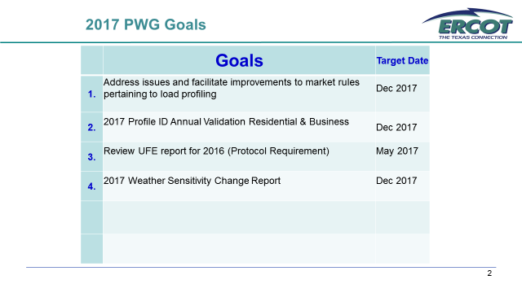

- Review of LPGRRs
REV REQ NO. | DESCRIPTION | RR TIMELINE | IMPACT ANALYSIS | ACTION
060LPGRR | Load Profiling Guide Clean Up Related to LPGRR057. This Load Profiling Guide Revision Request (LPGRR) provides additional clarification to the Load Profiling Guide by removing orphaned language that was not captured in the language changes of LPGRR057, Alignment with NPRR781, Updates to Nodal Protocol Section 18, Load Profiling, to Align with Current Market Processes, which was approved by TAC on October 27, 2016. [ERCOT] | 02/15/17 PWG IA; 03/08/17 COPS; 03/23/17 TAC | IA (No Impact) posted 12/14/16 | IMPACT ANALYSIS REVIEW:  PWG endorsed and will forward to COPS for the 3/8/17 PWG Report and vote.
061LPGRR | Modifications to Annual Validation Timelines. This Load Profiling Guide Revision Request (LPGRR) modifies the Annual Validation timelines for Residential (RES) and Business (BUS) Electric Service Identifier (ESI IDs) by starting the Annual Validation task list actions on March 30th and concluding on September 30th of each calendar year. [PWG] | 02/15/17 PWG IA; 03/08/17 COPS; 03/23/17 TAC | IA (No Impact) posted 02/01/17 | IMPACT ANALYSIS REVIEW:  PWG endorsed and will forward to COPS for the 3/8/17 PWG Report and vote.
062LPGRR | Load Profiling Guide Revision Request Process. This Load Profiling Guide Revision Request (LPGRR) refines the process for revising the Load Profiling Guide (LPG) so that LPGRRs are originally considered at the voting Subcommittee level, and expands the list of LPGRRs requiring ERCOT Board approval. [ERCOT] | 02/15/17 PWG; 03/29/17 PWG; 04/26/17 PWG IA; 04/27/17 TAC | IA (No Impact) posted 01/26/17 | LANGUAGE REVIEW:  PWG tabled the proposed LPGRR for further language review at the 3/29 F2F meeting.

Draft LPGRR Modification of Oil & Gas profile requests – Nikki presented the draft LPGRR. It was suggested additional language be added to the business case. This was tabled and will be reviewed at the next PWG meeting.

- Weather Sensitivity Change Report – presented by Randy Roberts
WEATHER SENSITIVITY CHANGES REQUIRED FOR SUMMER YEAR 2016
TDSPNAME | TOTAL_COUNT | HOLD | RESOLVED | OVERDUE
AEP TEXAS CENTRAL COMPANY (TDSP) | 83 |  | 83 | 0
AEP TEXAS NORTH COMPANY (TDSP) | 28 |  | 28 | 0
CENTERPOINT ENERGY HOUSTON ELECTRIC LLC (TDSP) | 487 |  | 487 | 0
NUECES ELECTRIC COOP INC (TDSP) | 3 |  | 0 | 3
ONCOR ELECTRIC DELIVERY COMPANY LLC (TDSP) | 1,119 | 4 | 1115 | 4
SHARYLAND UTILITIES LP (TDSP) | 1 |  | 1 | 0
TEXAS-NEW MEXICO POWER CO (TDSP) | 26 | 0 | 26 | 0
First ERCOT report date was 11/2/2016 so if not complete by 1/1/2017, these will be overdue.
11.4.3.1 - Weather Responsiveness Determination
(9)TSPs and/or DSPs shall successfully complete weather sensitivity code modifications (Load Profile ID changes) no later than 60 days after the ESI ID appears on the ERCOT report. Load Profile ID changes shall be effective as of the most current meter read date.
There was discussion again regarding overdue status and out of compliance issues. According to the protocol, 11.4.3.1 listed above, the 7 changes are in violation. ERCOT did confirm they are working with both Oncor and Nueces for resolution and anticipate resolution by March 1st. In discussion of the protocols, it was noted by ERCOT that PWG decides to notify COPS of any overdue status. ACTION: Next meeting, WG will review protocol language for out of compliance issues (that may have been used for out of compliance for Annual Validation)

- Next meeting will be F2F at ERCOT Met Center March 29th, 9:30 am
Proposed Agenda:
- Review of LPGRR 62 – LPGRR Process
- Review of Draft LPGRR for modification of Oil & Gas Profile requests
- Weather Sensitivity Change Report
- Annual Validation Update
- Adjourn

