February 2017 ERCOT Monthly Operations Report
Reliability and Operations Subcommittee Meeting
April 6th, 2017

Table of Contents
1. Report Highlights 2
2. Frequency Control 3
2.1. Frequency Events 3
2.2. Responsive Reserve Events 4
2.3. Load Resource Events 4
3. Reliability Unit Commitment 4
4. Wind Generation as a Percent of Load 5
5. Congestion Analysis 5
5.1. Notable Constraints for February 5
5.2. Generic Transmission Constraint Congestion 7
5.3. Manual Overrides for February 7
5.4. Congestion Costs for Calendar Year 2017 7
6. System Events 8
6.1. ERCOT Peak Load 8
6.2. Load Shed Events 9
6.3. Stability Events 9
6.4. Notable PMU Events 9
6.5. TRE/DOE Reportable Events 9
6.6. New/Updated Constraint Management Plans 9
6.7. New/Modified/Removed SPS 9
6.8. New Procedures/Forms/Operating Bulletins 9
7. Emergency Conditions 9
7.1. OCNs 9
7.2. Advisories 9
7.3. Watches 9
7.4. Emergency Notices 10
8. Application Performance 10
8.1. TSAT/VSAT Performance Issues 10
8.2. Communication Issues 10
8.3. Market System Issues 10
Appendix A: Real-Time Constraints 11

Report Highlights
- The unofficial ERCOT peak for February was 42,729 MW.
- There were two frequency events in February. PMU data indicates the ERCOT system transitioned well in each case.
- There was one instance where Responsive Reserves was deployed, which was the result of a frequency event.
- There were two RUC commitments in February.
- The level of reportable SCED congestion increased in February. This congestion was mostly due to planned outages as well as high wind output. There were fifty-one instances over 28 days on the Generic Transmission Constraints (GTCs) in February. There were twenty-one days on the Panhandle GTC, one day on the Valley Import GTC, nine days on the Zorillo to Ajo GTC, seven days on the Bakersfield GTC, and thirteen days on the Liston GTC in February. There was no activity on the remaining GTCs during the Month.
- There were no application issues to report for February.

Frequency Control

Frequency Events
The ERCOT Interconnection experienced two frequency events in February, all of which resulted from Resource trips. The average event duration was approximately 0:02:40.

When analyzing frequency events, ERCOT evaluates PMU data according to industry standards. Events with an oscillating frequency of less than 1 Hz are considered to be inter-area, while higher frequencies indicate local events. Industry standards specify that damping ratio for inter-area oscillations should be 3.0% or greater. All events listed below indicate the ERCOT system met these standards and transitioned well after each disturbance.

Reported frequency events will include both frequency events where frequency was outside the range of 60±0.1 Hz as well as those determined to be Frequency Measurable Events (FME) as defined by BAL-001-TRE-1. Delta Frequency is defined as the difference between the pre-perturbation and post-perturbation frequency. The Duration of Event is defined as the time it takes for the frequency to recover to lesser/greater of the frequency at the time of the frequency event (t(0) or “A-point”) for low/high-frequency events, respectively. Further details on FMEs can be found in the MIS posted BAL-001-TRE-1 PDCWG Unit Performance reports. A summary of the frequency events is provided below:

Date and Time | Delta Frequency |  | Max/Min Frequency |  | Duration of Event | PMU Data |  |  | Load | Wind | Inertia¹
 | (Hz) |  | (Hz) |  |  | Oscillation Mode (Hz) | Damping Ratio |  | (MW) | % | (MW-s)
2/13/2017 23:52 |  | 0.086 |  | 59.91 | 0:03:10 | 0.65 | 7% | 30,776 |  | 23% | 173,740
2/19/2017 22:49 |  | 0.055 |  | 59.84 | 0:02:10 | 0.80 | 12% | 32,690 |  | 20% | 182,283
(Note: frequency events highlighted in blue have been identified as FMEs per BAL-001-TRE-1 and the Performance Disturbance Compliance Working group.)

Currently, the Critical Inertia Level for ERCOT is approximately 100,000 MW-s (Source: link)
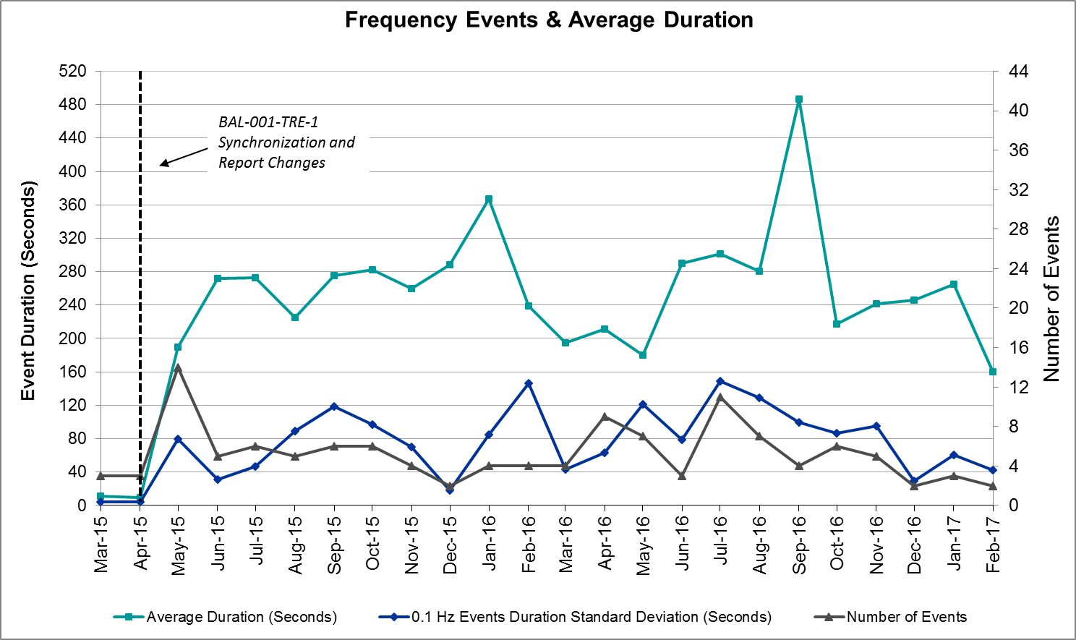

Responsive Reserve Events
There was one event where Responsive Reserve MWs were released to SCED in February. The events highlighted in blue were related to frequency events reported in Section 2.1 above.

Date and Time Released to SCED | Date and Time Recalled | Duration of Event | Maximum MWs Released
2/19/2017 22:49:08 | 2/19/2017 22:55:08 | 0:06:00 | 607.25

Load Resource Events
None.

Reliability Unit Commitment
ERCOT reports on Reliability Unit Commitments (RUC) on a monthly basis. Commitments are reported grouped by operating day and weather zone. The total number of hours committed is the sum of the hours for all the units in the specified region. Additional information on RUC commitments can be found on the MIS secure site at Grid Generation Reliability Unit Commitment.

There were no DRUC commitments in February.

There were two HRUC commitments in February.

Resource Location | # of Resources | Operating Day | Total # of Hours Committed | Total MWhs | Reason for Commitment
Southern | 2 | 2/27/2017 | 6 | 2,082 | Local Congestion
Southern | 1 | 2/28/2017 | 14 | 3,243 | Local Congestion

Wind Generation as a Percent of Load
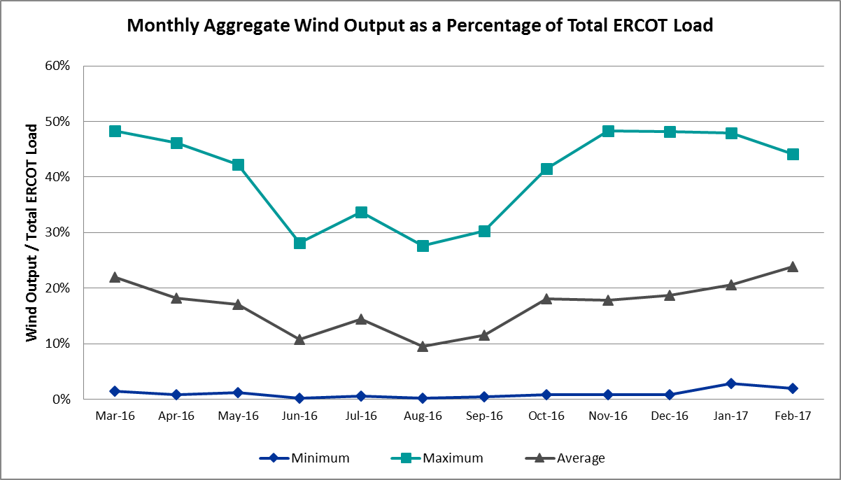

Congestion Analysis
The number of congestion events experienced by the ERCOT system decreased in February. There were fifty-one instances over 28 days on the Generic Transmission Constraints (GTCs) in February.

Notable Constraints for February
Nodal protocol section 3.20 specifies that ERCOT shall identify transmission constraints that are active or binding three or more times within a calendar month. As part of this process, ERCOT reports congestion that meets this criterion to ROS. In addition ERCOT also highlights notable constraints that have an estimated congestion rent exceeding $1,000,000 for a calendar month. These constraints are detailed in the table below. Rows highlighted in blue indicate the congestion was affected by one or more outages. For a list of all constraints activated in SCED for the month of February, please see Appendix A at the end of this report.

Contingency Name | Overloaded Element | # of Days Constraint Active | Congestion Rent | Transmission Project
Crlnw-Lwssw 345kv | Carrollton Northwest - Lakepointe Tnp 138kV | 22 | $9,118,012.88 | 5488
Basecase | PNHNDL GTC | 21 | $3,915,396.49 | Panhandle Upgrade
Rns-Rtw & Sng-Tb 345kv | Singleton - Zenith 345kV | 11 | $3,676,812.62 | Houston Import Project
Bbses-Jewet 345kv | Trinidad Ses - Richland Chambers 345kV | 1 | $3,672,664.11 | 5480
North Edinburg 345_1382 345/ | Burns Sub - Rio Hondo 138kV | 2 | $3,031,472.66
Rns-Rtw & Sng-Tb 345kv | Singleton - Zenith 345kV | 7 | $2,762,558.22 | Houston Import Project
Sng-Tb&Rns 345kv | Singleton - Zenith 345kV | 7 | $2,541,071.17 | Houston Import Project
Crlnw-Lwssw 345kv | Lewisville Switch - Jones Street Tnp 138kV | 6 | $1,550,362.24
Basecase | BKRSFL GTC | 7 | $1,155,428.61
Sndsw-Austro 345kv | Hutto Switch - Taylor West 138kV | 4 | $1,128,588.35 | 5800
Barrilla to Solstice 138 KV | Barrilla - Fort Stockton Switch 69kV | 8 | $1,078,056.00
Pleasant Valley Switch Axfmr | Lake Wichita Switch - Wichita Falls 69kV | 3 | $907,373.65 | 06TPIT0042
Basecase | ZO_AJO GTC | 9 | $394,367.58
Jardin to Cotulla Sub (2)138 | Dilley Switch Aep - Cotulla Sub 69kV | 3 | $334,655.49 | 5222
Basecase | LISTON GTC | 13 | $305,002.20 | 5171
Re Roserock Solar Plant to F | Barrilla - Fort Stockton Switch 69kV | 3 | $250,893.54
Loyola Sub to Kleberg Aep 13 | Loyola Sub 138/69kV | 7 | $233,474.99
Lwssw-Krwsw&Rnksw 345kv | Corinth (Oncor) - Pockrus Substation 138kV | 3 | $228,840.56
Mercers Gap Sw to Comanche S | Camp Bowie (Oncor) - Brownwood Switch 138kV | 16 | $175,925.95 | 5713
Asphalt Mines to Blewett (3) | Hamilton Road - Maverick 138kV | 5 | $96,652.47 | 16TPIT0024
Basecase | Randado Aep - Zapata 138kV | 8 | $40,865.69
Fort Stockton Plant 138_69t1 | Solstice - Pig Creek Tap 138kV | 14 | $35,425.79 | 3705
Basecase | Wkn_Bkr - Ena Snyder Wind 69kV | 7 | $21,064.80
Sndsw-Austro 345kv | Taylor West - Taylor (Oncor) 138kV | 5 | $19,039.39 | 5800
Sandow Switch Axfmr1h-H (3) | Sandow Switch 345/1kV | 6 | $6,131.96 | 5625
Scurry Switch to Sun Switch | Wolfgang - Rotan 69kV | 3 | $1,586.86
Laquinta to Lobo 138 KV | Bruni Sub 138/69kV | 3 | $1,010.38 | 5529

Generic Transmission Constraint Congestion
There were twenty-one days on the Panhandle GTC, one day on the Valley Import GTC, nine days on the Zorillo to Ajo GTC, seven days on the Bakersfield GTC, and thirteen days on the Liston GTC in February. There was no activity on the remaining GTCs during the Month.

Note: This is how many times a constraint has been activated to avoid exceeding a GTC limit, it does not imply an exceedance of the GTC occurred or that the GTC was binding.

Manual Overrides for February
None.

Congestion Costs for Calendar Year 2017
The following table represents the top twenty active constraints for the calendar year based on the estimated congestion rent attributed to the congestion. ERCOT updates this list on a monthly basis.

Contingency | Binding Element | # of 5-min SCED Intervals | Estimated Congestion Rent | Transmission Project
Hcksw-Allnc&Rnksw 345kv | Wagley Robertson - Summerfield 138kV | 1,429 | $20,785,800.16
Crlnw-Lwssw 345kv | Carrollton Northwest - Lakepointe Tnp 138kV | 2,787 | $11,982,271.80 | 5488
Victoria-V_Dupsw 138kv | Formosa - Lolita 138kV | 222 | $5,906,733.06
Basecase | Panhandle GTC | 5,230 | $5,089,207.63 | Panhandle Upgrade
Roserock Solar to Fort Stockton 138 kV | Barrilla - Fort Stockton Switch 69kV | 719 | $4,768,320.64
Rns-Rtw & Sng-Tb 345kv | Singleton - Zenith 345kV | 2,200 | $4,146,353.19 | Houston Import Project
Rns-Rtw & Sng-Tb 345kv | Singleton - Zenith 345kV | 1,806 | $3,977,069.64 | Houston Import Project
Bbses-Jewet 345kv | Trinidad Ses - Richland Chambers 345kV | 31 | $3,672,664.11 | 5480
North Edinburg 345_1382 345/138 KV | Burns Sub - Rio Hondo 138kV | 221 | $3,031,472.66
Sng-Tb&Rns 345kv | Singleton - Zenith 345kV | 744 | $2,541,071.17 | Houston Import Project
Twin Buttes AT2H 345/138 kV | San Angelo Red Creek T1H 345/13.2/138kV | 46 | $2,061,790.34 | 3664
Crlnw-Lwssw 345kv | Lewisville Switch - Jones Street Tnp 138kV | 413 | $1,892,190.87
Basecase | Bakersfield GTC | 753 | $1,155,428.61
Sndsw-Austro 345kv | Hutto Switch - Taylor West 138kV | 808 | $1,128,588.35 | 5800
Barilla to Solstice 138 kV | Barrilla - Fort Stockton Switch 69kV | 437 | $1,124,411.33
Jewet-Sng 345kv | Gibbons Creek - Singleton 345kV | 315 | $1,102,507.70 | Houston Import Project
Pleasant Valley Switch Axfmr1-H 138/69 KV | Lake Wichita Switch - Wichita Falls 69kV | 351 | $907,373.65 | 06TPIT0042
Sandow Switch to Austrop 345 KV | Sandow Switch - Austrop 345kV | 484 | $663,530.94 | 5625, 4477
Leg-Navarro 345kv | Trinidad Ses - Richland Chambers 345kV | 42 | $660,556.45 | 5480
Loyola Sub to Kleberg Aep 138 KV | Loyola Sub 69_1 138/69kV | 1,481 | $613,649.92

System Events

ERCOT Peak Load
The unofficial ERCOT peak load for the month was 42,729 MW and occurred on February 16th during hour ending 08:00.

Load Shed Events
None.

Stability Events
None.

Notable PMU Events
ERCOT analyzes PMU data for any significant system disturbances that do not fall into the Frequency Events category reported in section 2.1. The results are summarized in this section once the analysis has been completed.

There were no reportable events in February.

TRE/DOE Reportable Events
None.

New/Updated Constraint Management Plans
None.

New/Modified/Removed SPS
- Mitchell Bend SPS was activated on February 28, 2017.

New Procedures/Forms/Operating Bulletins
None.

Emergency Conditions

OCNs
None.

Advisories
Date and Time | Description
2/11/17 12:50 | Advisory issued due to delay in DAM solution.
2/18/17 14:45 | Advisory issued due to Physical Responsive Capability being below 3000 MW.

Watches
Date and Time | Description
2/11/17 18:05 | Watch issued due to RUC not completing on schedule.

Emergency Notices
None.

Application Performance

TSAT/VSAT Performance Issues
None.

Communication Issues
None.

Market System Issues
None.

Appendix A: Real-Time Constraints
The following is a complete list of constraints activated in SCED for the month of February. Full contingency descriptions can be found in the Standard Contingencies List located on the MIS secure site at Grid Generation Reliability Unit Commitment.

Contingency | Constrained Element | From Station | To Station | # of Days Constraint Active
DCRLLSW5 | 591__A | LKPNT | CRLNW | 22
BASE CASE | PNHNDL | n/a | n/a | 21
SZEPCMN8 | 670__B | BRNSW | CMPBW | 16
SZEPCMN8 | 670__B | CMPBW | BRNSW | 16
XFTS89 | PIGTAP_SOLSTI1_1 | SOLSTICE | PIGTAP | 14
XFTS89 | PIGTAP_SOLSTI1_1 | PIGTAP | SOLSTICE | 14
BASE CASE | LISTON | n/a | n/a | 13
DRNS_TB5 | SNGZEN98_A | SNG | ZEN | 11
BASE CASE | ZO_AJO | n/a | n/a | 9
SBARSOL8 | BARL_FTSW1_1 | FTSW | BARL | 8
BASE CASE | RANDAD_ZAPATA1_1 | RANDADO | ZAPATA | 8
DRNS_TB5 | SNGZEN99_A | SNG | ZEN | 7
SKLELOY8 | LOYOLA_69_1 | LOYOLA | LOYOLA | 7
BASE CASE | BKRSFL | n/a | n/a | 7
BASE CASE | SNYDER_WKN_BK1_1 | ENAS | WKN_BKR | 7
DSNG_TB5 | SNGZEN99_A | SNG | ZEN | 7
DCRLLSW5 | 590__A | LWSSW | LWVJS | 6
XSND58 | SNDSW_MR2H | SNDSW | SNDSW | 6
SBRAUVA8 | HAMILT_MAVERI1_1 | HAMILTON | MAVERICK | 5
DAUSSND5 | 1665__B | TAYLR | TLRWT | 5
DAUSSND5 | 1665__A | TLRWT | HUTTO | 4
DAUSSND5 | 1665__A | HUTTO | TLRWT | 4
BASE CASE | LGD_SANTIA1_1 | LGD | SANTIAGO | 4
DLWSRNK5 | 570_B_1 | POCKRUSC | CRNTH | 3
XPLV89 | 6945__A | LKWSW | WFALS | 3
SSCUSU28 | ROTN_WOLFGA1_1 | WOLFGANG | ROTN | 3
DAUSSND5 | HWRDLN_1 | HWRDTP | HWRDLN | 3
SWCSBOO8 | BARL_FTSW1_1 | FTSW | BARL | 3
SJARDIL8 | DIL_COTU_1 | DILLEYSW | COTULAS | 3
SLAQLOB8 | BRUNI_69_1 | BRUNI | BRUNI | 3
SWOORI38 | TNAF_FTS_1 | FTST | TNAF | 2
SWOORI38 | TNAF_FTS_1 | TNAF | FTST | 2
SCRDLOF9 | BOW_FMR1 | BOW | BOW | 2
SCABWES8 | HOLLY4_RODD_F1_1 | RODD_FLD | HOLLY4 | 2
DAUSSND5 | 216T421_1 | ELGSW | GILLCR | 2
SNEDLON5 | MV_YUT_RAYMND1_1 | RAYMND2 | MV_YUTT | 2
DNAVLEG5 | 31__A | RCHBR | TRSES | 2
DHILMAR5 | 581T581_1 | ECMORN | PARKWA | 2
SCOLBAL8 | BALG_HUMBLT1_1 | BALG | HUMBLTAP | 2
XNED258 | BURNS_RIOHONDO_1 | RIOHONDO | MV_BURNS | 2
SBIGOR45 | FRIR_ROCKSP1_1 | FRIR | ROCKSPRS | 2
SN_SLON5 | KINGSV_KLEBER1_1 | KLEBERG | KINGSVIL | 2
SNORODE5 | PIGTAP_SOLSTI1_1 | SOLSTICE | PIGTAP | 2
SSPUASP8 | ROTN_WOLFGA1_1 | WOLFGANG | ROTN | 2
DBBSJEW5 | 31__A | RCHBR | TRSES | 1
SHACPB38 | RIOPEC_WOODW21_1 | WOODWRD2 | RIOPECOS | 1
SSWDMGS8 | 6585__A | ESKSW | TRNT | 1
SGEOGEO8 | MAT_MAT_1 | MATHIS | MATHI_ST | 1
SMCEABS8 | ROBY_RONDTP1_1 | ROBY | RONDTPT | 1
BASE CASE | VALIMP | n/a | n/a | 1
SSCLWF18 | 6840__B | NVKSW | ANARN | 1
DLONOR58 | ARMSTR_LOYOLA1_1 | ARMSTRON | LOYOLA | 1
DLWSRNK5 | 587__A | ARGYL | LWSVH | 1
SZEPCMN8 | 670__C | CMPBW | BRNSO | 1
DNEDPAL8 | AZTECA_SE_EDI1_1 | AZTECA | SE_EDINB | 1
SBIGTWI5 | BONDRO_SONR1_1 | SONR | BONDROAD | 1
SDUKNED8 | DUKE_NEDIN2_1 | DUKE | NEDIN | 1
DHARSKY8 | F4_Y3_1_1 | F4 | Y3 | 1
SHLC6S8 | LY_PSA03_A | PSA | LY | 1
SLOBSA25 | NLARSW_PILONC1_1 | NLARSW | PILONCIL | 1
SSPUMW18 | ROTN_WOLFGA1_1 | WOLFGANG | ROTN | 1
DELMSAN5 | SANMIGL_ATAH | SANMIGL | SANMIGL | 1
DELMSAN5 | SANMIGL_ATAL | SANMIGL | SANMIGL | 1
DAUSSND5 | SNDSW_MR1H | SNDSW | SNDSW | 1
SN_SLON5 | CELANE_N_SHAR1_1 | N_SHARPE | CELANEBI | 1
SMCEABS8 | 6585__A | ESKSW | TRNT | 1
DWAPHLJ5 | DOWSTP27_A | STP | DOW | 1
DB_DPHA8 | HOLLY4_RODD_F1_1 | RODD_FLD | HOLLY4 | 1
SLOBSA25 | BRUNI_69_1 | BRUNI | BRUNI | 1
BASE CASE | POTOMES_1 | LNCRK2 | LNCRK2 | 1
BASE CASE | SMS_SPUR_1 | SPUR | SMS_SW_9 | 1
DAUSSND5 | 1261__C | MNRVA | MILANO | 1
DB_DAIR8 | AIRLIN_CABANI1_1 | AIRLINE | CABANISS | 1
DELMSTP5 | CKT_3124_1 | STP | HLJ | 1
XLOB58 | FREER_SAN_DI1_1 | SAN_DIEG | FREER | 1
DJEWSNG5 | JK_TOKSW_1 | TOKSW | JK_CK | 1
SSCLWF18 | NVKSW_FMR1 | NVKSW | NVKSW | 1
SRCHTRS5 | 31__A | RCHBR | TRSES | 1

