January 2017 ERCOT Monthly Operations Report
Reliability and Operations Subcommittee Meeting
March 4th, 2017

Table of Contents
1. Report Highlights 1
2. Frequency Control 2
2.1. Frequency Events 2
2.2. Responsive Reserve Events 3
2.3. Load Resource Events 3
3. Reliability Unit Commitment 3
4. Wind Generation as a Percent of Load 4
5. Congestion Analysis 4
5.1. Notable Constraints for January 5
5.2. Generic Transmission Constraint Congestion 7
5.3. Manual Overrides for January 7
5.4. Congestion Costs for Calendar Year 2017 7
6. System Events 8
6.1. ERCOT Peak Load 8
6.2. Load Shed Events 8
6.3. Stability Events 8
6.4. Notable PMU Events 9
6.5. TRE/DOE Reportable Events 9
6.6. New/Updated Constraint Management Plans 9
6.7. New/Modified/Removed SPS 9
6.8. New Procedures/Forms/Operating Bulletins 9
7. Emergency Conditions 9
7.1. OCNs 9
7.2. Advisories 9
7.3. Watches 9
7.4. Emergency Notices 10
8. Application Performance 10
8.1. TSAT/VSAT Performance Issues 10
8.2. Communication Issues 10
8.3. Market System Issues 10
Appendix A: Real-Time Constraints 11

Report Highlights
- The unofficial ERCOT peak for January was 59,636 MW.
- There were three frequency events in January. PMU data indicates the ERCOT system transitioned well in each case.
- There were three instances where Responsive Reserves were deployed, all of which were the result of a frequency event.
- There were four RUC commitments in January.
- The level of reportable SCED congestion increased in January. This congestion was mostly due to planned outages as well as high North to Houston imports. There were thirty-nine instances over 27 days on the Generic Transmission Constraints (GTCs) in January. There were seventeen days on the Panhandle GTC, one day on the North to Houston GTC and twenty-one days on the Liston GTC in January. There was no activity on the remaining GTCs during the Month.
- An advisory was issued to the unavailability of ERCOT’s Voltage Security Assessment Tool (VSAT).

Frequency Control

Frequency Events
The ERCOT Interconnection experienced three frequency events in January, all of which resulted from Resource trips. The average event duration was approximately 0:04:25.

When analyzing frequency events, ERCOT evaluates PMU data according to industry standards. Events with an oscillating frequency of less than 1 Hz are considered to be inter-area, while higher frequencies indicate local events. Industry standards specify that damping ratio for inter-area oscillations should be 3.0% or greater. All events listed below indicate the ERCOT system met these standards and transitioned well after each disturbance.

Reported frequency events will include both frequency events where frequency was outside the range of 60±0.1 Hz as well as those determined to be Frequency Measurable Events (FME) as defined by BAL-001-TRE-1. Delta Frequency is defined as the difference between the pre-perturbation and post-perturbation frequency. The Duration of Event is defined as the time it takes for the frequency to recover to lesser/greater of the frequency at the time of the frequency event (t(0) or “A-point”) for low/high-frequency events, respectively. Further details on FMEs can be found in the MIS posted BAL-001-TRE-1 PDCWG Unit Performance reports. A summary of the frequency events is provided below:

Date and Time | Delta Frequency |  | Max/Min Frequency |  | Duration of Event | PMU Data |  |  |  | Load | Wind | Inertia¹ | Comments
 | (Hz) |  | (Hz) |  |  | Oscillation Mode (Hz) | Damping Ratio |  |  | (MW) | % | (MW-s)
1/6/2017 23:58 |  | 0.087 |  | 59.89 | 0:04:50 | 0.65 | 7% |  | 54,225 |  | 8% | 300,468 | Unit Trip of 731MW
1/10/2017 15:13 |  | 0.062 |  | 59.90 | 0:05:08 | 0.80 |  | 15% | 35,510 |  | 10% | 210,483 | Unit Trip of 404MW
1/23/2017 21:50 |  | 0.038 |  | 59.81 | 0:03:16 | 0.75 | 23% |  | 34,576 |  | 43% | 167,735 | Unit Trip of 796MW
(Note: frequency events highlighted in blue have been identified as FMEs per BAL-001-TRE-1 and the Performance Disturbance Compliance Working group.)

Currently, the Critical Inertia Level for ERCOT appears to be around 100,000 MW-s (Source: link)
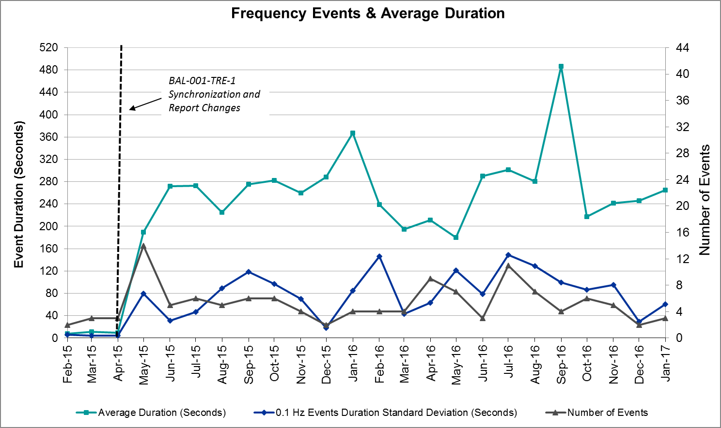

Responsive Reserve Events
There were three events where Responsive Reserve MWs were released to SCED in January. The events highlighted in blue were related to frequency events reported in Section 2.1 above.

Date and Time Released to SCED | Date and Time Recalled | Duration of Event | Maximum MWs Released
1/6/2017 23:58:52 | 1/7/2017 0:02:16 | 0:03:24 | 394.80
1/10/2017 15:13:18 | 1/10/2017 15:17:58 | 0:04:40 | 341.52
1/23/2017 21:50:20 | 1/23/2017 21:52:56 | 0:02:36 | 950.33

Load Resource Events
None.

Reliability Unit Commitment
ERCOT reports on Reliability Unit Commitments (RUC) on a monthly basis. Commitments are reported grouped by operating day and weather zone. The total number of hours committed is the sum of the hours for all the units in the specified region. Additional information on RUC commitments can be found on the MIS secure site at Grid Generation Reliability Unit Commitment.

There were no DRUC commitments in January.

There were four HRUC commitments in January.

Resource Location | # of Resources | Operating Day | Total # of Hours Committed | Total MWhs | Reason for Commitment
North Central | 2 | 1/13/2017 | 3 | 1,373 | Capacity
South Central | 1 | 1/13/2017 | 1 | 239 | Capacity
North Central | 4 | 1/14/2017 | 4 | 1,511 | Capacity
Southern | 1 | 1/18/2017 | 1 | 227 | Local Congestion

Wind Generation as a Percent of Load

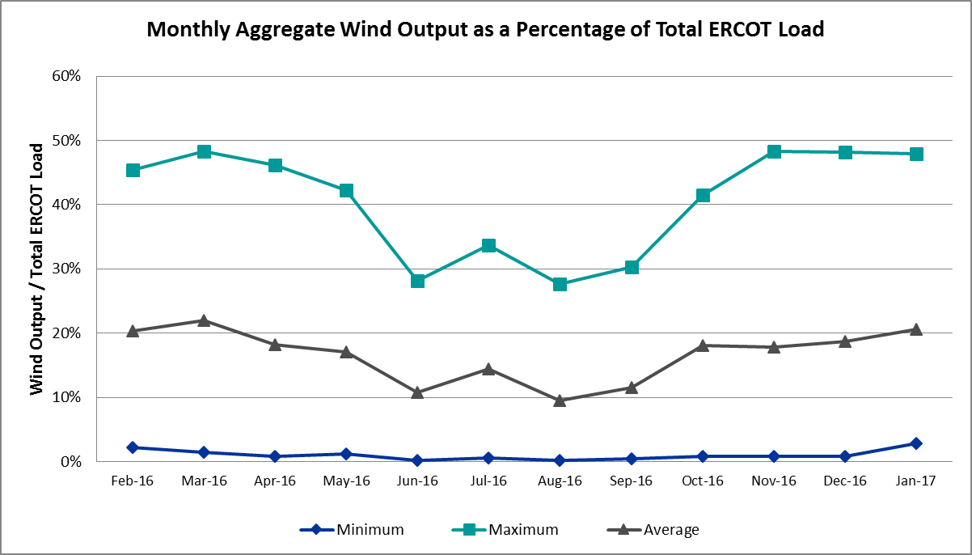

Congestion Analysis
The number of congestion events experienced by the ERCOT system increased in January. There were thirty-nine instances over 27 days on the Generic Transmission Constraints (GTCs) in January.

Notable Constraints for January
Nodal protocol section 3.20 specifies that ERCOT shall identify transmission constraints that are active or binding three or more times within a calendar month. As part of this process, ERCOT reports congestion that meets this criterion to ROS. In addition ERCOT also highlights notable constraints that have an estimated congestion rent exceeding $1,000,000 for a calendar month. These constraints are detailed in the table below. Rows highlighted in blue indicate the congestion was affected by one or more outages. For a list of all constraints activated in SCED for the month of January, please see Appendix A at the end of this report.

Contingency Name | Overloaded Element | # of Days Constraint Active | Congestion Rent | Transmission Project
Hicks Switch - Alliance & Roanoke Switch 345 kV | Wagley Robertson - Summerfield 138kV | 8 | $20,785,800
DCKT Victoria - Victoria Dupont Switch 138 kV | Formosa - Lolita 138kV | 2 | $5,906,733
Roserock Solar to Fort Stockton 138 kV | Barrilla - Fort Stockton Switch 69kV | 7 | $4,517,427
Carrolton Northwest - Lewisville Switch 345 kV | Carrollton Northwest - Lakepointe Tnp 138kV | 10 | $2,864,259 | 5488
Twin Buttes AT2H 345/138 kV | San Angelo Red Creek T1H 345/13.2/138kV | 1 | $2,061,790 | 3664
DKCT Roans Prarie-Rothwood & Singleton-Tomball 345kV | Singleton - Zenith 345kV | 8 | $1,214,511 | Houston Import Project
Basecase | Panhandle GTC | 17 | $1,173,811 | Panhandle Upgrade
DCKT Jewett - Singleton 345 kV | Gibbons Creek - Singleton 345kV | 2 | $1,102,508 | Houston Import Project
Sandow Switch - Austrop 345 kV | Sandow Switch - Austrop 345kV | 8 | $663,531 | 5625
Liston to Bates 138 kV | Garza 69A1 138/69kV | 12 | $540,083 | 5171
DKCT Roans Prarie-Rothwood & Singleton-Tomball 345kV | Singleton - Zenith 345kV | 3 | $469,541 | Houston Import Project
DCKT Whitepint - Lon Hill and South Texas Project 345 kV | Blessing - Lolita 138kV | 3 | $414,700
Loyola Sub to Kleberg Aep 138 kV | Loyola Sub 69_1 138/69kV | 8 | $380,175
Laquinta - Lobo 138 kV | Bruni Sub 69_1 138/69kV | 11 | $365,989 | 5529
Sandow Switch Axfmr1l-H (3)345/138 kV | Sandow Switch MR2H 345/13.8/138kV | 12 | $322,305 | 5625
Chb-Kg & Jor-Nb 345kV | Bigvue - Power Systems-Arco Cogen 138kV | 5 | $235,289
Mercers Gap Sw to Comanche Switch (Oncor) 138 kV | Camp Bowie (Oncor) - Brownwood Switch 138kV | 16 | $235,173 | 5713
Nelson Sharpe - Lon Hill 345 kV | Kingsville - Kleberg Aep 138kV | 5 | $234,782
Basecase | Liston GTC | 21 | $206,298 | 5171
Spur - Scurry Switch 138 kV | Aspermont Aep 69T1 138/69kV | 4 | $118,380
Basecase | Wkn_Bkr - Ena Snyder Wind 69kV | 8 | $91,840
DCKT Jewett - Singleton 345 kV | Btu_Jack_Creek - Twin Oak Switch 345kV | 5 | $75,986 | Houston Import Project
Uvalde Aep - Odlaw Switchyard 138 kV | Hamilton Road - Maverick 138kV | 5 | $54,262 | 16TPIT0024
Barrilla to Solstice 138 kV | Barrilla - Fort Stockton Switch 69kV | 4 | $46,355
Scurry Switch to Sun Switch 138 kV | Aspermont Aep 69T1 138/69kV | 4 | $29,610
Lake Ivey Booster to Lake Ivey Intake Pump (6)138/138/138/138/138/138 kV | Coleman Junctin - Santa Anna 69kV | 4 | $20,038
Downie Switching Station to Uvalde Aep 138 kV | Downie Switching Station AX1H 138/69kV | 3 | $19,691
Woodward 1 to Woodward 1 Tap (5)138/138/138/138/138 kV | Woodward 2 - Rio Pecos 138kV | 5 | $15,261 | 5535
DCKT Gibbons Creek - Singleton 345 kV | Jewett - Singleton 345kV | 3 | $14,105 | Houston Import Project
Woodward 1 to Woodward 1 Tap (5)138/138/138/138/138 kV | Fort Stockton Plant - Airport Tnp 138kV | 8 | $10,913
Basecase | Randado Aep - Zapata 138kV | 9 | $5,845
Scurry Switch to Sun Switch 138 kV | Wolfgang - Rotan 69kV | 3 | $2,015

Generic Transmission Constraint Congestion
There were seventeen days on the Panhandle GTC, one day on the North to Houston GTC and twenty-one days on the Liston GTC in January. There was no activity on the remaining GTCs during the Month.

Note: This is how many times a constraint has been activated to avoid exceeding a GTC limit, it does not imply an exceedance of the GTC occurred or that the GTC was binding.

Manual Overrides for January
None.

Congestion Costs for Calendar Year 2017
The following table represents the top twenty active constraints for the calendar year based on the estimated congestion rent attributed to the congestion. ERCOT updates this list on a monthly basis.

Contingency | Binding Element | # of 5-min SCED Intervals | Estimated Congestion Rent | Transmission Project
Hcksw-Allnc&Rnksw 345kv | Wagley Robertson - Summerfield 138kV | 1,429 | $ 20,785,800.16
Victoria-V_Dupsw 138kv | Formosa - Lolita 138kV | 222 | $ 5,906,733.06
Roserock Solar to Fort Stockton 138 kV | Barrilla - Fort Stockton Switch 69kV | 644 | $ 4,517,427.10 | 4703
Crlnw-Lwssw 345kv | Carrollton Northwest - Lakepointe Tnp 138kV | 736 | $ 2,864,258.92 | 5488
Twin Buttes AT2H 345/138 kV | San Angelo Red Creek T1H 345/13.2/138kV | 46 | $ 2,061,790.34 | 3664
Rns-Rtw & Sng-Tb 345kv | Singleton - Zenith 345kV | 806 | $ 1,214,511.42 | Houston Import Project
Basecase | Panhandle GTC | 2,082 | $ 1,173,811.14 | Panhandle Upgrade
Jewet-Sng 345kv | Gibbons Creek - Singleton 345kV | 315 | $ 1,102,507.70 | Houston Import Project
Sandow Switch to Austrop 345 KV | Sandow Switch - Austrop 345kV | 484 | $ 663,530.94 | 5625, 4477
Liston to Bates 138 kV | Garza 69A1 138/69kV | 2,470 | $ 540,083.26
Fort Mason to Gillespie Lcra 138 KV | Coronado AT4 138/69kV | 128 | $ 481,879.10
Rns-Rtw & Sng-Tb 345kv | Singleton - Zenith 345kV | 443 | $ 469,540.57 | Houston Import Project
Bevo Substation to Asherton 138 KV | Big Wells Sub - Cotulla Sub 69kV | 241 | $ 429,052.89 | 5217
White_Pt-Lon_Hill&Stp 345kv | Blessing - Lolita 138kV | 124 | $ 414,700.45
Loyola Sub to Kleberg Aep 138 KV | Loyola Sub 69_1 138/69kV | 800 | $ 380,174.93
Laquinta to Lobo 138 KV | Bruni Sub 69_1 138/69kV | 1,335 | $ 365,989.46
Crlnw-Lwssw 345kv | Lewisville Switch - Jones Street Tnp 138kV | 123 | $ 341,828.62
Sandow Switch Axfmr1l-H (3)345/138 KV | Sandow Switch MR2H 345/13.8/138kV | 1,599 | $ 322,304.85
Hcksw-Allnc&Rnksw 345kv | Rosen Heights Tap 2 - Saginaw Switch 138kV | 24 | $ 316,577.52 | 4252
Dilleysw-Sanmgsw&Cotulas 138kv | Dilley Switch Aep - Cotulla Sub 69kV | 261 | $ 279,090.56 | 5222

System Events

ERCOT Peak Load
The unofficial ERCOT peak load for the month was 59,636 MW and occurred on January 6th during hour ending 19:00.

Load Shed Events
None.

Stability Events
None.

Notable PMU Events
ERCOT analyzes PMU data for any significant system disturbances that do not fall into the Frequency Events category reported in section 2.1. The results are summarized in this section once the analysis has been completed.

There were no reportable events in January.

TRE/DOE Reportable Events
None.

New/Updated Constraint Management Plans
- MP_2017_01
- PCAP_2017_01

New/Modified/Removed SPS
None.

New Procedures/Forms/Operating Bulletins
ERCOT has revised the following procedure manuals, effective January 30, 2017.

Procedure Title | POB
Reliability Risk Desk V1 Rev 0 | 770

Emergency Conditions

OCNs
Date and Time | Description
1/13/17 21:18 | OCN issued due to reserve capacity shortage.

Advisories
Date and Time | Description
1/6/17 9:02 | Advisory issued due to extreme cold weather.
1/13/17 21:18 | Advisory issued due to Physical Responsive Capability being below 3000 MW.
1/26/17 10:04 | Advisory issued due to VSAT unavailability.

Watches
None.

Emergency Notices
None.

Application Performance

TSAT/VSAT Performance Issues
- 1/26/17 – An advisory was issued to the unavailability of ERCOT’s Voltage Security Assessment Tool (VSAT).

Communication Issues
None.

Market System Issues
None.

Appendix A: Real-Time Constraints
The following is a complete list of constraints activated in SCED for the month of January. Full contingency descriptions can be found in the Standard Contingencies List located on the MIS secure site at Grid Generation Reliability Unit Commitment.

Contingency | Constrained Element | From Station | To Station | # of Days Constraint Active
BASE CASE | LISTON | n/a | n/a | 21
BASE CASE | PNHNDL | n/a | n/a | 17
SZEPCMN8 | 670__B | BRNSW | CMPBW | 16
XSND58 | SNDSW_MR2H | SNDSW | SNDSW | 12
SLISBAT8 | GARZA_69A1 | GARZA | GARZA | 12
SLAQLOB8 | BRUNI_69_1 | BRUNI | BRUNI | 11
DCRLLSW5 | 591__A | LKPNT | CRLNW | 10
BASE CASE | RANDAD_ZAPATA1_1 | RANDADO | ZAPATA | 9
DHCKRNK5 | 6271__C | WGROB | SUMRFELD | 8
BASE CASE | SNYDER_WKN_BK1_1 | ENAS | WKN_BKR | 8
SSNDAU15 | 450__A | SNDSW | AUSTRO | 8
SKLELOY8 | LOYOLA_69_1 | LOYOLA | LOYOLA | 8
DRNS_TB5 | SNGZEN99_A | SNG | ZEN | 8
SWOORI38 | TNAF_FTS_1 | TNAF | FTST | 8
SWOORI38 | TNAF_FTS_1 | FTST | TNAF | 8
SWCSBOO8 | BARL_FTSW1_1 | BARL | FTSW | 7
SWCSBOO8 | BARL_FTSW1_1 | FTSW | BARL | 7
SMCEABS8 | 6780__A | ESKSW | LONGWRTH | 6
DCHB_NB5 | BCVPSA03_A | PSA | BCV | 5
SBRAUVA8 | HAMILT_MAVERI1_1 | HAMILTON | MAVERICK | 5
DJEWSNG5 | JK_TOKSW_1 | TOKSW | JK_CK | 5
SN_SLON5 | KINGSV_KLEBER1_1 | KLEBERG | KINGSVIL | 5
SWOORI38 | RIOPEC_WOODW21_1 | WOODWRD2 | RIOPECOS | 5
SWOORI38 | RIOPEC_WOODW21_1 | RIOPECOS | WOODWRD2 | 5
SSCUSU28 | ASPM_69T1 | ASPM | ASPM | 4
SCOLBAL8 | COLJ_SANA1_1 | SANA | COLJ | 4
SSPUMW18 | ASPM_69T1 | ASPM | ASPM | 4
SBARSOL8 | BARL_FTSW1_1 | FTSW | BARL | 4
SSCUSU28 | ROTN_WOLFGA1_1 | WOLFGANG | ROTN | 3
DWH_STP5 | BLESSI_LOLITA1_1 | BLESSING | LOLITA | 3
DGIBSNG5 | 260_A_1 | JEWET | SNG | 3
DRNS_TB5 | SNGZEN98_A | SNG | ZEN | 3
SDOWUVA8 | DOWNIES_AX1H | DOWNIES | DOWNIES | 3
DGBYCRN8 | BCVPSA03_A | PSA | BCV | 2
DJEWSNG5 | SNGXGC99_1 | GIBCRK | SNG | 2
SFORGIL8 | 31T106_1 | BUCHAN | CTECBU | 2
DWIRPAL8 | 342T195_1 | GRANMO | MARBFA | 2
SCOLPAW5 | COLETO_KENEDS1_1 | COLETO | KENEDSW | 2
DSTPWHI5 | BLESSI_LOLITA1_1 | BLESSING | LOLITA | 2
DVICV_D8 | GREENL_WEAVER1_1 | WEAVERRD | GREENLK | 2
DCRLLSW5 | 590__A | LWSSW | LWVJS | 2
DVICV_D8 | FORMOS_LOLITA1_1 | LOLITA | FORMOSA | 2
DFPPFAY5 | 192T175_1 | SMITHV | WINCHE | 2
DHCKRNK5 | 6260__C | EMSES | EMMCP | 2
DJEWSNG5 | SNGXGC75_1 | GIBCRK | SNG | 2
DBIGKEN5 | FRIR_ROCKSP1_1 | FRIR | ROCKSPRS | 2
XLOB58 | GARZA_ROMA_S1_1 | GARZA | ROMA_SW | 2
DDILCOT8 | DIL_COTU_1 | COTULAS | DILLEYSW | 2
SBEVASH8 | BIG_COTU_1 | COTULAS | BIGWELS | 2
SFORGIL8 | CORONA_AT4 | CORONA | CORONA | 2
DEMSHCK5 | 6271__C | WGROB | SUMRFELD | 2
DHUTGEA8 | 211T147_1 | GILLCR | MCNEIL_ | 1
DNAVBBS5 | 31__A | RCHBR | TRSES | 1
DMARPA_8 | 32T311_1 | BURNET | BERTRA | 1
DCAGCI58 | 460T460_1 | MEDILA | W1 | 1
DHCKRNK5 | 6265__C | RHTP2 | SAGNA | 1
BASE CASE | LGD_SANTIA1_1 | LGD | SANTIAGO | 1
XCO2L58 | VICTO_WARBU_1A_1 | VICTORIA | WARBURTN | 1
SBATFRO8 | GARZA_69A1 | GARZA | GARZA | 1
DMARZOR5 | MARION_AT2H | MARION | MARION | 1
SGEOGEO8 | MAT_MAT_1 | MATHIS | MATHI_ST | 1
XTWI258 | REDCREEK_T1H | REDCREEK | REDCREEK | 1
XFTS89 | BARL_PIGTAP1_1 | BARL | PIGTAP | 1
DWIRPAL8 | CORONA_AT4 | CORONA | CORONA | 1
DRIOHAR5 | BURNS_RIOHONDO_1 | RIOHONDO | MV_BURNS | 1
SCOLPAW5 | COLETO_VICTOR2_1 | COLETO | VICTORIA | 1
SLVOSON8 | ELDO_LVOK1_1 | LVOK | ELDO | 1
SFORJOS8 | FORMOS_LOLITA1_1 | LOLITA | FORMOSA | 1
DTOKJK_5 | 260_A_1 | JEWET | SNG | 1
DFERPAL8 | 32T311_1 | BURNET | BERTRA | 1
SGLDSUN8 | ECRSW_FMR1 | ECRSW | ECRSW | 1
SN_SLON5 | LOYOLA_69_1 | LOYOLA | LOYOLA | 1
SLOBSA25 | NLARSW_PILONC1_1 | NLARSW | PILONCIL | 1
BASE CASE | N_TO_H | n/a | n/a | 1
SDANBLE8 | BLESSING_69A1 | BLESSING | BLESSING | 1
SLOBSA25 | FREER_LOBO1_1 | LOBO | FREER | 1
SDENPOC8 | HIC_LOCU_1 | HICKRY_D | LOCUST_D | 1
DAUSSND5 | SNDSW_MR1H | SNDSW | SNDSW | 1
SCAGKEN5 | 75T243_1 | KENDAL | COMFOR | 1
SNEDRIO5 | BURNS_RIOHONDO_1 | RIOHONDO | MV_BURNS | 1
DMLSENT5 | ELKTN_MR3L | ELKTN | ELKTN | 1
SSPUASP8 | ROTN_WOLFGA1_1 | WOLFGANG | ROTN | 1

