 |  |  |  | System Planning
Monthly Status Report
January 2017

 |  | Report Highlights
- ERCOT is currently reviewing proposed transmission improvements with a total cost of $872.3 Million.
- Transmission Projects endorsed in 2016 total $489.1 Million.
- All projects (in engineering, routing, licensing and construction) total approximately $6.23 Billion as of October 1, 2016.
- Transmission Projects energized in 2016 total about $1.72 Billion as of October 1, 2016.

Regional Planning Group Project Reviews

- AEPSC has submitted the Maverick County Transmission project. This is a Tier 2 project that is estimated to cost $44.3 million. This project is currently under ERCOT independent review.

- AEPSC and Oncor have jointly submitted the Far West Texas project. This is a Tier 1 project that is estimated to cost $423 million. This project is currently under ERCOT independent review.

- Brazos Electric Cooperative (BEC) has submitted the Northern Johnson County Area Improvement project. This is a Tier 2 project that is estimated to cost $8.1 million. BEC requested to withdraw the project and the project is no longer under ERCOT independent review.

- LCRA TSC has submitted the Cooks Point substation project. This is a Tier 1 project that is estimated to cost $52 million. This project is currently under ERCOT independent review.

- Sharyland Utilities has submitted the South Plains Transmission project. This is a Tier 1 project that is estimated to cost $251 million. This project is currently under ERCOT independent review.

- LCRA TSC has submitted the Mountain Home substation and transmission line addition project. This is a Tier 1 project that is estimated to cost $77.3 million. This project is currently under ERCOT independent review.

- LCRA TSC has submitted the Winchester project. This is a Tier 3 project that is estimated to cost $32.8 million. This project has been submitted for RPG comments.

Planning Model Activities
The short term calendar of major planning model events is as follows:
- Nov 21, 2016 Complete Transmission Loss Factors
The following table shows interconnection projects that met Planning Guide section 6.9(1)(b) – 6.9(1)(d) and were not modeled in SSWG cases due to lack of RARF data in accordance with Planning Guide section 6.9(1)(a) and 6.9(3). “Insufficient Planning Data” refers to data needed only for the Steady State model and is not the complete set of data marked Required for Planning in the Resource Registration Glossary.

Permian Basin Oil Rig Count
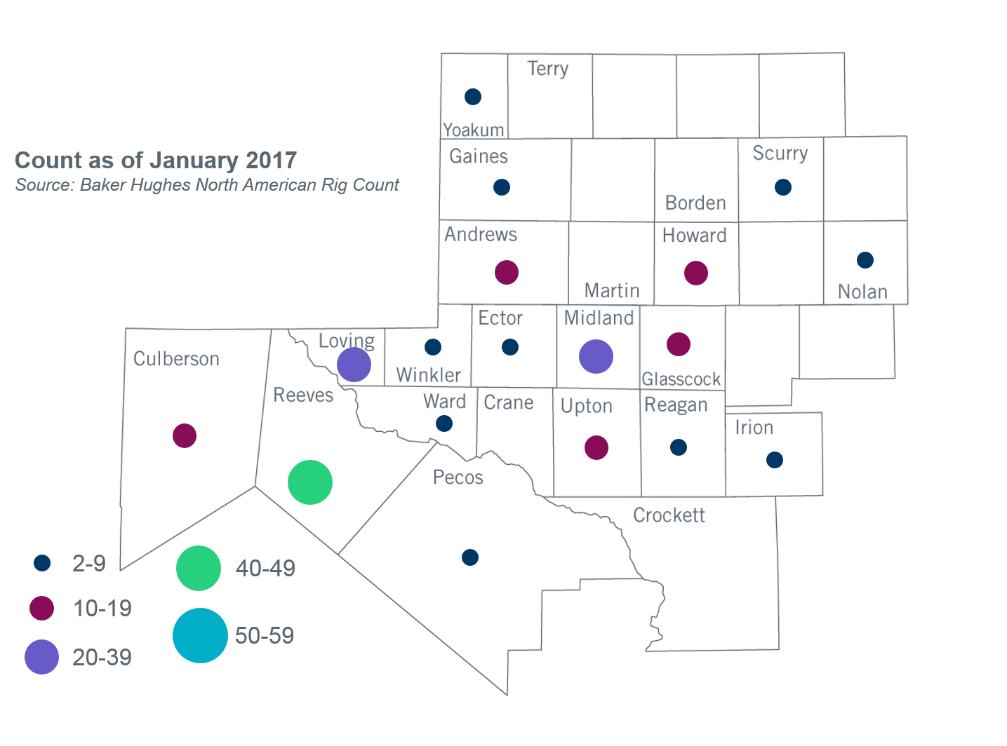

Other Notable Activities
- ERCOT completed the 2016 Regional Transmission Plan (RTP) study. The RTP study included reliability and economic analysis for the ERCOT System. The RTP report and its findings were shared with the RPG on December 28, 2016.
- ERCOT shared an intial scope and process document for the 2017 RTP with the Regional Planning Group (RPG) for feedback and review on October 21, 2016. ERCOT is working on finalizing the input assumptions for the 2017 RTP. ERCOT and TDSPs are reviewing the 2016 RTP load forecast using the bounded higher-of methodology.
- ERCOT has completed the 2016 Report on Existing and Potential Electric System Constraints and Needs. The report has been posted on the ERCOT website.
- On July 19, 2016, Public Utility Commission of Texas (PUCT) Chairman Nelson filed a memo in docket 45633 addressing the proposed move of the Lubbock Power and Light (LP&L) system from the Southwest Power Pool (SPP) grid into the Electric Reliability Council of Texas (ERCOT) grid. The memo included a recommendation for analyses to be performed by SPP and ERCOT. ERCOT is currently working on the SPP-ERCOT Coordinated Lubbock ERCOT Integration Study.
- ERCOT presented the Rayburn Load Integration Study scope to stakeholders at the September RPG meeting. ERCOT is currently working on the Rayburn Load Integration Study.
- The SPWG has started working on their 2017 Current Year base cases. ERCOT sent Pass 1 out to the group on 01/27/2017.

