NPRR Number | 815 | NPRR Title | Revise the Limitation of Load Resources Providing Responsive Reserve (RRS) Service
Date |  | February 8, 2017
Submitter’s Information
Name |  | John Dumas
E-mail Address |  | john.dumas@lcra.org
Company |  | Lower Colorado River Authority (LCRA)
Phone Number |  | 512-730-6847
Cell Number
Market Segment |  | Cooperative

Comments
LCRA is concerned that the proposed protocol language will lead to less online thermal generation which provides inertia and protects the system against both frequency events and voltage related events. The concern is due to the lack of inertial and voltage support the grid receives from load resources. Wind generation has continued to increase at a rapid rate with over 23,000 MW of wind capacity in 2019. This increase has led to a growing concern over the potential lack of inertia since thermal units are the only resources that can provide inertia. NPRR815 can increase the size of the safety net if an event occurs but it does not prevent an event from happening and it potentially increases the likelihood that an event will trigger the high set under frequency relays. Thermal generators are also voltage sources that help strengthen the system and protect against the risk of voltage collapse during events. Not only does a decrease in online generation lead to an inertia concern, but it can also create a weaker system which is much more sensitive to voltage changes.
ERCOT has designed their analysis around consistently meeting BAL-003 Interconnection Frequency Response Obligation, but this is not the only contingency that should be considered. LCRA reviewed the February 24th, 2007 EECP event in which wind generation in West Texas tripped due to extremely high winds. Wind gusts reached speeds of 64 MPH during this event. LCRA is aware that technology advances have improved speeds in which wind turbines trip, but the average cut out speeds on wind generation in West Texas has not been proven at 64 MPH. It should also be noted that the 64 MPH gusts were taken at stations that measure wind speed at a height of ten meters. Wind speeds at the turbine hub height are likely much higher due to less friction as you get higher above the ground. An excerpt from the 2007 EECP with LCRA’s analysis embedded shows what could happen with today’s level of generation in West Texas and what could happen with future levels of wind generation in West Texas:

Executive Summary

ERCOT implemented Step One of its Emergency Electric Curtailment Plan (EECP) on February 24, 2007. Factors that led to ERCOT implementing the EECP Step One:

Morning load pickup continued to climb by 1000 MW/Hr., leveling off at 10:30 AM at approximately 30,200 MW. Starting at 9:00 AM wind generation started to drop by 600 MW/Hr.

- In 2007, the West Zone Wind Capacity was 2,790 MW. The projected West Zone and Panhandle Wind Capacity for 2017 – 2021 is shown below:

2017 – 15,303 MW
2018 – 18,224 MW
2019 – 23,132 MW
2020 – 25,185 MW
2021 – 25,343 MW

- A 2007 600 MW/Hr. drop in wind generation translates into a wind generation decrease of:
3,300 MW/Hr. in 2017
3,920 MW/Hr. in 2018
4,980 MW/Hr. in 2019
5,420 MW/Hr. in 2020
5,450 MW/Hr. in 2021

At 10:20:00, ERCOT declared an Advisory for Adjusted Responsive Reserve (ARRS) below 3000 MW.

As ARRS and wind generation declined, ERCOT declared an Alert for ARRS below 2500 MW at 11:15:00.

At 11:43:00 ERCOT declared EECP. At this time wind generation had lost a total of 1550 MW from its morning peak generation. The aggregate SCE at this time was
-1369 MW.

- A 1550 MW loss in wind generation in 2007 translates to a:
8,500 MW loss in 2017
10,120 MW loss in 2018
12,850 MW loss in 2019
14,000 MW loss in 2020
14,100 MW loss in 2021

The hourly graph below shows hourly wind generation and hourly average wind speeds. During the 2007 event, the fastest 2-minute wind speed was 55.9 MPH, while the fastest 5-second wind speed was 64 MPH.

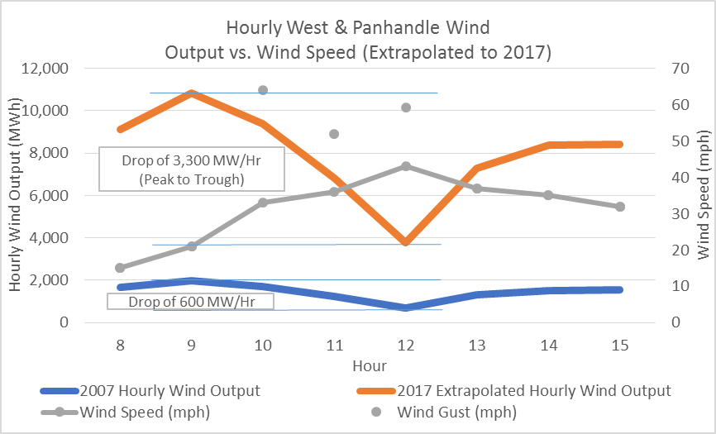

As ARRS was recovering, an 1180 MW Unit (Unit A) tripped while loaded at 226 MW at 12:00:00. ARRS did not show a significant change, however aggregate SCE dropped to -1498 MW. The unit was coming offline for a scheduled shutdown. Responsive Reserve (RRS) Deployed 364 MW.

EECP was terminated at 12:15:00.

Wind data is from the National Climate Data Center (NCDC) using Lubbock, Midland, San Angelo, Amarillo and Abilene weather stations.

If we take a look at December 16th 2016 (see table below), one of several recent high wind days, it is very possible that a repeat of the 2007 wind event would lead to firm load shed. Hourly data shows that West Texas wind was producing 11,290 MWs during hour ending 9:00 am, online reserves (includes LR providing RRS) were 6,118 MWs and offline reserves (30 minute or less) were 4,130 MWs. Even if we assume that the 30 minute offline reserves can get online fast enough to help with the event, simple addition indicates that the loss of 11,290 MWs of West Texas wind generation would exceed online and quick responding offline reserves by 1,042 MWs. ERCOT protocols state that ERCOT will maintain 1000 MWs of online reserves in EEA step 3. Of course, ERS would be deployed before firm Load shed but this additional ERS reserve is needed in order to try to maintain ERCOT’s 1000 MW requirement.

time | PRC | Total Wind | Online Reserves | Offline Reserves | West/North Wind | South/Houston Wind
12/16/2016 9:00 | 3,255 | 12,195 | 6,118 | 4,130 | 11,290 | 905
12/16/2016 10:00 | 3,212 | 11,990 | 6,413 | 4,058 | 11,016 | 974
12/16/2016 11:00 | 3,189 | 11,930 | 6,412 | 4,066 | 10,851 | 1,079
12/16/2016 12:00 | 3,460 | 12,058 | 7,129 | 4,106 | 10,794 | 1,264
It is not possible to know if all of the West Texas wind generation would trip or shut down in a similar wind event to 2007, nor is it possible to determine if all of the online reserves and offline reserves can respond timely enough to maintain frequency. However, LCRA believes that these types of events should be considered when ERCOT is determining the appropriate level of Ancillary Services. LCRA’s concern with removing the 50% Load Resource requirement could potentially be addressed through a minimum generation requirement. However, a minimum generation requirement would necessitate the need for a separate bid stack for generation and Load Resources. The minimum generation requirement should not only consider BAL-003 Interconnection Frequency Response Obligation but should also consider wind events similar to the 2007 event and should also consider the need for inertia and voltage sources.
LCRA has also looked back in the National Weather Service storm database and found that a high wind event occurred in 1996. This event seems to have been every bit as widespread as what occurred in 2007, with even higher wind speeds. It affected all of Far West Texas, the South Plains and the Panhandle. In this event, Amarillo reported winds to 61 mph, Midland 60 mph, Lubbock 59 mph and El Paso at 86 mph.
A cursory look at the years between 1996 and 2007 show that in about half of those years, there were high wind events with winds of 58-65 mph that affected at least 5-6 counties of West Texas. In some years, the high winds affected more over Far West Texas and in other years they were mostly across the Panhandle. Winds above 60 mph were surprisingly frequent.
For the period from 1996-2010, it appears the events in 1996 and 2007 were the most widespread, and contained the highest wind speeds. That’s a short sample period, but it gives you a frequency of 2 in 11 years, which is surprisingly frequent. LCRA requests that ERCOT and ROS take a closer look at this concern before NPRR815 moves forward.
Revised Cover Page Language
None proposed at this time.
Revised Proposed Protocol Language
None proposed at this time.

