PWG Meeting Notes – January 17, 2017
WebEx

Attendees:
Carolyn Reed – CNP
Lindsay Butterfield – ERCOT
Miguel Alvarado – Sharyland
Nikki McKenna – ERCOT
Sam Pak – Oncor
Sheri Wiegand – TXU
- 2017 Leadership Elections
  - Sheri Wiegand, TXU Energy, Chair
  - Sam Pak, Oncor, Vice-Chair
- Approval of December 2016 meeting notes with minor edits (ACTION: Nikki will make corrections discussed and post to PWG meeting page)
- Review of LPGRRs
  - LPGRR059, Administrative Changes for 1/1/17 Load Profiling Guide – Alignment with Section 21 – Lindsay presented LPGRR indicating the revision is an administrative change updating TRE and replacing with other governing bodies as Reliability Monitor, IMM, NERC etc. – No consensus is required as is simply a guide “clean up”
  - LPGRR060, Load Profiling Guide Clean Up Related to LPGRR057 (overhaul of LPG) – reviewed orphaned language – approved by PWG
    - Feb PWG – IA review
    - Mar COPS- Review and Vote
    - Mar TAC – Review and Vote
  - LPGRR061, Modifications to Annual Validation Timelines – approved by PWG
    - Feb PWG – IA review
    - Mar COPS- Review and Vote
    - Mar TAC – Review and Vote
    - 4/1/17 implementation
- Weather Sensitivity Change Report – presented
  - Discussion by WG on communication of report – both on the front end and back end
    - Nikki confirmed with Randy Roberts that both an email and a MarkeTrak is sent to the TDSPs notifying them the report is posted on MIS
    - Question on ‘overdue’ status if this needs to be reported to COPS for out of compliance issues – recall from earlier meetings language in the protocols or guides were reviewed indicating incompletion of the Annual Validation process by at least 99 % was to be reported to COPS. ACTION: Nikki was to check with Bill and Calvin on ‘out of compliance’ reporting requirements and directive language in the protocols/guides. Sheri will also review earlier meeting notes searching for appropriate language.
    - 11.4.3.1 (5) addressed report and presentation to PWG only
WEATHER SENSITIVITY CHANGES REQUIRED FOR SUMMER YEAR 2016
TDSPNAME | TOTAL_COUNT | HOLD | RESOLVED | OVERDUE
AEP TEXAS CENTRAL COMPANY (TDSP) | 83 |  | 83 | 0
AEP TEXAS NORTH COMPANY (TDSP) | 28 |  | 27 | 1
CENTERPOINT ENERGY HOUSTON ELECTRIC LLC (TDSP) | 487 |  | 487 | 0
NUECES ELECTRIC COOP INC (TDSP) | 3 |  | 0 | 3
ONCOR ELECTRIC DELIVERY COMPANY LLC (TDSP) | 1,119 | 4 | 1113 | 6
SHARYLAND UTILITIES LP (TDSP) | 1 |  | 1 | 0
TEXAS-NEW MEXICO POWER CO (TDSP) | 26 | 0 | 26 | 0
First ERCOT report date was 11/2/2016 so if not complete by 1/1/2017, these will be overdue.

- Review Oil & Gas Profile Request Process – at the request of ERCOT, in light of recent activity by a non-ROR CR, ERCOT is suggesting language be clarified in the request process for the Oil & Gas Profile. The WG reviewed and edited proposed language. See attached recommendations. ACTION: Nikki and Lindsay will draft official LPGRR recommending changes.
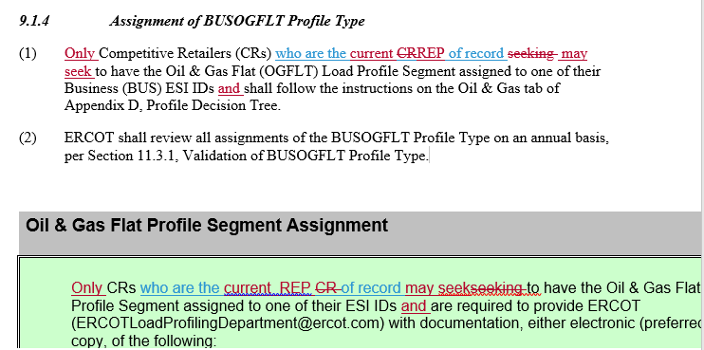
- Future Meetings – it was decided the meetings would continue to be conducted as WebEx unless the WG felt otherwise (for example, perhaps twice a year F2F when the WG has more reporting to review – UFE, AV, etc)
- Next meeting will be WebEx February 15th, 9:30 am
Proposed Agenda:
- Review of LPGRRs 60, 61 and associated IAs
- Review of Draft LPGRR for modification of Oil & Gas Profile requests
- 2017 Goals
- Adjourn

