December 2016 ERCOT Monthly Operations Report
Reliability and Operations Subcommittee Meeting
February 2nd, 2016

Table of Contents
1. Report Highlights 1
2. Frequency Control 2
2.1. Frequency Events 2
2.2. Responsive Reserve Events 3
2.3. Load Resource Events 3
3. Reliability Unit Commitment 3
4. Wind Generation as a Percent of Load 4
5. Congestion Analysis 4
5.1. Notable Constraints for December 4
5.2. Generic Transmission Constraint Congestion 6
5.3. Manual Overrides for December 6
5.4. Congestion Costs for Calendar Year 2016 6
6. System Events 7
6.1. ERCOT Peak Load 7
6.2. Load Shed Events 7
6.3. Stability Events 7
6.4. Notable PMU Events 8
6.5. TRE/DOE Reportable Events 8
6.6. New/Updated Constraint Management Plans 8
6.7. New/Modified/Removed SPS 8
6.8. New Procedures/Forms/Operating Bulletins 8
7. Emergency Conditions 8
7.1. OCNs 8
7.2. Advisories 8
7.3. Watches 9
7.4. Emergency Notices 9
8. Application Performance 9
8.1. TSAT/VSAT Performance Issues 9
8.2. Communication Issues 9
8.3. Market System Issues 9
Appendix A: Real-Time Constraints 10

Report Highlights
- The unofficial ERCOT peak for December was 57,968 MW.
- There were two frequency events in December. PMU data indicates the ERCOT system transitioned well in each case.
- There were two instances where Responsive Reserves were deployed, one of which was the result of a frequency event.
- There were no RUC commitments in December.
- The level of reportable SCED congestion decreased in December. This congestion was mostly due to planned outages. There were twenty-five instances over 20 days on the Generic Transmission Constraints (GTCs) in December. There were fifteen days on the Panhandle GTC and ten days on the Liston GTC in December. There was no activity on the remaining GTCs during the Month.
- There were no application issues to report for December.

Frequency Control

Frequency Events
The ERCOT Interconnection experienced two frequency events in December, all of which resulted from Resource trips. The average event duration was approximately 0:04:05.

When analyzing frequency events, ERCOT evaluates PMU data according to industry standards. Events with an oscillating frequency of less than 1 Hz are considered to be inter-area, while higher frequencies indicate local events. Industry standards specify that damping ratio for inter-area oscillations should be 3.0% or greater. All events listed below indicate the ERCOT system met these standards and transitioned well after each disturbance.

Reported frequency events will include both frequency events where frequency was outside the range of 60±0.1 Hz as well as those determined to be Frequency Measurable Events (FME) as defined by BAL-001-TRE-1. Delta Frequency is defined as the difference between the pre-perturbation and post-perturbation frequency. The Duration of Event is defined as the time it takes for the frequency to recover to lesser/greater of the frequency at the time of the frequency event (t(0) or “A-point”) for low/high-frequency events, respectively. Further details on FMEs can be found in the MIS posted BAL-001-TRE-1 PDCWG Unit Performance reports. A summary of the frequency events is provided below:

Date and Time | Delta Frequency | Max/Min Frequency | Duration of Event | PMU Data |  |  | Load | Wind | Inertia* | Comments
 | (Hz) | (Hz) |  | Oscillation Mode (Hz) | Damping Ratio |  | (MW) | % | (GW-s)
12/23/2016 16:54 | 0.100 | 59.87 | 0:04:26 | 0.76 | 13% | 36,671 |  | 14% | 196.710 |  | Unit Trip of 570MW
12/28/2016 10:06 | 0.052 | 59.87 | 0:03:45 | No PMU Data Available. |  | 35,616 |  | 19% | 197.118 |  | Unit Trip of 415MW
*Currently, the Critical Inertia Level for ERCOT appears to be around 100 GW-s (link)
(Note: frequency events highlighted in blue have been identified as FMEs per BAL-001-TRE-1 and the Performance Disturbance Compliance Working group.)

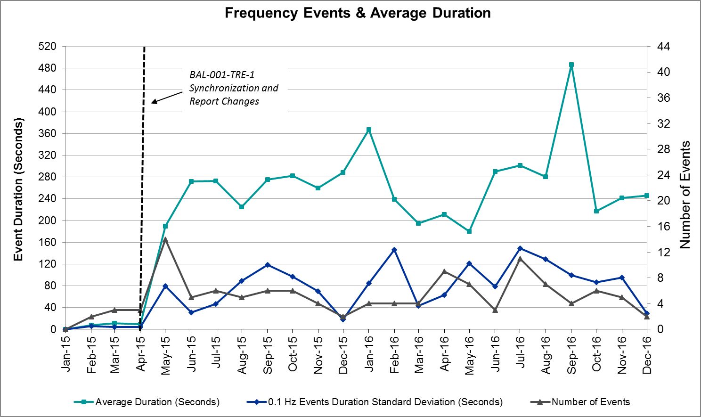

Responsive Reserve Events
There were two events where Responsive Reserve MWs were released to SCED in December. The events highlighted in blue were related to frequency events reported in Section 2.1 above.

Date and Time Released to SCED | Date and Time Recalled | Duration of Event | Maximum MWs Released | Comments
12/23/2016 16:54:13 | 12/23/2016 16:57:44 | 0:03:31 | 469.44
12/28/2016 10:06:28 | 12/28/2016 10:10:52 | 0:04:24 | 775.95

Load Resource Events
None.

Reliability Unit Commitment
ERCOT reports on Reliability Unit Commitments (RUC) on a monthly basis. Commitments are reported grouped by operating day and weather zone. The total number of hours committed is the sum of the hours for all the units in the specified region. Additional information on RUC commitments can be found on the MIS secure site at Grid Generation Reliability Unit Commitment.

There were no DRUC commitments in December.

There were no HRUC commitments in December.

Wind Generation as a Percent of Load
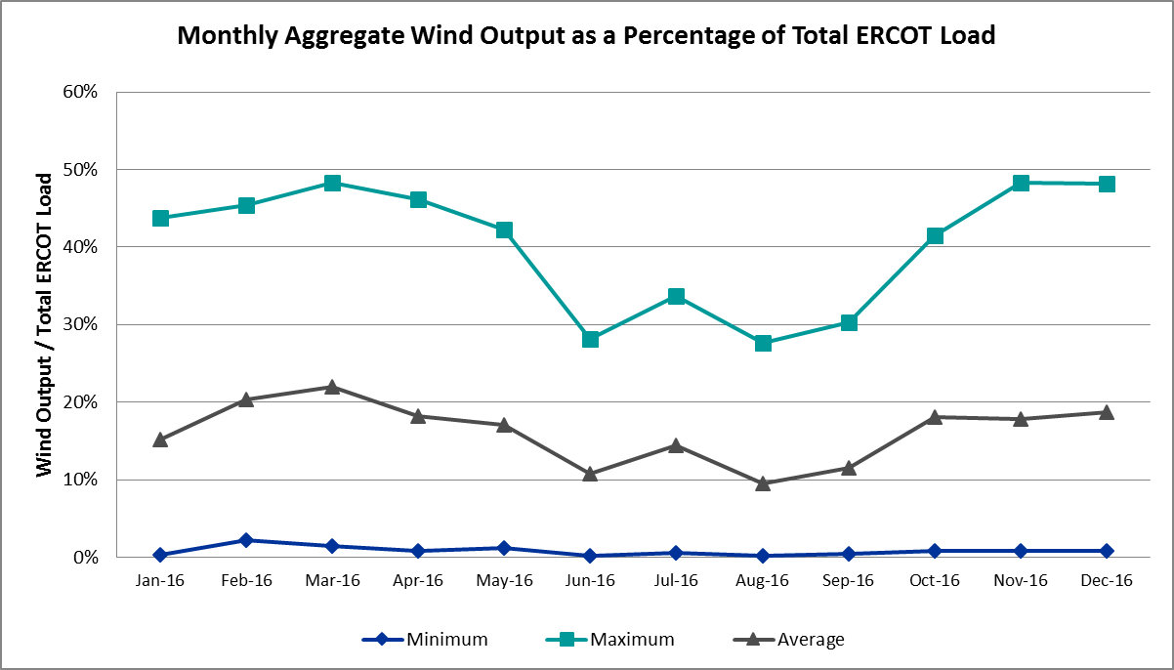

Congestion Analysis
The number of congestion events experienced by the ERCOT system decreased in December. There were twenty-five instances of activity on the Generic Transmission Constraints (GTCs) in December.

Notable Constraints for December
Nodal protocol section 3.20 specifies that ERCOT shall identify transmission constraints that are active or binding three or more times within a calendar month. As part of this process, ERCOT reports congestion that meets this criterion to ROS. In addition ERCOT also highlights notable constraints that have an estimated congestion rent exceeding $1,000,000 for a calendar month. These constraints are detailed in the table below. Rows highlighted in blue indicate the congestion was affected by one or more outages. For a list of all constraints activated in SCED for the month of December, please see Appendix A at the end of this report.

Contingency Name | Overloaded Element | # of Days Constraint Active | Congestion Rent | Transmission Project
Basecase | Panhandle GTC | 25 | $5,159,849.84 | Panhandle Upgrade
Hicks Switch - Alliance & Roanoke Switch 345 kV | Eagle Mountain Ses - Morris Dido 138kV | 3 | $3,540,816.14 | 4252
Hicks Switch - Alliance & Roanoke Switch 345 kV | Wagley Robertson - Summerfield 138kV | 2 | $2,216,780.97
DKCT Roans Prarie-Rothwood & Singleton-Tomball 345kV | Singleton - Zenith 345kV | 3 | $1,753,444.11 | Houston Import Project
Carrolton Northwest - Lewisville Switch 345 kV | Carrollton Northwest - Lakepointe Tnp 138kV | 7 | $1,277,369.54 | 5488
Carrolton Northwest - Lewisville Switch 345 kV | Ti Tnp - West Tnp 138kV | 4 | $947,958.58
Carrolton Northwest - Lewisville Switch 345 kV | Lewisville Switch - Jones Street Tnp 138kV | 5 | $589,172.37
DCKT Sandow Switch - Austrop 345kV | Howard Lane Tap - Howard Lane Aen 138kV | 16 | $574,750.29
Mercers Gap Sw to Comanche Switch (Oncor) 138 kV | Holder FMR1 138/69kV | 18 | $557,719.28
Loyola Sub to Kleberg Aep 138 kV | Loyola Sub 69_1 138/69kV | 7 | $527,897.44
Jardin to Cotulla Sub 138 kV | Dilley Switch Aep - Cotulla Sub 69kV | 4 | $503,779.18 | 5222
DCKT Jewett - Singleton 345 kV | Btu_Jack_Creek - Twin Oak Switch 345kV | 5 | $330,958.44 | Houston Import Project
DCKT Gibbons Creek - Singleton 345 kV | Jewett - Singleton 345kV | 3 | $215,811.77 | Houston Import Project
Laquinta - Lobo 138 kV | Bruni Sub 69_1 138/69kV | 9 | $215,520.95 | 5529
Basecase | Liston GTC | 13 | $207,335.26 | 5171
Fppyd1-Salem & Fayett 345kV | Smithville - Winchester 138kV | 3 | $188,671.42 | 5272
Mercers Gap Sw to Comanche Switch (Oncor) 138 kV | Camp Bowie (Oncor) - Brownwood Switch 138kV | 6 | $133,937.21 | 5713
Barrilla to Solstice 138 kV | Barrilla - Fort Stockton Switch 69kV | 5 | $120,012.04
DCKT Whitepint - Lon Hill and South Texas Project 345 kV | Blessing - Lolita 138kV | 3 | $114,464.00
Liston to Bates 138 kV | Garza - Roma Switch 138kV | 6 | $110,425.83 | 5171
Twinbu-Dvide 345kV | Nicole - Orient 138kV | 3 | $26,983.65
Sandow Switch - Austrop 345 kV | Sandow Switch - Austrop 345kV | 4 | $16,480.23 | 5625
Uvalde Aep - Odlaw Switchyard 138 kV | Hamilton Road - Maverick 138kV | 4 | $13,966.44 | 16TPIT0024
Markley (Oncor) to Rice Switch (2)138/138 kV | Navy Kickapoo Switch FMR1 138/69kV | 3 | $5,630.67
Eskota Switch - Abilene South 138 kV | Eskota Switch - Longworth 69kV | 3 | $3,886.72

Generic Transmission Constraint Congestion
There were fifteen days on the Panhandle GTC and ten days on the Liston GTC in December. There was no activity on the remaining GTCs during the Month.

Note: This is how many times a constraint has been activated to avoid exceeding a GTC limit, it does not imply an exceedance of the GTC occurred or that the GTC was binding.

Manual Overrides for December
None.

Congestion Costs for Calendar Year 2016
The following table represents the top twenty active constraints for the calendar year based on the estimated congestion rent attributed to the congestion. ERCOT updates this list on a monthly basis.

Contingency | Binding Element | # of 5-min SCED Intervals | Estimated Congestion Rent | Transmission Project
Rns-Rtw & Sng-Tb 345kv | Singleton - Zenith 345kV | 9,947 | $ 48,088,117.63 | Houston Import Project
Ph Robinson At1l_H (3)345/138 KV | Meadow AT1 345/138kV | 1,470 | $ 37,410,531.94 | 4708
Basecase | Panhandle GTC | 15,174 | $ 31,480,585.08 | Panhandle Upgrade
Villa Cavazos to Military Highway Aep (2)138/138 KV | Los Fresnos - Loma Alta Substation 138kV | 3,272 | $ 26,026,381.24
Jewet-Sng 345kv | Btu_Jack_Creek - Twin Oak Switch 345kV | 13,717 | $ 14,863,518.70 | Houston Import Project
Hcksw-Allnc&Rnksw 345kv | Eagle Mountain Ses - Morris Dido 138kV | 1,807 | $ 12,728,005.20 | 4252
Jim Christal Substation to West Denton 138 KV | Fort Worth Subsation - West Denton 138kV | 1,712 | $ 12,652,770.74
Fort Worth Subsation to West Denton 138 KV | Jim Christal Substation - West Denton 138kV | 2,075 | $ 10,854,453.30
Rnksw-W_Dent&Lwssw-Krwsw 345kv | Fort Worth Subsation - West Denton 138kV | 1,774 | $ 10,027,611.63
Moss Switch to Odessa Ehv Switch 345 KV | Odessa EHV Switch to Trigas Odessa Tap | 2,113 | $ 9,455,517.12
Hillctry-Marion&Elmcreek 345kv | Cibolo - Schertz 138kV | 1,308 | $ 7,775,371.11 | 5234
Gibcrk-Sng 345 Kv | Jewett - Singleton 345kV | 1,332 | $ 7,555,045.65 | Houston Import Project
Basecase | Valley Import | 205 | $ 7,406,577.64 | LRGV (ower Rio Grande Valley) Import Project
Bm-Sr73 & Sr81 138kv | Bellaire - San Felipe 138kV | 196 | $ 7,119,922.62 | 4703
Rosen Heights to Eagle Mountain Compressor (5)138/138/138/138/138 KV | Rosen Heights Tap 2 - Morris Dido 138kV | 857 | $ 6,945,775.57 | 4252
Meadow to Ph Robinson 345 KV | Meadow AT1 345/138kV | 89 | $ 6,552,987.55 | 4708
WA Parish - Bailey & Hillje 345 kV | Oasis - Dow Chemical 345kV | 64 | $ 5,749,309.96
Lwssw-Krwsw&Rnksw 345kv | Fort Worth Subsation - West Denton 138kV | 791 | $ 5,462,367.54
Crlnw-Lwssw 345kv | Carrollton Northwest - Lakepointe Tnp 138kV | 3,122 | $ 5,071,746.67 | 5488
Hcksw-Allnc&Rnksw 345kv | Rosen Heights Tap 2 - Morris Dido 138kV | 805 | $ 5,063,292.44 | 4252

System Events

ERCOT Peak Load
The unofficial ERCOT peak load for the month was 57,968 MW and occurred on December 19th during hour ending 8:00.

Load Shed Events
None.

Stability Events
None.

Notable PMU Events
ERCOT analyzes PMU data for any significant system disturbances that do not fall into the Frequency Events category reported in section 2.1. The results are summarized in this section once the analysis has been completed.

There were no reportable events in December.

TRE/DOE Reportable Events
None.

New/Updated Constraint Management Plans
- MP_2016_13

New/Modified/Removed SPS
None.

New Procedures/Forms/Operating Bulletins
ERCOT has revised the following procedure manuals, effective December 30, 2016.

Procedure Title | POB
Real-Time Desk | 766
Resource Desk | 767
Shift Supervisor Desk | 768
Transmission & Security Desk | 769

Emergency Conditions

OCNs
Date and Time | Description
12/07/16 10:37 | OCN issued due to freezing temperatures.
12/15/16 17:02 | OCN issued due to freezing temperatures.

Advisories
Date and Time | Description
12/16/16 16:29 | Advisory issued due to extreme cold weather.
12/26/16 14:30 | Advisory issued due to Physical Responsive Capability being below 3000 MW.
12/27/16 11:40 | Advisory issued due to Physical Responsive Capability being below 3000 MW.

Watches
None.

Emergency Notices
None.

Application Performance

TSAT/VSAT Performance Issues
None.

Communication Issues
None.

Market System Issues
None.

Appendix A: Real-Time Constraints
The following is a complete list of constraints activated in SCED for the month of December. Full contingency descriptions can be found in the Standard Contingencies List located on the MIS secure site at Grid Generation Reliability Unit Commitment.

Contingency | Constrained Element | From Station | To Station | # of Days Constraint Active
BASE CASE | PNHNDL | n/a | n/a | 25
SZEPCMN8 | HLD_FMR1 | HLD | HLD | 18
DAUSSND5 | HWRDLN_1 | HWRDTP | HWRDLN | 16
BASE CASE | LISTON | n/a | n/a | 13
SLAQLOB8 | BRUNI_69_1 | BRUNI | BRUNI | 9
DCRLLSW5 | 591__A | LKPNT | CRLNW | 7
SKLELOY8 | LOYOLA_69_1 | LOYOLA | LOYOLA | 7
SLISBAT8 | GARZA_ROMA_S1_1 | GARZA | ROMA_SW | 6
SZEPCMN8 | 670__B | BRNSW | CMPBW | 6
SBARSOL8 | BARL_FTSW1_1 | FTSW | BARL | 5
DCRLLSW5 | 590__A | LWSSW | LWVJS | 5
DJEWSNG5 | JK_TOKSW_1 | TOKSW | JK_CK | 5
SSNDAU15 | 450__A | SNDSW | AUSTRO | 4
SBRAUVA8 | HAMILT_MAVERI1_1 | HAMILTON | MAVERICK | 4
SJARDIL8 | DIL_COTU_1 | DILLEYSW | COTULAS | 4
DCRLLSW5 | 588_A_1 | LWSVW | LWVTI | 4
DWH_STP5 | BLESSI_LOLITA1_1 | BLESSING | LOLITA | 3
SMCEABS8 | 6780__A | ESKSW | LONGWRTH | 3
DRNS_TB5 | SNGZEN99_A | SNG | ZEN | 3
DTWIDIV5 | NICOLE_ORNT1_1 | NICOLE | ORNT | 3
DHCKRNK5 | 6265__A | EMSES | MRSDO | 3
BASE CASE | RANDAD_ZAPATA1_1 | RANDADO | ZAPATA | 3
SSCLWF18 | NVKSW_FMR1 | NVKSW | NVKSW | 3
DGIBSNG5 | 260_A_1 | JEWET | SNG | 3
DFPPFAY5 | 192T175_1 | SMITHV | WINCHE | 3
SBRAUVA8 | EAGLHY_ESCOND1_1 | EAGLHYTP | ESCONDID | 2
SCENLOB5 | GARZA_ROMA_S1_1 | GARZA | ROMA_SW | 2
DHCKRNK5 | 6271__C | WGROB | SUMRFELD | 2
DMARZOR5 | 459T459_1 | KENDAL | CAGNON | 2
SILLFTL8 | CTHR_SONR1_1 | SONR | CTHR | 2
DBIGKEN5 | FRIR_ROCKSP1_1 | FRIR | ROCKSPRS | 2
DDILCOT8 | DIL_COTU_1 | COTULAS | DILLEYSW | 2
BASE CASE | SNYDER_WKN_BK1_1 | ENAS | WKN_BKR | 1
DFPPFAY5 | 190T152_1 | GIDEON | WINCHE | 1
SN_SLON5 | LOYOLA_69_1 | LOYOLA | LOYOLA | 1
SRICGRS8 | 6840__A | ANARN | CRDSW | 1
SVICCO28 | COLETO_VICTOR2_1 | COLETO | VICTORIA | 1
SBEVASH8 | BIG_COTU_1 | COTULAS | BIGWELS | 1
SMGIENW8 | TRU_UAT1 | TRU | TRU | 1
DSTPWHI5 | BLESSI_LOLITA1_1 | BLESSING | LOLITA | 1
SRICGRS8 | 6840__B | NVKSW | ANARN | 1
SMGIENW8 | 921__D | ENSSW | TRU | 1
SPATDCR8 | BOW_FMR1 | BOW | BOW | 1
DELMSAN5 | COLETO_KENEDS1_1 | COLETO | KENEDSW | 1
DWHIHEC8 | RINCON_WHITE_2_1 | WHITE_PT | RINCON | 1
SMDLODE5 | 6475__C | ODEHV | TROTP | 1
SADALAM8 | 663__A | MGPSW | CMNSW | 1
DRYSFOR5 | FORSW_MR3H | FORSW | FORSW | 1
DMARSKY5 | 293T304_1 | CIBOLO | SCHERT | 1
DAUSSND5 | 211T147_1 | GILLCR | MCNEIL_ | 1
SSCLWF18 | 6840__B | NVKSW | ANARN | 1
SFORYEL8 | FORTMA_MASN1_1 | FORTMA | MASN | 1
DGBY_KG5 | GBYUV_03_A | GBY | UV | 1
DRIOHAR5 | BURNS_RIOHONDO_1 | RIOHONDO | MV_BURNS | 1
SCOLBAL8 | SANA_FMR1 | SANA | SANA | 1
SRDODES8 | 940__C | ENWSW | WXHCH | 1
SMCEABS8 | ROBY_RONDTP1_1 | ROBY | RONDTPT | 1
BASE CASE | LGD_SANTIA1_1 | LGD | SANTIAGO | 1
SLOBSA25 | NLARSW_PILONC1_1 | NLARSW | PILONCIL | 1

