November 2016 ERCOT Monthly Operations Report (REDLINE)
Reliability and Operations Subcommittee Meeting
January 12th, 2016

Table of Contents
1. Report Highlights 1
2. Frequency Control 2
2.1. Frequency Events 2
2.2. Responsive Reserve Events 3
2.3. Load Resource Events 3
3. Reliability Unit Commitment 3
4. Wind Generation as a Percent of Load 4
5. Congestion Analysis 4
5.1. Notable Constraints for November 5
5.2. Generic Transmission Constraint Congestion 6
5.3. Manual Overrides for November 6
5.4. Congestion Costs for Calendar Year 2016 6
6. System Events 8
6.1. ERCOT Peak Load 8
6.2. Load Shed Events 8
6.3. Stability Events 8
6.4. Notable PMU Events 8
6.5. TRE/DOE Reportable Events 8
6.6. New/Updated Constraint Management Plans 8
6.7. New/Modified/Removed SPS 8
6.8. New Procedures/Forms/Operating Bulletins 8
7. Emergency Conditions 8
7.1. OCNs 8
7.2. Advisories 8
7.3. Watches 9
7.4. Emergency Notices 9
8. Application Performance 9
8.1. TSAT/VSAT Performance Issues 9
8.2. Communication Issues 9
8.3. Market System Issues 9
Appendix A: Real-Time Constraints 10

Report Highlights
- The unofficial ERCOT peak for November was 50,084 MW.
- There were five frequency events in November. PMU data indicates the ERCOT system transitioned well in each case.
- There were four instances where Responsive Reserves were deployed, they were all the result of a frequency events.
- There were three RUC commitments in November.
- The level of reportable SCED congestion decreased in November. This congestion was mostly due to planned outages and area load/gen patterns. There were thirty-one instances over 20 days on the Generic Transmission Constraints (GTCs) in November. There were seventeen days on the Panhandle GTC and fourteen days on the Liston GTC in November. There was no activity on the remaining GTCs during the Month.
- There was one application issue to report for November. On 11/21/16 a watch was issued due to a SCED failure.

Frequency Control

Frequency Events
5 Events (6 in October 2016)
Nov 16 CPS1 = 176.53
Oct 16 CPS1 = 178.71

The ERCOT Interconnection experienced five frequency events in November, all of which resulted from Resource trips. The average event duration was approximately 0:04:01.

When analyzing frequency events, ERCOT evaluates PMU data according to industry standards. Events with an oscillating frequency of less than 1 Hz are considered to be inter-area, while higher frequencies indicate local events. Industry standards specify that damping ratio for inter-area oscillations should be 3.0% or greater. All events listed below indicate the ERCOT system met these standards and transitioned well after each disturbance.

Reported frequency events will include both frequency events where frequency was outside the range of 60±0.1 Hz as well as those determined to be Frequency Measurable Events (FME) as defined by BAL-001-TRE-1. Delta Frequency is defined as the difference between the pre-perturbation and post-perturbation frequency. The Duration of Event is defined as the time it takes for the frequency to recover to lesser/greater of the frequency at the time of the frequency event (t(0) or “A-point”) for low/high-frequency events, respectively. Further details on FMEs can be found in the MIS posted BAL-001-TRE-1 PDCWG Unit Performance reports. A summary of the frequency events is provided below:

Date and Time | Delta Frequency | Max/Min Frequency | Duration of Event | PMU Data |  |  | Load | Wind | Inertia | Comments
 | (Hz) | (Hz) |  | Oscillation Mode (Hz) | Damping Ratio |  | (MW) | % | (GW-s)
11/3/2016 14:31 | 0.138 | 59.81 | 0:03:46 | 0.70 | 8% |  | 44,882 | 7% | 255,811 | Unit Trip of 816MW (MLSES.UNIT2)
11/5/2016 17:56 | 0.111 | 59.82 | 0:05:36 | 0.73 | 15% | 37,079 |  | 7% | 223,061 |  | Unit Trip of 830MW (OGSES.UNIT1A)
11/19/2016 12:30 | 0.080 | 59.91 | 0:05:36 | No PMU Data Available. |  | 32,730 |  | 10% | 200,522 |  | Unit Trip of 467MW (WHCCS.WHCCS_CC1)
11/20/2016 5:54 | 0.038 | 59.88 | 0:01:55 | No PMU Data Available. |  | 31,875 |  | 36% | 190,575 |  | Unit Trip of 372MW (OGSES.UNIT1A)
11/29/2016 14:45 | 0.066 | 59.91 | 0:03:14 | No PMU Data Available. |  | 38,766 |  | 12% | 222,731 |  | Unit Trip of 317MW (CALAVERS.JKS1)

(Note: frequency events highlighted in blue have been identified as FMEs per BAL-001-TRE-1 and the Performance Disturbance Compliance Working group.)

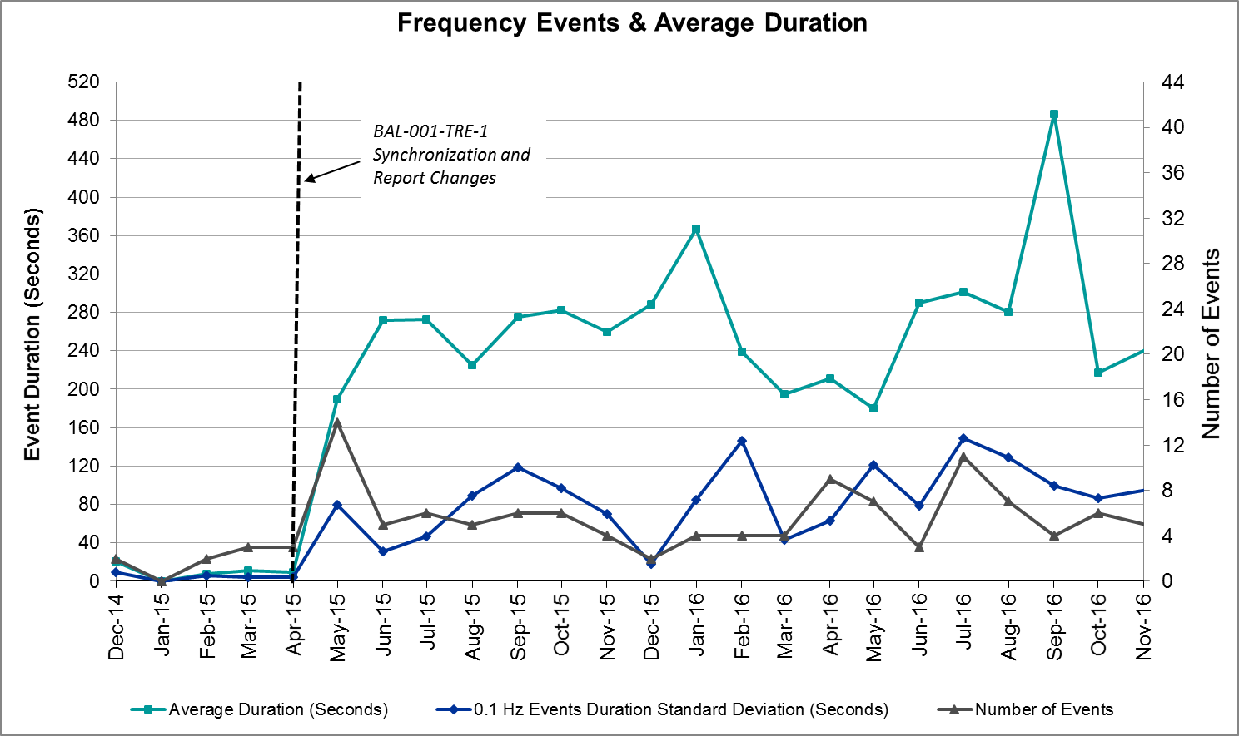

Responsive Reserve Events
4 Events (4 in October 2016, 4 in November 2015)

There were four events where Responsive Reserve MWs were released to SCED in November. The events highlighted in blue were related to frequency events reported in Section 2.1 above.

Date and Time Released to SCED | Date and Time Recalled | Duration of Event | Maximum MWs Released | Comments
11/3/2016 14:31:13 | 11/3/2016 14:33:40 | 0:02:27 | 1162.09
11/5/2016 17:56:24 | 11/5/2016 18:00:32 | 0:04:08 | 611.21
11/19/2016 12:30:13 | 11/19/2016 12:33:25 | 0:03:12 | 233.90
11/20/2016 5:54:30 | 11/20/2016 5:56:50 | 0:02:20 | 206.29

Load Resource Events
None.

Reliability Unit Commitment
3 total commitments as 7 individual hour requests.
ERCOT reports on Reliability Unit Commitments (RUC) on a monthly basis. Commitments are reported grouped by operating day and weather zone. The total number of hours committed is the sum of the hours for all the units in the specified region. Additional information on RUC commitments can be found on the MIS secure site at Grid Generation Reliability Unit Commitment.

There were no DRUC commitments in November.

There were 3 HRUC commitments in November.

HRUC Commitments
Resource Location | # of Resources | Operating Day | Total # of Hours Committed | Total MWhs | Reason for Commitment | Units
South Central | 1 | 11/14/2016 | 10 | 460 | Local Congestion | LEON_CRK_LCPCT4
South Central | 1 | 11/15/2016 | 1 | 46 | Local Congestion | LEON_CRK_LCPCT4
Southern | 1 | 11/29/2016 | 9 | 2,858 | Local Congestion | B_DAVIS_CC1_1

Wind Generation as a Percent of Load
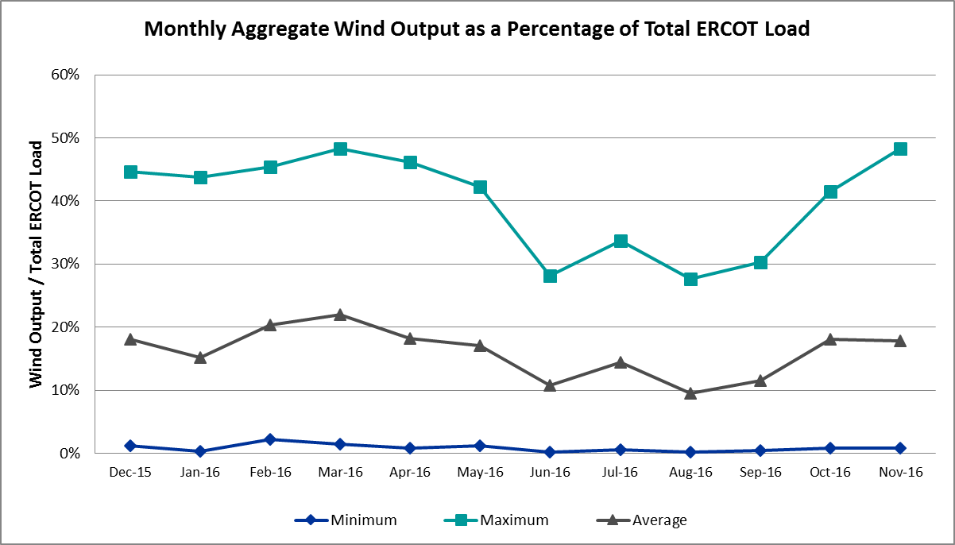

Congestion Analysis
The number of congestion events experienced by the ERCOT system decreased in November. There were thirty-one instances of activity on the Generic Transmission Constraints (GTCs) in November.

Notable Constraints for November
26 reportable events (49 for October 2016)
167 total congestion events (347 for October 2016, 228 for November 2015)

Nodal protocol section 3.20 specifies that ERCOT shall identify transmission constraints that are active or binding three or more times within a calendar month. As part of this process, ERCOT reports congestion that meets this criterion to ROS. In addition ERCOT also highlights notable constraints that have an estimated congestion rent exceeding $1,000,000 for a calendar month. These constraints are detailed in the table below. Rows highlighted in blue indicate the congestion was affected by one or more outages. For a list of all constraints activated in SCED for the month of November, please see Appendix A at the end of this report.

Contingency Name | Overloaded Element | # of Days Constraint Active | Congestion Rent | Transmission Project | Comments
Basecase | Panhandle GTC | 20 | $17,822,792.99 | Panhandle Upgrade | Multiple area line outages
DCKT Hill Country - Marion and Elmcreek 345 kV | Cibolo - Schertz 138kV | 11 | $7,220,084.57 | Cibolo to Schertz T-Line (T303) | Planned Outage on 345 kV line from SKYLINE to MARION and ELMCREEK
DCKT Gibbons Creek - Singleton 345 kV | Jewett - Singleton 345kV | 1 | $6,665,002.04 | Houston Import Project | Unavoidable extension on Jewet 345 kV bus
Midland East - Moss Switch - Odessa Ehv Switch 345 kV | Odessa EHV Switch to Trigas Odessa Tap | 1 | $1,271,800.29 |  | Planned 138 kV outage ODEHV to TXJTP to MDSSW
Mountain Creek Ses Axfmr1h (3)138/69 kV | Cedar Crest Switch - Oak Cliff South 138kV | 1 | $1,154,155.43 |  | Planned Outage of Davis Streep Tap (DVSTP) to Dallas West (DALLW), DVSTP to Davis Street (DAVST), and DVSTP to Westmorland North (WMRNR) 138kV Lines
DCKT Hill Country - Marion and Elmcreek 345 kV | Tri_Cnty - Parkway Lcra 138kV | 3 | $915,351.01 |  | Planned Outage on 345 kV line from SKYLINE to MARION and ELMCREEK
Cagnon to Kendall 345 kV | Cico - Comfort 138kV | 3 | $907,531.53 |  | Planned 345 kV line outage from WTRML to TRSES and planned 69 kV line outage from BCPOI to POWEL
DCKT Sandow Switch - Austrop 345kV | Howard Lane Tap - Howard Lane Aen 138kV | 10 | $680,095.73 |  | Multiple area line outages
Bosque Switch - Elm Mott 345 kV | Bosque Switch - Rogers Hill Bepc 138kV | 10 | $640,339.46 |  | 138 kV bus outage at HLSBR
Loyola Sub to Kleberg Aep 138 kV | Loyola Sub 69_1 138/69kV | 9 | $492,611.82 |  | Multiple area line outages
Sandow Switch - Austrop 345 kV | Sandow Switch - Austrop 345kV | 3 | $428,321.45 | Upgrade existing DCKT line | Area Load/Gen pattern
Jardin to Cotulla Sub 138 kV | Dilley Switch Aep - Cotulla Sub 69kV | 9 | $386,434.47 | Rebuild 4/0 ACSR 69 kV line with 138 kV capable 795 ACSR. 2015 RTP | High N-H Import
Dilleysw-Sanmgsw&Cotulas 138kV | Dilley Switch Aep - Cotulla Sub 69kV | 4 | $292,493.52 | Rebuild 4/0 ACSR 69 kV line with 138 kV capable 795 ACSR. 2015 RTP | High N-H Import
Basecase | Liston GTC | 16 | $291,559.05 | Increase the MOT rating of the Bates to Wormser 138kV line by raising xx structures | 138 kV bus outage at HLSBR
DCKT Whitepint - Lon Hill and South Texas Project 345 kV | Blessing - Lolita 138kV | 4 | $236,784.67 |  | High N-H Import
Laquinta - Lobo 138 kV | Bruni Sub 69_1 138/69kV | 6 | $127,259.13 |  | Area Load/Gen Pattern
DKCT Roans Prarie-Rothwood & Singleton-Tomball 345kV | Singleton - Zenith 345kV | 5 | $123,445.94 | Houston Import Project | Planned outages at Three_RI
Uvalde Aep - Odlaw Switchyard 138 kV | Hamilton Road - Maverick 138kV | 3 | $119,932.46 | Rebuild Hamilton Road to Escondido 138 kV line | Planned 345 kV line outages from SKYLINE to ELMCREEK and SKYLINE to MARION
DCKT Jewett - Singleton 345 kV | Btu_Jack_Creek - Twin Oak Switch 345kV | 7 | $84,514.49 | Houston Import Project | 138 kV planned bus outage at HLSBR
Dilleysw-Sanmgsw&Cotulas 138kV | Dilley Switch Aep - Cotulla Sub 69kV | 4 | $82,178.16 | Rebuild 4/0 ACSR 69 kV line with 138 kV capable 795 ACSR. 2015 RTP | 138 kV bus outage at HLSBR. Planned 69 kV line outage from BEVO to BRUNDGS.
Mercers Gap Sw to Comanche Switch (Oncor) 138 kV | Camp Bowie (Oncor) - Brownwood Switch 138kV | 5 | $31,579.18 | Reconductor Airline to Westside with 1966 ACCC/TW | Planned outage of 138 kV line N_Sharpe to Alazan
Eskota Switch - Abilene South 138 kV | Roby - Round Tree Tap 69kV | 8 | $23,024.53 |  | Area Load/Gen pattern
Javelina Wind Energy Project to Rio Bravo (4)138/138/138/138 kV | Bates - Liston 138kV | 3 | $17,121.55 | Increase the MOT rating of the Bates to Wormser 138kV line by raising xx structures | Area Load/Gen pattern
Liston to Bates 138 kV | Garza - Roma Switch 138kV | 7 | $4,297.16 |  | Area Load/Gen pattern
Eskota Switch - Abilene South 138 kV | Eskota Switch - Longworth 69kV | 3 | $4.61 |  | Area Load/Gen pattern

Generic Transmission Constraint Congestion
There were seventeen days on the Panhandle GTC and fourteen days on the Liston GTC in November. There was no activity on the remaining GTCs during the Month.

Note: This is how many times a constraint has been activated to avoid exceeding a GTC limit, it does not imply an exceedance of the GTC occurred or that the GTC was binding.

Manual Overrides for November
None.

Congestion Costs for Calendar Year 2016
The following table represents the top twenty active constraints for the calendar year based on the estimated congestion rent attributed to the congestion. ERCOT updates this list on a monthly basis.

Contingency | Binding Element | # of 5-min SCED Intervals | Estimated Congestion Rent | Transmission Project
Rns-Rtw & Sng-Tb 345kv | Singleton - Zenith 345kV | 9,728 | $ 46,334,673.52 | Houston Import Project
Ph Robinson At1l_H (3)345/138 KV | Meadow AT1 345/138kV | 1,470 | $ 37,410,531.94 | 4708
Basecase | Panhandle GTC | 12,104 | $ 26,320,735.24 | Panhandle Upgrade
Villa Cavazos to Military Highway Aep (2)138/138 KV | Los Fresnos - Loma Alta Substation 138kV | 3,272 | $ 26,026,381.24
Jewet-Sng 345kv | Btu_Jack_Creek - Twin Oak Switch 345kV | 13,429 | $ 14,532,560.26 | Houston Import Project
Jim Christal Substation to West Denton 138 KV | Fort Worth Subsation - West Denton 138kV | 1,712 | $ 12,652,770.74
Fort Worth Subsation to West Denton 138 KV | Jim Christal Substation - West Denton 138kV | 2,075 | $ 10,854,453.30
Rnksw-W_Dent&Lwssw-Krwsw 345kv | Fort Worth Subsation - West Denton 138kV | 1,774 | $ 10,027,611.63
Moss Switch to Odessa Ehv Switch 345 KV | Odessa EHV Switch to Trigas Odessa Tap | 2,101 | $ 9,455,517.12
Hcksw-Allnc&Rnksw 345kv | Eagle Mountain Ses - Morris Dido 138kV | 1,481 | $ 9,187,189.06 | 4252
Hillctry-Marion&Elmcreek 345kv | Cibolo - Schertz 138kV | 1,308 | $ 7,775,371.11
Gibcrk-Sng 345 Kv | Jewett - Singleton 345kV | 1,332 | $ 7,555,045.65
Basecase | Valley Import | 205 | $ 7,406,577.64 | LRGV (ower Rio Grande Valley) Import Project
Bm-Sr73 & Sr81 138kv | Bellaire - San Felipe 138kV | 196 | $ 7,119,922.62 | 4703
Rosen Heights to Eagle Mountain Compressor (5)138/138/138/138/138 KV | Rosen Heights Tap 2 - Morris Dido 138kV | 857 | $ 6,945,775.57 | 4252
Meadow to Ph Robinson 345 KV | Meadow AT1 345/138kV | 89 | $ 6,552,987.55 | 4708
WA Parish - Bailey & Hillje 345 kV | Oasis - Dow Chemical 345kV | 64 | $ 5,749,309.96
Lwssw-Krwsw&Rnksw 345kv | Fort Worth Subsation - West Denton 138kV | 791 | $ 5,462,367.54
Hcksw-Allnc&Rnksw 345kv | Rosen Heights Tap 2 - Morris Dido 138kV | 805 | $ 5,063,292.44 | 4252
South Carbide to Loma Alta Substation 138 KV | La Palma - Villa Cavazos 138kV | 505 | $ 5,060,645.62 | 4490

System Events

ERCOT Peak Load
The unofficial ERCOT peak load for the month was 50,084 MW and occurred on November 2nd during hour ending 17:00.

Instantaneous peak was 50,198 MW
November 2015 actual peak was 45,014 MW

Load Shed Events
None.

Stability Events
None.

Notable PMU Events
ERCOT analyzes PMU data for any significant system disturbances that do not fall into the Frequency Events category reported in section 2.1. The results are summarized in this section once the analysis has been completed.

There were no reportable events in November.

TRE/DOE Reportable Events
None.

New/Updated Constraint Management Plans
None.

New/Modified/Removed SPS
None.

New Procedures/Forms/Operating Bulletins
None.

Emergency Conditions

OCNs
None.

Advisories
Date and Time | Description
11/13/16 13:27 | Advisory issued due to DAM timeline deviation

Watches
Date and Time | Description
11/21/16 19:35 | Watch issued due to SCED failure

Emergency Notices
None.

Application Performance

TSAT/VSAT Performance Issues
None.

Communication Issues
None.

Market System Issues
- 11/21/16 – A watch was issued due to a SCED failure.

Appendix A: Real-Time Constraints
The following is a complete list of constraints activated in SCED for the month of November. Full contingency descriptions can be found in the Standard Contingencies List located on the MIS secure site at Grid Generation Reliability Unit Commitment.

Contingency | Constrained Element | From Station | To Station | # of Days Constraint Active
BASE CASE | PNHNDL | n/a | n/a | 20
BASE CASE | LISTON | n/a | n/a | 16
DHILELM5 | 293T304_1 | CIBOLO | SCHERT | 11
DAUSSND5 | HWRDLN_1 | HWRDTP | HWRDLN | 10
SBOSELM5 | 1030__B | BOSQUESW | RGH | 10
SKLELOY8 | LOYOLA_69_1 | LOYOLA | LOYOLA | 9
SJARDIL8 | DIL_COTU_1 | DILLEYSW | COTULAS | 9
SMCEABS8 | ROBY_RONDTP1_1 | ROBY | RONDTPT | 8
DJEWSNG5 | JK_TOKSW_1 | TOKSW | JK_CK | 7
SLISBAT8 | GARZA_ROMA_S1_1 | GARZA | ROMA_SW | 7
SLAQLOB8 | BRUNI_69_1 | BRUNI | BRUNI | 6
SZEPCMN8 | 670__B | BRNSW | CMPBW | 5
DRNS_TB5 | SNGZEN99_A | SNG | ZEN | 5
DDILCOT8 | DIL_COTU_1 | DILLEYSW | COTULAS | 4
DDILCOT8 | DIL_COTU_1 | COTULAS | DILLEYSW | 4
DWH_STP5 | BLESSI_LOLITA1_1 | BLESSING | LOLITA | 4
DGIBSNG5 | 260_A_1 | JEWET | SNG | 3
SSNDAU15 | 450__A | SNDSW | AUSTRO | 3
SMCEABS8 | 6780__A | ESKSW | LONGWRTH | 3
SBRAUVA8 | HAMILT_MAVERI1_1 | HAMILTON | MAVERICK | 3
SRIOWOR8 | BATES_LISTON1_1 | LISTON | BATES | 3
SCAGKEN5 | 74T148_1 | COMFOR | CICO | 3
DHILELM5 | PAR_TRI_CNTY_1 | PARKWA | F5 | 3
SN_SLON5 | KINGSV_KLEBER1_1 | KLEBERG | KINGSVIL | 2
DCC3_NED | BLESSI_LOLITA1_1 | BLESSING | LOLITA | 2
DCRLLSW5 | 591__A | LKPNT | CRLNW | 2
SSPUASP8 | ROTN_WOLFGA1_1 | WOLFGANG | ROTN | 2
SDANBLE8 | BLESSING_69A1 | BLESSING | BLESSING | 2
DELMMAR5 | 293T304_1 | CIBOLO | SCHERT | 2
STRCTRS5 | 2040__D | NVARO | MLDR2 | 2
BASE CASE | LGD_SANTIA1_1 | LGD | SANTIAGO | 2
DBIGKEN5 | FRIR_ROCKSP1_1 | FRIR | ROCKSPRS | 2
SSPUMW18 | ROTN_WOLFGA1_1 | WOLFGANG | ROTN | 2
DTHWZEN5 | OB_ZEN71_A | ZEN | OB | 2
XWFA89 | 6945__A | LKWSW | WFALS | 2
DAUSSND5 | 211T147_1 | GILLCR | MCNEIL_ | 2
DCRLLSW5 | 590__A | LWSSW | LWVJS | 2
XWL2V58 | 3130__B | INDST | CMPST | 1
DCRLLSW5 | 588_A_1 | LWSVW | LWVTI | 1
DMTSCOS5 | 6437__F | SCRCV | KNAPP | 1
SLOBSA25 | BRUNI_69_1 | BRUNI | BRUNI | 1
SGILNU78 | GILA_MORRIS1_1 | GILA | MORRIS | 1
DFPPFAY5 | HK_TB_66_A | TB | HK | 1
BASE CASE | THOMASTN_PS1 | THOMASTN | THOMASTN | 1
XMCS89 | 3160__A | CDCSW | OKCLS | 1
DGIBSNG5 | 240__A | JEWET | SNG | 1
DSCOFAR5 | 6437__F | SCRCV | KNAPP | 1
SECTPBS8 | 6485__A | MOSSW | PBSES | 1
SNADRIC8 | NAD_ELCM_1 | NADAS | ELCMPOS | 1
DTRCELK5 | 1000__B | TYLNW | TYWST | 1
SMDLODE5 | 6475__C | ODEHV | TROTP | 1
DFL_MAR8 | BETHK_66_A | HK | BET | 1
DBRACOL8 | KARNES_KENEDS1_1 | KENEDSW | KARNESCI | 1
SMYRSPR8 | SJO_SJO2 | SJO | SJO | 1
SBOSELM5 | 1030__A | RGH | ELMOT | 1
DHILELM5 | 581T581_1 | ECMORN | PARKWA | 1
SMDLODE5 | 6345__B | GNTSW | SPRTP | 1
DELMSAN5 | PAWNEE_SPRUCE_1 | CALAVERS | PAWNEE | 1
DFPPFAY5 | 190T152_1 | GIDEON | WINCHE | 1
DMARSKY5 | 293T304_1 | CIBOLO | SCHERT | 1
SSCLWC28 | G138_16_1 | BRAZORIA | WCOLMAIN | 1
DMARSKY5 | PAR_TRI_CNTY_1 | PARKWA | F5 | 1
DTOKJK_5 | 240__A | JEWET | SNG | 1
XTH2W58 | OB_ZEN71_A | ZEN | OB | 1
BASE CASE | RANDAD_ZAPATA1_1 | RANDADO | ZAPATA | 1
SPLUFLA8 | 154T176_1 | FAYETT | FRELSB | 1
SBRAUVA8 | EAGLHY_MAVERI1_1 | MAVERICK | EAGLHYTP | 1
SSPJFS8 | JFSSC_06_A | JFS | SC | 1
SSCUSU28 | ROTN_WOLFGA1_1 | WOLFGANG | ROTN | 1
SSWDMGS8 | ROBY_RONDTP1_1 | ROBY | RONDTPT | 2
STRCTRS5 | 2040__D | NVARO | MLDR2 | 1
BASE CASE | RIOHND_ERIOHND_1 | MV_RIOHO | RIOHONDO | 1
SRICGRS8 | 6850__B | NVKSW | ARCTY | 1
DB_DPHA8 | AIRLIN_B_DAVI1_1 | B_DAVIS | AIRLINE | 1
XSA2R58 | BALG_ROWE1_1 | BALG | ROWE | 1
SBEVASH8 | BIG_COTU_1 | COTULAS | BIGWELS | 1
DSC_SL28 | CO_WAS84_A | CO | WAS | 1
DCHBJOR5 | CV_LH_03_A | LH | CV | 1
SWEIWES8 | MCKENZ_WESTSI1_1 | MCKENZIE | WESTSIDE | 1
SSARBLU5 | NICOLE_ORNT1_1 | NICOLE | ORNT | 1
XSA2R58 | ORNT_REDCRE1_1 | ORNT | REDCREEK | 1
DTOKJK_5 | 240__A | JEWET | SNG | 1
SSCLWF18 | 6840__B | NVKSW | ANARN | 1
SRNGCBY8 | CV_LH_03_A | LH | CV | 1
DJFSFT_8 | GV_UN_30_A | UN | GV | 1
XSND58 | SNDSW_MR2H | SNDSW | SNDSW | 1
XALV89 | 2040__D | NVARO | MLDR2 | 1
SSALFPP5 | 501T231_1 | AUSTRO | WEBBER | 1
DHCKRNK5 | 6271__A | EMSES | WGROB | 1
SALAN_28 | AIRLIN_CABANI1_1 | AIRLINE | CABANISS | 1
SDTCR8 | DT_GS_32_A | GS | DT | 1
SHINDIL8 | PLESNTN_TORDLO_1 | TORDILLO | PLSNTOS | 1
DALNRYS5 | 1627__A | APOLLO | REAST | 1
SGRIVE28 | 2040__D | NVARO | MLDR2 | 1
DMCSCDC8 | 3405__B | TRIRA | IHFT2 | 1
DBEEPAL8 | 43T365_1 | FLATRO | PALEPE | 1
SEMMEM28 | 6265__A | EMSES | MRSDO | 1
SALAN_28 | AIRLIN_B_DAVI1_1 | B_DAVIS | AIRLINE | 1
SJMCW_D8 | FTW_W_DE_1 | W_DENT | FTWORTH | 1
SN_MNED8 | MCOLL__NEDIN1_1 | NEDIN | MCOLL_RD | 1
XSA2N58 | SANMIGL_ATAL | SANMIGL | SANMIGL | 1
DTOKJK_5 | 260_A_1 | JEWET | SNG | 1
DELMMAR5 | 293T304_1 | CIBOLO | SCHERT | 1
XMCS89 | 3160__A | CDCSW | OKCLS | 1
SCNRFOR5 | 568__A | RYSSW | NEVADA | 1
SSWDMGS8 | 6940__C | SWTWR | ROSCO | 1
DWH_STP5 | AIRCO4_NCARBI1_1 | NCARBIDE | AIRCO4 | 1
SSIGSAN8 | NCA_SMTP_1 | SANMTAP | NCALHMS | 1
SNUELON8 | NUECES_WHITE_2_1 | NUECES_B | WHITE_PT | 1
DMARSKY5 | PAR_TRI_CNTY_1 | PARKWA | F5 | 1
DELMSAN5 | PAWNEE_SPRUCE_1 | CALAVERS | PAWNEE | 1
SPHRCTR5 | RINRNG87_A | RNG | RIN | 1
SBOSELM5 | WHTNY_MR2L | WHTNY | WHTNY | 1
DHILELM5 | 293T304_1 | CIBOLO | SCHERT | 1
XWL2V58 | 3130__B | INDST | CMPST | 1
DFPPFAY5 | 500T231_1 | WEBBER | BASTCI | 1
XAN2A58 | 562__B | MEMWT | VANAL | 1
SSCLWF28 | 6560__B | MRKLY | RICSW | 1
DB_DPHA8 | B_DAVI_RODD_F1_1 | B_DAVIS | RODD_FLD | 1
DCBYRN28 | CV_LH_03_A | LH | CV | 1
DAUSSND5 | 1665__A | TLRWT | HUTTO | 1
XAN2A58 | 562__D | PAYSW | MEMWT | 1
SSANSAN8 | BIG_FO_PLEASA1_1 | PLEASANT | BIG_FOOT | 1
DWH_STP5 | BLESSI_LOLITA1_1 | BLESSING | LOLITA | 1
DWRNCRV8 | BT_HL_66_A | BT | HL | 1
SBATFRO8 | GARZA_ROMA_S1_1 | GARZA | ROMA_SW | 1
SE4LEO8 | KARNES_KENEDS1_1 | KENEDSW | KARNESCI | 1
BASE CASE | VALIMP | n/a | n/a | 1
SSALSND8 | 1666__B | GILLCR | PFLGV | 1
SMCEABS8 | 6780__A | ESKSW | LONGWRTH | 1
SPHRCTR5 | ATKRIN87_A | RIN | ATK | 1
XO3B58 | BETHK_66_A | HK | BET | 1
SE3X28 | PLESNTN_TORDLO_1 | TORDILLO | PLSNTOS | 1
DPBSHLT8 | 6480__B | ECTHP | PBSES | 1

