MGRR Number | 0023 | MGRR Title | Phase Angle
Date |  | 01/17/2017
Submitter’s Information
Name |  | Joe Weatherly
E-mail Address |  | Joe.Weatherly@ercot.com
Company |  | ERCOT
Phone Number |  | 512-248-6339
Cell Number
Market Segment

Comments

Add Phase Angle as required attribute in breaker and disconnector.

Overall NMMS User Benefit | Meeting requirement of NPRR 790.
Overall NMMS User Impact | Add Phase Angle as required field; however, field has been populated from previous RFIs.
ERCOT Impact | Meeting requirement of NPRR 790.

Revised Proposed Modeling Guidelines Language

Modeling Breakers

Modeling Approach
The ERCOT CIM model defines a Breaker as a mechanical switching device capable of making, carrying, and breaking currents under normal circuit conditions and also making, carrying for a specified time, and breaking currents under specified abnormal circuit conditions e.g. those of short circuit. ERCOT shall develop the naming convention with the assistance of the TSP and the approval of TAC.
A Breaker is modeled under a VoltageLevel or a Bay in a Substation. Two Terminals are modeled under the Breaker as connection points to the circuit. Each terminal has a link to a connectivity node. Naming requirements for this connectivity node are, the name length of the connectivity node should not exceed 4 characters and the name has to be unique within a substation.
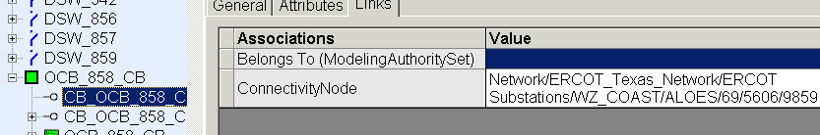
SCADA values modeled under a Terminal provide the Open/Close status of the Breakers to the model. Figure below shows a Breaker modeled in the Information Model Manager model hierarchy with parent/child associations labeled. For more information on modeling SCADA values, refer to the section on ‘Modeling SCADA’.
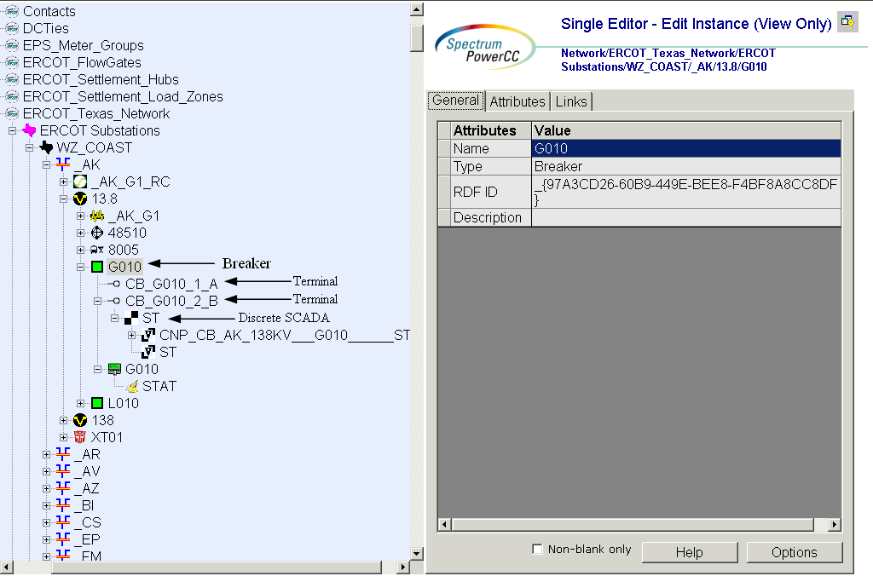
Figure 1 - Breaker

Attributes
The attributes for a Breaker are shown in the table below.

Attribute | Description | Data Type | Default Value | Sample Data
Name | Name of the instance of this class | String |  | CB_1
Teid | Transmission Element ID | Integer | Auto-populated
normalOpen | The attribute is used in cases when no Measurement for the status value is present. | Boolean | False
initiallyOpen | T = The initial breaker state for the online switching device model is open. | Boolean | False
inTransitTime | The transition time from open to close, in seconds. | Float | 0
Alias Name | Free text name of the object or instance. | String | None
Current Flow | Fault interrupting rating in amperes. | Float | None
DAM Monitored | The Boolean flags to indicate which process(s) monitor the branch devices and by which process the devices is secured. | Boolean | False
DAM Secured | The Boolean flags to indicate which process(s) monitor the branch devices and by which process the devices is secured. | Boolean | True
Enable Manual Switching | T = Enables manual switching capability for the device. | Boolean | True
Latitude | Latitude coordinates. | Float | None
Local Name | The localName is a human readable name of the object. It is only used with objects organized in a naming hierarchy. The simplest naming hierarchy has just one parent (the root) giving a flat naming hierarchy. However, the naming hierarchy usually has several levels, e.g. Substation, VoltageLevel, Equipment etc. Children of the same parent have names that are unique among them. If the uniqueness requirement cannot be met IdentifiedObject.localName shall not be used, use IdentifiedObject.name instead. | String | None
Longitude | Longitude coordinates. | Float | None
Model Resource ID | A Model Authority issues mRIDs. Given that each Model Authority has a unique id and this id is part of the mRID, then the mRID is globally unique. | Integer | None
OUS Priority | An Outage Scheduler priority is included in all ConductingEquipment classes except BusbarSection and TransformerWinding. | Integer | None
Path Name | The pathname is a system unique name composed from all IdentifiedObject.names in a standard naming hierarchy path from the object to the root. | String | None
Phases | Describes the phases carried by a conducting equipment. Possible values { ABCN , ABC, ABN, ACN, BCN, AB, AC, BC, AN, BN, CN, A, B, C, N }. | PhaseCode | None
PSS/E ID | Attribute will give Information Model Manager modelers control over the PSS/E ID that the Topology Processor uses to properly name units, loads, branches, and transformers | String | None
recloseMaxAngle | Max Phase Angle for reclosing.  0 to 90 is allowed | Integer | -90
Remove | The equipment is removed from the network. | Boolean | False
Remove Enable | The equipment can be removed from the network. | Boolean | False
RUC Monitored | The Boolean flags to indicate which process(s) monitor the branch devices and by which process the devices is secured. | Boolean | False
RUC Secured | The Boolean flags to indicate which process(s) monitor the branch devices and by which process the devices is secured. | Boolean | True
Switch On Count | The switch on count since the switch was last reset or initialized. | Integer | None
Switch On Date | The date and time when the switch was last switched on. | Date/Time | None
Switch Operation Over | Over Limit Violation Switch Operation (Open/Close). | Boolean | None
Switch Operation Under | Under Limit Violation Switch Operation (Open/Close). | Boolean | None
Switched By Schedule | T = The switch will follow a switching schedule to change state in the network applications. | Boolean | False
Trigger Network Sequence | T = The switch will trigger the realtime network application sequence when the switch changes state in SCADA. | Boolean | False
Trip Lockout | Lockout after trip. | Boolean | None
Zero Impedance Branch | Mark Switching devices that should be converted to Zero Impedance Branches in Connectivity Node to Bus Processing. | Boolean | False

Modeling Disconnectors

Modeling Approach
The ERCOT CIM model defines a Disconnector as manually operated or motor operated mechanical switching device used for changing the connections in a circuit, or for isolating a circuit or equipment from a source of power. It is required to open or close circuits when negligible current is broken or made. ERCOT shall develop the naming convention with the assistance of the TSP and the approval of TAC.
A Disconnector is modeled under a VoltageLevel or a Bay in a Substation. Two Terminals are modeled under the Disconnector as connection points to the circuit. Each terminal has a link to a connectivity node. Naming requirements for this connectivity node are, the name length of the connectivity node should not exceed 4 characters and the name has to be unique within a substation.
SCADA values modeled under the Terminals provide the Open/Close status of the Disconnectors to the model. Figure below shows a Disconnector modeled in the Information Model Manager model hierarchy with parent/child associations labeled. For more information on modeling SCADA values, refer to the section on SCADA.
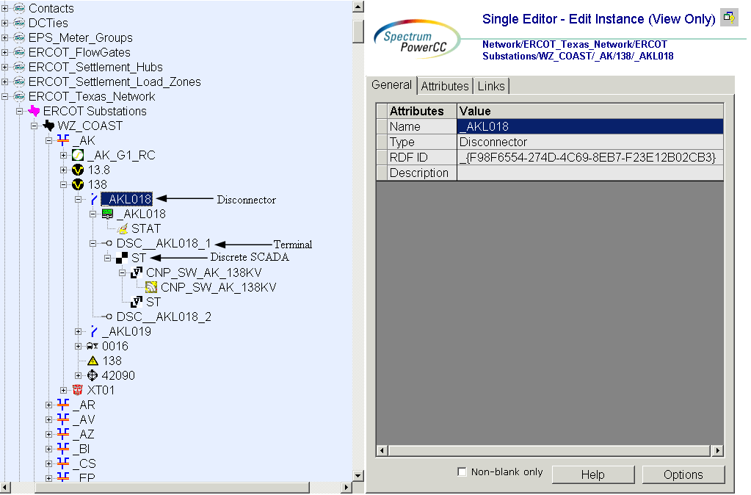
Figure 2 - Disconnector

Attributes
The attributes for a Disconnector are shown in the table below.

Attribute | Description | Data Type | Default Value | Sample Data
name | Name of the instance of this class | String |  | CB_1
normalOpen | The attribute is used in cases when no Measurement for the status value is present. | Boolean | False
initiallyOpen | T = The initial breaker state for the online switching device model is open. | Boolean | False
Alias Name | Free text name of the object or instance. | String | None
DAM Monitored | The Boolean flags to indicate which process(s) monitor the branch devices and by which process the devices is secured. | Boolean | False
DAM Secured | The Boolean flags to indicate which process(s) monitor the branch devices and by which process the devices is secured. | Boolean | True
Enable Manual Switching | T = Enables manual switching capability for the device. | Boolean | True
Latitude | Latitude coordinates. | Float | None
Local Name | The localName is a human readable name of the object. It is only used with objects organized in a naming hierarchy. The simplest naming hierarchy has just one parent (the root) giving a flat naming hierarchy. However, the naming hierarchy usually has several levels, e.g. Substation, VoltageLevel, Equipment etc. Children of the same parent have names that are unique among them. If the uniqueness requirement cannot be met IdentifiedObject.localName shall not be used, use IdentifiedObject.name instead. | String | None
Longitude | Longitude coordinates. | Float | None
Model Resource ID | A Model Authority issues mRIDs. Given that each Model Authority has a unique id and this id is part of the mRID, then the mRID is globally unique. | Integer | Auto-populated
OUS Priority | An Outage Scheduler priority is included in all ConductingEquipment classes except BusbarSection and TransformerWinding. | Integer | None
Path Name | The pathname is a system unique name composed from all IdentifiedObject.names in a standard naming hierarchy path from the object to the root. | String | None
Phases | Describes the phases carried by a conducting equipment. Possible values { ABCN , ABC, ABN, ACN, BCN, AB, AC, BC, AN, BN, CN, A, B, C, N }. | PhaseCode | None
PSS/E ID | Attribute will give Information Model Manager modelers control over the PSS/E ID that the Topology Processor uses to properly name units, loads, branches, and transformers | String | None
recloseMaxAngle | Max Phase Angle for reclosing.  0 to 90 is allowed | Integer | -90
Remove | The equipment is removed from the network. | Boolean | False
Remove Enable | The equipment can be removed from the network. | Boolean | False
RUC Monitored | The Boolean flags to indicate which process(s) monitor the branch devices and by which process the devices is secured. | Boolean | False
RUC Secured | The Boolean flags to indicate which process(s) monitor the branch devices and by which process the devices is secured. | Boolean | True
Switch On Count | The switch on count since the switch was last reset or initialized. | Integer | None
Switch On Date | The date and time when the switch was last switched on. | Date/Time | None
Switched By Schedule | T = The switch will follow a switching schedule to change state in the network applications. | Boolean | False
Trigger Network Sequence | T = The switch will trigger the realtime network application sequence when the switch changes state in SCADA. | Boolean | False
Zero Impedance Branch | Mark Switching devices that should be converted to Zero Impedance Branches in Connectivity Node to Bus Processing. | Boolean | False

Appendix A - Validation Rules – Required Fields
This appendix lists all of the validation rules for attributes that must be defined for a specific class. It also lists any validation for attributes that must be within a specific value range.
ClassName | Attributes | Required | Range

Rating | forNetwork | x
recloseMaxAngle | recloseMaxAngle | x | >=0 and <=90
RegulationSchedule | startTime | x

