October 2016 ERCOT Monthly Operations Report
Reliability and Operations Subcommittee Meeting
December 8th, 2016

Table of Contents
1. Report Highlights 1
2. Frequency Control 2
2.1. Frequency Events 2
2.2. Responsive Reserve Events 3
2.3. Load Resource Events 3
3. Reliability Unit Commitment 3
4. Wind Generation as a Percent of Load 5
5. Congestion Analysis 5
5.1. Notable Constraints for October 5
5.2. Generic Transmission Constraint Congestion 8
5.3. Manual Overrides for October 8
5.4. Congestion Costs for Calendar Year 2016 8
6. System Events 9
6.1. ERCOT Peak Load 9
6.2. Load Shed Events 9
6.3. Stability Events 9
6.4. Notable PMU Events 9
6.5. TRE/DOE Reportable Events 9
6.6. New/Updated Constraint Management Plans 9
6.7. New/Modified/Removed SPS 10
6.8. New Procedures/Forms/Operating Bulletins 10
7. Emergency Conditions 10
7.1. OCNs 10
7.2. Advisories 10
7.3. Watches 10
7.4. Emergency Notices 10
8. Application Performance 10
8.1. TSAT/VSAT Performance Issues 10
8.2. Communication Issues 10
8.3. Market System Issues 11
Appendix A: Real-Time Constraints 12

Report Highlights
- The unofficial ERCOT peak for October was 59,848 MW.
- There were six frequency events in October. PMU data indicates the ERCOT system transitioned well in each case.
- There were four instances where Responsive Reserves were deployed, they were all the result of a frequency events.
- There were fifteen RUC commitments in October.
- The level of reportable SCED congestion slightly increased in October. This congestion was due primarily to planned outages and area load/gen patterns as well as high North to Houston Imports. There were forty-two instances over 27 days on the Generic Transmission Constraints (GTCs) in October. There were twenty-four days on the Panhandle GTC, one day on the Valley Import GTC and seventeen days on the Liston GTC in October. There was no activity on the remaining GTCs during the Month.
- There were two application issues to report for October. On 10/5/16 a watch was issued due to a SCED failure. Additionally, on 10/5/16, a watch issued due to HRUC not completing.

Frequency Control

Frequency Events
The ERCOT Interconnection experienced six frequency events in October, all of which resulted from Resource trips. The average event duration was approximately 0:03:37.

When analyzing frequency events, ERCOT evaluates PMU data according to industry standards. Events with an oscillating frequency of less than 1 Hz are considered to be inter-area, while higher frequencies indicate local events. Industry standards specify that damping ratio for inter-area oscillations should be 3.0% or greater. All events listed below indicate the ERCOT system met these standards and transitioned well after each disturbance.

Reported frequency events will include both frequency events where frequency was outside the range of 60±0.1 Hz as well as those determined to be Frequency Measurable Events (FME) as defined by BAL-001-TRE-1. Delta Frequency is defined as the difference between the pre-perturbation and post-perturbation frequency. The Duration of Event is defined as the time it takes for the frequency to recover to lesser/greater of the frequency at the time of the frequency event (t(0) or “A-point”) for low/high-frequency events, respectively. Further details on FMEs can be found in the MIS posted BAL-001-TRE-1 PDCWG Unit Performance reports. A summary of the frequency events is provided below:

Date and Time | Delta Frequency | Max/Min Frequency | Duration of Event | PMU Data |  |  | Load | Wind | Inertia | Comments
 | (Hz) | (Hz) |  | Oscillation Mode (Hz) | Damping Ratio |  | (MW) | % | (GW-s)
10/5/2016 13:39 | 0.025 | 59.93 | 0:01:49 | No PMU Data Available. |  |  | 55,510 | 3% | 313,089 | Unit Trip of 213MW
10/6/2016 15:28 | 0.080 | 59.85 | 0:05:25 | 0.64 | 14% | 57,179 |  | 7% | 309,331 |  | Unit Trip of 573MW
10/13/2016 11:46 | 0.070 | 59.81 | 0:03:39 | 0.68 | 9% | 43,708 |  | 2% | 267,512 |  | Unit Trip of 809MW
10/23/2016 14:34 | 0.062 | 59.84 | 0:05:04 | 0.72 | 6% | 36,270 |  | 11% | 216,384 |  | Unit Trip of 621MW
10/28/2016 12:14 | 0.065 | 59.87 | 0:03:27 | 0.75 | 8% | 42,586 |  | 16% | 247,849 |  | Unit Trip of 599MW
10/28/2016 14:49 | 0.033 | 59.92 | 0:02:19 | No PMU Data Available. |  | 47,302 |  | 14% | 249,321 |  | Unit Trip of 289MW

(Note: frequency events highlighted in blue have been identified as FMEs per BAL-001-TRE-1 and the Performance Disturbance Compliance Working group.)

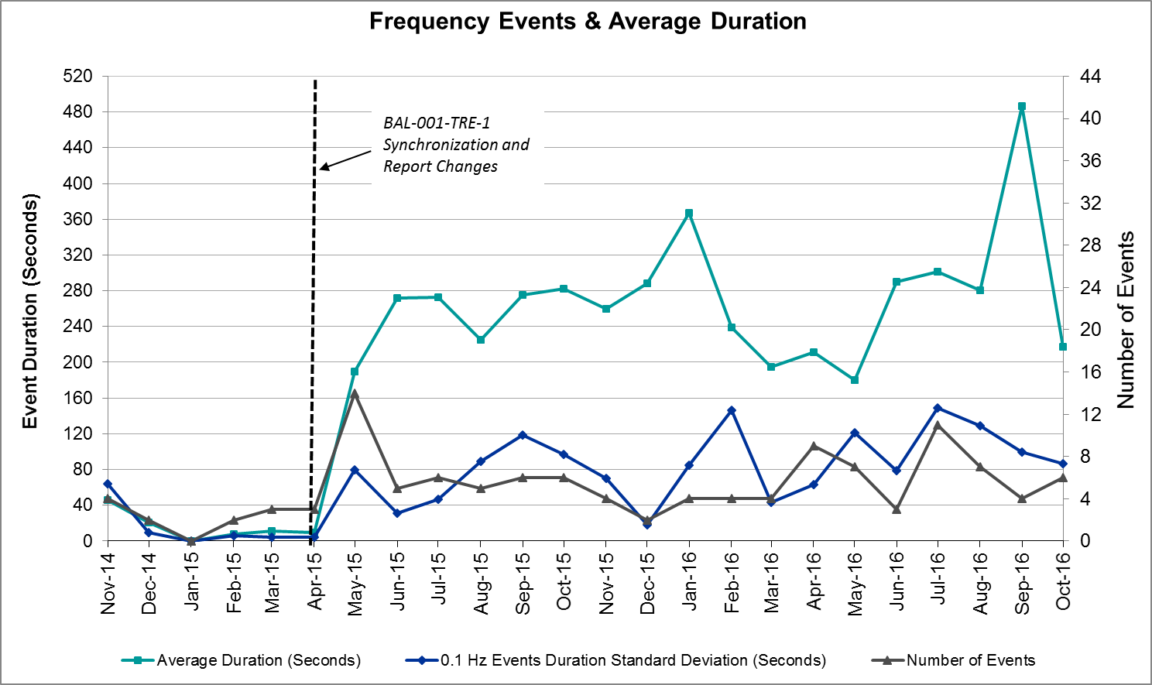

Responsive Reserve Events
There were four events where Responsive Reserve MWs were released to SCED in October. The events highlighted in blue were related to frequency events reported in Section 2.1 above.

Date and Time Released to SCED | Date and Time Recalled | Duration of Event | Maximum MWs Released | Comments
10/6/2016 15:28:06 | 10/6/2016 15:31:50 | 0:03:44 | 568.75
10/13/2016 11:46:18 | 10/13/2016 11:49:46 | 0:03:28 | 828.62
10/23/2016 14:34:42 | 10/23/2016 14:39:46 | 0:05:04 | 793.03
10/28/2016 12:14:46 | 10/28/2016 12:17:22 | 0:02:36 | 455.41

Load Resource Events
None.

Reliability Unit Commitment
ERCOT reports on Reliability Unit Commitments (RUC) on a monthly basis. Commitments are reported grouped by operating day and weather zone. The total number of hours committed is the sum of the hours for all the units in the specified region. Additional information on RUC commitments can be found on the MIS secure site at Grid Generation Reliability Unit Commitment.

There were no DRUC commitments in October.

There were 15 HRUC commitments in October.

HRUC Commitments
Resource Location | # of Resources | Operating Day | Total # of Hours Committed | Total MWhs | Reason for Commitment
Southern | 3 | 10/1/2016 | 19 | 5,498 | Local Congestion
Southern | 1 | 10/2/2016 | 3 | 948 | Local Congestion
Southern | 5 | 10/3/2016 | 40 | 9,508 | Local Congestion and Valley Import
Southern | 5 | 10/4/2016 | 26 | 8,614 | Local Congestion and Valley Import
Southern | 1 | 10/5/2016 | 8 | 2,569 | Local Congestion and Valley Import
Southern | 2 | 10/6/2016 | 10 | 742 | Local Congestion and Valley Import
Southern | 4 | 10/7/2016 | 24 | 3,249 | Local Congestion and Valley Import
Southern | 1 | 10/8/2016 | 6 | 224 | Valley Import
Southern | 2 | 10/10/2016 | 8 | 394 | Valley Import
Southern | 1 | 10/11/2016 | 4 | 1,343 | Local Congestion and Valley Import
Far West | 1 | 10/11/2016 | 4 | 592 | Local Congestion
North Central | 1 | 10/18/2016 | 4 | 936 | Capacity
Southern | 1 | 10/24/2016 | 1 | 22 | Local Congestion
Southern | 2 | 10/26/2016 | 2 | 96 | Local Congestion
East | 1 | 10/27/2016 | 7 | 1,645 | Local Congestion

Wind Generation as a Percent of Load
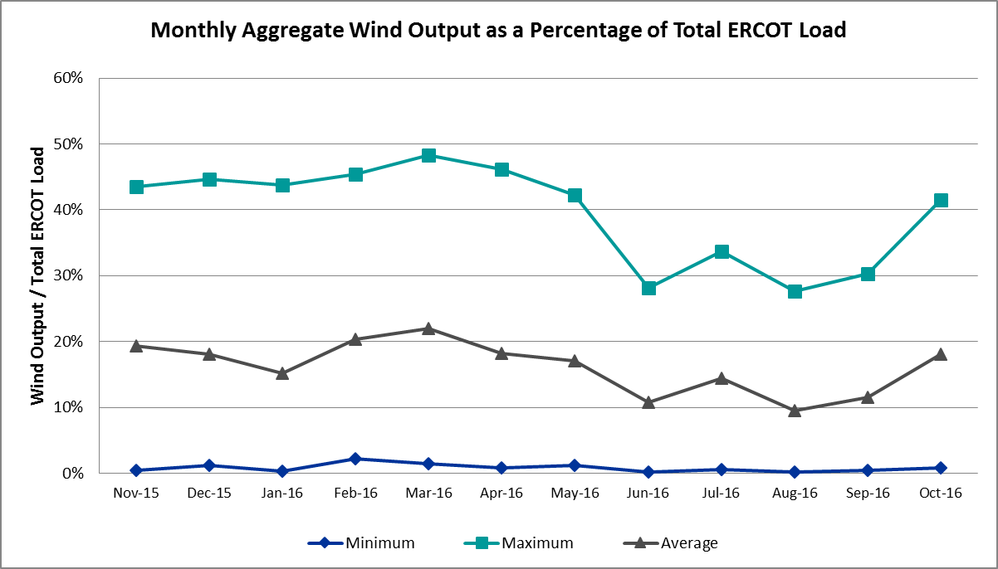

Congestion Analysis
The number of congestion events experienced by the ERCOT system slightly increased in October. There were forty-nine instances of activity on the Generic Transmission Constraints (GTCs) in October.

Notable Constraints for October
Nodal protocol section 3.20 specifies that ERCOT shall identify transmission constraints that are active or binding three or more times within a calendar month. As part of this process, ERCOT reports congestion that meets this criterion to ROS. In addition ERCOT also highlights notable constraints that have an estimated congestion rent exceeding $1,000,000 for a calendar month. These constraints are detailed in the table below. Rows highlighted in blue indicate the congestion was affected by one or more outages. For a list of all constraints activated in SCED for the month of October, please see Appendix A at the end of this report.

Contingency Name | Overloaded Element | # of Days Constraint Active | Congestion Rent | Transmission Project
DKCT Roans Prarie-Rothwood & Singleton-Tomball 345kV | Singleton - Zenith 345kV | 12 | $5,232,403.24 | Houston Import Project
Midland East - Moss Switch - Odessa Ehv Switch 345 kV | Odessa EHV Switch to Trigas Odessa Tap | 15 | $4,640,521.25
Mlses - Elktn And Tygnd 345 | Tyler Northwest - Shamburger Switch 138kV | 14 | $3,587,857.04 | 09TPIT0122
Btu_Bry_E_C to Btu_East (2)138/138 kV | Gibbons Creek - Btu_Greens_Prairie 138kV | 3 | $2,808,922.35
DCKT Jewett - Singleton 345 kV | Btu_Jack_Creek - Twin Oak Switch 345kV | 28 | $2,798,403.39 | Houston Import Project
San Angelo Red Creek T1t (3)345/138 kV | Nicole - Orient 138kV | 4 | $2,486,641.57
Jardin to Cotulla Sub 138 kV | Dilley Switch Aep - Cotulla Sub 69kV | 13 | $1,861,848.13 | 5222
North Mcallen to North Edinburg 138 kV | North Edinburg - Mccoll Road 138kV | 1 | $1,580,559.72
DCKT Sandow Switch - Austrop 345kV | Gilleland - Mcneil Lcra 138kV | 19 | $1,379,976.00 | 5269
Mountain Creek Ses Axfmr1h (3)138/69 kV | Cedar Crest Switch - Oak Cliff South 138kV | 1 | $1,236,144.29
DCKT Calaveras-Hotwells & Laredo1 138 kV | Kirby - St_Hedwg 138kV | 5 | $1,142,928.75
DCKT Gibbons Creek - Singleton 345 kV | Jewett - Singleton 345kV | 19 | $1,084,623.13 | Houston Import Project
Mcses-Cdcsw 138kV | Irving Hunter Ferrell Tap 2 - Trinity River Authority 138kV | 1 | $1,011,095.36
Dupont Pp1 - Ingleside to Ingleside Cogen Switch (2)138/138 kV | Dupont Pp1 - Ingleside - Dupont Switch - Ingleside 138kV | 5 | $816,014.75
DCKT Wa Parish - Jeanetta 345 kV | Bellaire - Smithers 345kV | 5 | $633,169.68
Dmtsw-Scosw 345kV | Knapp - Scurry Chevron 138kV | 5 | $574,083.05
Ector Harper to Moss Switch (2)138/138 kV | Moss Switch - Permian Basin Ses 138kV | 5 | $512,906.27
Fppyd1-Salem & Fayett 345kV | Austrop - Sim Gideon 138kV | 5 | $485,369.92
Cedar Bayou Plant - Chambers & Jordan 345 kV | Aritek - Chorin 138kV | 3 | $442,315.77 | 4426
Hecker to Whitepoint 138 kV | Whitepoint - Rincon 138kV | 3 | $417,727.84
Bighil-Kendal 345kV | Rocksprings - Friess Ranch 69kV | 10 | $406,532.36
Carrolton Northwest - Lewisville Switch 345 kV | Lewisville Switch - Jones Street Tnp 138kV | 5 | $373,834.21
Carrolton Northwest - Lewisville Switch 345 kV | Carrollton Northwest - Lakepointe Tnp 138kV | 8 | $337,259.01
Basecase | Panhandle GTC | 24 | $275,262.03 | Panhandle Upgrade
Polk Street to Oak Cliff South (6)138/138/138/138/138/138 kV | Cedar Crest Switch - Oak Cliff South 138kV | 4 | $270,994.90
Hutto-Round Rock & Georgetown South 138 kV | Gilleland - Mcneil Lcra 138kV | 6 | $211,000.04 | 5269
Bosque Switch - Elm Mott 345 kV | Bosque Switch - Rogers Hill Bepc 138kV | 14 | $190,432.77
Somerset to Howard 138 kV | Pleasanton Sub - Tordillo 138_69 69kV | 5 | $179,919.00 | 4883
Lobo 2_345_138 345/138 kV | Freer - San Diego 69kV | 6 | $155,124.90
DCKT Gibbons Creek - Singleton 345 kV | Jewett - Singleton 345kV | 4 | $131,693.82 | Hourton Import Project
Mercers Gap Sw to Comanche Switch (Oncor) 138 kV | Camp Bowie (Oncor) - Brownwood Switch 138kV | 5 | $120,165.89 | 5713
Fppyd1-Salem & Fayett 345kV | Sim Gideon - Winchester 138kV | 3 | $101,681.96 | 5267
White Pt-Mccampbe & Hecker 138 kV | Whitepoint - Rincon 138kV | 3 | $90,031.50
Sandow Switch - Austrop 345 kV | Sandow Switch - Austrop 345kV | 9 | $86,010.43 | 5625
Lobo 2_345_138 345/138 kV | Garza - Roma Switch 138kV | 3 | $75,275.20
Basecase | Liston GTC | 17 | $67,595.32
Liston to Bates 138 kV | Garza - Roma Switch 138kV | 6 | $43,057.56
Dmtsw-Scosw 345kV | Morgan Creek Ses - Sun Switch 138kV | 3 | $29,181.08
Uvalde Aep - Odlaw Switchyard 138 kV | Hamilton Road - Maverick 138kV | 5 | $28,059.86 | 16TPIT0024
Bighil-Kendal 345kV | Hamilton Road - Maverick 138kV | 3 | $19,207.46 | 16TPIT0024
Eskota Switch - Abilene South 138 kV | Roby - Round Tree Tap 69kV | 8 | $11,821.22
Aspermont Aep - Spur 138 kV | Wolfgang - Rotan 69kV | 4 | $11,616.93
Aspermont Aep - Spur 138 kV | Girard Tap - Jayton 69kV | 3 | $10,283.96
Air Liquide Ingleside to Air Liquid Switch (3)138/138/138 kV | Dupont Pp1 - Ingleside - Dupont Switch - Ingleside 138kV | 3 | $9,285.27
White Pt-McCampbell & Hecker-Dupont 138 kV | Whitepoint - Rincon 138kV | 3 | $7,298.68
Basecase | Wkn_Bkr - Ena Snyder Wind 69kV | 8 | $7,117.01
Cottonwood Road Switch - Loftin 69 kV | Bowie FMR1 138/69kV | 3 | $5,688.78
Scurry Switch to Sun Switch 138 kV | Wolfgang - Rotan 69kV | 6 | $3,727.02
Basecase | Randado Aep - Zapata 138kV | 5 | $1,061.86

Generic Transmission Constraint Congestion
There were twenty-four days on the Panhandle GTC, one day on the Valley Import GTC and seventeen days on the Liston GTC in October. There was no activity on the remaining GTCs during the Month.

Note: This is how many times a constraint has been activated to avoid exceeding a GTC limit, it does not imply an exceedance of the GTC occurred or that the GTC was binding.

Manual Overrides for October
Oct 12 2016 07:34:00 CST ERCOT is taking manual actions to pre-posture for the Salt Creek to Scurry Switch 138kv line planned outage.

Oct 20 2016 07:06:12 CST ERCOT is taking manual actions to pre-posture for the Salt Creek to Scurry Switch 138kv line planned outage

Congestion Costs for Calendar Year 2016
The following table represents the top twenty active constraints for the calendar year based on the estimated congestion rent attributed to the congestion. ERCOT updates this list on a monthly basis.

Contingency | Binding Element | # of 5-min SCED Intervals | Estimated Congestion Rent | Transmission Project
Rns-Rtw & Sng-Tb 345kv | Singleton - Zenith 345kV | 9,351 | $ 46,211,227.58 | Houston Import Project
Ph Robinson At1l_H (3)345/138 KV | Meadow AT1 345/138kV | 1,470 | $ 37,410,531.94 | 4708
Villa Cavazos to Military Highway Aep (2)138/138 KV | Los Fresnos - Loma Alta Substation 138kV | 3,272 | $ 26,026,381.24
Jewet-Sng 345kv | Btu_Jack_Creek - Twin Oak Switch 345kV | 12,942 | $ 14,448,045.77 | Houston Import Project
Jim Christal Substation to West Denton 138 KV | Fort Worth Subsation - West Denton 138kV | 1,712 | $ 12,652,770.74
Fort Worth Subsation to West Denton 138 KV | Jim Christal Substation - West Denton 138kV | 2,075 | $ 10,854,453.30
Rnksw-W_Dent&Lwssw-Krwsw 345kv | Fort Worth Subsation - West Denton 138kV | 1,774 | $ 10,027,611.63
Hcksw-Allnc&Rnksw 345kv | Eagle Mountain Ses - Morris Dido 138kV | 1,481 | $ 9,187,189.06 | 4252
Basecase | Panhandle GTC | 8,943 | $ 8,497,942.25 | Panhandle Upgrade
Moss Switch to Odessa Ehv Switch 345 KV | Odessa EHV Switch to Trigas Odessa Tap | 2,020 | $ 8,183,716.83
Basecase | Valley Import | 205 | $ 7,406,577.64 | LRGV (lower Rio Grande Valley) Import Project
Bm-Sr73 & Sr81 138kv | Bellaire - San Felipe 138kV | 196 | $ 7,119,922.62 | 4703
Rosen Heights to Eagle Mountain Compressor (5)138/138/138/138/138 KV | Rosen Heights Tap 2 - Morris Dido 138kV | 857 | $ 6,945,775.57 | 4252
Meadow to Ph Robinson 345 KV | Meadow AT1 345/138kV | 89 | $ 6,552,987.55 | 4708
WA Parish - Bailey & Hillje 345 kV | Oasis - Dow Chemical 345kV | 64 | $ 5,749,309.96
Lwssw-Krwsw&Rnksw 345kv | Fort Worth Subsation - West Denton 138kV | 791 | $ 5,462,367.54
Hcksw-Allnc&Rnksw 345kv | Rosen Heights Tap 2 - Morris Dido 138kV | 805 | $ 5,063,292.44 | 4252
South Carbide to Loma Alta Substation 138 KV | La Palma - Villa Cavazos 138kV | 505 | $ 5,060,645.62 | 4490
WA Parish - Bailey & Hillje 345 kV | Dow Chemical - South Texas Project 345kV | 225 | $ 5,002,442.42
Tmpsw-Knbsw 345kv & Belcnty 138kv | Round Rock - Chief Brady 138kV | 151 | $ 4,788,796.74

System Events

ERCOT Peak Load
The unofficial ERCOT peak load for the month was 59,848 MW and occurred on October 5th during hour ending 17:00.

Load Shed Events
None.

Stability Events
None.

Notable PMU Events
ERCOT analyzes PMU data for any significant system disturbances that do not fall into the Frequency Events category reported in section 2.1. The results are summarized in this section once the analysis has been completed.

There were no reportable events in October.

TRE/DOE Reportable Events
DOE reportable events for October:
- 10/03-04/2016 OE-417 Rio Grande Valley Public Appeal - 100316
- 10/05/2016 OE-417 Rio Grande Valley Public Appeal - 100516
- 10/06/2016 OE-417 Rio Grande Valley Public Appeal - 100616
- 10/07/2016 OE-417 Rio Grande Valley Public Appeal - 100716
- 10/10/2016 OE-417 Rio Grande Valley Public Appeal - 101016

New/Updated Constraint Management Plans
None.

New/Modified/Removed SPS
None.

New Procedures/Forms/Operating Bulletins
- 11/02/2016 | Transmission and Security Desk V1 Rev 48 | 765 (doc – 439.5 KB)
- 11/02/2016 | Scripts V1 Rev 9 | 764 (doc – 354 KB)
- 11/02/2016 | Reliability Unit Commitment Desk V1, Rev 37 | 763 (doc – 234 KB)
- 11/02/2016 | Real Time Desk V1 Rev 45 | 762 (doc – 309 KB)
- 11/02/2016 | DC Tie Desk V1 Rev 40 | 761 (doc – 244 KB)

Emergency Conditions

OCNs
Date and Time | Description
10/18/16 07:03 | OCN issued due to capacity insufficiency
10/22/16 05:49 | OCN issued due to insufficient ramping capability

Advisories
Date and Time | Description
10/25/16 09:15 | Advisory issued due to a GMD Alert of K-7.

Watches
Date and Time | Description
10/05/16 00:36 | Watch issued due to SCED failure
10/05/16 00:47 | Watch due to HRUC not completing for intervals 00:00 to 01:00.

Emergency Notices
None.

Application Performance

TSAT/VSAT Performance Issues
None.

Communication Issues
None.

Market System Issues
- 10/5/16 – A watch was issued due to a SCED failure.
- 10/5/16 – A watch issued due to HRUC not completing.

Appendix A: Real-Time Constraints
The following is a complete list of constraints activated in SCED for the month of October. Full contingency descriptions can be found in the Standard Contingencies List located on the MIS secure site at Grid Generation Reliability Unit Commitment.

Contingency | Constrained Element | From Station | To Station | # of Days Constraint Active
DJEWSNG5 | JK_TOKSW_1 | TOKSW | JK_CK | 28
BASE CASE | PNHNDL | n/a | n/a | 24
DGIBSNG5 | 260_A_1 | JEWET | SNG | 19
DAUSSND5 | 211T147_1 | GILLCR | MCNEIL_ | 19
BASE CASE | LISTON | n/a | n/a | 17
SMDLODE5 | 6475__C | ODEHV | TROTP | 15
SBOSELM5 | 1030__B | BOSQUESW | RGH | 14
DTRCELK5 | 1760__A | SHBSW | TYLNW | 14
SJARDIL8 | DIL_COTU_1 | DILLEYSW | COTULAS | 13
DRNS_TB5 | SNGZEN99_A | SNG | ZEN | 12
DBIGKEN5 | FRIR_ROCKSP1_1 | FRIR | ROCKSPRS | 10
SSNDAU15 | 450__A | SNDSW | AUSTRO | 9
BASE CASE | SNYDER_WKN_BK1_1 | ENAS | WKN_BKR | 8
DCRLLSW5 | 591__A | LKPNT | CRLNW | 8
SMCEABS8 | ROBY_RONDTP1_1 | ROBY | RONDTPT | 8
SSCUSU28 | ROTN_WOLFGA1_1 | WOLFGANG | ROTN | 6
DHUTGEA8 | 211T147_1 | GILLCR | MCNEIL_ | 6
SLISBAT8 | GARZA_ROMA_S1_1 | GARZA | ROMA_SW | 6
XLOB58 | FREER_SAN_DI1_1 | SAN_DIEG | FREER | 6
SI_DI_48 | I_DUPP_I_DUPS2_1 | I_DUPP1 | I_DUPSW | 5
DMTSCOS5 | 6437__F | SCRCV | KNAPP | 5
DCALHOT8 | C4_L2_1 | C4 | L2 | 5
SE3S18 | PLESNTN_TORDLO_1 | TORDILLO | PLSNTOS | 5
DFPPFAY5 | 197T171_1 | AUSTRO | GIDEON | 5
BASE CASE | RANDAD_ZAPATA1_1 | RANDADO | ZAPATA | 5
SBRAUVA8 | HAMILT_MAVERI1_1 | HAMILTON | MAVERICK | 5
SZEPCMN8 | 670__B | BRNSW | CMPBW | 5
DCRLLSW5 | 590__A | LWSSW | LWVJS | 5
SECTPBS8 | 6485__A | MOSSW | PBSES | 5
DWAP_JN5 | BI_SMR98_A | SMITHERS | BI | 5
SSPUASP8 | ROTN_WOLFGA1_1 | WOLFGANG | ROTN | 4
XSA2R58 | NICOLE_ORNT1_1 | NICOLE | ORNT | 4
DGIBSNG5 | 240__A | JEWET | SNG | 4
SPLKMCS8 | 3160__A | CDCSW | OKCLS | 4
DCBYJOR5 | ATKRIN87_A | RIN | ATK | 3
SCRDLOF9 | BOW_FMR1 | BOW | BOW | 3
SALII_D8 | I_DUPP_I_DUPS2_1 | I_DUPP1 | I_DUPSW | 3
DBIGKEN5 | HAMILT_MAVERI1_1 | HAMILTON | MAVERICK | 3
SBRYGIB8 | GRE_GIBC_1 | GIBCRK | GREENS_P | 3
DWHIHEC8 | RINCON_WHITE_2_1 | WHITE_PT | RINCON | 3
SHECWHI8 | RINCON_WHITE_2_1 | WHITE_PT | RINCON | 3
DWHIDUP8 | RINCON_WHITE_2_1 | RINCON | WHITE_PT | 3
DFPPFAY5 | 190T152_1 | GIDEON | WINCHE | 3
SSPUASP8 | JATN_SPUR_1C_1 | DKEC | GIRA_TAP | 3
XLOB58 | GARZA_ROMA_S1_1 | GARZA | ROMA_SW | 3
SSPUASP8 | JATN_SPUR_1C_1 | GIRA_TAP | DKEC | 3
DMTSCOS5 | 6474__A | SUNSW | MGSES | 3
SHONMOO8 | BIG_FOOT_69A1 | BIG_FOOT | BIG_FOOT | 2
SSPUASP8 | ROBY_ROTN1_1 | ROTN | ROBY | 2
SSWDMGS8 | ROBY_RONDTP1_1 | ROBY | RONDTPT | 2
SSPUASP8 | SPUR_69_1 | SPUR | SPUR | 2
DHCKRNK5 | 6265__A | EMSES | MRSDO | 2
SBIGMO38 | BIG_FOOT_69A1 | BIG_FOOT | BIG_FOOT | 2
DHUTHUT5 | HUTTO_MR1H | HUTTO | HUTTO | 2
DFPPFAY5 | 501T231_1 | AUSTRO | WEBBER | 2
SSWDMGS8 | 6780__A | ESKSW | LONGWRTH | 2
SSCLWF18 | NVKSW_FMR1 | NVKSW | NVKSW | 2
DHCKRNK5 | 6270__A | EMSES | EGPOI | 2
SFTWW_D8 | AIR_W_DE_1 | W_DENT | JMCRSTL | 2
DAUSSND5 | HWRDLN_1 | HWRDTP | HWRDLN | 2
DLONWAR5 | LONHILL_PAWNEE_1 | PAWNEE | LON_HILL | 2
SARMRA38 | RAYMND_RAYMON1_1 | RAYMND2 | RAYMOND1 | 2
XTRS258 | 1920__A | ATHNS | TRSES | 2
SARMRA38 | RAYMND_RAYMON1_1 | RAYMOND1 | RAYMND2 | 2
SSPUASP8 | ROBY_ROTN1_1 | ROBY | ROTN | 2
SSANSAN8 | PLESNTN_TORDLO_1 | TORDILLO | PLSNTOS | 2
DODEQAL5 | 6144__A | BSPRW | STASW | 2
SRIOZAP8 | BATES_LISTON1_1 | LISTON | BATES | 2
SVICCO28 | COLETO_VICTOR2_1 | COLETO | VICTORIA | 2
SB_DAIR8 | B_DAVI_RODD_F1_1 | B_DAVIS | RODD_FLD | 2
DALNRYS5 | 1627__A | APOLLO | REAST | 1
DTOKJK_5 | 240__A | JEWET | SNG | 1
DTOKJK_5 | 260_A_1 | JEWET | SNG | 1
SALAN_28 | AIRLIN_CABANI1_1 | AIRLINE | CABANISS | 1
SSANSAN8 | BIG_FO_PLEASA1_1 | PLEASANT | BIG_FOOT | 1
DWH_STP5 | BLESSI_LOLITA1_1 | BLESSING | LOLITA | 1
DWRNCRV8 | BT_HL_66_A | BT | HL | 1
XALV89 | 2040__D | NVARO | MLDR2 | 1
SSALFPP5 | 501T231_1 | AUSTRO | WEBBER | 1
DPBSHLT8 | 6480__B | ECTHP | PBSES | 1
SRICGRS8 | 6850__B | NVKSW | ARCTY | 1
DB_DPHA8 | AIRLIN_B_DAVI1_1 | B_DAVIS | AIRLINE | 1
SE4LEO8 | KARNES_KENEDS1_1 | KENEDSW | KARNESCI | 1
SWEIWES8 | MCKENZ_WESTSI1_1 | MCKENZIE | WESTSIDE | 1
SSARBLU5 | NICOLE_ORNT1_1 | NICOLE | ORNT | 1
XSA2R58 | ORNT_REDCRE1_1 | ORNT | REDCREEK | 1
SE3X28 | PLESNTN_TORDLO_1 | TORDILLO | PLSNTOS | 1
SBOSELM5 | WHTNY_MR2L | WHTNY | WHTNY | 1
DHILELM5 | 293T304_1 | CIBOLO | SCHERT | 1
XWL2V58 | 3130__B | INDST | CMPST | 1
SEMMEM28 | 6265__A | EMSES | MRSDO | 1
SMCEABS8 | 6780__A | ESKSW | LONGWRTH | 1
DWH_STP5 | AIRCO4_NCARBI1_1 | NCARBIDE | AIRCO4 | 1
DB_DPHA8 | B_DAVI_RODD_F1_1 | B_DAVIS | RODD_FLD | 1
SRNGCBY8 | CV_LH_03_A | LH | CV | 1
SGRIVE28 | 2040__D | NVARO | MLDR2 | 1
XAN2A58 | 562__B | MEMWT | VANAL | 1
SCNRFOR5 | 568__A | RYSSW | NEVADA | 1
XSA2R58 | BALG_ROWE1_1 | BALG | ROWE | 1
SDTCR8 | DT_GS_32_A | GS | DT | 1
DAUSSND5 | 1665__A | TLRWT | HUTTO | 1
XMCS89 | 3160__A | CDCSW | OKCLS | 1
DFPPFAY5 | 500T231_1 | WEBBER | BASTCI | 1
SSCLWF18 | 6840__B | NVKSW | ANARN | 1
SALAN_28 | AIRLIN_B_DAVI1_1 | B_DAVIS | AIRLINE | 1
SBEVASH8 | BIG_COTU_1 | COTULAS | BIGWELS | 1
DMARSKY5 | PAR_TRI_CNTY_1 | PARKWA | F5 | 1
DELMMAR5 | 293T304_1 | CIBOLO | SCHERT | 1
XO3B58 | BETHK_66_A | HK | BET | 1
DCBYRN28 | CV_LH_03_A | LH | CV | 1
SJMCW_D8 | FTW_W_DE_1 | W_DENT | FTWORTH | 1
SN_MNED8 | MCOLL__NEDIN1_1 | NEDIN | MCOLL_RD | 1
SNUELON8 | NUECES_WHITE_2_1 | NUECES_B | WHITE_PT | 1
DELMSAN5 | PAWNEE_SPRUCE_1 | CALAVERS | PAWNEE | 1
BASE CASE | RIOHND_ERIOHND_1 | MV_RIOHO | RIOHONDO | 1
SSALSND8 | 1666__B | GILLCR | PFLGV | 1
STRCTRS5 | 2040__D | NVARO | MLDR2 | 1
DMCSCDC8 | 3405__B | TRIRA | IHFT2 | 1
SSCLWF28 | 6560__B | MRKLY | RICSW | 1
SSWDMGS8 | 6940__C | SWTWR | ROSCO | 1
SPHRCTR5 | ATKRIN87_A | RIN | ATK | 1
DSC_SL28 | CO_WAS84_A | CO | WAS | 1
SBATFRO8 | GARZA_ROMA_S1_1 | GARZA | ROMA_SW | 1
SHINDIL8 | PLESNTN_TORDLO_1 | TORDILLO | PLSNTOS | 1
XSA2N58 | SANMIGL_ATAL | SANMIGL | SANMIGL | 1
DBEEPAL8 | 43T365_1 | FLATRO | PALEPE | 1
XAN2A58 | 562__D | PAYSW | MEMWT | 1
DHCKRNK5 | 6271__A | EMSES | WGROB | 1
DCHBJOR5 | CV_LH_03_A | LH | CV | 1
DJFSFT_8 | GV_UN_30_A | UN | GV | 1
SSIGSAN8 | NCA_SMTP_1 | SANMTAP | NCALHMS | 1
SPHRCTR5 | RINRNG87_A | RNG | RIN | 1
XSND58 | SNDSW_MR2H | SNDSW | SNDSW | 1
BASE CASE | VALIMP | n/a | n/a | 1

