Concept Paper on Data Product Change Management

Submitted to the Market Data Working Group on Month DD, YYYY.

Document Revisions
Date | Version | Description | Author(s)
MM/DD/YYYY | 1.0 |  | Kaci Jacobs(TXU), Daniel Spence (DME), Aubrey Hale (ERCOT)

Table of Contents
1 Executive Summary 4
2 Introduction 4
3 Problem Statements 4
4 Case Studies 5
4.1 Wind Report 5
4.2 Browser Upgrade to IE11 5
4.3 ERCOT Client Services 5
5 Current Process 5
5.1 Initiation of Change 5
5.2 Prioritization of Change 5
5.3 Approval of Change 5
5.4 Release Coordination 6
5.5 Release Communication 6
5.6 Publishing End Points 6
6 Constraints to Current Process 7
7 Gaps in Current Process 7
8 How Others Approach 7
8.1 Peer Institutions 7
8.2 Other Industries 7
9 Solutions 8

Executive Summary
The objective of this White Paper is to describe a proposal for the development of a database establishing transparency for all internal ERCOT initiated projects, as well as Market driven projects initiated through the Market Stakeholder process.

Introduction
On March 31, 2016 concerns were expressed at the Technical Advisory Committee (TAC) by Market Participants regarding negative impacts experienced upon release of ERCOT driven initiatives due to the lack of timely notification. TAC recommended a data workshop be conducted as an appropriate forum to address Market Participant visibility into upcoming ERCOT initiated internal system or report changes.
The Market Data Workshop, hosted by ERCOT on May 20, 2016, identified the process in which Market changes are currently performed establishing the framework for dialogue regarding data changes, delivery methods and desires for a future communication state. The Market Data Working Group (MDWG) agreed to be the venue for gathering these discoveries.
Problem Statements were developed and agreed upon at MDWG whereby Market Participants would participate in a sub-working group to begin a deep dive exploring potential solutions to increase change transparency.

Problem Statements
The following problem statements reflect impacts to consumers of ERCOT data products. Not all problem statements are present in all cases and don’t necessarily impact all stakeholders equally. The problem statements do not capture any constraints that may impact potential solutions to the problem statements.

- A 30-day notice of data product changes does not provide a sufficient window within which to assess and address Market Participant downstream technical impacts.
- Design, development, and testing efforts for Market Participants are hindered by a lack of accurate data definitions and sample data.
- There is no single location/repository for documentation of the drivers behind changes and affected reports and data elements.

- There is no single historical record of changes made to reports and data elements.

- The lack of a central repository for releases with details and links to change management discussions and approvals accessible to Market Participants makes it difficult to track status of changes.

- Impacts to Market Participant downstream system owners are not included in the Impact Analysis for proposed changes.

- Since changes with Market Participant downstream impacts often result in downtime and/or outages, maintenance/release windows for changes are too broad.

Case Studies

Wind Report
Case study written, waiting for approval from DME.

Browser Upgrade to IE11
At the September 2014 Technical Data Transport Working Group (TDTWG) ERCOT noted an upcoming change to occur at the end of 2014, upgrading ERCOT’s current IE8 supported browser to IE11. For many in the room, this announcement came as a surprise. In the November 2014 TDTWG meeting numerous questions arose and concerns from Market Participants regarding the tight timeline for notice, implementation and lack of information. ERCOT noted that supported Internet Explorer versions and browsers would not be known until after March 2015. Market Participants requested more information be provided which could not be obtained until the following TDTMS meeting. Being made aware of this upcoming project earlier would have allowed all impacted MPs ample time for adequate preparations to systems and related dependencies. Fortunately, due to browser compatibility issues, ERCOT’s release of IE11 did not occur until September of 2015.

ERCOT Dashboard Change Impacts

Draft language in progress.

Current Change Process
In response to market and regulatory needs, ERCOT manages a variety of projects each year. ERCOT's ongoing Project Priority Planning Process ensures that projects are prioritized as part of the transparent system of governance. Proposed Revision Requests are reviewed by the Protocol Revision Subcommittee (PRS). If approved at PRS, the Revision Request proceeds to the Technical Advisory Committee (TAC) and then to the Board for final review and approval. The ERCOT budget is approved every two years. To ensure fiscal responsibility, the ERCOT budget, which includes funding to support project activity, is reviewed by the Finance and Audit Committee and approved by the ERCOT Board.
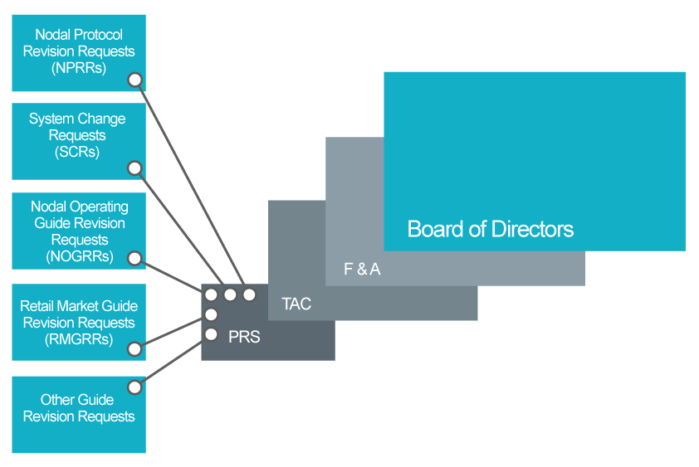
High level text about how the following departments are involved in the change process

Portfolio Management
Project Management Office
Market Rules
Change Control Management
Production Support
Development and Testing

Initiation
- SCR
- Revision Request
- ERCOT Sponsored Project

Approval
- Committee process
- ERCOT internal project process
- Board Approval in some cases

Prioritization
- PPL

Release Coordination
Release scheduled based on:
- Resource availability
- Priority
- Impacts to other scheduled changes
- CAB Process
Release Types:
  - On-Cycle – Follows standard process and schedule
  - Off-Cycle – Follows standard process and non-standard schedule
  - Exception – Follows highly accelerated process due to non-critical production issue
  - Emergency – Emergency, paperwork later release due to critical issue

Market Facing
  - How does this change the process?

Release Windows
  - Release window can span a few days

Release Communication

Commercial Operations Market Guide
Communication about changes to Data Products follows the process outlined in Section 5: Market Notice Communication Process of the Commercial Operations Market Guide. Section 5.1.3.2 defines the parameters around planned releases.
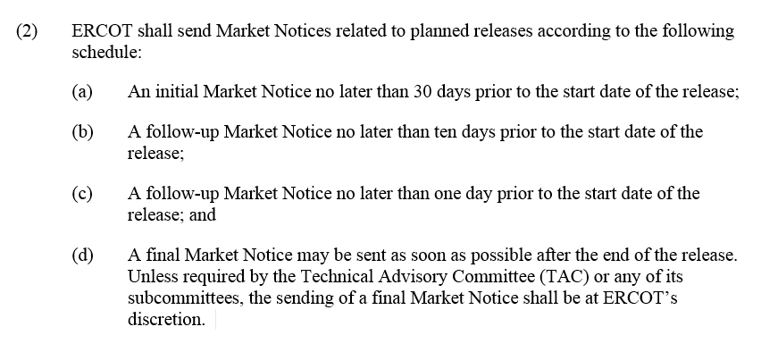
Figure 1 - Section 5.1.3.2 of the Commercial Operations Market Guide
Market Notice Lists

Market Notices are sent as emails to a number of different lists depending on the topic. Changes to extracts and reports will be sent to Notice_Extracts_Retail and Notice_Extracts_Wholesale if the change is not part of a release. If the changes are part of a release, it would be communicated via Notice_Release_Retail and Notice_Release_Wholesale and be identified as a Market Facing Change.

List | Description
NOTICE_CONTRACTS | Market Notices for Requests for Proposal and Requests for Information that are issued by ERCOT and contracted services such as Reliability Must Run and Black Start.
NOTICE_CREDIT | Market Notices concerning management of credit in the ERCOT market.
NOTICE_CRR | Market Notices concerning Congestion Revenue Rights.
NOTICE_EXTRACTS_RETAIL | Market Notices relating to Data Extracts and reports supporting Retail data transactions, including procedures, postings or changes.
NOTICE_EXTRACTS_WHOLESALE | Market Notices relating Data Extracts and reports supporting Wholesale data transactions, including procedures, postings or changes.
NOTICE_GENERAL | Market Notices of general nature intended for distribution to the ERCOT Market, but not applicable to any other specific mailing list.
NOTICE_GRIDCONDITION | Market Notices of Grid Emergency events in progress  ***Locked List This list requires approval from the entity authorized representative to enter ***
NOTICE_LEGAL_NOTIFICATIONS | Market Notices to the ERCOT Market of a legal nature.
NOTICE_OPERATIONS | Market Notices Concerning Power Operations and related Technical Issues at ERCOT.
NOTICE_OUTAGES_RETAIL | Market Notices concerning system outages, business process failures, service degradations and related issues that affect retail market functions.
NOTICE_OUTAGES_WHOLESALE | Market Notices concerning system outages, business process failures, service degradations and related issues that affect wholesale market functions.
NOTICE_PRR_SCR | Market Notices of System Change that include the implementation of Protocol Revision Requests or System Change Requests
NOTICE_RELEASE_RETAIL | Market Notices concerning system outages or upgrade releases and testing that affect retail market functions.
NOTICE_RELEASE_WHOLESALE | Market Notices concerning system outages or upgrade releases and testing that affect wholesale market functions.
NOTICE_RETAIL_PROCESSING | Market Notices concerning the processing of retail transactions.
NOTICE_SETTLEMENTS | Market Notices concerning the Wholesale Settlements issued by ERCOT that are public in nature.
NOTICE_TESTING_RETAIL | Market Notices concerning Market Participant testing with respect to Retail Test Flights and Retail Systems Testing.
NOTICE_TRAINING | Market Notices concerning ERCOT training events.

Sample Notice
  - Form elements
  - Attachments

Market Facing
  - How does this change process?

Publishing End Points
Information related to Report and Extract Data Changes is published to the following channels and locations. All content currently published is classified as Public.
ERCOT.com
  - Committees
  - Meeting Pages
  - Market Rules – Revision Requests, SCRs
  - Projects page in About Section
    - Release Targets
    - ERCOT Porfolio Gantt
    - Project Priority Process
  - Market Notices Archives (Feb 2017)

Lists.ercot.com

List | Description
NOTICE_CONTRACTS | http://lists.ercot.com/scripts/wa-ercot.exe?A0=NOTICE_CONTRACTS
NOTICE_CREDIT | http://lists.ercot.com/scripts/wa-ercot.exe?A0=NOTICE_CREDIT
NOTICE_CRR | http://lists.ercot.com/scripts/wa-ercot.exe?A0=NOTICE_CRR
NOTICE_EXTRACTS_RETAIL | http://lists.ercot.com/scripts/wa-ercot.exe?A0=NOTICE_EXTRACTS_RETAIL
NOTICE_EXTRACTS_WHOLESALE | http://lists.ercot.com/scripts/wa-ercot.exe?A0=NOTICE_EXTRACTS_WHOLESALE
NOTICE_GENERAL | http://lists.ercot.com/scripts/wa-ercot.exe?A0=NOTICE_GENERAL
NOTICE_GRIDCONDITION | http://lists.ercot.com/scripts/wa-ercot.exe?A0=NOTICE_GRIDCONDITION
NOTICE_LEGAL_NOTIFICATIONS | http://lists.ercot.com/scripts/wa-ercot.exe?A0=NOTICE_LEGAL_NOTIFICATIONS
NOTICE_OPERATIONS | http://lists.ercot.com/scripts/wa-ercot.exe?A0=NOTICE_OPERATIONS
NOTICE_OUTAGES_RETAIL | http://lists.ercot.com/scripts/wa-ercot.exe?A0=NOTICE_OUTAGES_RETAIL
NOTICE_OUTAGES_WHOLESALE | http://lists.ercot.com/scripts/wa-ercot.exe?A0=NOTICE_OUTAGES_WHOLESALE
NOTICE_PRR_SCR | http://lists.ercot.com/scripts/wa-ercot.exe?A0=NOTICE_PRR_SCR
NOTICE_RELEASE_RETAIL | http://lists.ercot.com/scripts/wa-ercot.exe?A0=NOTICE_RELEASE_RETAIL
NOTICE_RELEASE_WHOLESALE | http://lists.ercot.com/scripts/wa-ercot.exe?A0=NOTICE_RELEASE_WHOLESALE
NOTICE_RETAIL_PROCESSING | http://lists.ercot.com/scripts/wa-ercot.exe?A0=NOTICE_RETAIL_PROCESSING
NOTICE_SETTLEMENTS | http://lists.ercot.com/scripts/wa-ercot.exe?A0=NOTICE_SETTLEMENTS
NOTICE_TESTING_RETAIL | http://lists.ercot.com/scripts/wa-ercot.exe?A0=NOTICE_TESTING_RETAIL
NOTICE_TRAINING | http://lists.ercot.com/scripts/wa-ercot.exe?A0=NOTICE_TRAINING

Constraints to Current Process
Constraints to current process go here.

Initiation
  - N/A

Approval

  - N/A

Prioritization

  - N/A

Release Coordination

Schedule can change based on:
  - Schedule slippage
  - Critical production issues
  - Change in priority, project cancelled (?)
  - Failed deployment (uncommon)
  - Code deployed but backed out due to missed defects (uncommon)

Release Window:

  - Why can’t release be specific time instead of over a few days?

Release Communication
  - N/A

Publishing End Points
  - N/A

Gaps in Current Process

Initiation

  - N/A

Approval
  - N/A

Prioritization

  - N/A

Release Coordination

  - Broad release window, waiting for something to break
  - Lack of flag for Extract and Report changes makes it difficult to identify changes in internal systems
  - Market Facing flag, who reviews
  - An adequate test environment isn’t currently available. MOTE.

Release Communication

Documentation gaps:
  - Data Definitions
  - Sample Data
  - Version History

Publishing End Points
ERCOT.com:
  - Content is spread out and not organized around this use case

Lists.ercot.com:
  - Not everyone is subscribed to all lists
  - Information overload
  - Can’t search across lists

How Others Approach

Peer Institutions

ERCOT Peer institutions communicate changes in the following way.
PJM – Add relevant URLs?
- If there’s a revision to a primary product, like LMP’s, the notification will appear on that page of the website. These notifications are archived, so that consumers coming in after the fact can see a history of reposts, to ensure they’re using the correct data.
- Other avenues include email notifications through their subcommittee system
ISO-NE – Add relevant URLs?
- Market notices are sent out for any changes to our Web Services, we give 30-day notices to participants for any changes to the Web Services so they can make any updates as needed.
- We use a page on our site to communicate in a more “human” way about our Web Services than that api documentation page. This page (and the XLS on the page) gives more details about the reports we offer, available parameters, how far back data is available for, etc.: https://www.iso-ne.com/participate/support/web-services-data
- Version history is not provided. There is a secure portal for one-off requests and there are separate sites that have data specifically for generators (Local Control Centers) but I’m not aware of exactly what’s included on those.

CAISO – Add relevant URLs?
- CAISO has a Secure Portal, like our MIS, that holds all its data: oasis.caiso.com. In the Atlas Reference > Oasis Publications and Revisions section they have an interface that allows you to query publications and notifications. Utilizing the Version drop-down, you can choose either “New” or “Revised”. The former signifies when the report is initially dropped to the system; the latter if/when it’s revised/corrected. You also have the option to download the query results in XML and CSV.

MISO – Add relevant URLs?
- MISO utilizes subscription-based notifications to alert MP’s about report revisions.
NYISO– Add relevant URLs?
- NYISO has a Reports & Information section where corrected reports/prices are listed and downloadable

Other Industries
The following are excellent examples of developer portals. While not strictly data change management, they do emphasize change visibility and interaction.
GitHub Developer – Add URL?
- Extensive documentation that is easy to navigate and search.
- A stay in the know section with posts of the most recent changes to their API.
- A versions page with a change log with the differences in the API from version to version.
- Callouts of breaking changes.
- Code examples of request and responses of every endpoint.

New Zealand Electric Authority Developer – Add URL?
- Detailed information about each API service.
- Each API service has the GET, POST and DELETE operations broken out
- Code examples of responses and requests in a variety of languages.
- Ability to try out API services in the browser.
- ESwagger API documentation.

Stripe – Add URL
- Clean easy to navigate interface
- Uses google groups for API updates, mailing lists, discussion
- Provides a change log and history of API services
- Code examples in a variety of languages

Solutions

Dev Portal
Include wireframes of what it could have and look like
Detail out some of the data elements
Web app version of EMIL
What about ERCOT initiated changes? What’s the fix? How can we make sure there’s a conversation? NZ site. All proposed changes route through MDWG? Create another forum?
Add categorization to Release Management system so that data product changes can be flagged
Data definitions for all products, including CDR
Release window timing could use narrower window. Automated release pipeline.
Create centralized, categorized location for upcoming changes.

Content types on ERCOT.com that allow for more flexible relationships of content. Relationship between Market Notices, Revision Requests, EMIL, Calendar (?), PPL.
Subscribe to alert changes.

