TDTMS Meeting
October 11, 2016
09:30 AM

Agenda
1. | Antitrust Statement
2. | Introductions  Monica Jones - NRG  Jim Lee - AEP  Sheri Wiegand - TXU  Kaci Jacobs – TXU  Catherine Meiners - ERCOT  Monsherra Odanga - Oncor  Carolyn Reed - CenterPoint  Dave Pagliai - ERCOT  Kyle Patrick - NRG  Lindsay Butterfield - ERCOT  Isabelle Durham - CenterPoint  Diana Rehfeldt - TNMP  Kathy Scott - CenterPoint  Tammy Stewart - ERCOT  Tomas Fernandez-NRG  Stephen Wilson-Sharyland
3. | Review of Agenda
4. | Review/Approve September Meeting Notes  - Minor edits made to the meeting notes to how 814_20 will be processed in the cert environment
5. | ERCOT System Instances & MarkeTrak Monthly Performance Review  - Retail Market IT systems met all SLA targets  - No incidents  - MarkeTrak performing as expected no issues. All the averages look good.  - MT API Performance hit all performance targets
6. | MarkeTrak Upgrade - Discuss additional functionality/requirements (aka parking lot items)  - TDTMS went through the parking lot items and added comments to the working document.  - Jim converted parking lot list into Excel format. Created column for enhancements and column for comments. AI: add a column to spreadsheet for issue tracking ID and submitter. Will be posted to the home page  - AI: Monica will provide the MT enhancements received from the September market training  - Sheri(RMTTF) gave a reminder of the Retail 101/MarkeTrak Trainings for the 2017
7. | Proposed RMGRR – 7.3.2.1 Buyer’s Remorse  - NRG had an IAG rejected due Breach of Contract; however Breach of Contract is not included in the Valid Reject Reasons, so there is interpretation inconsistencies.  - Sheri: TXU energy is opposed to striking the language from the Retail Market Guide. Would like to move it elsewhere in the guide. Where is the suggested section to move the language in the guide? How does this impact Bi-Lateral agreements? Is that relevant?  - The TDSPs are indifferent  - Jim: As leadership unable to endorse the RMGRR on behalf of TDTMS working group.  - AI: Sheri: TXU would like to take this up with NRG offline to try and come up with a workable resolution
8. | Inadvertent Gain Reporting Refinements  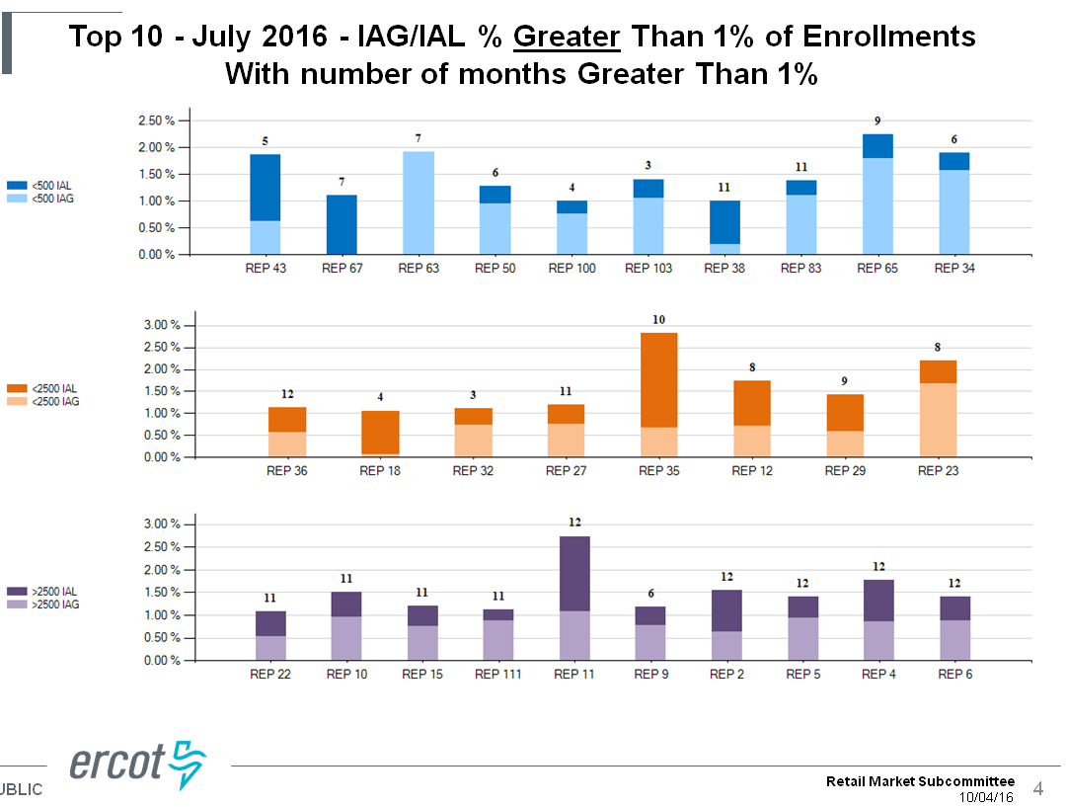  - ERCOT added “Hit rate” to this slide  - Evaluated the most current IAG data with new format  - ERCOT provided all the report data to generate the report the market to customize/filter the metrics as needed  - ERCOT provides to the PUC the raw data metrics with IAG REP and performance.  - Request to ERCOT to perform outreach and provide the report to the REPS identified as needing improvement. Advise of the upcoming IAG training to be provided to the market.  - Sheri: Add the report graphs to the IAG training and walk thru the data with the attendees. Create a segment in the training to review the graphs and understand the difference between gains and losses  - AI: Work with RMTTF to improve the IAG education materials with drafting Tips and Tricks document  - AI: Catherine to review IAG report data and identity REPS who have attended the market trainings. What % of the 30 REPs on the IAG report attended the trainings?  - AI: Review the report to identify what the % would like if the heavy hitters were omitted from the report data. How does that impact the overall number?  - AI: Is there a threshold identified for what % is acceptable in the market for IAG rate? Per Catherine: the current average is .67%- 2/3 of a percent so less than 1%  - MarkeTrak Data Analysis  - AI: Homework- review the Days to Close vs the metrics of the top 10 on the IAG report to see if there is any correlation  - AI: Enforcement- How do we enforce corrective behavior? Who starts the dialogue and how? How is issue raised to the PUC?
9. | DEV Subtypes – are they increasing in volume? No  - AMS deployment and maturity in the market has caused the decreased the number of DEV issues  - Tammy- pulled some DEV data from 2012 for DEV LSE subtypes- Total submitted 2012- 3732 and 2013-997, 2014-561, 2015-438 and YTD-194  LSE in MP system in ERCOT- de-energized most common issue type submitted. 167 of the 194 issues submitted this year was this subtype.  - AI: Will address refinement of the DEV Training at RMTTF
10. | SCR786 User Orientation Documentation for Sandbox Testing  Jim made edits to the document provided by ERCOT and will post to next month’s meeting agenda for suggestions and feedback. AI: Jim add the additional language and will post the TDTMS meeting page for review at next month’s meeting  Tomas: Do we need to have an issue tracking form submitted to ERCOT for what they would like achieve through the testing environment? AI: Next meeting will review possible need for a test template. Jim will work with Catherine from ERCOT offline to obtain a draft of the template and post for review.  Catherine- currently there are a little over 100,000 ESIDS in the test environment  AI: Review the document internally and bring back feedback next month to add to the document
11. | Look ahead to Oct/Nov/Dec:  - 2016 Goals & Accomplishments  - 2017 Meeting Schedule- Discussion took place during TX SET to determine how we coordinate working groups to increase participation. Reviewed the 2017 meeting dates of TX SET and TDTMS. August date change for TDTMS to August 17  - MarkeTrak Subtype Analysis “Gameplan” for Annual Review  AI: November 2nd meeting will be WebEx only
12. | Adjourn

