September 2016 ERCOT Monthly Operations Report
Reliability and Operations Subcommittee Meeting
November 3rd, 2016

Table of Contents
1. Report Highlights 1
2. Frequency Control 2
2.1. Frequency Events 2
2.2. Responsive Reserve Events 3
2.3. Load Resource Events 3
3. Reliability Unit Commitment 3
4. Wind Generation as a Percent of Load 5
5. Congestion Analysis 5
5.1. Notable Constraints for September 5
5.2. Generic Transmission Constraint Congestion 7
5.3. Manual Overrides for September 7
5.4. Congestion Costs for Calendar Year 2016 7
6. System Events 8
6.1. ERCOT Peak Load 8
6.2. Load Shed Events 9
6.3. Stability Events 9
6.4. Notable PMU Events 9
6.5. TRE/DOE Reportable Events 9
6.6. New/Updated Constraint Management Plans 9
6.7. New/Modified/Removed SPS 9
6.8. New Procedures/Forms/Operating Bulletins 9
7. Emergency Conditions 9
7.1. OCNs 9
7.2. Advisories 10
7.3. Watches 10
7.4. Emergency Notices 10
8. Application Performance 10
8.1. TSAT/VSAT Performance Issues 10
8.2. Communication Issues 10
8.3. Market System Issues 10
Appendix A: Real-Time Constraints 11

Report Highlights
- The unofficial ERCOT peak for September was 66,853 MW.
- There were four frequency events in September. PMU data indicates the ERCOT system transitioned well in each case.
- There was one instance where Responsive Reserves were deployed, this sole event was the result of a frequency events.
- There were twenty-five RUC commitments in September.
- The level of reportable SCED congestion slightly increased in September. This congestion was due primarily to high loads, planned outages and area load/gen patterns as well as high North to Houston Imports. There were forty-one instances over 23 days on the Generic Transmission Constraints (GTCs) in September. There was one day of activity on the Zorillo – Ajo GTC, thirteen days on the Panhandle GTC, seven days on the Laredo GTC, one day on the Valley Import and nineteen days on the Liston GTC in September. There was no activity on the remaining GTCs during the Month.
- There were two application issues to report for September. On 9/8/16, there was a SCED failure where a watch was issued and on 9/15/16, a watch was issued due to MMS Application unavailable resulting in HRUC application failure.

Frequency Control

Frequency Events
The ERCOT Interconnection experienced four frequency events in September, all of which resulted from Resource trips. The average event duration was approximately 0:08:06.

When analyzing frequency events, ERCOT evaluates PMU data according to industry standards. Events with an oscillating frequency of less than 1 Hz are considered to be inter-area, while higher frequencies indicate local events. Industry standards specify that damping ratio for inter-area oscillations should be 3.0% or greater. All events listed below indicate the ERCOT system met these standards and transitioned well after each disturbance.

Reported frequency events will include both frequency events where frequency was outside the range of 60±0.1 Hz as well as those determined to be Frequency Measurable Events (FME) as defined by BAL-001-TRE-1. Delta Frequency is defined as the difference between the pre-perturbation and post-perturbation frequency. The Duration of Event is defined as the time it takes for the frequency to recover to lesser/greater of the frequency at the time of the frequency event (t(0) or “A-point”) for low/high-frequency events, respectively. Further details on FMEs can be found in the MIS posted BAL-001-TRE-1 PDCWG Unit Performance reports. A summary of the frequency events is provided below:

Date and Time | Delta Frequency | Max/Min Frequency | Duration of Event | PMU Data |  | Load | Wind | Inertia | Comments
 | (Hz) | (Hz) |  | Oscillation Mode (Hz) | Damping Ratio | (MW) | % | (GW-s)
9/8/2016 13:22 | 0.096 | 59.90 | 0:07:55 | 0.61 | 11% | 60,355 | 8% | 340,759 | Unit Trip of 582MW
9/18/2016 9:16 | 0.053 | 59.94 | 0:05:54 | No PMU Data Available. |  | 40,609 | 6% | 293,422 | Unit Trip of 453MW
9/18/2016 12:00 | 0.072 | 59.92 | 0:09:50 | No PMU Data Available. |  | 51,520 | 3% | 322,706 | Unit Trip of 437MW
9/19/2016 16:23 | 0.042 | 59.92 | 0:08:46 | No PMU Data Available. |  | 66,988 | 3% | 373,597 | Unit Trip of 419MW

(Note: frequency events highlighted in blue have been identified as FMEs per BAL-001-TRE-1 and the Performance Disturbance Compliance Working group.)

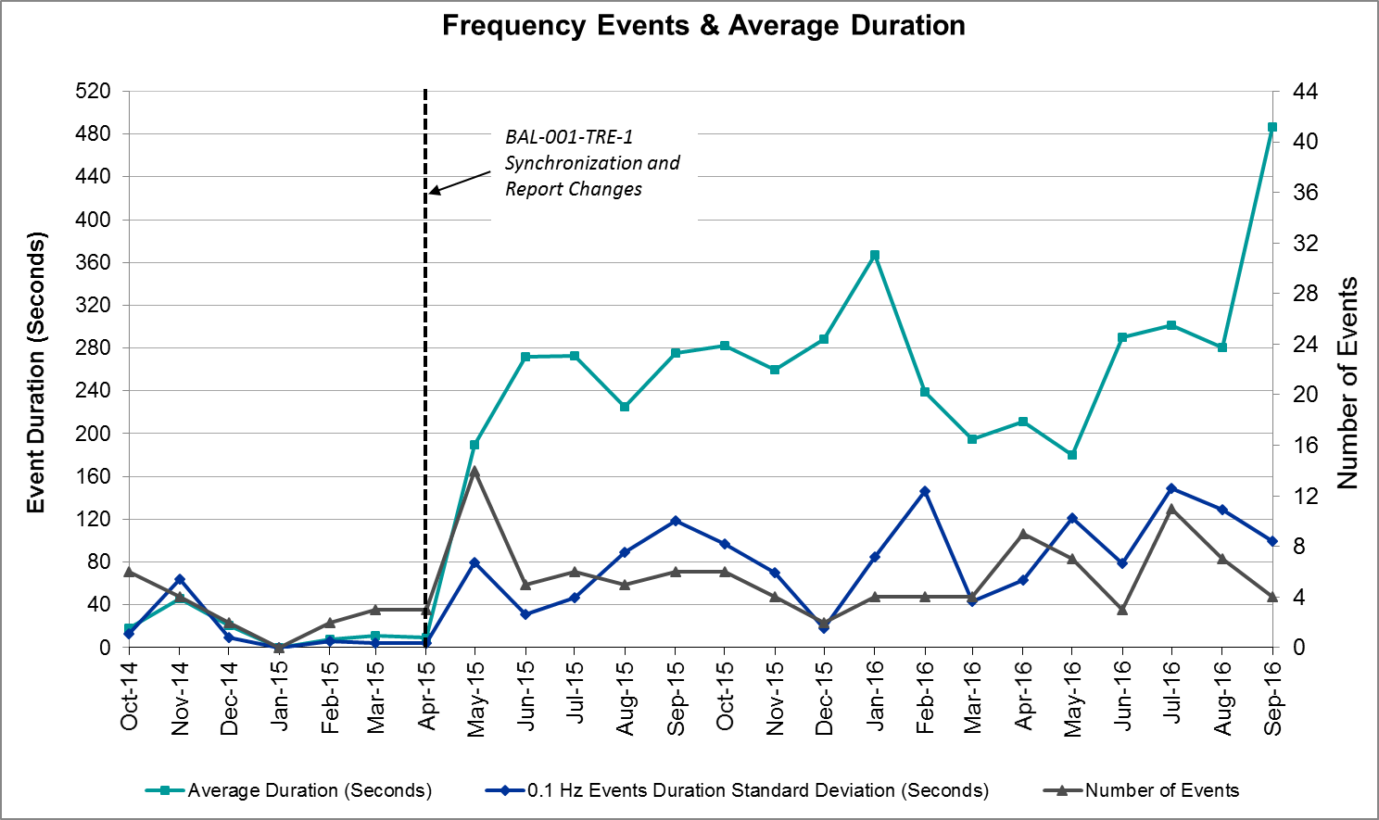

Responsive Reserve Events
There were one events where Responsive Reserve MWs were released to SCED in September. The events highlighted in blue were related to frequency events reported in Section 2.1 above.

Date and Time Released to SCED | Date and Time Recalled | Duration of Event | Maximum MWs Released | Comments
9/8/2016 13:23:04 | 9/8/2016 13:26:40 | 0:03:36 | 261.40

Load Resource Events
None.

Reliability Unit Commitment
ERCOT reports on Reliability Unit Commitments (RUC) on a monthly basis. Commitments are reported grouped by operating day and weather zone. The total number of hours committed is the sum of the hours for all the units in the specified region. Additional information on RUC commitments can be found on the MIS secure site at Grid Generation Reliability Unit Commitment.

There were no DRUC commitments in September.

There were 25 HRUC commitments in September.

HRUC Commitments
Resource Location | # of Resources | Operating Day | Total # of Hours Committed | Total MWhs | Reason for Commitment
North Central | 3 | 9/4/2016 | 15 | 1,458 | Local Congestion and Capacity
North | 1 | 9/4/2016 | 4 | 932 | Local Congestion
Coastal | 1 | 9/5/2016 | 8 | 4,200 | Local Congestion
North Central | 1 | 9/5/2016 | 7 | 427 | Local Congestion
North Central | 3 | 9/6/2016 | 15 | 1,939 | Local Congestion
Coastal | 1 | 9/6/2016 | 5 | 810 | Local Congestion
Southern | 1 | 9/12/2016 | 8 | 2,563 | Local Congestion
Coastal | 1 | 9/13/2016 | 5 | 845 | Local Congestion
North Central | 1 | 9/13/2016 | 2 | 236 | Local Congestion
Coastal | 1 | 9/14/2016 | 8 | 4,200 | Local Congestion
South Central | 1 | 9/14/2016 | 1 | 220 | Local Congestion
North Central | 1 | 9/14/2016 | 2 | 236 | Local Congestion
North Central | 1 | 9/15/2016 | 2 | 236 | Local Congestion
North Central | 2 | 9/16/2016 | 8 | 3,741 | Local Congestion
Coastal | 2 | 9/16/2016 | 12 | 4,876 | Local Congestion
Southern | 1 | 9/19/2016 | 8 | 309 | Local Congestion
Coastal | 4 | 9/21/2016 | 22 | 6,928 | Local Congestion
Southern | 1 | 9/21/2016 | 1 | 56 | Local Congestion
North Central | 1 | 9/21/2016 | 1 | 449 | Local Congestion
Coastal | 2 | 9/22/2016 | 12 | 4,860 | Local Congestion
North Central | 2 | 9/23/2016 | 7 | 834 | Local Congestion
North Central | 1 | 9/24/2016 | 2 | 236 | Local Congestion
Southern | 2 | 9/26/2016 | 7 | 486 | Local Congestion
Southern | 1 | 9/29/2016 | 8 | 2,495 | Local Congestion
Southern | 1 | 9/30/2016 | 13 | 8,060 | Local Congestion

Wind Generation as a Percent of Load
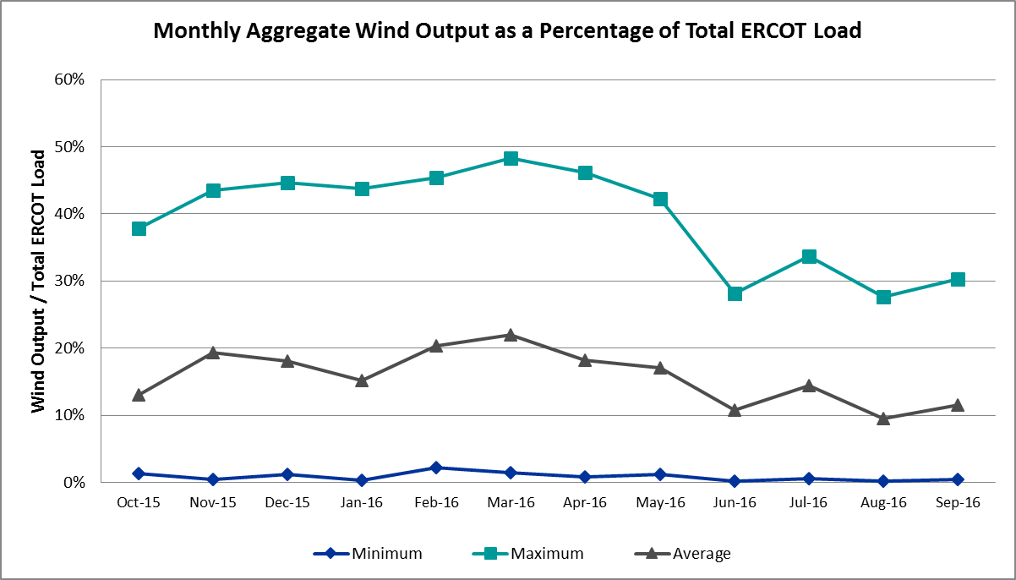

Congestion Analysis
The number of congestion events experienced by the ERCOT system slightly increased in September. There were forty-one instances of activity on the Generic Transmission Constraints (GTCs) in September.

Notable Constraints for September
Nodal protocol section 3.20 specifies that ERCOT shall identify transmission constraints that are active or binding three or more times within a calendar month. As part of this process, ERCOT reports congestion that meets this criterion to ROS. In addition ERCOT also highlights notable constraints that have an estimated congestion rent exceeding $1,000,000 for a calendar month. These constraints are detailed in the table below. Rows highlighted in blue indicate the congestion was affected by one or more outages. For a list of all constraints activated in SCED for the month of September, please see Appendix A at the end of this report.

Contingency | Overload | # of Days Constraint Active | Estimated Congestion Rent | Transmission Project
DKCT Roans Prarie-Rothwood & Singleton-Tomball 345kV | Singleton - Zenith 345kV | 24 | $15,401,819.47 | Houston Import Project
WA Parish - Bailey & Hillje 345 kV | Oasis - Dow Chemical 345kV | 1 | $5,749,309.96
WA Parish - Bailey & Hillje 345 kV | Dow Chemical - South Texas Project 345kV | 5 | $5,002,442.42
Tmpsw-Knbsw 345kV & Belcnty 138kV | Round Rock - Chief Brady 138kV | 2 | $4,788,796.74
Fort Worth Subsation to West Denton 138 kV | Jim Christal Substation - West Denton 138kV | 7 | $4,486,985.63
Midland East - Moss Switch - Odessa Ehv Switch 345 kV | Odessa EHV Switch to Trigas Odessa Tap | 12 | $3,326,505.23
North Mcallen to North Edinburg 138 kV | North Edinburg - Mccoll Road 138kV | 3 | $2,422,336.31
DCKT Jewett - Singleton 345 kV | Btu_Jack_Creek - Twin Oak Switch 345kV | 25 | $2,362,070.30 | Houston Import Project
Jim Christal Substation - West Denton 138 kV | Fort Worth Subsation - West Denton 138kV | 5 | $1,589,501.52
Hicks Switch - Alliance & Roanoke Switch 345 kV | Eagle Mountain Ses - Eagle Mountain Poi 138kV | 3 | $1,479,031.96
WA Parish - Hillje & Bailey 345 kV | Dow Chemical - South Texas Project 345kV | 2 | $1,240,885.28
Mountain Creek Ses Unit Unit8 | Industrial Blvd - Compton Street 138kV | 2 | $1,115,685.69
Basecase | Laredo | 7 | $568,364.58
DCKT Hill Country - Marion and Elmcreek 345 kV | Cibolo - Schertz 138kV | 5 | $555,286.54 | 5234
Bevo Substation - Asherton 138 kV | Big Wells Sub - Cotulla Sub 69kV | 6 | $491,818.85 | 5217
Mcses-Cdcsw 138kV | Irving Hunter Ferrell Tap 2 - Trinity River Authority 138kV | 6 | $354,220.29
Jardin to Cotulla Sub 138 kV | Dilley Switch Aep - Cotulla Sub 69kV | 10 | $352,873.73 | 5222
Mlses - Elktn And Tygnd 345 | Tyler Northwest - Shamburger Switch 138kV | 4 | $348,001.36 | 09TPIT0122
DCKT Gibbons Creek - Singleton 345 kV | Jewett - Singleton 345kV | 8 | $338,626.00 | Houston Import Project
Polk Street to Oak Cliff South (6)138/138/138/138/138/138 kV | Cedar Crest Switch - Oak Cliff South 138kV | 5 | $268,046.68
DCKT Chambers - King and Cedar Bayou - Jordan 345 kV | Aritek - Chorin 138kV | 3 | $260,107.73 | 4426
Elmcreek-Marion 345kV | Cibolo - Schertz 138kV | 3 | $162,861.93 | 5235
Basecase | Liston | 19 | $126,907.38
Gila - Hiway 9 138 kV | Morris Street - Gila 138kV | 5 | $122,594.93 | 5542
Basecase | Panhandle | 13 | $107,969.33 | Panhandle Upgrade
Lobo 2_345_138 345/138 kV | Freer - San Diego 69kV | 4 | $73,513.06
Choke Canyon Aep to Sigmor (2)138/138 kV | San Miguel Tap - North Calliham Sub 69kV | 3 | $55,897.02 | 3819
DCKT Sandow Switch - Austrop 345kV | Howard Lane Tap - Howard Lane Aen 138kV | 4 | $50,861.19
Skyline-Marion&Elmcreek 345kV | Cibolo - Schertz 138kV | 3 | $43,875.47 | 5236
West Levee Switch Axfmr1h_H (3)345/138 kV | Industrial Blvd - Compton Street 138kV | 4 | $31,652.05
Uvalde Aep - Odlaw Switchyard 138 kV | Hamilton Road - Maverick 138kV | 4 | $31,477.19 | 16TPIT0024
Mesa View Switch to Fort Lancaster 138 kV | Big Lake - Big Lake Phillips Tap 69kV | 3 | $27,214.56
Mercers Gap Sw to Comanche Switch (Oncor) 138 kV | Camp Bowie (Oncor) - Brownwood Switch 138kV | 3 | $18,212.52 | 5713
Eskota Switch - Abilene South 138 kV | Eskota Switch - Longworth 69kV | 3 | $10,143.07
Laquinta - Lobo 138 kV | Bruni Sub 69_1 138/69kV | 3 | $6,930.59
Bighil-Kendal 345kV | Hamilton Road - Maverick 138kV | 4 | $6,076.09 | 16TPIT0024
Carrolton Northwest - Lewisville Switch 345 kV | Lewisville Switch - Jones Street Tnp 138kV | 3 | $4,667.45
DCKT Ferguson - Granite Mountain and Wirtz - Starcke - Paleface 138 kV | Flat Rock Lcra - Paleface 138kV | 3 | $2,432.92 | 4465

Generic Transmission Constraint Congestion
There were seven days of activity on the Laredo GTC, one day of activity on the Zorillo – Ajo GTC, thirteen days on the Panhandle GTC, one day on the Valley Import GTC and nineteen days on the Liston GTC in September. There was no activity on the remaining GTCs during the Month.

Note: This is how many times a constraint has been activated to avoid exceeding a GTC limit, it does not imply an exceedance of the GTC occurred or that the GTC was binding.

Manual Overrides for September
There were no manual overrides for the month of September 2016.

Congestion Costs for Calendar Year 2016
The following table represents the top twenty active constraints for the calendar year based on the estimated congestion rent attributed to the congestion. ERCOT updates this list on a monthly basis.

Contingency | Binding Element | # of 5-min SCED Intervals | Estimated Congestion Rent | Transmission Project
Rns-Rtw & Sng-Tb 345kv | Singleton - Zenith 345kV | 7,942 | $ 40,978,824.35 | Houston Import Project
Ph Robinson At1l_H (3)345/138 KV | Meadow AT1 345/138kV | 1,470 | $ 37,410,531.94 | 4708
Villa Cavazos to Military Highway Aep (2)138/138 KV | Los Fresnos - Loma Alta Substation 138kV | 3,272 | $ 26,026,381.24
Jim Christal Substation to West Denton 138 KV | Fort Worth Subsation - West Denton 138kV | 1,662 | $ 12,552,670.88
Jewet-Sng 345kv | Btu_Jack_Creek - Twin Oak Switch 345kV | 9,539 | $ 11,649,642.38 | Houston Import Project
Fort Worth Subsation to West Denton 138 KV | Jim Christal Substation - West Denton 138kV | 1,977 | $ 10,434,357.63
Rnksw-W_Dent&Lwssw-Krwsw 345kv | Fort Worth Subsation - West Denton 138kV | 1,774 | $ 10,027,611.63
Hcksw-Allnc&Rnksw 345kv | Eagle Mountain Ses - Morris Dido 138kV | 1,420 | $ 8,755,553.47 | 4252
Basecase | Panhandle | 6,612 | $ 8,222,680.21 | Panhandle Upgrade
Bm-Sr73 & Sr81 138kv | Bellaire - San Felipe 138kV | 196 | $ 7,119,922.62 | 4703
Rosen Heights to Eagle Mountain Compressor (5)138/138/138/138/138 KV | Rosen Heights Tap 2 - Morris Dido 138kV | 857 | $ 6,945,775.57 | 4252
Meadow to Ph Robinson 345 KV | Meadow AT1 345/138kV | 89 | $ 6,552,987.55 | 4708
Basecase | Valley Import | 113 | $ 6,494,964.50 | LRGV (lower Rio Grande Valley) Import Project
WA Parish - Bailey & Hillje 345 kV | Oasis - Dow Chemical 345kV | 64 | $ 5,749,309.96
Lwssw-Krwsw&Rnksw 345kv | Fort Worth Subsation - West Denton 138kV | 791 | $ 5,462,367.54
Hcksw-Allnc&Rnksw 345kv | Rosen Heights Tap 2 - Morris Dido 138kV | 805 | $ 5,063,292.44 | 4252
South Carbide to Loma Alta Substation 138 KV | La Palma - Villa Cavazos 138kV | 505 | $ 5,060,645.62 | 4490
WA Parish - Bailey & Hillje 345 kV | Dow Chemical - South Texas Project 345kV | 225 | $ 5,002,442.42
Tmpsw-Knbsw 345kv & Belcnty 138kv | Round Rock - Chief Brady 138kV | 151 | $ 4,788,796.74
Mason Road to Obrien 138 KV | Betka - Hockley 138kV | 257 | $ 4,451,883.67 | 3682A,3682,3682C

System Events

ERCOT Peak Load
The unofficial ERCOT peak load for the month was 66,853 MW and occurred on September 19th during hour ending 17:00.

Load Shed Events
None.

Stability Events
None.

Notable PMU Events
ERCOT analyzes PMU data for any significant system disturbances that do not fall into the Frequency Events category reported in section 2.1. The results are summarized in this section once the analysis has been completed.

There were no reportable events in September.

TRE/DOE Reportable Events
None.

New/Updated Constraint Management Plans
None.

New/Modified/Removed SPS
- 09/06/2016 ONCOR's ALNSW SPS 15 has been retired from service.

New Procedures/Forms/Operating Bulletins
09/28/2016 | Transmission and Security Desk V1 Rev 47 | 760 (doc – 524.5 KB)
09/28/2016 | Shift Supervisor Desk V1 Rev 40 | 759 (doc – 328 KB)
09/28/2016 | Scripts V1 Rev 8 | 758 (doc – 264.5 KB)
09/28/2016 | Reliability Unit Commitment Desk V1, Rev 36 | 757 (doc – 239.5 KB)
09/28/2016 | Real Time Desk V1 Rev44 | 756 (doc – 328 KB)
09/28/2016 | DC Tie Desk V1 Rev 39 | 755 (doc – 277.5 KB)

Emergency Conditions

OCNs
Date and Time | Description
9/16/16 02:34 | OCN issued due to capacity insufficiency

Advisories
Date and Time | Description
9/3/16 15:02 | Advisory issued due to Physically Responsive Capability being less than 3,000MW.
9/15/16 15:06 | Advisory issued due to Physically Responsive Capability being less than 3,000MW.
9/17/16 14:00 | Advisory issued due to Physically Responsive Capability being less than 3,000MW.
9/18/16 15:27 | Advisory issued due to Physically Responsive Capability being less than 3,000MW.
9/19/16 15:27 | Advisory issued due to Physically Responsive Capability being less than 3,000MW.
9/28/16 15:56 | Advisory issued due to Physically Responsive Capability being less than 3,000MW.

Watches
Date and Time | Description
9/08/16 19:56 | Watch issued due to MMS Application unavailable resulting in SCED application failure
9/15/16 03:53 | Watch due to HRUC not completing due MMS Application unavailable resulting in HRUC application failure.

Emergency Notices
None.

Application Performance

TSAT/VSAT Performance Issues
None.

Communication Issues
None.

Market System Issues
    - 9/8/16 – A watch was issued due to MMS Application unavailable resulting in SCED application failure
    - 9/15/16 – A watch was issued due to MMS Application unavailable resulting in HRUC application failure.

Appendix A: Real-Time Constraints
The following is a complete list of constraints activated in SCED for the month of September. Full contingency descriptions can be found in the Standard Contingencies List located on the MIS secure site at Grid Generation Reliability Unit Commitment.

Contingency | Constrained Element | From Station | To Station | # of Days Constraint Active
DJEWSNG5 | JK_TOKSW_1 | TOKSW | JK_CK | 25
DRNS_TB5 | SNGZEN99_A | SNG | ZEN | 24
BASE CASE | LISTON | n/a | n/a | 19
BASE CASE | PNHNDL | n/a | n/a | 13
SMDLODE5 | 6475__C | ODEHV | TROTP | 12
SJARDIL8 | DIL_COTU_1 | DILLEYSW | COTULAS | 10
DGIBSNG5 | 260_A_1 | JEWET | SNG | 8
SFTWW_D8 | AIR_W_DE_1 | W_DENT | JMCRSTL | 7
BASE CASE | LAREDO | n/a | n/a | 7
DMCSCDC8 | 3405__B | TRIRA | IHFT2 | 6
SBEVASH8 | BIG_COTU_1 | COTULAS | BIGWELS | 6
SGILNU78 | GILA_MORRIS1_1 | GILA | MORRIS | 5
SPLKMCS8 | 3160__A | CDCSW | OKCLS | 5
DHILELM5 | 293T304_1 | CIBOLO | SCHERT | 5
DWAPHLJ5 | DOWSTP27_A | STP | DOW | 5
SJMCW_D8 | FTW_W_DE_1 | W_DENT | FTWORTH | 5
DAUSSND5 | HWRDLN_1 | HWRDTP | HWRDLN | 4
SBRAUVA8 | HAMILT_MAVERI1_1 | HAMILTON | MAVERICK | 4
XLOB58 | FREER_SAN_DI1_1 | SAN_DIEG | FREER | 4
DBIGKEN5 | HAMILT_MAVERI1_1 | HAMILTON | MAVERICK | 4
DTRCELK5 | 1760__A | SHBSW | TYLNW | 4
XWL2V58 | 3130__B | INDST | CMPST | 4
SLAQLOB8 | BRUNI_69_1 | BRUNI | BRUNI | 3
DCHBJOR5 | ATKRIN87_A | RIN | ATK | 3
DSKYMAR5 | 293T304_1 | CIBOLO | SCHERT | 3
SFTLMES8 | BGLK_PHBL_T1_1 | BGLK | PHBL_TAP | 3
SZEPCMN8 | 670__B | BRNSW | CMPBW | 3
DCRLLSW5 | 590__A | LWSSW | LWVJS | 3
DFERPAL8 | 43T365_1 | PALEPE | FLATRO | 3
SN_MNED8 | MCOLL__NEDIN1_1 | NEDIN | MCOLL_RD | 3
DHCKRNK5 | 6270__A | EMSES | EGPOI | 3
DELMMAR5 | 293T304_1 | CIBOLO | SCHERT | 3
DFERPAL8 | 43T365_1 | FLATRO | PALEPE | 3
SSIGSAN8 | NCA_SMTP_1 | SANMTAP | NCALHMS | 3
DAUSDUN8 | CKT_972_1 | HWRDLN | MCNEIL | 3
SMCEABS8 | 6780__A | ESKSW | LONGWRTH | 3
UMC2UNI1 | 3130__B | INDST | CMPST | 2
STENCR28 | TEN_CRD1_1 | TEN | CRD | 2
BASE CASE | NEDIN_REDTAP1_1 | REDTAP | NEDIN | 2
DHLJBLY5 | DOWSTP27_A | STP | DOW | 2
SCABWES8 | B_DAVI_RODD_F1_1 | B_DAVIS | RODD_FLD | 2
XLOB58 | ASHERT_CATARI1_1 | ASHERTON | CATARINA | 2
SFT_BAL8 | CONCHO_VRBS1_1 | CONCHO | VRBS | 2
SBUZLME8 | BUZSW_AXF1 | BUZSW | BUZSW | 2
DTMPBE58 | 213T378_1 | RNDRK | CHIEBR | 2
DMARSKY5 | 293T304_1 | CIBOLO | SCHERT | 2
XSA2N58 | SANMIGL_ATAH | SANMIGL | SANMIGL | 2
BASE CASE | RANDAD_ZAPATA1_1 | RANDADO | ZAPATA | 2
XWTR58 | 3130__B | INDST | CMPST | 2
DWH_STP5 | BLESSI_LOLITA1_1 | BLESSING | LOLITA | 2
XSCS58 | 1450__B | NCDSE | NCSFA | 1
DTOKJK_5 | 260_A_1 | JEWET | SNG | 1
DELMSKY5 | 293T304_1 | CIBOLO | SCHERT | 1
DFERGRA8 | 38T365_1 | WIRTZ | FLATRO | 1
DELMMAR5 | MAR_SKY_1 | MARION | SKYLINE | 1
SVLDO2W8 | MRK_VNVL_1 | MRKHMSW | VNVLKSW | 1
SMCEABS8 | ROBY_RONDTP1_1 | ROBY | RONDTPT | 1
DFERGRA8 | SANDCR_AT1 | SANDCR | SANDCR | 1
SCOLLON5 | VICTO_WARBU_1A_1 | VICTORIA | WARBURTN | 1
SSNDAU15 | 450__A | SNDSW | AUSTRO | 1
DSNGZEN5 | BETHK_66_A | HK | BET | 1
DWAPHLJ5 | DOWOAS18_A | DOW | OAS | 1
BASE CASE | VALIMP | n/a | n/a | 1
XJEW158 | 1240__K | TRSES | WINKLER | 1
XNED258 | NEDIN_138H | NEDIN | NEDIN | 1
BASE CASE | S104A_1 | RIOHONDO | MV_BURNS | 1
SW_DJCK5 | HLND_LWSSW_1 | LWSSW | HILND | 1
SFTLMES8 | MIDW_OZONA1_1 | MIDW | OZONA | 1
DALNRYS5 | 1627__A | APOLLO | REAST | 1
XLOB58 | GARZA_ROMA_S1_1 | GARZA | ROMA_SW | 1
DELMMAR5 | HIL_MAR_1 | MARION | HILLCTRY | 1
SFTLMES8 | LVOK_SANTIA1_1 | SANTIAGO | LVOK | 1
DHILELM5 | MAR_SKY_1 | MARION | SKYLINE | 1
XDOW58 | MRK_VNVL_1 | MRKHMSW | VNVLKSW | 1
XSA2N58 | SANMIGL_ATAL | SANMIGL | SANMIGL | 1
XLWS58 | 1065__L | EULES | GRHWY | 1
DFERGRA8 | 458T458_1 | PALEFA | BEECRE | 1
SBRNCMN8 | 670__B | BRNSW | CMPBW | 1
XLOB58 | DILLEY_JARDIN1_1 | DILLEYSW | JARDIN | 1
DVICV_D8 | GREENL_WEAVER1_1 | WEAVERRD | GREENLK | 1
SHIWCIT8 | WEIL_T_WESTSI1_1 | WEIL_TRC | WESTSIDE | 1
DFERHOR8 | 41T196_1 | WIRTZ | STARCK | 1
SRDODES8 | 940__C | ENWSW | WXHCH | 1
SFORGIL8 | FRPHIL_GILLES1_1 | GILLES | FRPHILLT | 1
SLISBAT8 | GARZA_ROMA_S1_1 | GARZA | ROMA_SW | 1
DNEDPAL8 | MCOLL__NEDIN1_1 | NEDIN | MCOLL_RD | 1
BASE CASE | ZO_AJO | n/a | n/a | 1

