August 2016 ERCOT Monthly Operations Report
Reliability and Operations Subcommittee Meeting
October 6th, 2016

Table of Contents
1. Report Highlights 1
2. Frequency Control 2
2.1. Frequency Events 2
2.2. Responsive Reserve Events 3
2.3. Load Resource Events 3
3. Reliability Unit Commitment 3
4. Wind Generation as a Percent of Load 5
5. Congestion Analysis 5
5.1. Notable Constraints for August 5
5.2. Generic Transmission Constraint Congestion 7
5.3. Manual Overrides for August 7
5.4. Congestion Costs for Calendar Year 2016 7
6. System Events 8
6.1. ERCOT Peak Load 8
6.2. Load Shed Events 8
6.3. Stability Events 8
6.4. Notable PMU Events 8
6.5. TRE/DOE Reportable Events 8
6.6. New/Updated Constraint Management Plans 8
6.7. New/Modified/Removed SPS 8
6.8. New Procedures/Forms/Operating Bulletins 9
7. Emergency Conditions 9
7.1. OCNs 9
7.2. Advisories 9
7.3. Watches 10
7.4. Emergency Notices 10
8. Application Performance 10
8.1. TSAT/VSAT Performance Issues 10
8.2. Communication Issues 10
8.3. Market System Issues 10
Appendix A: Real-Time Constraints 11

Report Highlights
- The unofficial ERCOT peak for August was 71,197 MW. This is an unofficial ERCOT peak. Multiple peaks were set in the month.
- There were seven frequency events in August. PMU data indicates the ERCOT system transitioned well in each case.
- There were four instances where Responsive Reserves were deployed, three of which were the result of frequency events.
- There were eighteen RUC commitments in August.
- The level of reportable SCED congestion decreased in August. This congestion was due primarily to high loads on peak days, planned outages and area load/gen patterns as well as high North to Houston Imports. There were thirty-five instances over 26 days on the Generic Transmission Constraints (GTCs) in August. There were four days of activity on the Zorillo – Ajo GTC, two days on the Panhandle GTC, four days on the Laredo GTC and twenty-five days on the Liston GTC in August. There was no activity on the remaining GTCs during the Month.
- There was a loss of load event for the month on the 23rd. It was not directed by ERCOT.
- There were two application issues to report for August. On 8/25/16 there was a SCED failure and on 8/31/16 there was a delay in the posting of the DAM solution.

Frequency Control

Frequency Events
The ERCOT Interconnection experienced seven frequency events in August, six of which resulted from Resource trips. The average event duration was approximately 0:04:41.

When analyzing frequency events, ERCOT evaluates PMU data according to industry standards. Events with an oscillating frequency of less than 1 Hz are considered to be inter-area, while higher frequencies indicate local events. Industry standards specify that damping ratio for inter-area oscillations should be 3.0% or greater. All events listed below indicate the ERCOT system met these standards and transitioned well after each disturbance.

Reported frequency events will include both frequency events where frequency was outside the range of 60±0.1 Hz as well as those determined to be Frequency Measurable Events (FME) as defined by BAL-001-TRE-1. Delta Frequency is defined as the difference between the pre-perturbation and post-perturbation frequency. The Duration of Event is defined as the time it takes for the frequency to recover to lesser/greater of the frequency at the time of the frequency event (t(0) or “A-point”) for low/high-frequency events, respectively. Further details on FMEs can be found in the MIS posted BAL-001-TRE-1 PDCWG Unit Performance reports. A summary of the frequency events is provided below:

Date and Time | Delta Frequency | Max/Min Frequency | Duration of Event | PMU Data |  | Load | Wind | Inertia | Comments
 | (Hz) | (Hz) |  | Oscillation Mode (Hz) | Damping Ratio | (MW) | % | (GW-s)
8/2/2016 18:37 | 0.071 | 59.91 | 0:07:09 | No PMU Data Available. |  | 65,997 | 10% | 352,201 | Unit Trip of 526MW
8/15/2016 19:39 | 0.091 | 59.83 | 0:05:04 | 0.66 | 14% | 46,541 | 6% | 305,126 | Unit Trip of 856MW
8/23/2016 18:05 | -0.008 | 60.10 | 0:00:30 | 0.66 | 6% | 61,120 | 17% | 325,123 | Loss of 495MW of Load
8/27/2016 14:43 | 0.070 | 59.92 | 0:03:24 | No PMU Data Available. |  | 56,038 | 3% | 324,034 | Unit Trip of 484MW
8/28/2016 14:13 | 0.098 | 59.88 | 0:05:34 | 0.64 | 10% | 54,209 | 2% | 316,030 | Unit Trip of 534MW
8/31/2016 2:53 | 0.074 | 59.89 | 0:05:32 | No PMU Data Available. |  | 35,277 | 3% | 265,398 | Unit Trip of 596MW
8/31/2016 13:18 | 0.057 | 59.91 | 0:05:31 | No PMU Data Available. |  | 58,207 | 1% | 347,753 | Unit Trip of 453MW

(Note: frequency events highlighted in blue have been identified as FMEs per BAL-001-TRE-1 and the Performance Disturbance Compliance Working group.)

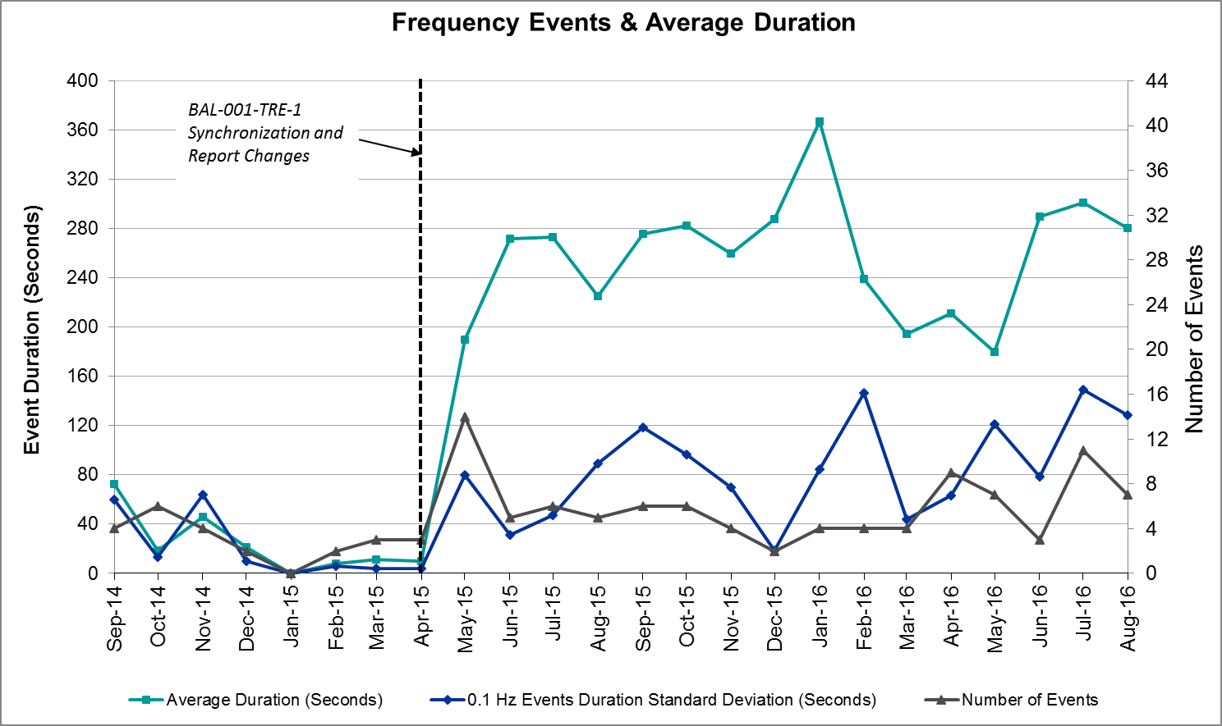

Responsive Reserve Events
There were four events where Responsive Reserve MWs were released to SCED in August. The events highlighted in blue were related to frequency events reported in Section 2.1 above.

Date and Time Released to SCED | Date and Time Recalled | Duration of Event | Maximum MWs Released | Comments
8/15/2016 19:39:50 | 8/15/2016 19:43:18 | 0:03:28 | 769.52
8/27/2016 13:41:02 | 8/27/2016 13:44:30 | 0:03:28 | 458.92 | A resource ran back and tripped, bringing frequency down to 59.88Hz. Event recovered back to 60Hz in 06:38.
8/28/2016 14:13:42 | 8/28/2016 14:17:46 | 0:04:04 | 340.37
8/31/2016 2:53:22 | 8/31/2016 2:56:50 | 0:03:28 | 371.98

Load Resource Events
None.

Reliability Unit Commitment
ERCOT reports on Reliability Unit Commitments (RUC) on a monthly basis. Commitments are reported grouped by operating day and weather zone. The total number of hours committed is the sum of the hours for all the units in the specified region. Additional information on RUC commitments can be found on the MIS secure site at Grid Generation Reliability Unit Commitment.

There were no DRUC commitments in August.

There were 18 HRUC commitments in August.

HRUC Commitments
Resource Location | # of Resources | Operating Day | Total # of Hours Committed | Total MWhs | Reason for Commitment
North Central | 2 | 8/2/2016 | 6 | 2,144 | Local Congestion and Capacity
South Central | 1 | 8/3/2016 | 1 | 315 | Local Congestion
North Central | 2 | 8/4/2016 | 10 | 6,712 | Local Congestion
North | 2 | 8/4/2016 | 14 | 7,070 | Local Congestion
North Central | 1 | 8/5/2016 | 3 | 414 | Local Congestion
South | 2 | 8/6/2016 | 16 | 7,602 | Local Congestion
South | 1 | 8/7/2016 | 8 | 2,400 | Local Congestion
North Central | 3 | 8/8/2016 | 4 | 596 | Local Congestion
Coast | 2 | 8/8/2016 | 6 | 444 | Local Congestion
East | 2 | 8/8/2016 | 4 | 345 | Local Congestion
North Central | 1 | 8/9/2016 | 8 | 856 | Local Congestion
East | 1 | 8/9/2016 | 4 | 440 | Local Congestion
East | 2 | 8/10/2016 | 10 | 3,155 | Local Congestion
North Central | 5 | 8/10/2016 | 6 | 946 | Local Congestion
North Central | 7 | 8/11/2016 | 7 | 1,118 | Local Congestion
South | 1 | 8/13/2016 | 8 | 2,400 | Local Congestion
Coast | 3 | 8/20/2016 | 11 | 2,250 | Local Congestion
North Central | 2 | 8/24/2016 | 14 | 822 | Local Congestion

Wind Generation as a Percent of Load
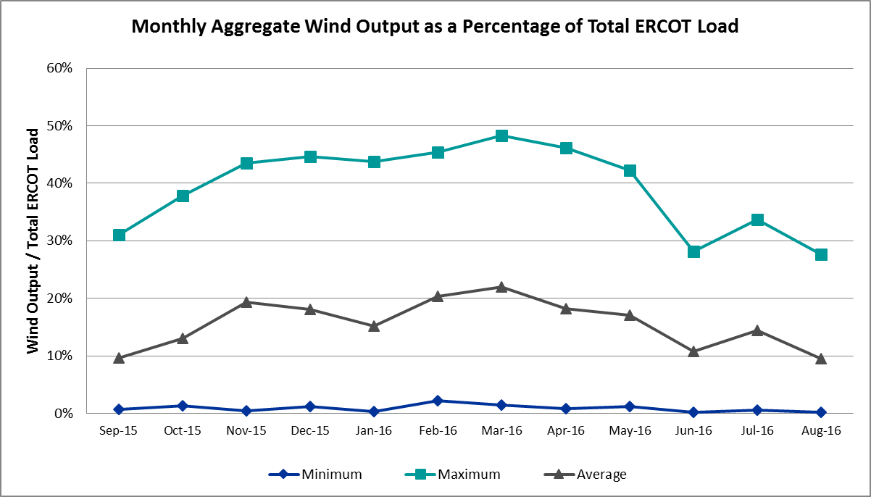

Congestion Analysis
The number of congestion events experienced by the ERCOT system decreased in August. There were thirty-five instances of activity on the Generic Transmission Constraints (GTCs) in August.

Notable Constraints for August
Nodal protocol section 3.20 specifies that ERCOT shall identify transmission constraints that are active or binding three or more times within a calendar month. As part of this process, ERCOT reports congestion that meets this criterion to ROS. In addition ERCOT also highlights notable constraints that have an estimated congestion rent exceeding $1,000,000 for a calendar month. These constraints are detailed in the table below. Rows highlighted in blue indicate the congestion was affected by one or more outages. For a list of all constraints activated in SCED for the month of August, please see Appendix A at the end of this report.

Contingency | Overload | # of Days Constraint Active | Estimated Congestion Rent | Transmission Project
DKCT Roans Prarie-Rothwood & Singleton-Tomball 345kV | Singleton - Zenith 345kV | 18 | $15,763,821.37 | Houston Import Project
Jim Christal Substation - West Denton 138 kV | Fort Worth Substation - West Denton 138kV | 11 | $9,874,531.49
DCKT Chambers - King and Cedar Bayou - Jordan 345 kV | Aritek - Chorin 138kV | 6 | $3,130,019.07 | 4426
South Texas # 1 & # 2 | Blessing - Lolita 138kV | 5 | $2,863,727.72
DCKT Flewellen - Obrien and Mason Road 138 kV | Betka - Hockley 138kV | 7 | $2,678,565.19 | 3682A,3682,3682C
Lewisville Switch Axfmr12 345/138 kV | Grapevine Highway 360 - Euless 138kV | 6 | $2,573,601.96 | 11TPIT0012
Fort Worth Subsation to West Denton 138 kV | Jim Christal Substation - West Denton 138kV | 9 | $2,313,207.35
Basecase | Laredo GTC | 4 | $2,197,493.89
DCKT Jewett - Singleton 345 kV | Btu_Jack_Creek - Twin Oak Switch 345kV | 16 | $1,801,128.54 | Houston Import Project
Hicks Switch - Alliance & Roanoke Switch 345 kV | Eagle Mountain Ses - Eagle Mountain Poi 138kV | 4 | $1,233,663.60 | 15TPIT0085
DCKT Whitepint - Lon Hill and South Texas Project 345 kV | Bonnieview - Rincon 69kV | 6 | $653,577.12
Basecase | Liston GTC | 25 | $649,013.70
Laquinta - Lobo 138 kV | Bruni Sub 69_1 138/69kV | 16 | $617,381.43
DCKT Chambers - King and Cedar Bayou - Jordan 345 kV | Brine - Winfree 138kV | 3 | $597,404.99
Aen Dunlap At1h 345/138 kV | Austrop AT2H 345/13.2/138kV | 4 | $514,864.56 | 4086
Locust Substation to Spencer Switch 69 kV | Denton Steam AT1 138/69kV | 11 | $502,451.92 | 5430C
DKCT Roans Prarie-Rothwood & Singleton-Tomball 345kV | Singleton - Zenith 345kV | 3 | $207,089.18 | Houston Import Project
DCKT Chambers - King and Cedar Bayou - Jordan 345 kV | Brine - Langston 138kV | 3 | $162,477.23
Midland East - Moss Switch - Odessa Ehv Switch 345 kV | Odessa EHV Switch to Trigas Odessa Tap | 4 | $155,192.51
Uvalde Aep - Odlaw Switchyard 138 kV | Hamilton Road - Maverick 138kV | 6 | $146,259.10 | 16TPIT0024
Gila - Hiway 9 138 kV | Morris Street - Gila 138kV | 6 | $74,398.66
Somerset to Howard 138 kV | Pleasanton Sub - Tordillo 138_69 69kV | 3 | $73,317.53
DCKT Ferguson - Granite Mountain and Wirtz - Starcke - Paleface 138 kV | Flat Rock Lcra - Wirtz 138kV | 15 | $48,268.68 | 4465
Spencer Switch to Denton Steam 69 kV | Hickory Substation - Locust Substation 69kV | 3 | $41,877.11 | 5430I
Mlses - Elktn And Tygnd 345 | Tyler Northwest - Shamburger Switch 138kV | 10 | $17,839.59 | 09TPIT0122
Ph Robinson to Center 345 kV | Cedar Bayou Plant - Strang 138kV | 3 | $13,076.97
Mercers Gap Sw to Comanche Switch (Oncor) 138 kV | Camp Bowie (Oncor) - Brownwood Switch 138kV | 3 | $12,176.57
Lobo 2_345_138 345/138 kV | Garza - Roma Switch 138kV | 3 | $7,731.06
Eagle Mountain 2 Compressor Station to Eagle Mountain Poi (5)138/138/138/138/138 kV | Eagle Mountain Ses - Wagley Robertson 138kV | 5 | $2,476.32 | 15TPIT0085

Generic Transmission Constraint Congestion
There were four days of activity on the Laredo GTC, four days of activity on the Zorillo – Ajo GTC, two days on the Panhandle GTC, and twenty-five days on the Liston GTC in August. There was no activity on the remaining GTCs during the Month.

Note: This is how many times a constraint has been activated to avoid exceeding a GTC limit, it does not imply an exceedance of the GTC occurred or that the GTC was binding.

Manual Overrides for August
There were no manual overrides for the month of August 2016.

Congestion Costs for Calendar Year 2016
The following table represents the top twenty active constraints for the calendar year based on the estimated congestion rent attributed to the congestion. ERCOT updates this list on a monthly basis.

Contingency | Binding Element | # of 5-min SCED Intervals | Estimated Congestion Rent | Transmission Project
Ph Robinson At1l_H (3)345/138 KV | Meadow AT1 345/138kV | 1,470 | $ 37,410,531.94 | 4708
Villa Cavazos to Military Highway Aep (2)138/138 KV | Los Fresnos - Loma Alta Substation 138kV | 3,272 | $ 26,026,381.24
Rns-Rtw & Sng-Tb 345kv | Singleton - Zenith 345kV | 5,780 | $ 25,577,004.88 | Houston Import Project
Jim Christal Substation to West Denton 138 KV | Fort Worth Subsation - West Denton 138kV | 1,353 | $ 10,963,169.35
Rnksw-W_Dent&Lwssw-Krwsw 345kv | Fort Worth Subsation - West Denton 138kV | 1,774 | $ 10,027,611.63 | 4252
Jewet-Sng 345kv | Btu_Jack_Creek - Twin Oak Switch 345kV | 6,629 | $ 9,287,572.08 | Houston Import Project
Hcksw-Allnc&Rnksw 345kv | Eagle Mountain Ses - Morris Dido 138kV | 1,420 | $ 8,755,553.47
Basecase | Panhandle GTC | 5,518 | $ 8,114,710.88 | Panhandle Upgrade
Bm-Sr73 & Sr81 138kv | Bellaire - San Felipe 138kV | 196 | $ 7,119,922.62 | 4703
Rosen Heights to Eagle Mountain Compressor (5)138/138/138/138/138 KV | Rosen Heights Tap 2 - Morris Dido 138kV | 857 | $ 6,945,775.57 | 4252
Meadow to Ph Robinson 345 KV | Meadow AT1 345/138kV | 89 | $ 6,552,987.55 | 4708
Basecase | Valley Import | 110 | $ 6,494,964.50 | LRGV (lower Rio Grande Valley) Import Project
Fort Worth Subsation to West Denton 138 KV | Jim Christal Substation - West Denton 138kV | 1,498 | $ 5,947,372.00
Lwssw-Krwsw&Rnksw 345kv | Fort Worth Subsation - West Denton 138kV | 791 | $ 5,462,367.54
Hcksw-Allnc&Rnksw 345kv | Rosen Heights Tap 2 - Morris Dido 138kV | 805 | $ 5,063,292.44 | 4252
South Carbide to Loma Alta Substation 138 KV | La Palma - Villa Cavazos 138kV | 505 | $ 5,060,645.62 | 4490
Mason Road to Obrien 138 KV | Betka - Hockley 138kV | 257 | $ 4,451,883.67 | 3682A,3682,3682C
South Texas # 1 & # 2 | Marion - Clear Springs 345kV | 18 | $ 4,402,597.52
Nelson Sharpe to Ajo 345 KV | Javalina Tap - Molina 138kV | 4,406 | $ 4,208,950.27 | 4401
Ph Robinson At4_H (3)345/138 KV | Meadow AT1 345/138kV | 62 | $ 3,994,537.45 | 4708

System Events

ERCOT Peak Load
The unofficial ERCOT peak load for the month was 71,197 MW and occurred on August 11th during hour ending 17:00.

Load Shed Events
8/23/16 - Loss of approximately 400 MW of Load in Kluge (KL) and Cyfair (CYF) stations. This was not an ERCOT directed load shed event.

Stability Events
None.

Notable PMU Events
ERCOT analyzes PMU data for any significant system disturbances that do not fall into the Frequency Events category reported in section 2.1. The results are summarized in this section once the analysis has been completed.

There were no reportable events in August.

TRE/DOE Reportable Events
None.

New/Updated Constraint Management Plans
None.

New/Modified/Removed SPS
- On 8/3/16 a market notice was sent for the modification of the Permian Basin SPS.
- On 8/31/16 a new Wirtz SPS was added.
- On 8/24/16 a market notice was sent out for the removal of the Allen Switch SPS to be retired on 9/2/16.

New Procedures/Forms/Operating Bulletins
None.

Emergency Conditions

OCNs
Date and Time | Description
8/2/16 10:19 | OCN issued due to capacity insufficiency

Advisories
Date and Time | Description
8/2/16 14:02 | Advisory issued due to Physically Responsive Capability being less than 3,000MW.
8/3/16 13:08 | Advisory issued due to Physically Responsive Capability being less than 3,000MW.
8/4/16 15:09 | Advisory issued due to Physically Responsive Capability being less than 3,000MW.
8/5/16 14:32 | Advisory issued due to Physically Responsive Capability being less than 3,000MW.
8/6/16 13:57 | Advisory issued due to Physically Responsive Capability being less than 3,000MW.
8/10/16 14:12 | Advisory issued due to Physically Responsive Capability being less than 3,000MW.
8/11/16 13:30 | Advisory issued due to Physically Responsive Capability being less than 3,000MW.
8/17/16 12:21 | Advisory issued due to Physically Responsive Capability being less than 3,000MW.
8/24/16 14:46 | Advisory issued due to Physically Responsive Capability being less than 3,000MW.
8/25/16 13:17 | Advisory issued due to Physically Responsive Capability being less than 3,000MW.
8/27/16 13:02 | Advisory issued due to Physically Responsive Capability being less than 3,000MW.
8/31/16 13:30 | Advisory issued due to postponed DAM solution

Watches
Date and Time | Description
8/25/16 08:35 | Watch issued due to SCED failure
8/27/16 13:50 | Watch issued due to Physical Responsive Capability being less than 2,500 MW.

Emergency Notices
None.

Application Performance

TSAT/VSAT Performance Issues
None.

Communication Issues
None.

Market System Issues
8/25/16 – A watch was issued due to a SCED failure. This resulted in ERCOT performing an un-scheduled site failover of its Energy Market Management System.

8/31/16 – DAM was postponed due to a long solution time.

Appendix A: Real-Time Constraints
The following is a complete list of constraints activated in SCED for the month of August. Full contingency descriptions can be found in the Standard Contingencies List located on the MIS secure site at Grid Generation Reliability Unit Commitment.

Contingency | Constrained Element | From Station | To Station | # of Days Constraint Active
BASE CASE | LISTON | n/a | n/a | 25
DRNS_TB5 | SNGZEN99_A | SNG | ZEN | 18
DJEWSNG5 | JK_TOKSW_1 | TOKSW | JK_CK | 16
SLAQLOB8 | BRUNI_69_1 | BRUNI | BRUNI | 16
DFERPAL8 | 38T365_1 | WIRTZ | FLATRO | 15
SLOCSPN9 | DENTON_AT1 | DENTON | DENTON | 11
SJMCW_D8 | FTW_W_DE_1 | W_DENT | FTWORTH | 11
DTRCELK5 | 1760__A | SHBSW | TYLNW | 10
SFTWW_D8 | AIR_W_DE_1 | W_DENT | JMCRSTL | 9
DFL_MAR8 | BETHK_66_A | HK | BET | 7
XLWS58 | 1065__L | EULES | GRHWY | 6
DWH_STP5 | BONIVI_RINCON1_1 | RINCON | BONIVIEW | 6
SBRAUVA8 | HAMILT_MAVERI1_1 | HAMILTON | MAVERICK | 6
DCHBJOR5 | ATKRIN87_A | RIN | ATK | 6
SGILNU78 | GILA_MORRIS1_1 | GILA | MORRIS | 6
DSTEXP12 | BLESSI_LOLITA1_1 | LOLITA | BLESSING | 5
SEMMEM28 | 6271__A | EMSES | WGROB | 5
DHCKRNK5 | 6270__A | EMSES | EGPOI | 4
SMDLODE5 | 6475__C | ODEHV | TROTP | 4
BASE CASE | ZO_AJO | n/a | n/a | 4
XDUN58 | AUSTRO_AT2H | AUSTRO | AUSTRO | 4
BASE CASE | LAREDO | n/a | n/a | 4
DGIBSNG5 | 260_A_1 | JEWET | SNG | 3
SPHRCTR5 | CBYRNG87_A | CBY | RNG | 3
DCHBJOR5 | BRNLAN86_A | LAN | BRN | 3
XLOB58 | GARZA_ROMA_S1_1 | GARZA | ROMA_SW | 3
SSPNDEN9 | HIC_LOCU_1 | LOCUST_D | HICKRY_D | 3
DRNS_TB5 | SNGZEN98_A | SNG | ZEN | 3
DCHBJOR5 | BRNWIN86_A | BRN | WIN | 3
SZEPCMN8 | 670__B | BRNSW | CMPBW | 3
SE3S18 | PLESNTN_TORDLO_1 | TORDILLO | PLSNTOS | 3
DI_DWHI8 | RINCON_WHITE_2_1 | RINCON | WHITE_PT | 2
DKOCNUE8 | CHAMPL_WEIL_T1_1 | WEIL_TRC | CHAMPLIN | 2
DCHB_NB5 | CV_LH_03_A | LH | CV | 2
DWLV89N8 | 3410__A | ELVSW | REGST | 2
SLWSLW38 | 1065__L | EULES | GRHWY | 2
SBEVASH8 | BIG_COTU_1 | COTULAS | BIGWELS | 2
XLOB58 | ASHERT_CATARI1_1 | ASHERTON | CATARINA | 2
SPHRCTR5 | ATKRIN87_A | RIN | ATK | 2
DMARPA_8 | 38T365_1 | WIRTZ | FLATRO | 2
SSWDMGS8 | 6940__C | SWTWR | ROSCO | 2
SSWDMGS8 | 6780__A | ESKSW | LONGWRTH | 2
BASE CASE | PNHNDL | n/a | n/a | 2
SWILJA28 | WISECNTY_JCKCN_1 | JACKCNTY | WISECNTY | 1
SGARROM8 | GARZA_69A1 | GARZA | GARZA | 1
STNWRIO8 | M_69_N1_1 | TNPINION | TNFS | 1
XWLV158 | 3416__A | NORSW | CHROW | 1
SHNRNCD8 | 1350__A | NCSTP | LUFKN | 1
DCC3_NED | ASHERT_CATARI1_1 | ASHERTON | CATARINA | 1
SREDMCC8 | 102T375_1 | MCCALA | RNRD12 | 1
XHUT58 | 1666__B | GILLCR | PFLGV | 1
DFPPFAY5 | 190T152_1 | GIDEON | WINCHE | 1
SBATPEA8 | 2584_1 | DOWNIES | UVALDE | 1
DLWSRNK5 | FTW_W_DE_1 | W_DENT | FTWORTH | 1
SCOLPAW5 | COLETO_KENEDS1_1 | COLETO | KENEDSW | 1
DDUNLOS5 | AUSTRO_AT2H | AUSTRO | AUSTRO | 1
SE3S18 | BIG_FOOT_69A1 | BIG_FOOT | BIG_FOOT | 1
SFORYEL8 | FORTMA_MASN1_1 | FORTMA | MASN | 1
XFOR89 | HEXT_YELWJC1_1 | YELWJCKT | HEXT | 1
DSNGZEN5 | BETHK_66_A | HK | BET | 1
SENSEN28 | 941__C | ENWSW | ENSSO | 1
DLWSRNK5 | 570_B_1 | POCKRUSC | CRNTH | 1
SLCSTH25 | 505__A | THSES | SAMSW | 1
SBREHIG8 | 367T347_1 | MAXZUE | GAYHIL | 1
XRNK58 | RNKSW_MR1L | RNKSW | RNKSW | 1
BASE CASE | RANDAD_ZAPATA1_1 | RANDADO | ZAPATA | 1
DHILELM5 | MAR_SKY_1 | MARION | SKYLINE | 1
SLAQLOB8 | FRE_BRUN_1 | BRUNI | FREERS | 1
BASE CASE | LV1BL_1 | LV1 | LV1 | 1
SRDODES8 | 940__C | ENWSW | WXHCH | 1
DCHBJOR5 | EXNLH_03_A | EXN | LH | 1

