Other ISO’s Revision & Change Management Notification Process

PJM
If there’s a revision to a primary product, like LMP’s, the notification will appear on that page of the website. These notifications are archived, so that consumers coming in after the fact can see a history of reposts, to ensure they’re using the correct data:
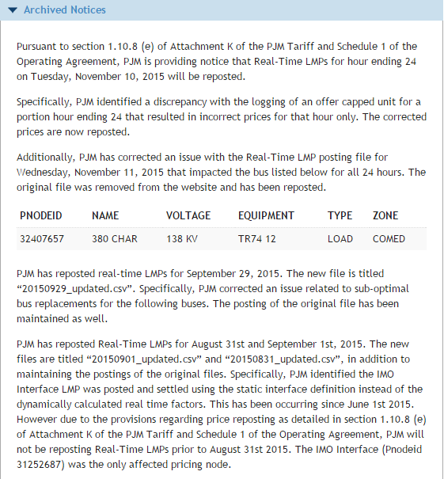
Other examples:
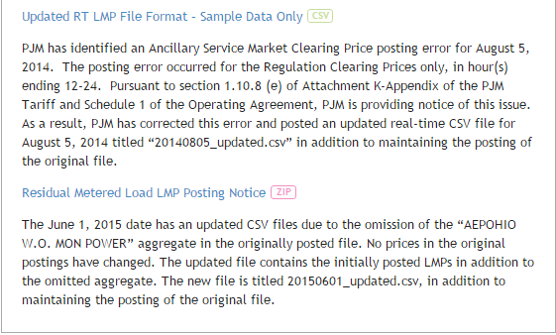
Other avenues include email notifications through their subcommittee system:
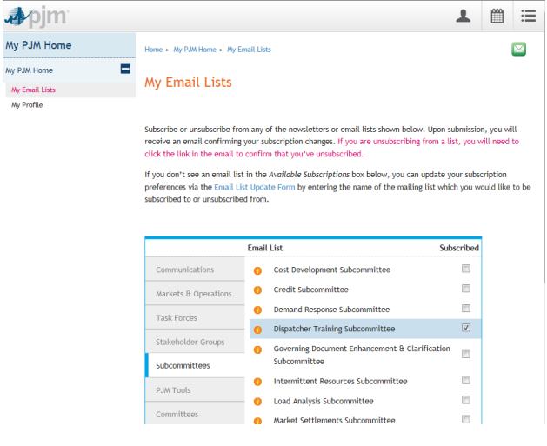

CAISO
CAISO has a “sister” site, like our MIS, that holds all its data: oasis.caiso.com. In the Atlas Reference > Oasis Publications and Revisions section they have an interface that allows you to query publications and notifications:
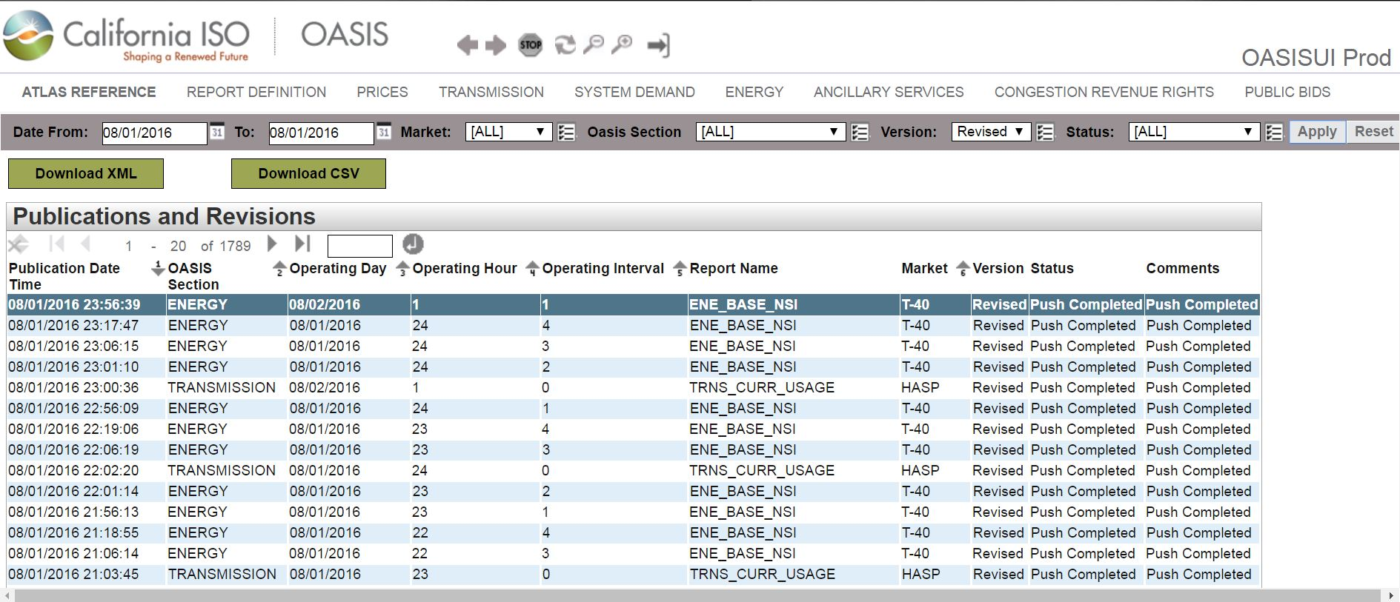
Utilizing the Version drop-down, you can choose either “New” or “Revised”. The former signifies when the report is initially dropped to the system; the latter if/when it’s revised/corrected. You also have the option to download the query results in XML and CSV.
New England ISO
Market notices are sent out for any changes to our Web Services, so we rely on those. We give 30-day notices to participants for any changes to the Web Services so they can make any updates they need.
We use a page on our site to communicate in a more “human” way about our Web Services than that api documentation page. This page (and the XLS on the page) gives more details about the reports we offer, available parameters, how far back data is available for, etc.: https://www.iso-ne.com/participate/support/web-services-data
No version history. There is a secure portal for one-off requests and there are separate sites that have data specifically for generators (Local Control Centers) but I’m not aware of exactly what’s included on those…
MISO
MISO utilizes subscription-based notifications to alert MP’s about report revisions:

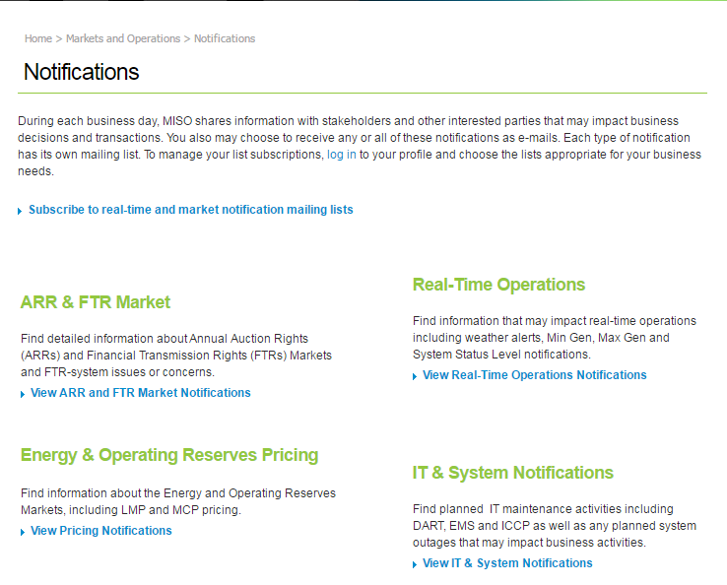
I requested more information from them, but my email went unanswered.
NYISO
NYISO has a Reports & Information section where corrected reports/prices are listed and downloadable:
http://www.nyiso.com/public/markets_operations/market_data/reports_info/index.jsp
