TDTMS Meeting
September 07, 2016
09:30 AM

Agenda
1. | Antitrust Statement
2. | Introductions  Monica Jones - NRG  Jim Lee - AEP  Sheri Wiegand - TXU  Kaci Jacobs – TXU  Catherine Meiners - ERCOT  Monsherra Odanga - Oncor  Carolyn Reed - CenterPoint  Dave Pagliai - ERCOT  Kyle Patrick - NRG  Lindsay Butterfield - ERCOT  Isabelle Durham - CenterPoint  Debbie McKeever - Oncor  Diana Rehfeldt - TNMP  Jayasree Kannala - CenterPoint  Kathy Scott - CenterPoint  Dave Michelsen - ERCOT  Tammy Stewart - ERCOT  Vikram Gupta – ERCOT  Rebecca Zerwas – NRG  Susan Young – Direct Energy
3. | Review of Agenda
4. | Review/Approve August Meeting Notes  - Approved
5. | Reminder: ERCOT Q2 Performance Measures posted  - All performance measures were at 100% with the exception of 867_02s which was at 99%.
6. | ERCOT System Instances & MarkeTrak Monthly Performance Review  - Retail Mkt IT systems met all SLA targets  - Dave will begin to ‘trim down’ the market notice which currently shows 9pm as the completion time – over the past several releases, ERCOT has been able to complete at 3pm or earlier.  - ERCOT System Instances Report:  - Kaci noted that the following outages were not listed on the report. Why did these not make the report?  - Unplanned Maintenance: 8/25 (Dave P: Energy Management System (EMS) issue impacting reports, but not part of Dave’s SLA – he reports this through COPS)  - MarkeTrak outage: 8/24 (Dave P: less than 5 minute issue affecting MIS/MT GUI)  - MIS outage: 8/23 (Dave P did not find anything on this)  - MT API Performance hit all performance targets
7. | MarkeTrak Upgrade - Discuss additional functionality/requirements (aka parking lot items)  - TDTMS went through the parking lot items and added comments to the working document.  - AI:Jim will convert parking lot list into Excel format and post to the TDTMS home page.  MT Upgrade →  - Dave Michelsen: working on upgrade now, but still has work left to be done. There will be cosmetic changes to the tool as part of the upgrade but all functionality will stay the same. ERCOT is working to give the market the chance to experience the upgraded version in the SCR786 Sandbox environment prior to the MarkeTrak upgrade being migrated to Production.  - Trying to get MT in the CERT/Sandbox environment (eta end of 2016/beginning of 2017)
8. | Proposed RMGRR – 7.3.2.1 Buyer’s Remorse  - Tabling this until October → NRG will bring this up again next month in more details – Tomas Fernandez will attend to discuss in more detail.  - NRG had an IAG rejected due Breach of Contract; however BoC is not included in the Valid Reject Reasons, so there is interpretation inconsistencies.
9. | MarkeTrak Subtype Analysis  - Follow-up: confirm MT User Guide changes for ‘U/B AMS-LSE Dispute’  - Review of all other MarkeTrak subtype volumes – anything else?  - Spend the last quarter of 2016 to map out the requirements/steps needed for the annual review. (Leadership to add this to the Oct/Nov/Dec agendas)  - Jim to add data slides to the Sept TDTMS update to RMS
10. | Inadvertent Gain Reporting Refinements  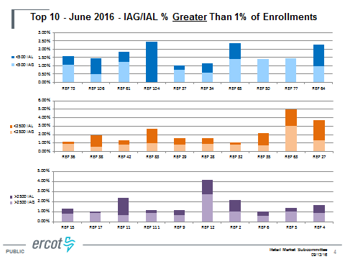  - ERCOT will add “Hit rate” to this slide – possibly have it for RMS  - Evaluate most current IAG data with new format  - Do we have consensus to move forward?  - Yes TDTMS to give recommendation to present this to RMS in September  - TDTMS will then review the small tweaks/fine tuning in Oct/Nov/Dec  - “hit rate” to slide 4  - % of market lower than 1%  - Keep in mind that IAG reporting should be thought of as: actionable data vs reporting data  - Achievement: Days to resolution is reduced for IAG and Rescissions!  - Jim to add “coordinated work with ERCOT on IAG reporting” to TDTMS Update to RMS.
11. | SCR786 Update  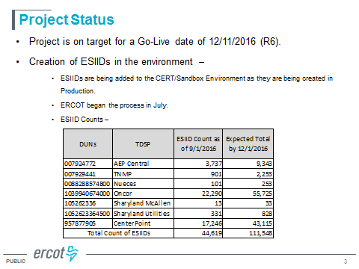  - ERCOT processing all 814_20 Adds sent in by TDSPs and process those through CERT environment to mimic PROD to populate the database of ESIIDs for testing purposes.  ACTION ITEM:  - TDTMS to develop User Documentation for Sandbox Testing (Catherine Meiners gave a starting point for TDTMS to use)  - If a MP leaves their CERT environment open at all times (and do not purge) then there is a possibility of having unexpected transaction in queue – probably best to purge CERT environment, or not leave it open ended.  - Final Orientation document to be housed where? Flight website, ETOD site, RMS homepage? Discuss further… do not let this reside behind a certificate area.
12. | Look ahead to Oct/Nov/Dec:  - 2016 Goals & Accomplishments  - 2017 Meeting Schedule  - SCR786 Orientation documentation  - IAG reporting tweaks  - MarkeTrak Subtype Analysis “Gameplan” for Annual Review  - MarkeTrak Enhancements – Parking Lot
13. | Adjourn

