July 2016 ERCOT Monthly Operations Report
Reliability and Operations Subcommittee Meeting
September 8th, 2016

Table of Contents
1. Report Highlights 1
2. Frequency Control 2
2.1. Frequency Events 2
2.2. Responsive Reserve Events 3
2.3. Load Resource Events 3
3. Reliability Unit Commitment 4
4. Wind Generation as a Percent of Load 6
5. Congestion Analysis 6
5.1. Notable Constraints for July 6
5.2. Generic Transmission Constraint Congestion 8
5.3. Manual Overrides for July 8
5.4. Congestion Costs for Calendar Year 2016 9
6. System Events 10
6.1. ERCOT Peak Load 10
6.2. Load Shed Events 10
6.3. Stability Events 10
6.4. Notable PMU Events 10
6.5. TRE/DOE Reportable Events 10
6.6. New/Updated Constraint Management Plans 10
6.7. New/Modified/Removed SPS 10
6.8. New Procedures/Forms/Operating Bulletins 10
7. Emergency Conditions 10
7.1. OCNs 10
7.2. Advisories 11
7.3. Watches 11
7.4. Emergency Notices 12
8. Application Performance 12
8.1. TSAT/VSAT Performance Issues 12
8.2. Communication Issues 12
8.3. Market System Issues 12
Appendix A: Real-Time Constraints 13

Report Highlights
- The unofficial ERCOT peak for July was 67,594 MW.
- There were ten frequency events in July. PMU data indicates the ERCOT system transitioned well in each case.
- There were eight instances where Responsive Reserves were deployed, all of which were the result of frequency events.
- There were thirty-four RUC commitments in July.
- The level of reportable SCED congestion decrease in July. This congestion was due primarily to planned outages and area load/gen patterns as well as high North to Houston Imports. There were sixty-six instances over 31 days on the Generic Transmission Constraints (GTCs) in July. There were twenty-one days of activity on the Zorillo – Ajo GTC, sixteen days on the Panhandle GTC, and twenty-nine days on the Liston GTC in July. There was no activity on the remaining GTCs during the Month.
- There were two significant system events for the month of July. One for a complete loss of monitoring capabilities and one for multiple unit trips.
- There were four application issues to report for July; most notably an EMS failure on July 7th at approximately 11:41.

Frequency Control

Frequency Events
The ERCOT Interconnection experienced ten frequency events in July, all of which resulted from Resource trips. The average event duration was approximately 0:03:23.

When analyzing frequency events, ERCOT evaluates PMU data according to industry standards. Events with an oscillating frequency of less than 1 Hz are considered to be inter-area, while higher frequencies indicate local events. Industry standards specify that damping ratio for inter-area oscillations should be 3.0% or greater. All events listed below indicate the ERCOT system met these standards and transitioned well after each disturbance.

Reported frequency events will include both frequency events where frequency was outside the range of 60±0.1 Hz as well as those determined to be Frequency Measurable Events (FME) as defined by BAL-001-TRE-1. Delta Frequency is defined as the difference between the pre-perturbation and post-perturbation frequency. The Duration of Event is defined as the time it takes for the frequency to recover to lesser/greater of the frequency at the time of the frequency event (t(0) or “A-point”) for low/high-frequency events, respectively. Further details on FMEs can be found in the MIS posted BAL-001-TRE-1 PDCWG Unit Performance reports. A summary of the frequency events is provided below:

Date and Time | Delta Frequency | Max/Min Frequency | Duration of Event | PMU Data |  |  | Load | Wind | Inertia | Comments
 | (Hz) | (Hz) |  | Oscillation Mode (Hz) |  | Damping Ratio | (MW) | % | (GW-s)
7/7/2016 13:01 | 0.047 | 59.85 | 0:06:14 | 0.61 | 10% |  | 61,006 | 13% | 346,996 | Unit Trip of 634 MW
7/10/2016 1:14 | 0.049 | 59.86 | 0:04:59 | 0.72 | 9% |  | 40,585 | 22% | 268,383 | Unit Trip of 541 MW
7/10/2016 18:54 | 0.082 | 59.79 | 0:04:27 | 0.63 | 8% |  | 59,942 | 16% | 323,106 | Unit Trip of 1376 MW
 |  |  |  | 0.66 | 5%
7/13/2016 13:30 | 0.074 | 59.86 | 0:03:32 | 0.63 | 12% |  | 63,895 | 15% | 339,623 | Unit Trip of 722 MW
7/14/2016 15:50 | 0.076 | 59.89 | 0:05:23 | 0.62 | 9% |  | 67,317 | 9% | 356,559 | Unit Trip of 581 MW
7/18/2016 18:03 | 0.058 | 59.86 | 0:05:05 | 0.63 | 11% |  | 63,661 | 8% | 351,213 | Unit Trip of 533 MW
7/21/2016 14:53 | 0.117 | 59.88 | 0:08:32 | 0.59 | 11% |  | 66,744 | 6% | 366,087 | Unit Trip of 703 MW
7/24/2016 16:22 | 0.109 | 59.89 | 0:03:23 | 0.61 | 8% |  | 66,407 | 5% | 360,413 | Unit Trip of 547 MW
7/25/2016 16:45 | 0.084 | 59.88 | 0:04:31 | 0.63 | 7% |  | 63,570 | 5% | 361,878 | Unit Trip of 733 MW
7/30/2016 16:39 | 0.067 | 59.93 | 0:09:08 | No PMU Data Available. |  |  | 63,125 | 8% | 343,928 | Unit Trip of 393 MW

(Note: frequency events highlighted in blue have been identified as FMEs per BAL-001-TRE-1 and the Performance Disturbance Compliance Working group.)

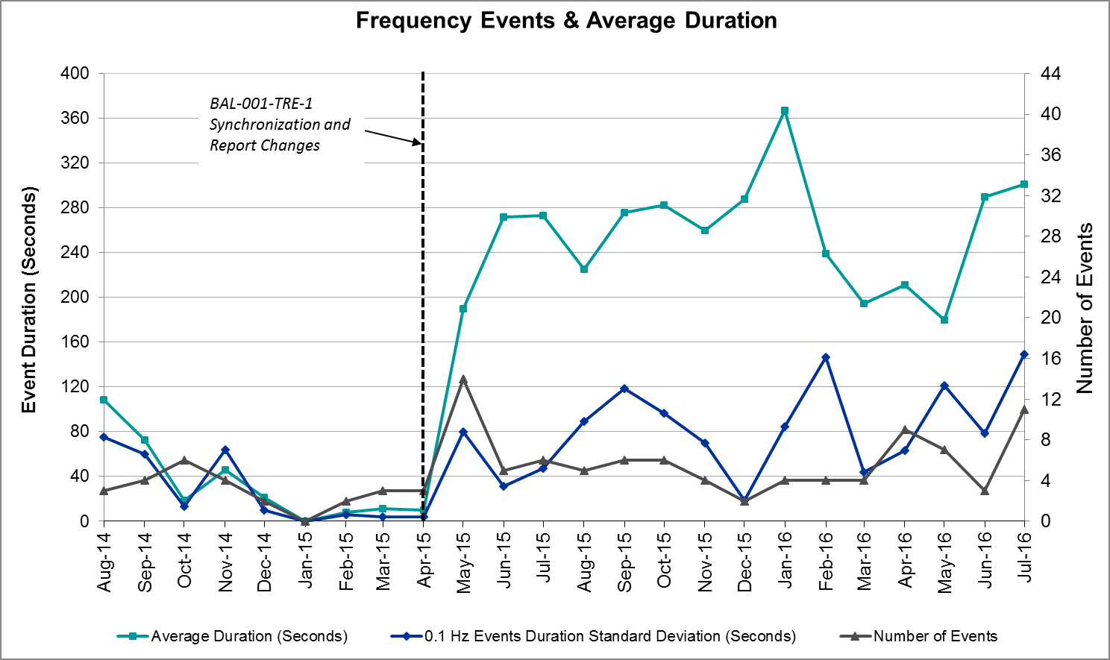

Responsive Reserve Events
There were eight events where Responsive Reserve MWs were released to SCED in July. The events highlighted in blue were related to frequency events reported in Section 2.1 above.

Date and Time Released to SCED | Date and Time Recalled | Duration of Event | Maximum MWs Released | Comments
7/10/2016 1:14:08 | 7/10/2016 1:19:56 | 0:05:48 | 812.90
7/10/2016 18:54:30 | 7/10/2016 18:58:42 | 0:04:12 | 1095.91
7/13/2016 13:30:08 | 7/13/2016 13:33:20 | 0:03:12 | 620.11
7/14/2016 15:51:02 | 7/14/2016 15:55:40 | 0:04:38 | 375.68
7/18/2016 18:03:26 | 7/18/2016 18:09:02 | 0:05:36 | 702.05
7/21/2016 14:53:34 | 7/21/2016 14:59:38 | 0:06:04 | 361.72
7/24/2016 16:23:06 | 7/24/2016 16:26:14 | 0:03:08 | 406.30
7/25/2016 16:46:00 | 7/25/2016 16:49:44 | 0:03:44 | 453.82

Load Resource Events
None.

Reliability Unit Commitment
ERCOT reports on Reliability Unit Commitments (RUC) on a monthly basis. Commitments are reported grouped by operating day and weather zone. The total number of hours committed is the sum of the hours for all the units in the specified region. Additional information on RUC commitments can be found on the MIS secure site at Grid Generation Reliability Unit Commitment.

There were no DRUC commitments in July.

There were 34 HRUC commitments in July.

HRUC Commitments
Resource Location | # of Resources | Operating Day | Total # of Hours Committed | Total MWhs | Reason for Commitment
North Central | 1 | 7/1/2016 | 2 | 1,046 | Local Congestion
North Central | 2 | 7/2/2016 | 14 | 756 | Local Congestion
Coastal | 1 | 7/3/2016 | 6 | 1,014 | Local Congestion
Coastal | 2 | 7/4/2016 | 7 | 1,609 | Local Congestion
East | 1 | 7/6/2016 | 6 | 270 | Local Congestion
North Central | 1 | 7/7/2016 | 6 | 300 | Local Congestion
East | 4 | 7/7/2016 | 14 | 644 | Local Congestion
North Central | 1 | 7/8/2016 | 6 | 5,372 | Local Congestion
Coastal | 1 | 7/8/2016 | 6 | 1,014 | Local Congestion
Southern | 6 | 7/8/2016 | 6 | 546 | Local Congestion
Coastal | 7 | 7/9/2016 | 20 | 3,233 | Local Congestion
Coastal | 3 | 7/10/2016 | 27 | 5,026 | Local Congestion
North Central | 9 | 7/11/2016 | 35 | 10,790 | Local Congestion
North | 1 | 7/12/2016 | 1 | 704 | Local Congestion
Coastal | 1 | 7/13/2016 | 8 | 4,216 | Local Congestion
Far West | 1 | 7/13/2016 | 4 | 592 | Local Congestion
South Central | 1 | 7/13/2016 | 3 | 141 | Local Congestion
North Central | 1 | 7/14/2016 | 6 | 366 | Local Congestion
Coastal | 1 | 7/14/2016 | 3 | 522 | Local Congestion
North Central | 2 | 7/16/2016 | 12 | 708 | Local Congestion
Coastal | 1 | 7/17/2016 | 4 | 676 | Local Congestion
Southern | 2 | 7/18/2016 | 2 | 182 | Local Congestion
Southern | 3 | 7/19/2016 | 3 | 275 | Local Congestion
Coastal | 2 | 7/21/2016 | 12 | 4,892 | Local Congestion
North Central | 1 | 7/22/2016 | 1 | 234 | Local Congestion
Southern | 1 | 7/23/2016 | 8 | 2,680 | Local Congestion
Coastal | 5 | 7/23/2016 | 19 | 2,464 | Local Congestion
Coastal | 4 | 7/24/2016 | 19 | 5,623 | Local Congestion
Southern | 1 | 7/24/2016 | 8 | 2,680 | Local Congestion
Southern | 1 | 7/25/2016 | 8 | 2,680 | Capacity
North Central | 2 | 7/25/2016 | 9 | 1,843 | Capacity
Coastal | 2 | 7/30/2016 | 10 | 2,088 | Local Congestion
North Central | 1 | 7/31/2016 | 8 | 456 | Local Congestion
Coastal | 1 | 7/31/2016 | 6 | 972 | Local Congestion

Wind Generation as a Percent of Load
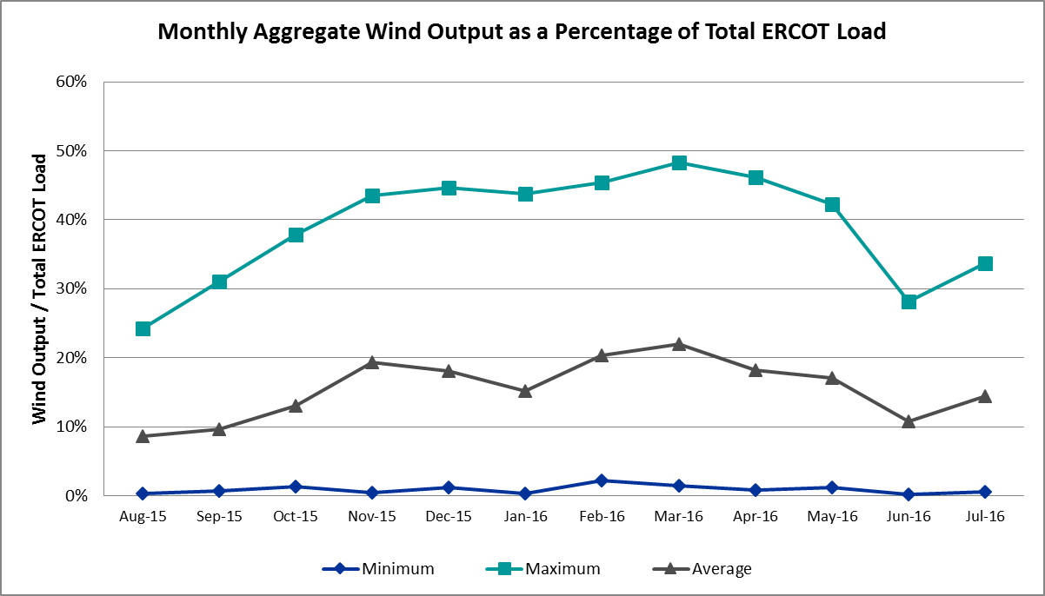

Congestion Analysis
The number of congestion events experienced by the ERCOT system decreased in July. There were sixty-six instances of activity on the Generic Transmission Constraints (GTCs) in July.

Notable Constraints for July
Nodal protocol section 3.20 specifies that ERCOT shall identify transmission constraints that are active or binding three or more times within a calendar month. As part of this process, ERCOT reports congestion that meets this criterion to ROS. In addition ERCOT also highlights notable constraints that have an estimated congestion rent exceeding $1,000,000 for a calendar month. These constraints are detailed in the table below. Rows highlighted in blue indicate the congestion was affected by one or more outages. For a list of all constraints activated in SCED for the month of July, please see Appendix A at the end of this report.

Contingency | Overload | # of Days Constraint Active | Estimated Congestion Rent | Transmission Project
DKCT Roans Prarie-Rothwood & Singleton-Tomball 345kV | Singleton - Zenith 345kV | 23 | $4,766,174.55 | Houston Import Project
DCKT Lost Pines - Austrop & Dunlop 345 kV | Fayetteville 6AT2 345/138kV | 3 | $3,746,945.40
Lobo 2_345_138 345/138 kV | Dilley Switch Aep - Jardin 138kV | 2 | $2,701,669.47
Carrolton Northwest - Lewisville Switch 345 kV | Lewisville Switch - Jones Street Tnp 138kV | 9 | $2,269,938.60
Hicks Switch - Alliance & Roanoke Switch 345 kV | Eagle Mountain Ses AX2H 345/13.8/138kV | 2 | $2,048,471.99
Nacogdoches Se to Mt Enterprise 345 kV | Lufkin - Lufkin Switch 138kV | 1 | $1,970,340.29 | 5405
Hicks Switch - Alliance & Roanoke Switch 345 kV | Eagle Mountain Ses - Eagle Mountain Poi 138kV | 10 | $1,524,389.13 | 3209
Laquinta - Lobo 138 kV | Bruni Sub 69_1 138/69kV | 28 | $1,151,660.04
Basecase | Liston GTC | 29 | $1,120,828.98
Jim Christal Substation - West Denton 138 kV | Fort Worth Subsation - West Denton 138kV | 11 | $1,088,637.86
Fort Worth Subsation to West Denton 138 kV | Jim Christal Substation - West Denton 138kV | 10 | $1,026,191.96
DCKT Jewett - Singleton 345 kV | Btu_Jack_Creek - Twin Oak Switch 345kV | 25 | $978,629.46 | Houston Import Project
Hutto - Round Rock & Gabriel 138 kV | Gilleland - Mcneil Lcra 138kV | 13 | $876,557.29 | 5269
Btu_Atkins Axfmr1 138/69 kV | Btu_Briarcrest - Btu_Nall_Lane 69kV | 5 | $716,285.30 | 4574
DCKT West Levee Switch - 800/900 Network 138 kV | East Levee Switch - Reagan Street 138kV | 4 | $464,349.08 | 16TPIT0061
Mercers Gap Sw to Comanche Switch (Oncor) 138 kV | Camp Bowie (Oncor) - Brownwood Switch 138kV | 11 | $428,168.41
Bluff Creek T2 (3) 345/138 kV | Bluff Creek T1_H 345/34.5/138kV | 3 | $406,612.78
DCKT Whitepint - Lon Hill and South Texas Project 345 kV | Bonnieview - Rincon 69kV | 10 | $353,084.09
Lobo 2_345_138 345/138 kV | Freer - San Diego 69kV | 4 | $311,607.53 | 3903
Bevo Substation - Asherton 138 kV | Big Wells Sub - Cotulla Sub 69kV | 9 | $268,395.33 | 5217
Nacogdoches Se Axfmr1t (3)345/138 kV | Lufkin - Lufkin Switch 138kV | 3 | $251,478.09 | 5405
DCKT Ferguson - Granite Mountain and Wirtz - Starcke - Paleface 138 kV | Flat Rock Lcra - Wirtz 138kV | 24 | $211,607.94 | 4465
Basecase | Panhandle GTC | 16 | $172,823.20 | Panhandle Upgrade
Uvalde Aep - Odlaw Switchyard 138 kV | Hamilton Road - Maverick 138kV | 6 | $164,689.56 | 16TPIT0024
Basecase | Randado Aep - Zapata 138kV | 19 | $160,749.27
Jardin to Cotulla Sub 138 kV | Dilley Switch Aep - Cotulla Sub 69kV | 5 | $111,707.64 | 5222
Garza to Roma Switch 138 kV | Garza 69A1 138/69kV | 3 | $91,807.99
Yellow Jacket - Fort Mason 138 kV | Fort Mason - Mason Aep 69kV | 5 | $76,200.08
Bighil-Kendal 345kV | Rocksprings - Friess Ranch 69kV | 4 | $73,051.54
Midland East - Moss Switch - Odessa Ehv Switch 345 kV | Odessa EHV Switch to Trigas Odessa Tap | 3 | $61,497.86
Mlses - Elktn And Tygnd 345 | Tyler Northwest - Shamburger Switch 138kV | 4 | $58,644.92 | 09TPIT0122
Bevo Substation - Asherton 138 kV | Hamilton Road - Maverick 138kV | 3 | $55,490.00 | 16TPIT0024
Gila - Hiway 9 138 kV | Morris Street - Gila 138kV | 7 | $35,670.01
Lobo 2_345_138 345/138 kV | Lon Hill to Bessel 138 kV | 5 | $30,216.14
Bosque Switch - Elm Mott 345 kV | Bosque Switch - Rogers Hill Bepc 138kV | 7 | $24,882.80 | 4356
DCKT Sandow Switch - Austrop 345kV | Howard Lane Tap - Howard Lane Aen 138kV | 3 | $15,414.86
Basecase | Zorillo to Ajo GTC | 21 | $3,207.20 | LRGV (lower Rio Grande Valley) Import Project

Generic Transmission Constraint Congestion
There were twenty-one days of activity on the Zorillo – Ajo GTC, sixteen days on the Panhandle GTC, and twenty-nine days on the Liston GTC in July. There was no activity on the remaining GTCs during the Month.

Note: This is how many times a constraint has been activated to avoid exceeding a GTC limit, it does not imply an exceedance of the GTC occurred or that the GTC was binding.

Manual Overrides for July
Eight SCED intervals (7/19/2016 5:00-5:35) had an HDL override due to pre-posturing for a maintenance outage. The constraint was activated for congestion management and override was removed.

Congestion Costs for Calendar Year 2016
The following table represents the top twenty active constraints for the calendar year based on the estimated congestion rent attributed to the congestion. ERCOT updates this list on a monthly basis.

Contingency | Binding Element | # of 5-min SCED Intervals | Estimated Congestion Rent | Transmission Project
Ph Robinson At1l_H (3)345/138 KV | Meadow AT1 345/138kV | 1,470 | $ 37,410,531.94 | 4708
Villa Cavazos to Military Highway Aep (2)138/138 KV | Los Fresnos - Loma Alta Substation 138kV | 3,272 | $ 26,026,381.24
Rnksw-W_Dent&Lwssw-Krwsw 345kv | Fort Worth Subsation - West Denton 138kV | 1,774 | $ 10,027,611.63
Rns-Rtw & Sng-Tb 345kv | Singleton - Zenith 345kV | 4,673 | $ 9,813,183.51 | Houston Import Project
Hcksw-Allnc&Rnksw 345kv | Eagle Mountain Ses - Morris Dido 138kV | 1,420 | $ 8,755,553.47 | 4252
Basecase | Panhandle GTC | 5,455 | $ 8,110,050.26 | Panhandle Upgrade
Jewet-Sng 345kv | Btu_Jack_Creek - Twin Oak Switch 345kV | 5,484 | $ 7,486,443.54 | Houston Import Project
Bm-Sr73 & Sr81 138kv | Bellaire - San Felipe 138kV | 196 | $ 7,119,922.62
Rosen Heights to Eagle Mountain Compressor (5)138/138/138/138/138 KV | Rosen Heights Tap 2 - Morris Dido 138kV | 857 | $ 6,945,775.57 | 4252
Meadow to Ph Robinson 345 KV | Meadow AT1 345/138kV | 89 | $ 6,552,987.55 | 4708
Basecase | Valley Import | 110 | $ 6,494,964.50 | LRGV (lower Rio Grande Valley) Import Project
Lwssw-Krwsw&Rnksw 345kv | Fort Worth Subsation - West Denton 138kV | 788 | $ 5,462,367.54
Hcksw-Allnc&Rnksw 345kv | Rosen Heights Tap 2 - Morris Dido 138kV | 805 | $ 5,063,292.44 | 4252
South Carbide to Loma Alta Substation 138 KV | La Palma - Villa Cavazos 138kV | 505 | $ 5,060,645.62 | 4490
Mason Road to Obrien 138 KV | Betka - Hockley 138kV | 257 | $ 4,451,883.67 | 3682A,3682,3682C
South Texas # 1 & # 2 | Marion - Clear Springs 345kV | 18 | $ 4,402,597.52
Nelson Sharpe to Ajo 345 KV | Javalina Tap - Molina 138kV | 4,406 | $ 4,208,950.27 | 4401
Ph Robinson At4_H (3)345/138 KV | Meadow AT1 345/138kV | 62 | $ 3,994,537.45 | 4708
Eagle Mountain Ses Axfmr1l (3)345/138 KV | Eagle Mountain Ses AX2L 345/13.8/138kV | 329 | $ 3,993,367.46
Eagle Mountain Ses Axfmr1l (3)345/138 KV | Eagle Mountain Ses AX2H 345/13.8/138kV | 813 | $ 3,865,585.22

System Events

ERCOT Peak Load
The unofficial ERCOT peak load for the month was 67,594 MW and occurred on July 14th during hour ending 17:00.

Load Shed Events
None.

Stability Events
None.

Notable PMU Events
ERCOT analyzes PMU data for any significant system disturbances that do not fall into the Frequency Events category reported in section 2.1. The results are summarized in this section once the analysis has been completed.

There were no reportable events in July.

TRE/DOE Reportable Events
There were two reportable events for July
07/07/2016 EOP-004-2 Reportable Event - Complete Loss of Monitoring Capabilities – 07072016
07/10/2016 EOP-004-2 Reportable Event - Multiple Unit Trips - 07102016

New/Updated Constraint Management Plans
None.

New/Modified/Removed SPS
None.

New Procedures/Forms/Operating Bulletins

Date | Subject | Bulletin No.
07/15/2016 | Real Time Desk V1 Rev43 | 754

Emergency Conditions

OCNs
Date and Time | Description
7/12/16 08:33 | OCN issued due to the forecasted probability of a 4,000 MW down-ramp in the next 180 minutes
7/25/16 16:42 | OCN issued due to capacity insufficiency

Advisories
Date and Time | Description
7/1/16 14:17 | Advisory issued due to ERCOTs Voltage Security Assessment Tool not solving for the last 30 min.
7/7/16 12:19 | Advisory issued due to ERCOTs State Estimator/RTCA being unavailable.
7/7/16 12:21 | Advisory issued due to ERCOTs Voltage Security Assessment Tool being unavailable.
7/13/16 16:47 | Advisory issued due to ERCOTs Voltage Security Assessment Tool being unavailable.
7/14/16 14:48 | Advisory issued due to Physically Responsive Capability being less than 3,000MW.
7/16/16 14:56 | Advisory issued due to Physically Responsive Capability being less than 3,000MW.
7/21/16 15:08 | Advisory issued due to Physically Responsive Capability being less than 3,000MW.
7/22/16 15:01 | Advisory issued due to Physically Responsive Capability being less than 3,000MW.
7/23/16 15:28 | Advisory issued due to Physically Responsive Capability being less than 3,000MW.
7/24/16 14:27 | Advisory issued due to Physically Responsive Capability being less than 3,000MW.
7/25/16 14:15 | Advisory issued due to Physically Responsive Capability being less than 3,000MW.
7/29/16 16:13 | Advisory issued due to Physically Responsive Capability being less than 3,000MW.
7/31/16 16:05 | Advisory issued due to Physically Responsive Capability being less than 3,000MW.

Watches
Date and Time | Description
7/23/16 06:04 | Watch issued due to HRUC unable to solve due to application issue.
7/23/16 07:00 | Watch issued due to HRUC unable to solve due to application issue.

Emergency Notices
Date and Time | Description
7/7/16 12:09 | Emergency Notice due to the failure of SCED/RLC being unavailable.
.

Application Performance
There were four issues to report for July. On 7/7/16 at approximately 11:41 the ERCOT EMS went down. All online tools were affected. EMS Systems was unavailable from 07/07/2016 11:42 AM till 12:05:50 and running in degraded state from 12:05:50 until 13:23. EMS system was fully functional from 13:23.

TSAT/VSAT Performance Issues

7/13/16 – VSAT did not update for 30min 58sec due to DSA having Powerflow convergence issues.

Communication Issues
None.

Market System Issues
7/1/16 – After successful VSAT solution and calculation of VSAT GTL values to EMS at 12:59:43, subsequent RTDCP runs resulted in successful VSAT solution but failure to update GTL values in EMS Table. Control Room displays/tools read PI tag tied to successful calculation to indicate DSA failure/delay and therefore failed to indicate file transfer issue or issue any type of alarm. At approximately 13:45:00, after multiple successful VSAT solutions did not generate unique new limits, the transfer failure was identified. EMMS Production Support was able to resolve issue for one successful transfer of VSAT limits at 14:08:40.

7/07/2016 - SCED solution executed with Invalid EMS data from 11:42 AM until 13:23 due to EMS issue, required price correction.

7/23/2016 – HRUC unable to solve due to ESSP sizing issue, EMMS Production was able to resolve the issue.

Appendix A: Real-Time Constraints
The following is a complete list of constraints activated in SCED for the month of July. Full contingency descriptions can be found in the Standard Contingencies List located on the MIS secure site at Grid Generation Reliability Unit Commitment.

Contingency | Constrained Element | From Station | To Station | # of Days Constraint Active
BASE CASE | LISTON | n/a | n/a | 29
SLAQLOB8 | BRUNI_69_1 | BRUNI | BRUNI | 28
DJEWSNG5 | JK_TOKSW_1 | TOKSW | JK_CK | 25
DFERPAL8 | 38T365_1 | WIRTZ | FLATRO | 24
DRNS_TB5 | SNGZEN99_A | SNG | ZEN | 23
BASE CASE | ZO_AJO | n/a | n/a | 21
BASE CASE | RANDAD_ZAPATA1_1 | RANDADO | ZAPATA | 19
BASE CASE | PNHNDL | n/a | n/a | 16
DHUTGAB8 | 211T147_1 | GILLCR | MCNEIL_ | 13
SJMCW_D8 | FTW_W_DE_1 | W_DENT | FTWORTH | 11
SZEPCMN8 | 670__B | BRNSW | CMPBW | 11
DHCKRNK5 | 6270__A | EMSES | EGPOI | 10
SFTWW_D8 | AIR_W_DE_1 | W_DENT | JMCRSTL | 10
DWH_STP5 | BONIVI_RINCON1_1 | RINCON | BONIVIEW | 10
DCRLLSW5 | 590__A | LWSSW | LWVJS | 9
SBEVASH8 | BIG_COTU_1 | COTULAS | BIGWELS | 9
SBOSELM5 | 1030__B | BOSQUESW | RGH | 7
SGILNU78 | GILA_MORRIS1_1 | GILA | MORRIS | 7
SBRAUVA8 | HAMILT_MAVERI1_1 | HAMILTON | MAVERICK | 6
SFORYEL8 | FORTMA_MASN1_1 | FORTMA | MASN | 5
SJARDIL8 | DIL_COTU_1 | DILLEYSW | COTULAS | 5
XLOB58 | BESSEL_LON_HI1_1 | LON_HILL | BESSEL | 5
XATK89 | NAL_BRIR_1 | NALL_LN | BRIRCRT | 5
DTRCELK5 | 1760__A | SHBSW | TYLNW | 4
DWLV89N8 | 3410__A | ELVSW | REGST | 4
XLOB58 | FREER_SAN_DI1_1 | SAN_DIEG | FREER | 4
DBIGKEN5 | FRIR_ROCKSP1_1 | FRIR | ROCKSPRS | 4
SGARROM8 | GARZA_69A1 | GARZA | GARZA | 3
DAUSSND5 | HWRDLN_1 | HWRDTP | HWRDLN | 3
XNCD58 | 1360__A | LFKSW | LUFKN | 3
SRDODES8 | 940__C | ENWSW | WXHCH | 3
SMCEABS8 | MKLT_TRNT1_1 | TRNT | MKLT | 3
XLY2T58 | LYTTON_S_AT1H | LYTTON_S | LYTTON_S | 3
SBEVASH8 | HAMILT_MAVERI1_1 | HAMILTON | MAVERICK | 3
SLOCSPN9 | DENTON_AT1 | DENTON | DENTON | 3
DAUSLOS5 | FAYETT_6AT2 | FAYETT | FAYETT | 3
XBL2U58 | BLUF_CRK_T1_H | BLUF_CRK | BLUF_CRK | 3
SMDLODE5 | 6475__C | ODEHV | TROTP | 3
DAUSLOS5 | 137T176_1 | FRELSB | MOCKINGB | 2
DAUSLOS5 | 155T217_1 | BELLSO | PT | 2
SBESLON8 | ALICE_N_ELLA1_1 | ALICE | N_ELLA | 2
SSPNDEN9 | HIC_LOCU_1 | LOCUST_D | HICKRY_D | 2
DAUSLOS5 | 176T165_1 | FAYETT | WINCHE | 2
XLOB58 | ALICE_N_ELLA1_1 | ALICE | N_ELLA | 2
DFL_MAR8 | BETHK_66_A | HK | BET | 2
DFPPLOS5 | FAYETT_6AT2 | FAYETT | FAYETT | 2
XLOB58 | DILLEY_JARDIN1_1 | DILLEYSW | JARDIN | 2
SRAZD18 | 2584_1 | DOWNIES | UVALDE | 2
DHCKRNK5 | EMSES_AX2H | EMSES | EMSES | 2
DAUSLOS5 | 154T176_1 | FAYETT | FRELSB | 2
SMCSCDH8 | 3210__A | CDHSW | MCSES | 2
SSALFPP5 | FAYETT_6AT2 | FAYETT | FAYETT | 2
BASE CASE | S104A_1 | RIOHONDO | MV_BURNS | 2
DSTEXP12 | BLESSI_LOLITA1_1 | LOLITA | BLESSING | 2
SKLELOY8 | LOYOLA_69_1 | LOYOLA | LOYOLA | 2
XLOB58 | RIO_BR_S_YGNA1_1 | S_YGNACI | RIO_BRAV | 2
XGIL89 | 340T287_1 | FREDER | GOEHTA | 1
SWINWIN8 | WINKS_MR2H | WINKS | WINKS | 1
SSCUSU28 | ASPM_69T1 | ASPM | ASPM | 1
SPHRCTR5 | CBYRNG87_A | CBY | RNG | 1
BASE CASE | CEDRHILL_69_1 | CEDRHILL | CEDRHILL | 1
XLOB58 | DIL_COTU_1 | DILLEYSW | COTULAS | 1
SKMCKW25 | KMCHI_KWASS1_1 | KMCHI | KWASS | 1
UHLSUNI1 | 3180__A | CDHSW | FCRSW | 1
DCRLLSW5 | 591__A | LKPNT | CRLNW | 1
DVENLIG5 | 6300__C | BWNT2 | VGCRK | 1
DCHBJOR5 | ATKRIN87_A | RIN | ATK | 1
SW_BASH8 | BIG_COTU_1 | COTULAS | BIGWELS | 1
SORE2B8 | FL_FOS25_A | FOS | FL | 1
SBATPEA8 | 2584_1 | DOWNIES | UVALDE | 1
BASE CASE | LGD_SANTIA1_1 | LGD | SANTIAGO | 1
SMDLODE5 | ODEHV_MR1H | ODEHV | ODEHV | 1
SPHRCTR5 | RINRNG87_A | RNG | RIN | 1
BASE CASE | SNYDER_WKN_BK1_1 | ENAS | WKN_BKR | 1
SNCDTRS5 | 1360__A | LFKSW | LUFKN | 1
SLCSTM25 | 315__A | TMPSW | TMPCR | 1
SARMGA28 | 3416__A | NORSW | CHROW | 1
XREN58 | 3640__D | SCHRD | DALTI | 1
SABMAB38 | ABSO_WTGULF1_1 | ABSO | WTGULFTA | 1
SEAGHAM8 | ASHERT_W_BATE1_1 | W_BATESV | ASHERTON | 1
SOAKNIC8 | NICOLE_ORNT1_1 | NICOLE | ORNT | 1
SLCSTH25 | 505__A | THSES | SAMSW | 1
SMCEABS8 | 6585__A | ESKSW | TRNT | 1
DCHBJOR5 | EXNLH_03_A | EXN | LH | 1
SPOACSS8 | NAL_BRIR_1 | NALL_LN | BRIRCRT | 1
SSCUSU28 | ROBY_ROTN1_1 | ROBY | ROTN | 1
XEV2R58 | 6290__A | EVRSW | RLHT1 | 1
XNC2A99 | BLESSI_PALACI1_1 | BLESSING | PALACIOS | 1
SPALNED5 | LOMA_A_L_FRES1_1 | L_FRESNO | LOMA_ALT | 1
XODE58 | ODEHV_MR1H | ODEHV | ODEHV | 1
DRIOHAR5 | S104A_1 | RIOHONDO | MV_BURNS | 1
SFERZ48 | WEIDER_RAND_1 | WEIDER | W2 | 1
DAUSSND5 | 211T147_1 | GILLCR | MCNEIL_ | 1
SVICCOL8 | COLETO_VICTOR1_1 | COLETO | VICTORIA | 1
SBOSELM5 | WHTNY_HT1L | WHTNY | WHTNY | 1
SPRAWAL8 | 155T217_1 | BELLSO | PT | 1
DTHSLCS5 | 290__A | LCSES | THSES | 1
XWLV158 | 3416__A | NORSW | CHROW | 1
SCLNWLC8 | 565__D | PAYSW | SHRTI | 1
SPHRCTR5 | ATKRIN87_A | RIN | ATK | 1
DCHBJOR5 | BRNWIN86_A | BRN | WIN | 1
SVICCO28 | COLETO_VICTOR2_1 | COLETO | VICTORIA | 1
BASE CASE | SNYDER_WKN_BK1_1 | WKN_BKR | ENAS | 1
XCDH58 | 931__C | CDHIL | DCVSO | 1

